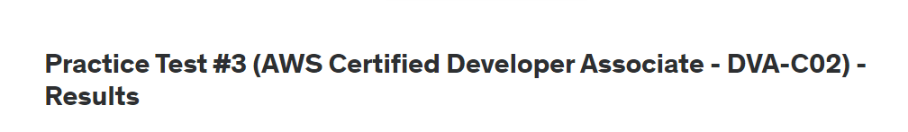

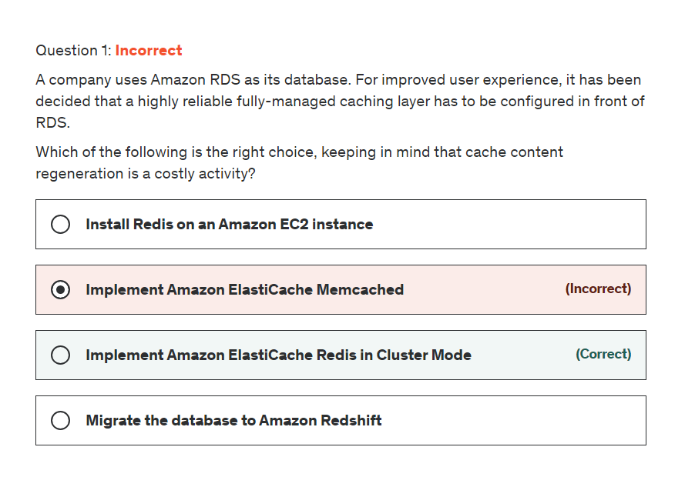

**Explanation**

Correct option:

**Implement Amazon ElastiCache Redis in Cluster-Mode** - One can leverage ElastiCache for Redis with cluster mode enabled to enhance reliability and availability with little change to your existing workload. Cluster mode comes with the primary benefit of horizontal scaling of your Redis cluster, with almost zero impact on the performance of the cluster.

When building production workloads, you should consider using a configuration with replication, unless you can easily recreate your data. Enabling Cluster-Mode provides a number of additional benefits in scaling your cluster. In short, it allows you to scale in or out the number of shards (horizontal scaling) versus scaling up or down the node type (vertical scaling). This means that Cluster-Mode can scale to very large amounts of storage (potentially 100s of terabytes) across up to 90 shards, whereas a single node can only store as much data in memory as the instance type has capacity for.

Redis Cluster config: 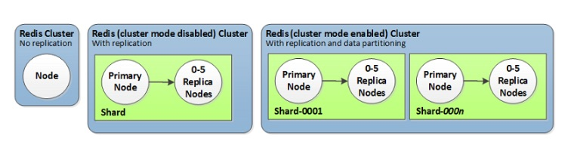 via - <https://aws.amazon.com/blogs/database/work-with-cluster-mode-on-amazon-elasticache-for-redis/>

Incorrect options:

**Install Redis on an Amazon EC2 instance** - It is possible to install Redis directly onto Amazon EC2 instance. But, unlike ElastiCache for Redis, which is a managed service, you will need to maintain and manage your Redis installation.

**Implement Amazon ElastiCache Memcached** - Redis and Memcached are popular, open-source, in-memory data stores. Although they are both easy to use and offer high performance, there are important differences to consider when choosing an engine. Memcached is designed for simplicity while Redis offers a rich set of features that make it effective for a wide range of use cases. Redis offers snapshots facility, replication, and supports transactions, which Memcached cannot and hence ElastiCache Redis is the right choice for our use case.

**Migrate the database to Amazon Redshift** - Amazon Redshift belongs to "Big Data as a Service" cloud facility, while Redis can be primarily classified under "In-Memory Databases". "Data Warehousing" is the primary reason why developers consider Amazon Redshift over the competitors, whereas "Performance" is the key factor in picking Redis.

References:

<https://aws.amazon.com/blogs/database/work-with-cluster-mode-on-amazon-elasticache-for-redis/>

<https://aws.amazon.com/elasticache/redis-vs-memcached/>

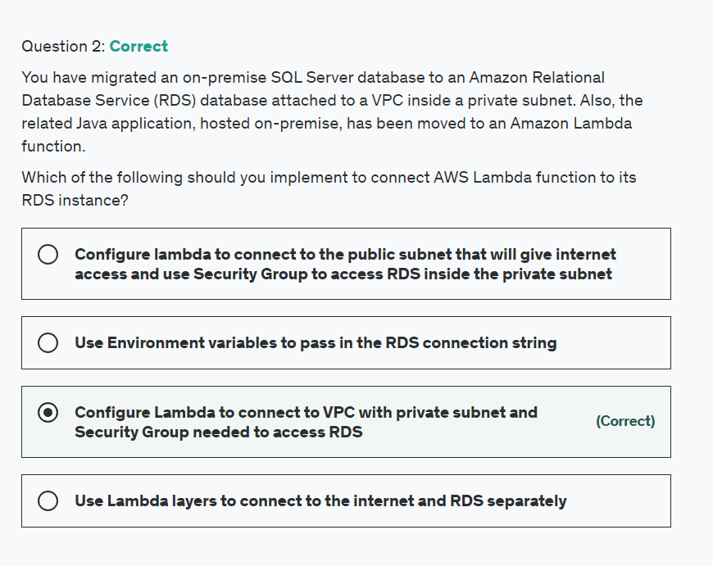

Explanation

Correct option:

**Configure Lambda to connect to VPC with private subnet and Security Group needed to access RDS** - You can configure a Lambda function to connect to private subnets in a virtual private cloud (VPC) in your account. Use Amazon Virtual Private Cloud (Amazon VPC) to create a private network for resources such as databases, cache instances, or internal services. Connect your lambda function to the VPC to access private resources during execution. When you connect a function to a VPC, Lambda creates an elastic network interface for each combination of the security group and subnet in your function's VPC configuration. This is the right way of giving RDS access to Lambda.

Lambda VPC Config: 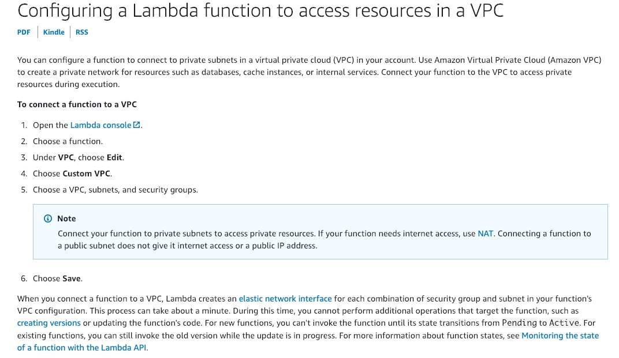 via - <https://docs.aws.amazon.com/lambda/latest/dg/configuration-vpc.html>

Incorrect options:

**Use Lambda layers to connect to the internet and RDS separately** - You can configure your Lambda function to pull in additional code and content in the form of layers. A layer is a ZIP archive that contains libraries, a custom runtime, or other dependencies. Layers will not help in configuring access to RDS instance and hence is an incorrect choice.

**Configure lambda to connect to the public subnet that will give internet access and use the Security Group to access RDS inside the private subnet** - This is an incorrect statement. Connecting a Lambda function to a public subnet does not give it internet access or a public IP address. To grant internet access to your function, its associated VPC must have a NAT gateway (or NAT instance) in a public subnet.

**Use Environment variables to pass in the RDS connection string** - You can use environment variables to store secrets securely and adjust your function's behavior without updating code. You can use environment variables to exchange data with RDS, but you will still need access to RDS, which is not possible with just environment variables.

References:

<https://docs.aws.amazon.com/lambda/latest/dg/configuration-vpc.html>

<https://docs.aws.amazon.com/lambda/latest/dg/configuration-layers.html>

<https://docs.aws.amazon.com/lambda/latest/dg/configuration-envvars.html>

<https://aws.amazon.com/premiumsupport/knowledge-center/internet-access-lambda-function/>

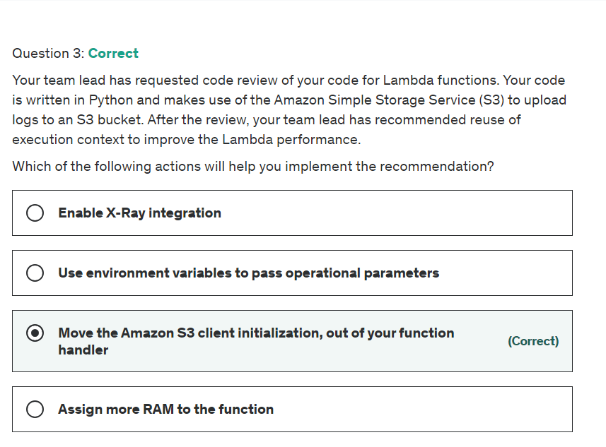

Explanation

Correct option:

**Move the Amazon S3 client initialization, out of your function handler** - AWS best practices for Lambda suggest taking advantage of execution context reuse to improve the performance of your functions. Initialize SDK clients and database connections outside of the function handler, and cache static assets locally in the /tmp directory. Subsequent invocations processed by the same instance of your function can reuse these resources. This saves execution time and cost. To avoid potential data leaks across invocations, don’t use the execution context to store user data, events, or other information with security implications.

Incorrect options:

**Use environment variables to pass operational parameters** - This is one of the suggested best practices for Lambda. By using environment variables to pass operational parameters you can avoid hard-coding useful information. But, this is not the right answer for the current use-case, since it talks about reusing context.

**Assign more RAM to the function** - Increasing RAM will help speed up the process. But, in the current question, the reviewer has specifically mentioned about reusing context. Hence, this is not the right answer.

**Enable X-Ray integration** - You can use AWS X-Ray to visualize the components of your application, identify performance bottlenecks, and troubleshoot requests that resulted in an error. Your Lambda functions send trace data to X-Ray, and X-Ray processes the data to generate a service map and searchable trace summaries. This is a useful tool for troubleshooting. But, for the current use-case, we already know the bottleneck that needs to be fixed and that is the context reuse.

References:

<https://docs.aws.amazon.com/lambda/latest/dg/best-practices.html>

<https://docs.aws.amazon.com/lambda/latest/dg/services-xray.html>

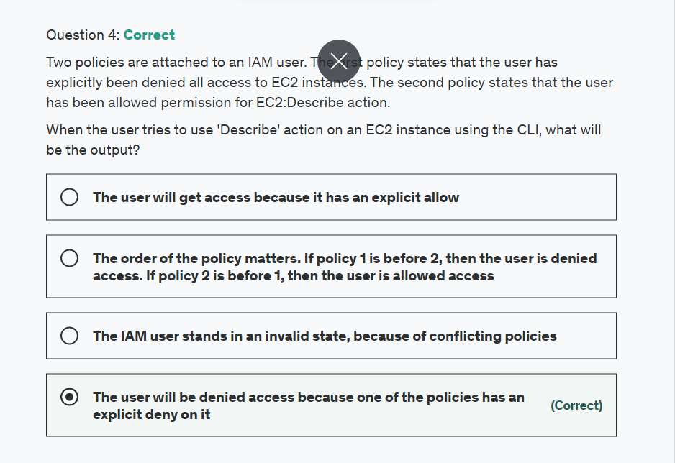

Explanation

Correct option:

**The user will be denied access because the policy has an explicit deny on it** - User will be denied access because any explicit deny overrides the allow.

Policy Evaluation explained: 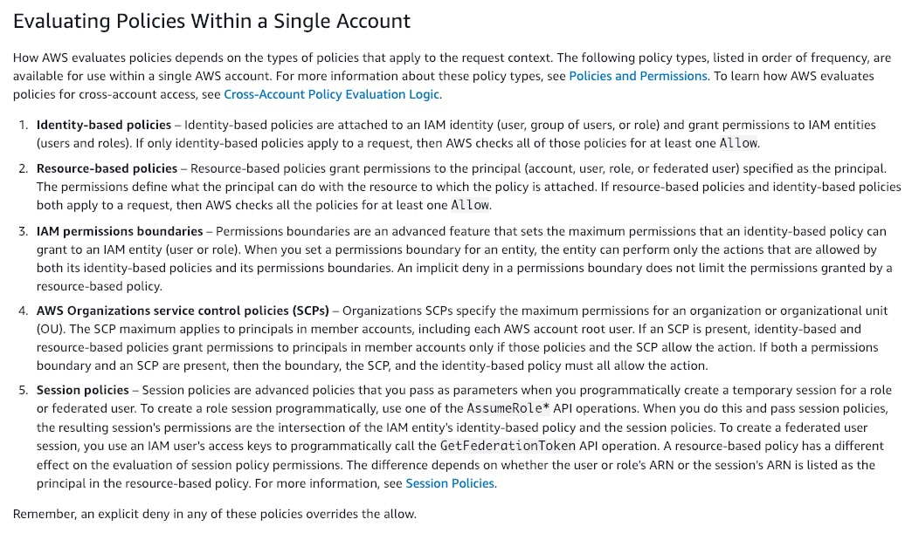 via - <https://docs.aws.amazon.com/IAM/latest/UserGuide/reference_policies_evaluation-logic.html>

Incorrect options:

**The IAM user stands in an invalid state, because of conflicting policies** - This is an incorrect statement. Access policies can have allow and deny permissions on them and based on policy rules they are evaluated. A user account does not get invalid because of policies.

**The user will get access because it has an explicit allow** - As discussed above, explicit deny overrides all other permissions and hence the user will be denied access.

**The order of the policy matters. If policy 1 is before 2, then the user is denied access. If policy 2 is before 1, then the user is allowed access** - If policies that apply to a request include an Allow statement and a Deny statement, the Deny statement trumps the Allow statement. The request is explicitly denied.

Reference:

<https://docs.aws.amazon.com/IAM/latest/UserGuide/reference_policies_evaluation-logic.html>

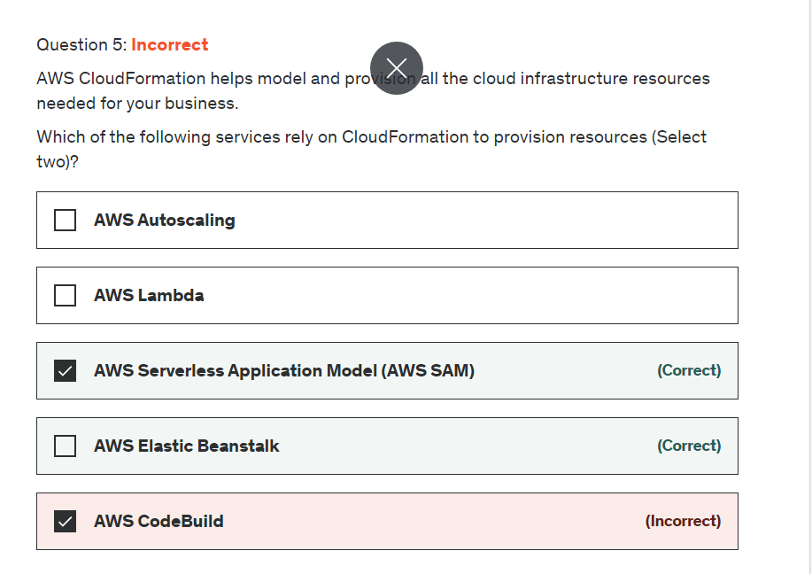

Explanation

Correct option:

**AWS Elastic Beanstalk** - AWS Elastic Beanstalk is an easy-to-use service for deploying and scaling web applications and services developed with Java, .NET, PHP, Node.js, Python, Ruby, Go, and Docker on familiar servers such as Apache, Nginx, Passenger, and IIS. Elastic Beanstalk uses AWS CloudFormation to launch the resources in your environment and propagate configuration changes.

**AWS Serverless Application Model (AWS SAM)** - You use the AWS SAM specification to define your serverless application. AWS SAM templates are an extension of AWS CloudFormation templates, with some additional components that make them easier to work with. AWS SAM needs CloudFormation templates as a basis for its configuration.

Incorrect options:

**AWS Lambda** - AWS Lambda lets you run code without provisioning or managing servers. You pay only for the compute time you consume. Hence, Lamda does not need CloudFormation to run its services.

**AWS Autoscaling** - AWS Auto Scaling monitors your applications and automatically adjusts the capacity to maintain steady, predictable performance at the lowest possible cost. Using AWS Auto Scaling, it’s easy to setup application scaling for multiple resources across multiple services in minutes. Auto Scaling used CloudFormation but is not a mandatory requirement.

**AWS CodeBuild** - AWS CodeBuild is a fully managed continuous integration service that compiles source code, runs tests, and produces software packages that are ready to deploy. With CodeBuild, you don’t need to provision, manage, and scale your own build servers. AWS CodePipeline uses AWS CloudFormation as a deployment action but is not a mandatory service.

References:

<https://docs.aws.amazon.com/serverless-application-model/latest/developerguide/sam-specification.html>

<https://aws.amazon.com/elasticbeanstalk/>

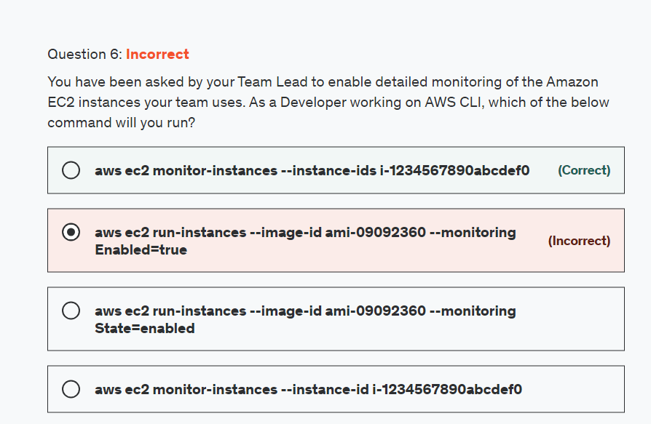

Explanation

Correct option:

**aws ec2 monitor-instances --instance-ids i-1234567890abcdef0** - This enables detailed monitoring for a running instance.

EC2 detailed monitoring: 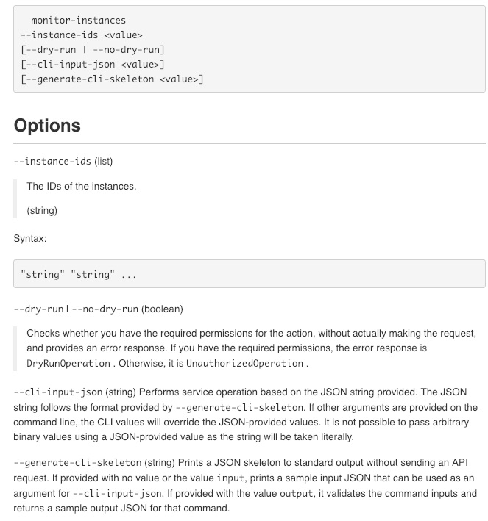 via - <https://docs.aws.amazon.com/cli/latest/reference/ec2/monitor-instances.html>

Incorrect options:

**aws ec2 run-instances --image-id ami-09092360 --monitoring Enabled=true** - This syntax is used to enable detailed monitoring when launching an instance from AWS CLI.

**aws ec2 run-instances --image-id ami-09092360 --monitoring State=enabled** - This is an invalid syntax

**aws ec2 monitor-instances --instance-id i-1234567890abcdef0** - This is an invalid syntax

References:

<https://docs.aws.amazon.com/AWSEC2/latest/UserGuide/using-cloudwatch-new.html>

<https://docs.aws.amazon.com/cli/latest/reference/ec2/run-instances.html>

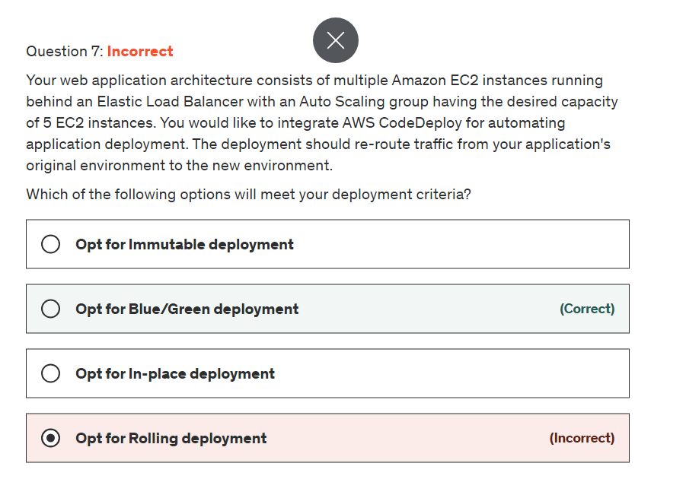

**Explanation**

Correct option:

**Opt for Blue/Green deployment** - A Blue/Green deployment is used to update your applications while minimizing interruptions caused by the changes of a new application version. CodeDeploy provisions your new application version alongside the old version before rerouting your production traffic. The behavior of your deployment depends on which compute platform you use:

AWS Lambda: Traffic is shifted from one version of a Lambda function to a new version of the same Lambda function.

Amazon ECS: Traffic is shifted from a task set in your Amazon ECS service to an updated, replacement task set in the same Amazon ECS service.

EC2/On-Premises: Traffic is shifted from one set of instances in the original environment to a replacement set of instances.

Incorrect options:

**Opt for Rolling deployment** - This deployment type is present for AWS Elastic Beanstalk and not for EC2 instances directly.

**Opt for Immutable deployment** - This deployment type is present for AWS Elastic Beanstalk and not for EC2 instances directly.

**Opt for In-place deployment** - Under this deployment type, the application on each instance in the deployment group is stopped, the latest application revision is installed, and the new version of the application is started and validated. You can use a load balancer so that each instance is deregistered during its deployment and then restored to service after the deployment is complete.

References:

<https://docs.aws.amazon.com/codedeploy/latest/userguide/welcome.html#welcome-deployment-overview-blue-green>

<https://docs.aws.amazon.com/codedeploy/latest/userguide/deployments.html>

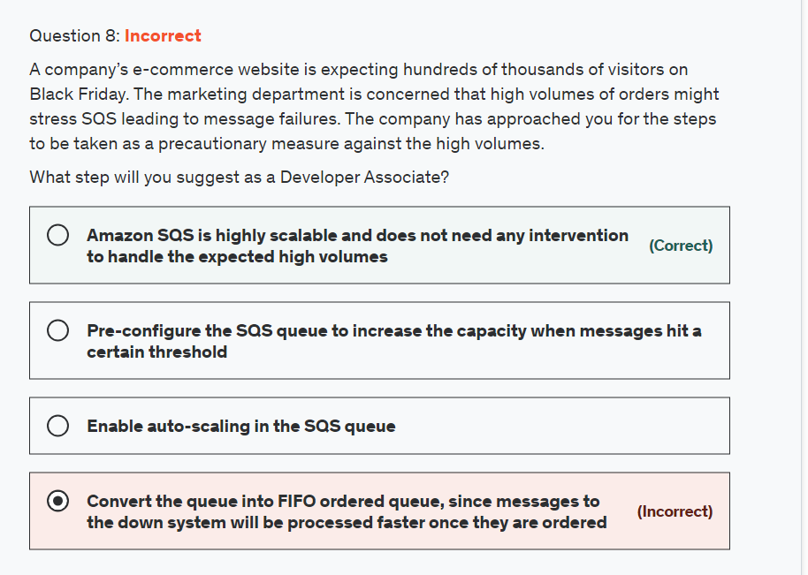

Top of Form

**Explanation**

Correct option:

**Amazon SQS is highly scalable and does not need any intervention to handle the expected high volumes**

Amazon SQS leverages the AWS cloud to dynamically scale, based on demand. SQS scales elastically with your application so you don't have to worry about capacity planning and pre-provisioning. For most standard queues (depending on queue traffic and message backlog), there can be a maximum of approximately 120,000 inflight messages (received from a queue by a consumer, but not yet deleted from the queue).

Info on Queue Quotas: 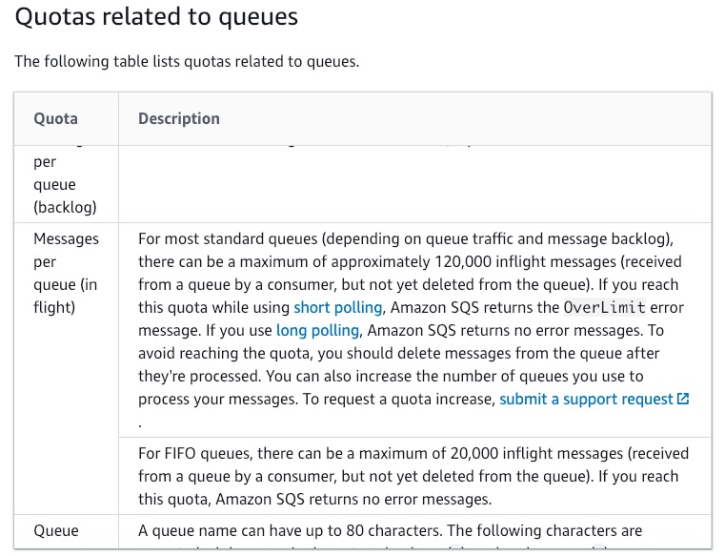 via - <https://docs.aws.amazon.com/AWSSimpleQueueService/latest/SQSDeveloperGuide/sqs-quotas.html>

Incorrect options:

**Pre-configure the SQS queue to increase the capacity when messages hit a certain threshold** - This is an incorrect statement. Amazon SQS scales dynamically, automatically provisioning the needed capacity.

**Enable auto-scaling in the SQS queue** - SQS queues are, by definition, auto-scalable and do not need any configuration changes for auto-scaling.

**Convert the queue into FIFO ordered queue, since messages to the down system will be processed faster once they are ordered** - This is a wrong statement. You cannot convert an existing standard queue to FIFO queue. To make the move, you must either create a new FIFO queue for your application or delete your existing standard queue and recreate it as a FIFO queue.

Standard to FIFO queue conversion: 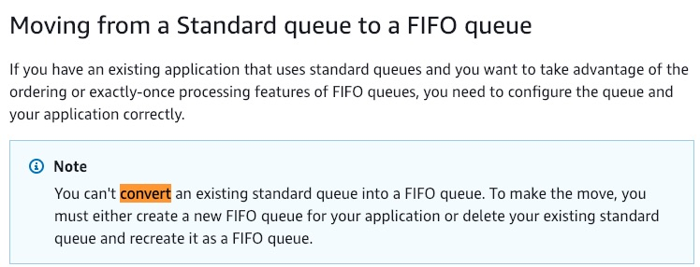 via - <https://docs.aws.amazon.com/AWSSimpleQueueService/latest/SQSDeveloperGuide/FIFO-queues.html>

References:

<https://docs.aws.amazon.com/AWSSimpleQueueService/latest/SQSDeveloperGuide/sqs-quotas.html>

<https://docs.aws.amazon.com/AWSSimpleQueueService/latest/SQSDeveloperGuide/FIFO-queues.html>

Bottom of Form

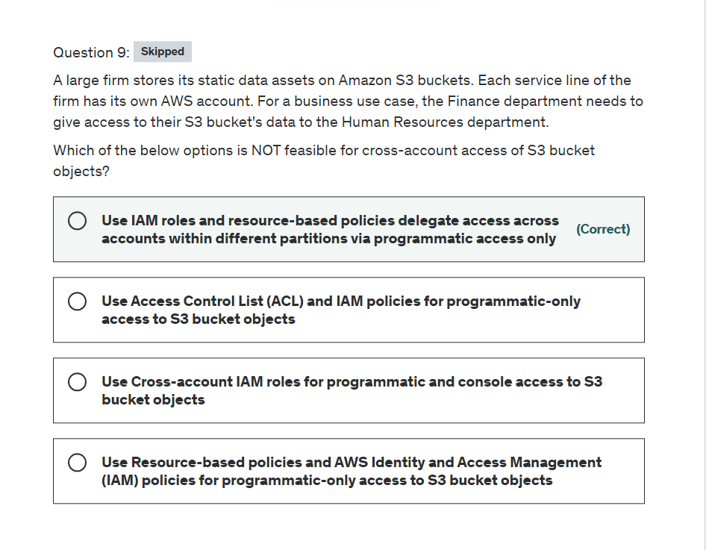

Explanation

Correct option:

**Use IAM roles and resource-based policies delegate access across accounts within different partitions via programmatic access only** - This statement is incorrect and hence the right choice for this question. IAM roles and resource-based policies delegate access across accounts only within a single partition. For example, assume that you have an account in US West (N. California) in the standard aws partition. You also have an account in China (Beijing) in the aws-cn partition. You can't use an Amazon S3 resource-based policy in your account in China (Beijing) to allow access for users in your standard AWS account.

Incorrect options:

**Use Resource-based policies and AWS Identity and Access Management (IAM) policies for programmatic-only access to S3 bucket objects** - Use bucket policies to manage cross-account control and audit the S3 object's permissions. If you apply a bucket policy at the bucket level, you can define who can access (Principal element), which objects they can access (Resource element), and how they can access (Action element). Applying a bucket policy at the bucket level allows you to define granular access to different objects inside the bucket by using multiple policies to control access. You can also review the bucket policy to see who can access objects in an S3 bucket.

**Use Access Control List (ACL) and IAM policies for programmatic-only access to S3 bucket objects** - Use object ACLs to manage permissions only for specific scenarios and only if ACLs meet your needs better than IAM and S3 bucket policies. Amazon S3 ACLs allow users to define only the following permissions sets: READ, WRITE, READ_ACP, WRITE_ACP, and FULL_CONTROL. You can use only an AWS account or one of the predefined Amazon S3 groups as a grantee for the Amazon S3 ACL.

**Use Cross-account IAM roles for programmatic and console access to S3 bucket objects** - Not all AWS services support resource-based policies. This means that you can use cross-account IAM roles to centralize permission management when providing cross-account access to multiple services. Using cross-account IAM roles simplifies provisioning cross-account access to S3 objects that are stored in multiple S3 buckets, removing the need to manage multiple policies for S3 buckets. This method allows cross-account access to objects that are owned or uploaded by another AWS account or AWS services. If you don't use cross-account IAM roles, the object ACL must be modified.

References:

<https://docs.aws.amazon.com/AmazonS3/latest/dev/example-walkthroughs-managing-access-example3.html>

<https://docs.aws.amazon.com/IAM/latest/UserGuide/tutorial_cross-account-with-roles.html>

<https://docs.aws.amazon.com/IAM/latest/UserGuide/id_roles_compare-resource-policies.html>

<https://aws.amazon.com/premiumsupport/knowledge-center/cross-account-access-s3/>

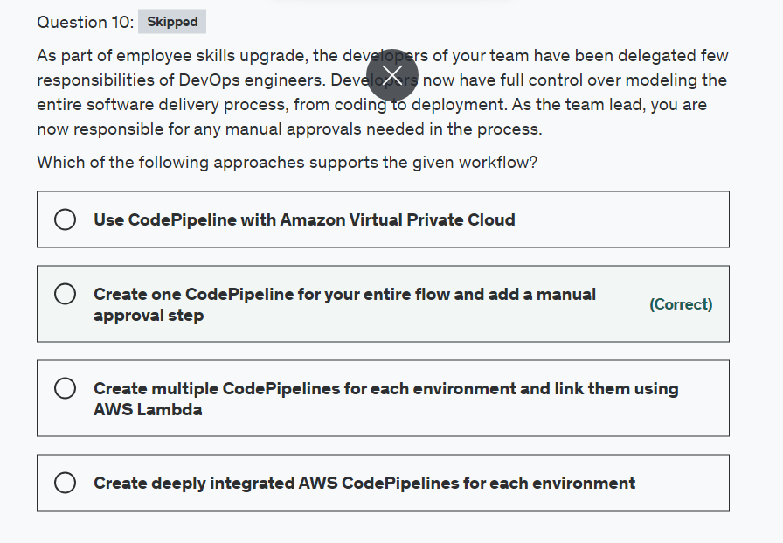

Explanation

Correct option:

**Create one CodePipeline for your entire flow and add a manual approval step** - You can add an approval action to a stage in a CodePipeline pipeline at the point where you want the pipeline to stop so someone can manually approve or reject the action. Approval actions can't be added to Source stages. Source stages can contain only source actions.

Incorrect options:

**Create multiple CodePipelines for each environment and link them using AWS Lambda** - You can create Lambda functions and add them as actions in your pipelines but the approval step is confined to a workflow process and cannot be outsourced to any other AWS service.

**Create deeply integrated AWS CodePipelines for each environment** - You can use an AWS CloudFormation template in conjunction with AWS CodePipeline and AWS CodeCommit to create a test environment that deploys to your production environment when the changes to your application are approved, helping you automate a continuous delivery workflow. This is a possible answer but not an optimized way of achieving what the client needs.

**Use CodePipeline with Amazon Virtual Private Cloud** - AWS CodePipeline supports Amazon Virtual Private Cloud (Amazon VPC) endpoints powered by AWS PrivateLink. This means you can connect directly to CodePipeline through a private endpoint in your VPC, keeping all traffic inside your VPC and the AWS network. This is a robust security feature but is of no value for our current use-case.

References:

<https://docs.aws.amazon.com/codepipeline/latest/userguide/approvals-action-add.html>

<https://docs.aws.amazon.com/codepipeline/latest/userguide/vpc-support.html>

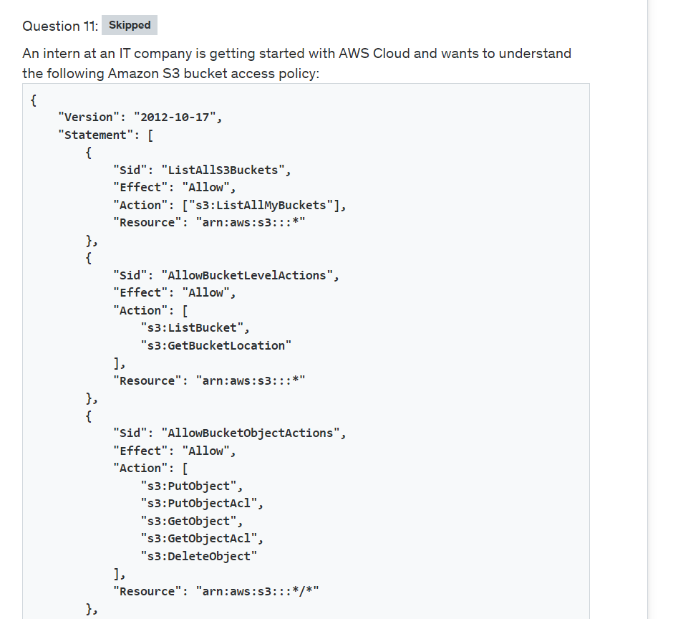

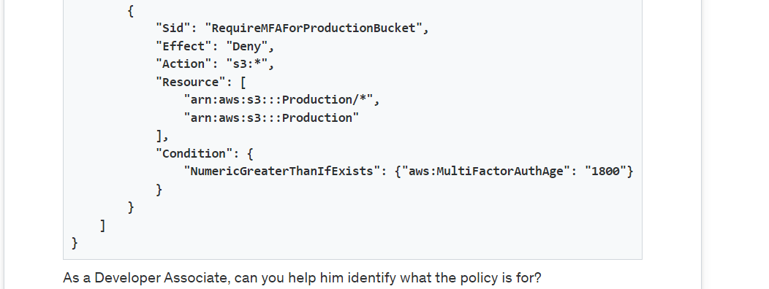

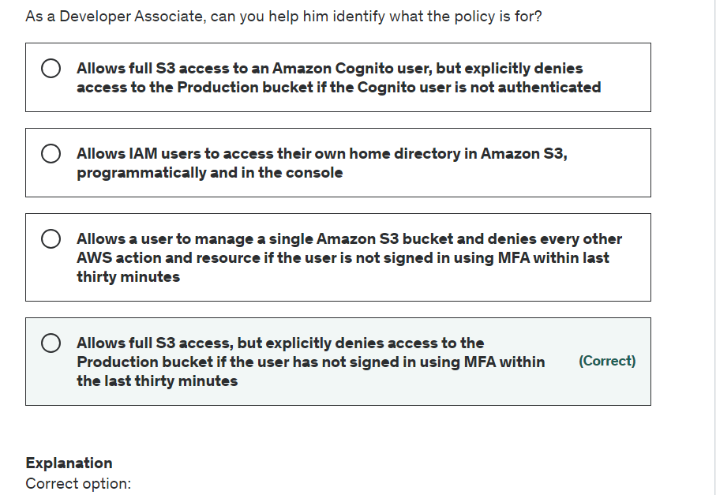

Explanation

Correct option:

**Allows full S3 access, but explicitly denies access to the Production bucket if the user has not signed in using MFA within the last thirty minutes** - This example shows how you might create a policy that allows an Amazon S3 user to access any bucket, including updating, adding, and deleting objects. However, it explicitly denies access to the Production bucket if the user has not signed in using multi-factor authentication (MFA) within the last thirty minutes. This policy grants the permissions necessary to perform this action in the console or programmatically using the AWS CLI or AWS API.

This policy never allows programmatic access to the Production bucket using long-term user access keys. This is accomplished using the aws:MultiFactorAuthAge condition key with the NumericGreaterThanIfExists condition operator. This policy condition returns true if MFA is not present or if the age of the MFA is greater than 30 minutes. In those situations, access is denied. To access the Production bucket programmatically, the S3 user must use temporary credentials that were generated in the last 30 minutes using the GetSessionToken API operation.

Incorrect options:

**Allows a user to manage a single Amazon S3 bucket and denies every other AWS action and resource if the user is not signed in using MFA within last thirty minutes**

**Allows full S3 access to an Amazon Cognito user, but explicitly denies access to the Production bucket if the Cognito user is not authenticated**

**Allows IAM users to access their own home directory in Amazon S3, programmatically and in the console**

These three options contradict the explanation provided above, so these options are incorrect.

Reference:

<https://docs.aws.amazon.com/IAM/latest/UserGuide/reference_policies_examples_s3_full-access-except-production.html>

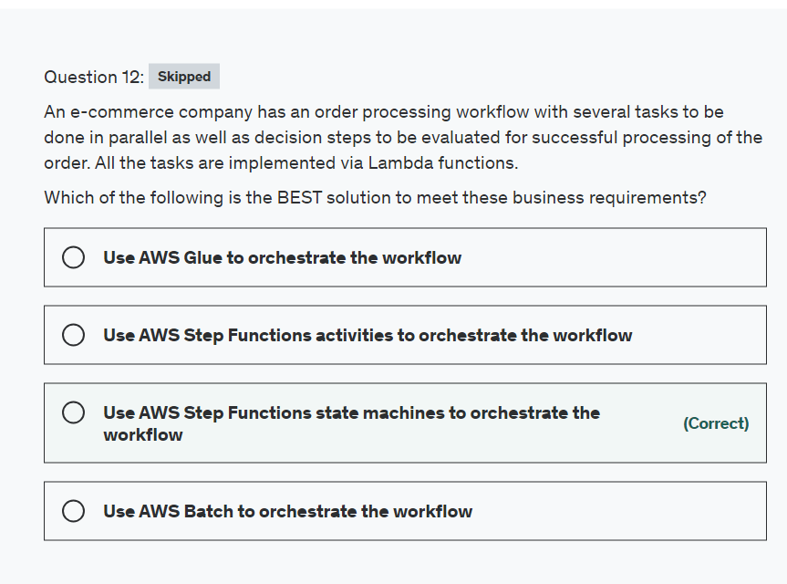

Explanation

Correct option:

**Use AWS Step Functions state machines to orchestrate the workflow**

AWS Step Functions is a web service that enables you to coordinate the components of distributed applications and microservices using visual workflows. You build applications from individual components that each perform a discrete function, or task, allowing you to scale and change applications quickly.

How Step Functions Work: 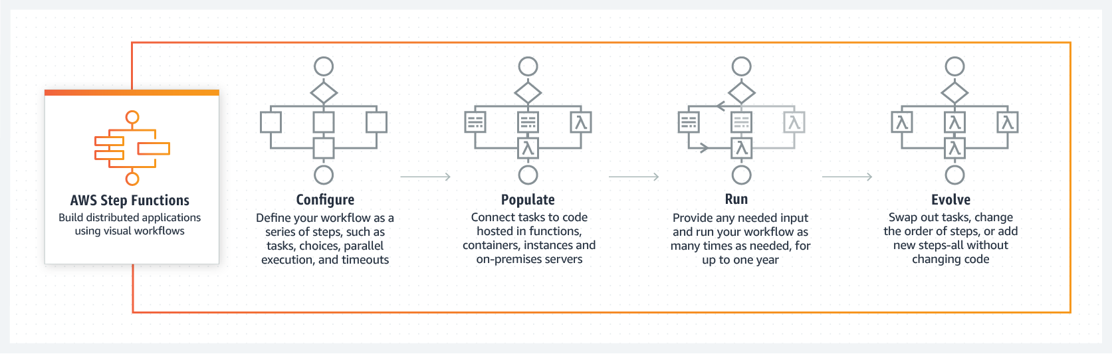 via - <https://aws.amazon.com/step-functions/>

The following are key features of AWS Step Functions:

Step Functions are based on the concepts of tasks and state machines. You define state machines using the JSON-based Amazon States Language. A state machine is defined by the states it contains and the relationships between them. States are elements in your state machine. Individual states can make decisions based on their input, perform actions, and pass output to other states. In this way, a state machine can orchestrate workflows.

Please see this note for a simple example of a State Machine: 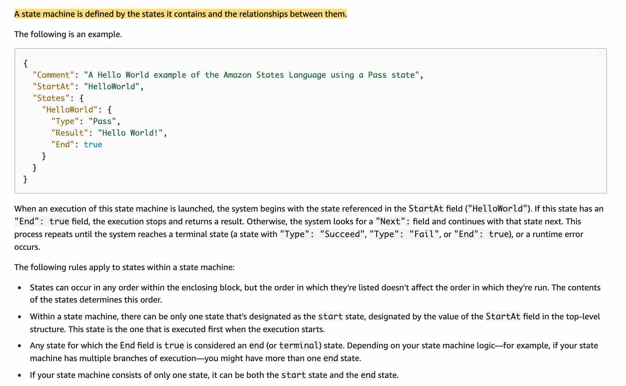 via - <https://docs.aws.amazon.com/step-functions/latest/dg/amazon-states-language-state-machine-structure.html>

Incorrect options:

**Use AWS Step Functions activities to orchestrate the workflow** - In AWS Step Functions, activities are a way to associate code running somewhere (known as an activity worker) with a specific task in a state machine. When a Step Function reaches an activity task state, the workflow waits for an activity worker to poll for a task. For example, an activity worker can be an application running on an Amazon EC2 instance or an AWS Lambda function. AWS Step Functions activities cannot orchestrate a workflow.

**Use AWS Glue to orchestrate the workflow** - AWS Glue is a fully managed extract, transform, and load (ETL) service that makes it easy for customers to prepare and load their data for analytics. AWS Glue cannot orchestrate a workflow.

**Use AWS Batch to orchestrate the workflow** - AWS Batch runs batch computing jobs on the AWS Cloud. AWS Batch dynamically provisions the optimal quantity and type of compute resources (e.g., CPU or memory optimized instances) based on the volume and specific resource requirements of the batch jobs submitted. AWS Batch cannot orchestrate a workflow.

Reference:

<https://aws.amazon.com/step-functions/>

<https://docs.aws.amazon.com/step-functions/latest/dg/amazon-states-language-state-machine-structure.html>

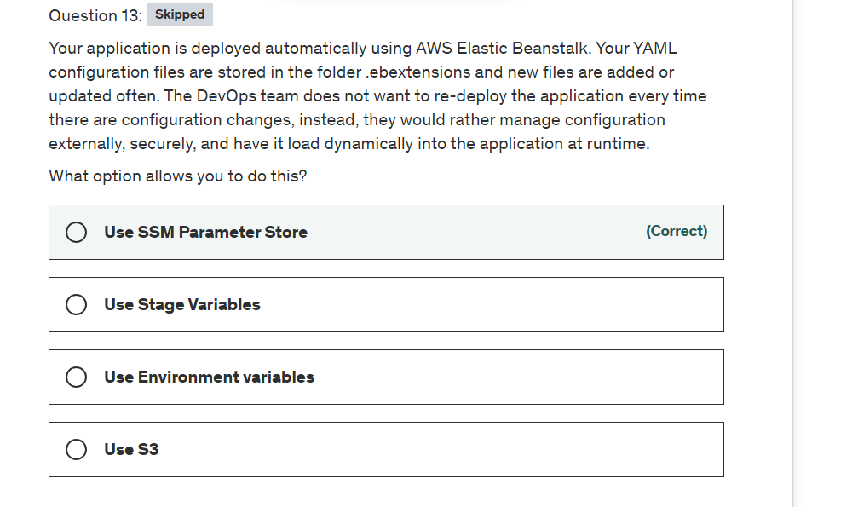

Explanation

Correct option:

**Use SSM Parameter Store**

AWS Systems Manager Parameter Store provides secure, hierarchical storage for configuration data management and secrets management. You can store data such as passwords, database strings, and license codes as parameter values. For the given use-case, as the DevOps team does not want to re-deploy the application every time there are configuration changes, so they can use the SSM Parameter Store to store the configuration externally.

Incorrect options:

**Use Environment variables** - Environment variables provide another way to specify configuration options and credentials, and can be useful for scripting or temporarily setting a named profile as the default. Your application is not running AWS CLI. Since the use-case requires the configuration to be stored securely, so using Environment variables is ruled out, as these are not encrypted at rest and these are visible in clear text in the AWS Console as well as in the response of some actions of the Elastic BeanStalk API.

**Use Stage Variables** - You can use stage variables for managing multiple release stages for API Gateway, this is not what you are looking for here.

**Use S3** - S3 offers the same benefit as the SSM Parameter Store where there are no servers to manage. With S3 you have to set encryption and choose other security options and there are more chances of misconfiguring security if you share your S3 bucket with other objects. You would have to create a custom setup to come close to the parameter store. Use Parameter Store and let AWS handle the rest.

Reference:

<https://docs.aws.amazon.com/systems-manager/latest/userguide/systems-manager-paramstore.html>

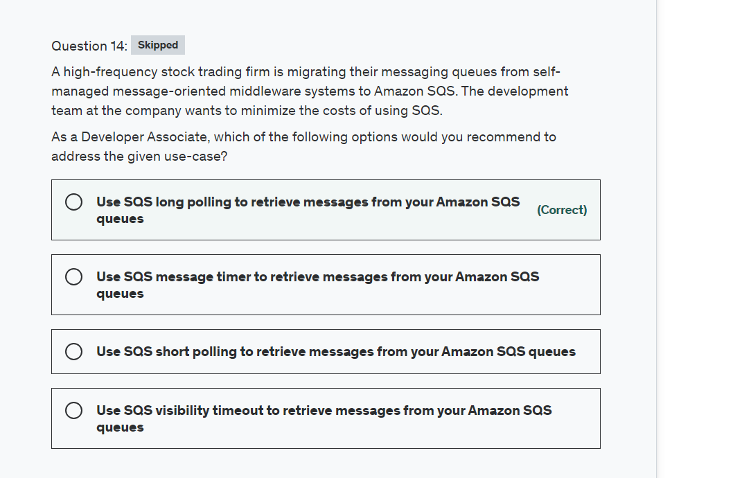

Explanation

Correct option:

**Use SQS long polling to retrieve messages from your Amazon SQS queues**

Amazon Simple Queue Service (SQS) is a fully managed message queuing service that enables you to decouple and scale microservices, distributed systems, and serverless applications.

Amazon SQS provides short polling and long polling to receive messages from a queue. By default, queues use short polling. With short polling, Amazon SQS sends the response right away, even if the query found no messages. With long polling, Amazon SQS sends a response after it collects at least one available message, up to the maximum number of messages specified in the request. Amazon SQS sends an empty response only if the polling wait time expires.

Long polling makes it inexpensive to retrieve messages from your Amazon SQS queue as soon as the messages are available. Long polling helps reduce the cost of using Amazon SQS by eliminating the number of empty responses (when there are no messages available for a ReceiveMessage request) and false empty responses (when messages are available but aren't included in a response). When the wait time for the ReceiveMessage API action is greater than 0, long polling is in effect. The maximum long polling wait time is 20 seconds.

Exam Alert:

Please review the differences between Short Polling vs Long Polling: 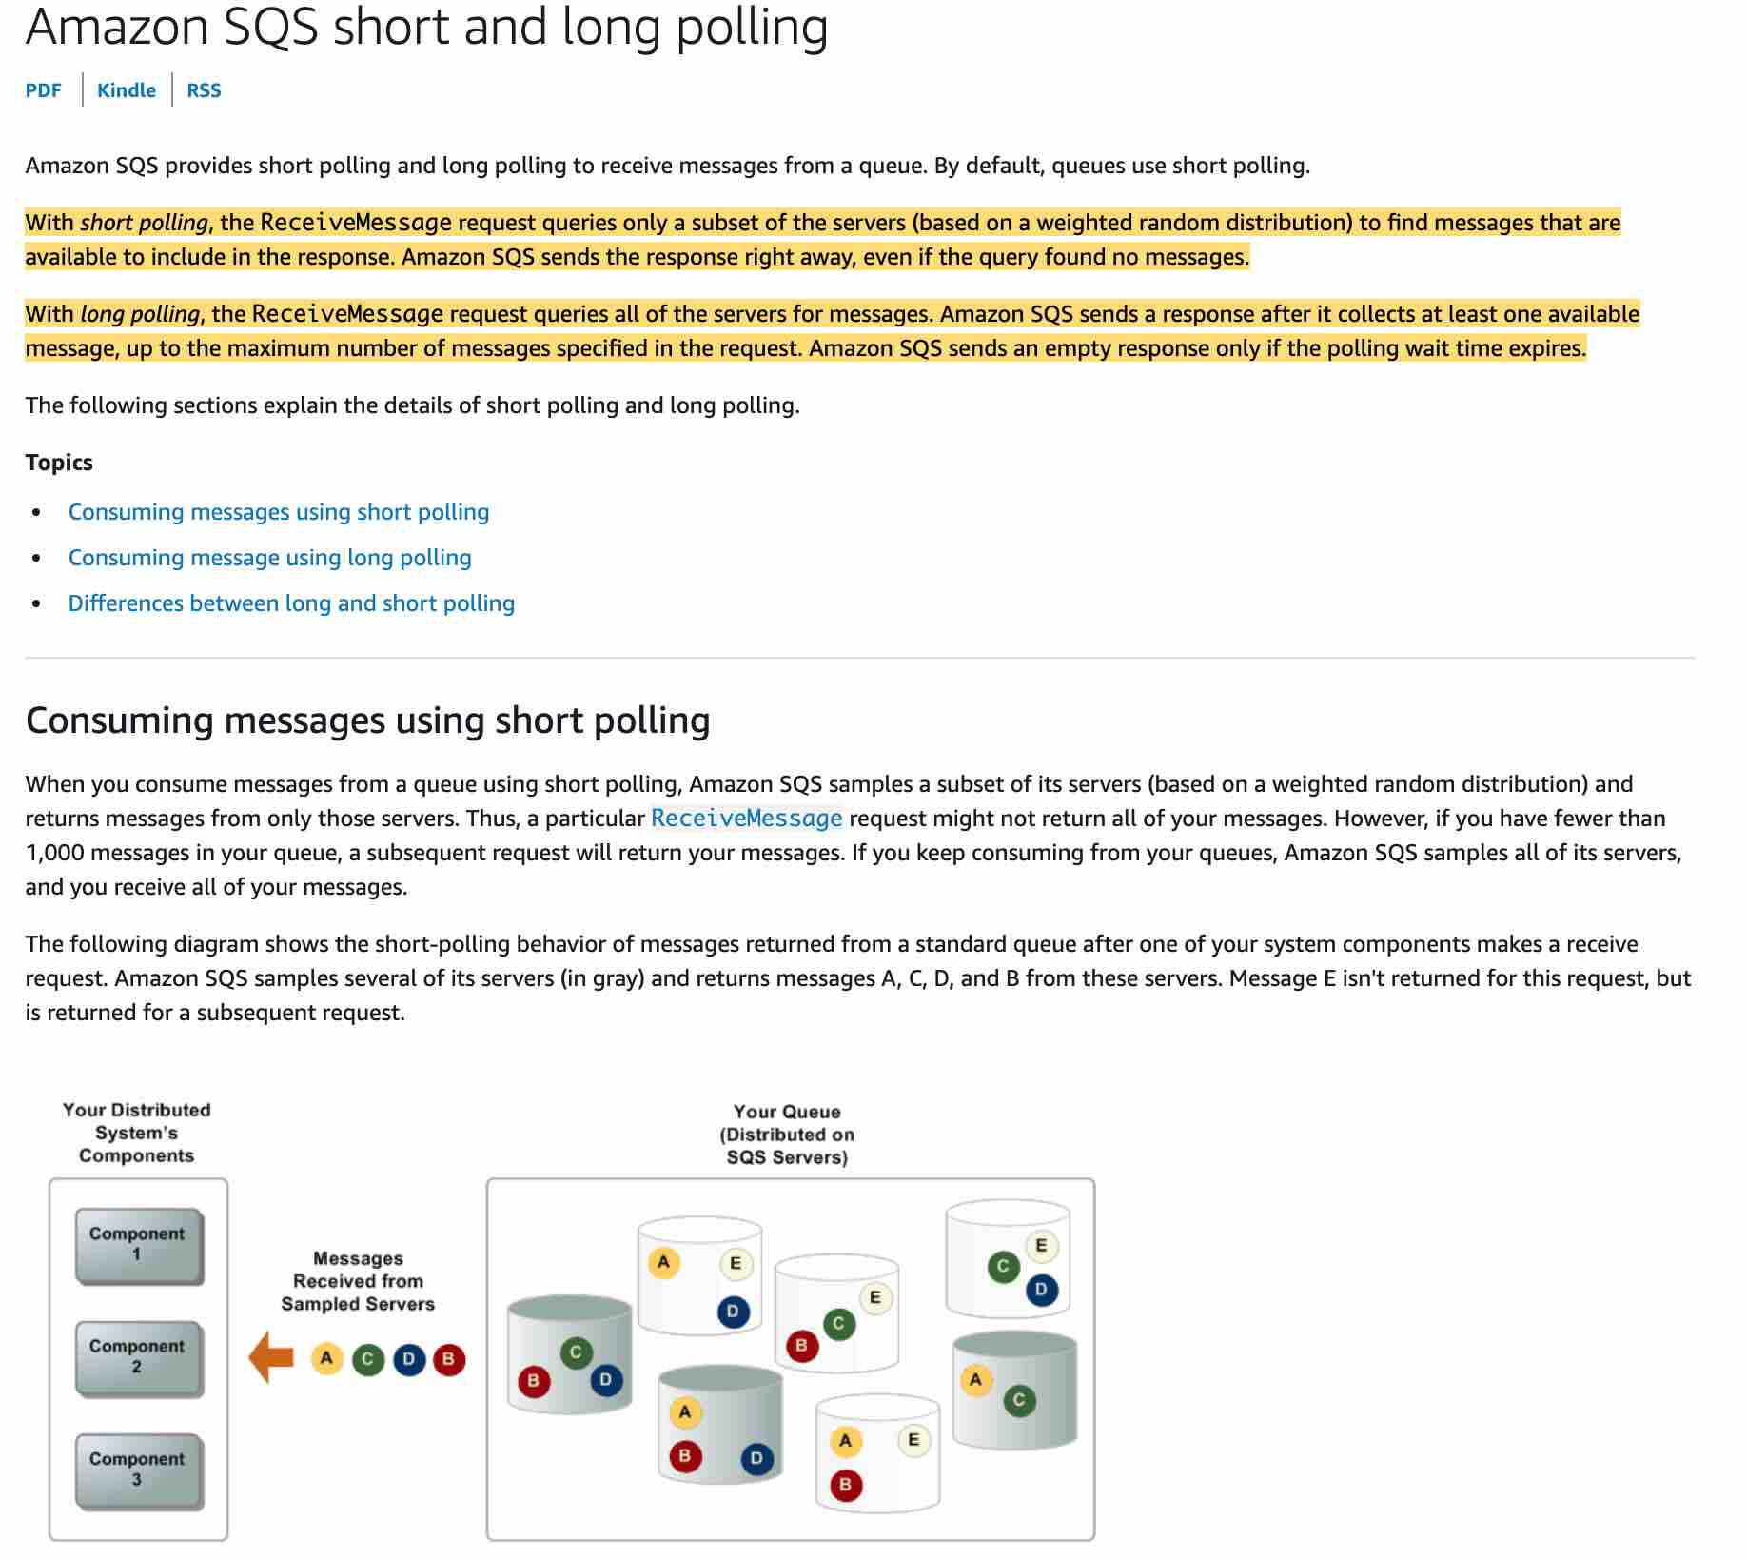 via - <https://docs.aws.amazon.com/AWSSimpleQueueService/latest/SQSDeveloperGuide/sqs-short-and-long-polling.html>

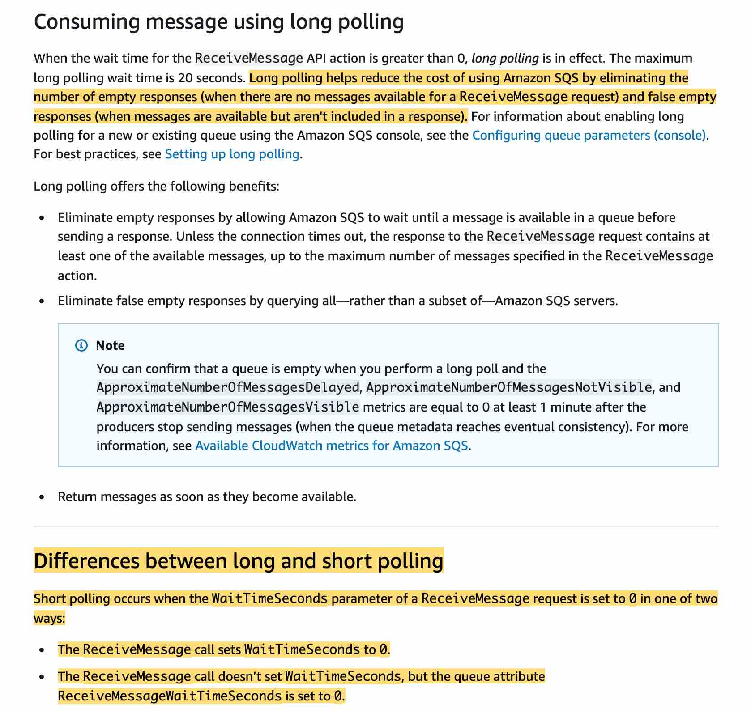 via - <https://docs.aws.amazon.com/AWSSimpleQueueService/latest/SQSDeveloperGuide/sqs-short-and-long-polling.html>

Incorrect options:

**Use SQS short polling to retrieve messages from your Amazon SQS queues** - With short polling, Amazon SQS sends the response right away, even if the query found no messages. You end up paying more because of the increased number of empty receives.

**Use SQS visibility timeout to retrieve messages from your Amazon SQS queues** - Visibility timeout is a period during which Amazon SQS prevents other consumers from receiving and processing a given message. The default visibility timeout for a message is 30 seconds. The minimum is 0 seconds. The maximum is 12 hours. You cannot use visibility timeout to retrieve messages from your Amazon SQS queues. This option has been added as a distractor.

**Use SQS message timer to retrieve messages from your Amazon SQS queues** - You can use message timers to set an initial invisibility period for a message added to a queue. So, if you send a message with a 60-second timer, the message isn't visible to consumers for its first 60 seconds in the queue. The default (minimum) delay for a message is 0 seconds. The maximum is 15 minutes. You cannot use message timer to retrieve messages from your Amazon SQS queues. This option has been added as a distractor.

Reference:

<https://docs.aws.amazon.com/AWSSimpleQueueService/latest/SQSDeveloperGuide/sqs-short-and-long-polling.html>

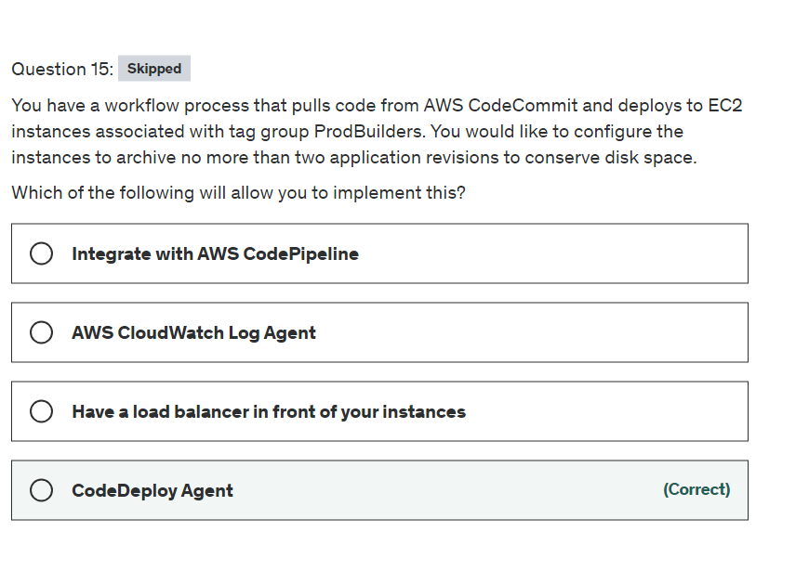

Explanation

Correct option:

"CodeDeploy Agent"

The CodeDeploy agent is a software package that, when installed and configured on an instance, makes it possible for that instance to be used in CodeDeploy deployments. The CodeDeploy agent archives revisions and log files on instances. The CodeDeploy agent cleans up these artifacts to conserve disk space. You can use the :max_revisions: option in the agent configuration file to specify the number of application revisions to the archive by entering any positive integer. CodeDeploy also archives the log files for those revisions. All others are deleted, except for the log file of the last successful deployment.

More info here: 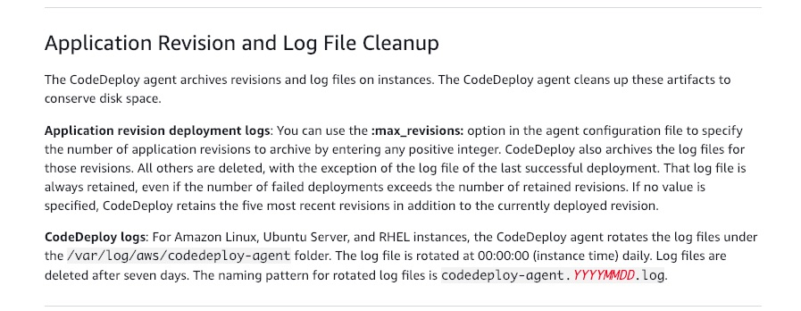 via - <https://docs.aws.amazon.com/codedeploy/latest/userguide/codedeploy-agent.html>

Incorrect options:

**AWS CloudWatch Log Agent** - The CloudWatch Logs agent provides an automated way to send log data to CloudWatch Logs from Amazon EC2 instances. This is an incorrect choice for the current use case.

**Integrate with AWS CodePipeline** - AWS CodePipeline is a fully managed continuous delivery service that helps you automate your release pipelines for fast and reliable application and infrastructure updates. CodeCommit and CodePipeline are already integrated services. CodePipeline cannot help in version control and management of archives on an EC2 instance.

**Have a load balancer in front of your instances** - Load Balancer helps balance incoming traffic across different EC2 instances. It is an incorrect choice for the current use case.

References:

<https://docs.aws.amazon.com/codedeploy/latest/userguide/codedeploy-agent.html>

<https://docs.aws.amazon.com/AmazonCloudWatch/latest/logs/AgentReference.html>

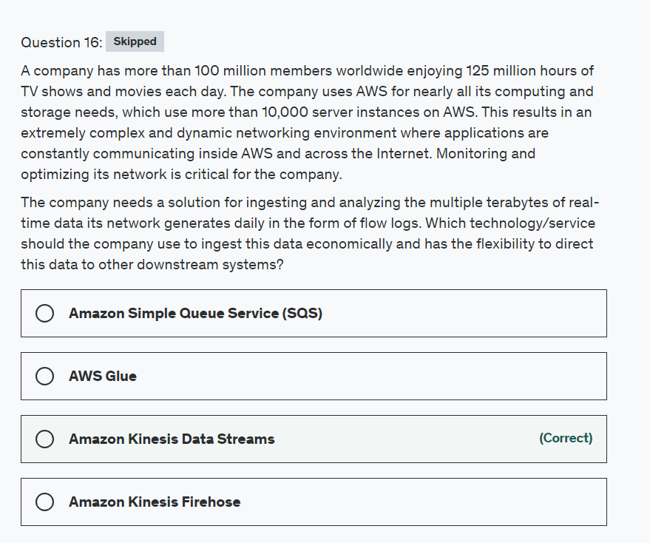

Explanation

Correct option:

**Amazon Kinesis Data Streams**

Amazon Kinesis Data Streams (KDS) is a massively scalable and durable real-time data streaming service. KDS can continuously capture gigabytes of data per second from hundreds of thousands of sources such as website clickstreams, database event streams, financial transactions, social media feeds, IT logs, and location-tracking events. The data collected is available in milliseconds to enable real-time analytics use cases such as real-time dashboards, real-time anomaly detection, dynamic pricing, and more.

Kinesis Data Streams enables real-time processing of streaming big data. It provides ordering of records, as well as the ability to read and/or replay records in the same order to multiple Amazon Kinesis Applications. The Amazon Kinesis Client Library (KCL) delivers all records for a given partition key to the same record processor, making it easier to build multiple applications reading from the same Amazon Kinesis data stream (for example, to perform counting, aggregation, and filtering).

Incorrect options:

**Amazon Simple Queue Service (SQS)** - Amazon Simple Queue Service (Amazon SQS) offers a reliable, highly scalable hosted queue for storing messages as they travel between computers. Amazon SQS lets you easily move data between distributed application components and helps you build applications in which messages are processed independently (with message-level ack/fail semantics), such as automated workflows. AWS recommends using Amazon SQS for cases where individual message fail/success are important, message delays are needed and there is only one consumer for the messages received (if more than one consumers need to consume the message, then AWS suggests configuring more queues).

**Amazon Kinesis Firehose** - Amazon Kinesis Data Firehose is the easiest way to load streaming data into data stores and analytics tools. It can capture, transform, and load streaming data into Amazon S3, Amazon Redshift, Amazon Elasticsearch Service, and Splunk, enabling near real-time analytics with existing business intelligence tools and dashboards you’re already using today. It is a fully managed service that automatically scales to match the throughput of your data and requires no ongoing administration.

Kinesis data streams is highly customizable and best suited for developers building custom applications or streaming data for specialized needs. Data Streams also provide greater flexibility in integrating downstream applications than Firehose. Data Streams is also a cost-effective option compared to Firehose. Therefore, KDS is the right solution.

**AWS Glue** - AWS Glue is a serverless data integration service that makes it easy to discover, prepare, and combine data for analytics, machine learning, and application development. AWS Glue provides all of the capabilities needed for data integration so that you can start analyzing your data and putting it to use in minutes instead of months. Glue is not best suited to handle real-time data.

References:

<https://aws.amazon.com/kinesis/data-streams/>

<https://aws.amazon.com/sqs/>

<https://aws.amazon.com/kinesis/data-firehose/>

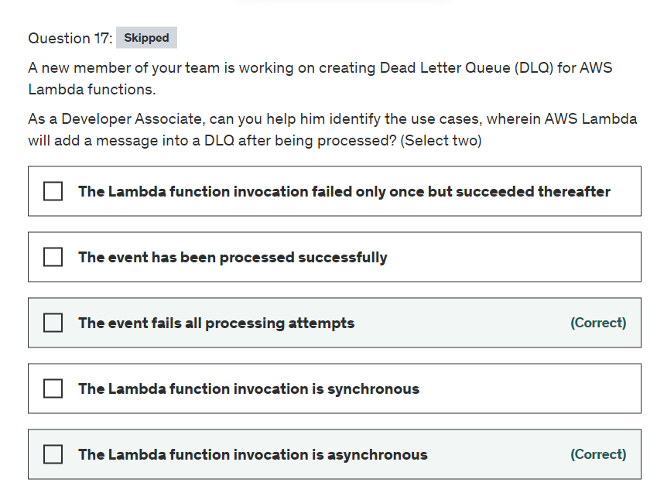

Explanation

Correct option:

**The Lambda function invocation is asynchronous** - When an asynchronous invocation event exceeds the maximum age or fails all retry attempts, Lambda discards it. Or sends it to dead-letter queue if you have configured one.

**The event fails all processing attempt** - A dead-letter queue acts the same as an on-failure destination in that it is used when an event fails all processing attempts or expires without being processed.

Incorrect options:

**The Lambda function invocation is synchronous** - When you invoke a function synchronously, Lambda runs the function and waits for a response. Queues are generally used with asynchronous invocations since queues implement the decoupling feature of various connected systems. It does not make sense to use queues when the calling code will wait on it for a response.

**The event has been processed successfully** - A successfully processed event is not sent to the dead-letter queue.

**The event processing failed only once but succeeded thereafter** - A successfully processed event is not sent to the dead-letter queue.

Reference:

<https://docs.aws.amazon.com/lambda/latest/dg/invocation-async.html>

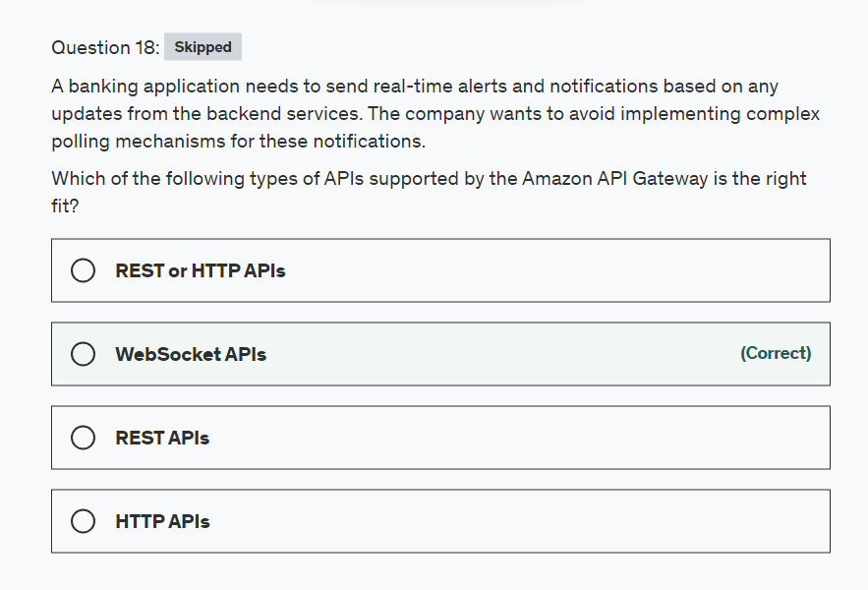

**Explanation**

Correct option:

**WebSocket APIs**

In a WebSocket API, the client and the server can both send messages to each other at any time. Backend servers can easily push data to connected users and devices, avoiding the need to implement complex polling mechanisms.

For example, you could build a serverless application using an API Gateway WebSocket API and AWS Lambda to send and receive messages to and from individual users or groups of users in a chat room. Or you could invoke backend services such as AWS Lambda, Amazon Kinesis, or an HTTP endpoint based on message content.

You can use API Gateway WebSocket APIs to build secure, real-time communication applications without having to provision or manage any servers to manage connections or large-scale data exchanges. Targeted use cases include real-time applications such as the following:

Chat applications

Real-time dashboards such as stock tickers

Real-time alerts and notifications

API Gateway provides WebSocket API management functionality such as the following:

Monitoring and throttling of connections and messages

Using AWS X-Ray to trace messages as they travel through the APIs to backend services

Easy integration with HTTP/HTTPS endpoints

Incorrect options:

**REST or HTTP APIs**

**REST APIs** - An API Gateway REST API is made up of resources and methods. A resource is a logical entity that an app can access through a resource path. A method corresponds to a REST API request that is submitted by the user of your API and the response returned to the user.

For example, /incomes could be the path of a resource representing the income of the app user. A resource can have one or more operations that are defined by appropriate HTTP verbs such as GET, POST, PUT, PATCH, and DELETE. A combination of a resource path and an operation identifies a method of the API. For example, a POST /incomes method could add an income earned by the caller, and a GET /expenses method could query the reported expenses incurred by the caller.

**HTTP APIs** - HTTP APIs enable you to create RESTful APIs with lower latency and lower cost than REST APIs. You can use HTTP APIs to send requests to AWS Lambda functions or to any publicly routable HTTP endpoint.

For example, you can create an HTTP API that integrates with a Lambda function on the backend. When a client calls your API, API Gateway sends the request to the Lambda function and returns the function's response to the client.

Server push mechanism is not possible in REST and HTTP APIs.

Reference:

<https://docs.aws.amazon.com/apigateway/latest/developerguide/api-gateway-overview-developer-experience.html>

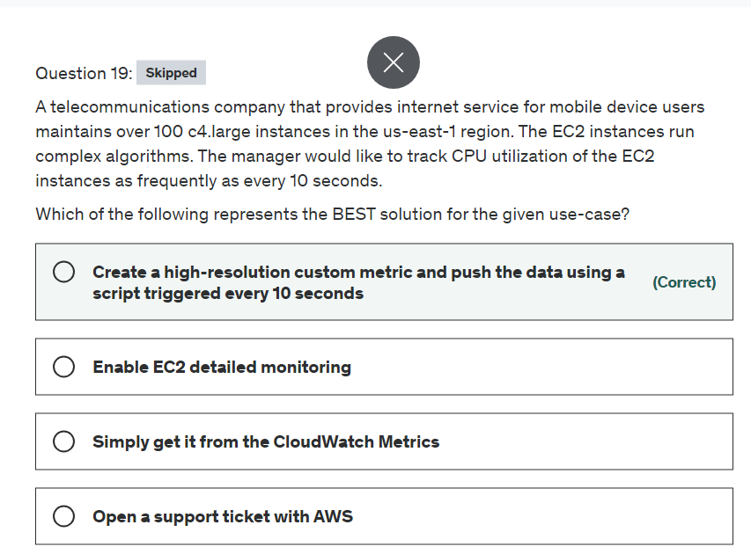

Explanation

Correct option:

**Create a high-resolution custom metric and push the data using a script triggered every 10 seconds**

Using high-resolution custom metric, your applications can publish metrics to CloudWatch with 1-second resolution. You can watch the metrics scroll across your screen seconds after they are published and you can set up high-resolution CloudWatch Alarms that evaluate as frequently as every 10 seconds. You can alert with High-Resolution Alarms, as frequently as 10-second periods. High-Resolution Alarms allow you to react and take actions faster and support the same actions available today with standard 1-minute alarms.

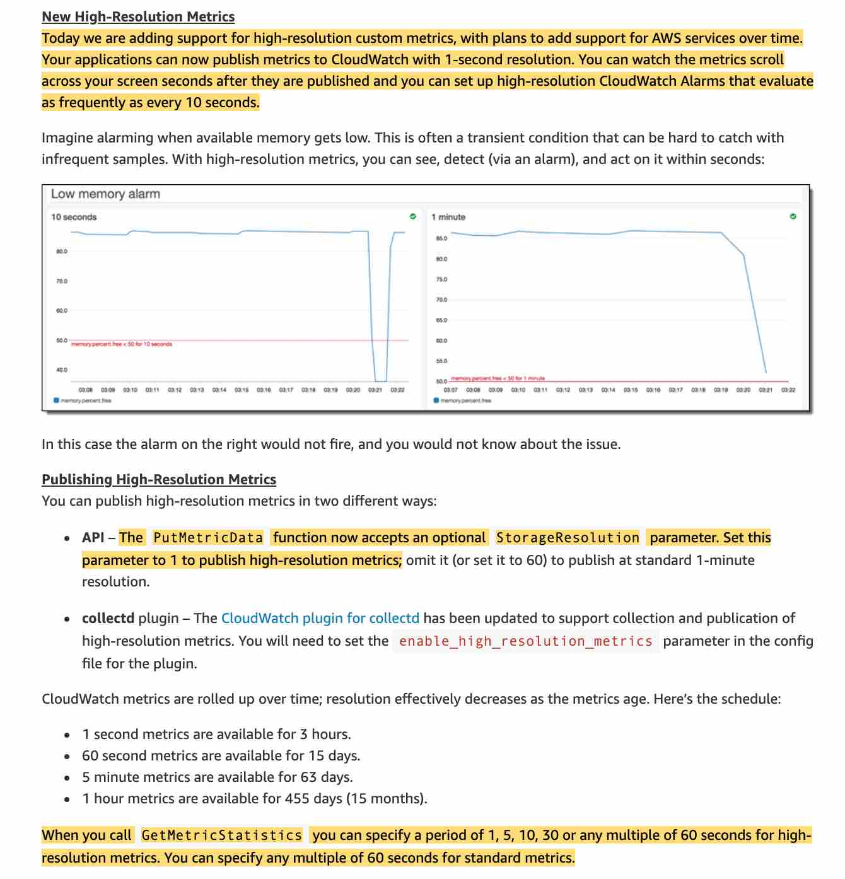 via - <https://aws.amazon.com/blogs/aws/new-high-resolution-custom-metrics-and-alarms-for-amazon-cloudwatch/>

Incorrect options:

**Enable EC2 detailed monitoring** - As part of basic monitoring, Amazon EC2 sends metric data to CloudWatch in 5-minute periods. To send metric data for your instance to CloudWatch in 1-minute periods, you can enable detailed monitoring on the instance, however, this comes at an additional cost.

**Simply get it from the CloudWatch Metrics** - You can get data from metrics. The basic monitoring data is available automatically in a 5-minute interval and detailed monitoring data is available in a 1-minute interval.

**Open a support ticket with AWS** - This option has been added as a distractor.

Reference:

<https://aws.amazon.com/blogs/aws/new-high-resolution-custom-metrics-and-alarms-for-amazon-cloudwatch/>

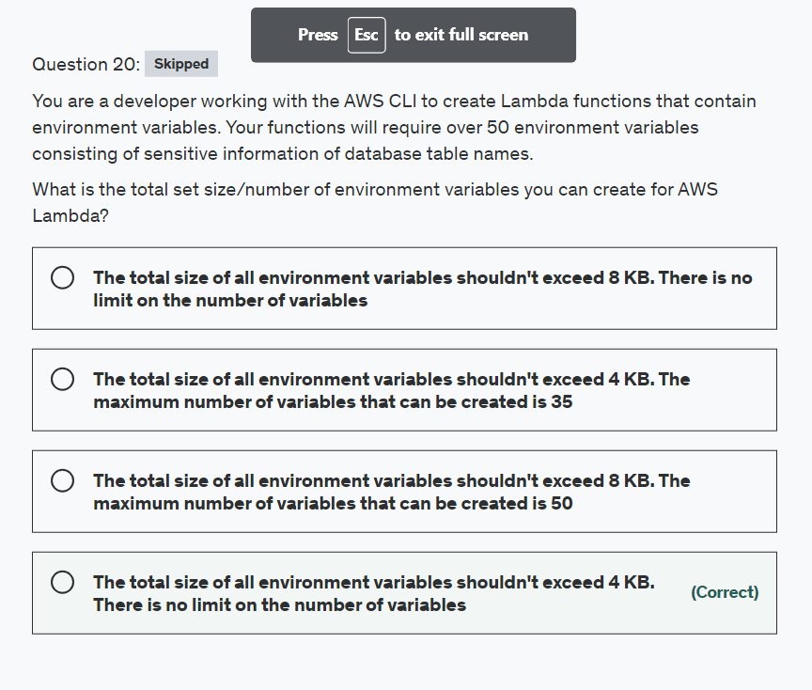

Explanation

Correct option:

**The total size of all environment variables shouldn't exceed 4 KB. There is no limit on the number of variables**

An environment variable is a pair of strings that are stored in a function's version-specific configuration. The Lambda runtime makes environment variables available to your code and sets additional environment variables that contain information about the function and invocation request. The total size of all environment variables doesn't exceed 4 KB. There is no limit defined on the number of variables that can be used.

Incorrect options:

**The total size of all environment variables shouldn't exceed 8 KB. The maximum number of variables that can be created is 50** - Incorrect option. The total size of environment variables cannot exceed 4 KB with no restriction on the number of variables.

**The total size of all environment variables shouldn't exceed 8 KB. There is no limit on the number of variables** - Incorrect option. The total size of environment variables cannot exceed 4 KB with no restriction on the number of variables.

**The total size of all environment variables shouldn't exceed 4 KB. The maximum number of variables that can be created is 35** - Incorrect option. The total size of environment variables cannot exceed 4 KB with no restriction on the number of variables.

Reference:

<https://docs.aws.amazon.com/lambda/latest/dg/configuration-envvars.html>

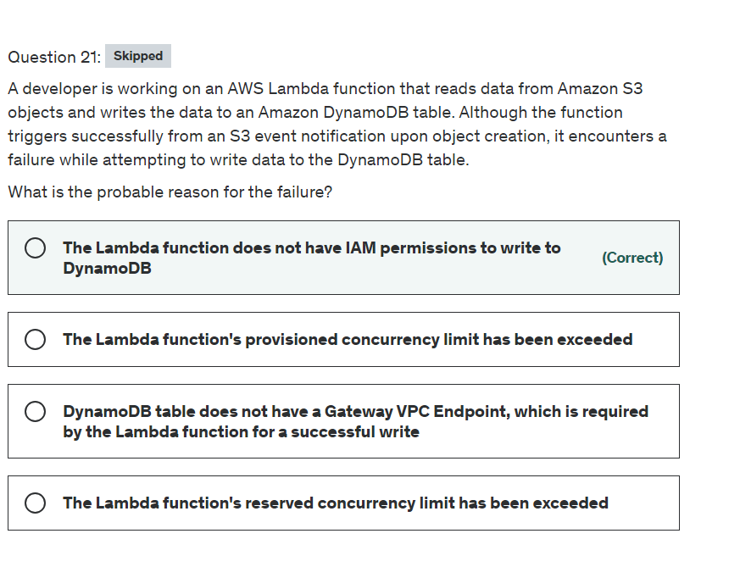

Explanation

Correct option:

**The Lambda function does not have IAM permissions to write to DynamoDB**

You need to use an identity-based policy that allows read and write access to a specific Amazon DynamoDB table. To use this policy, attach the policy to a Lambda service role. A service role is a role that you create in your account to allow a service to perform actions on your behalf. That service role must include AWS Lambda as the principal in the trust policy. The role is then used to grant a Lambda function access to a DynamoDB table. By using an IAM policy and role to control access, you don’t need to embed credentials in code and can tightly control which services the Lambda function can access.

Incorrect options:

**The Lambda function's provisioned concurrency limit has been exceeded**

**The Lambda function's reserved concurrency limit has been exceeded**

Reserved concurrency – Reserved concurrency guarantees the maximum number of concurrent instances for the function. When a function has reserved concurrency, no other function can use that concurrency. There is no charge for configuring reserved concurrency for a function.

Provisioned concurrency – Provisioned concurrency initializes a requested number of execution environments so that they are prepared to respond immediately to your function's invocations. Note that configuring provisioned concurrency incurs charges to your AWS account.

Neither reserved concurrency nor provisioned concurrency has any relevance to the given use case. Both options have been added as distractors.

**DynamoDB table does not have a Gateway VPC Endpoint, which is required by the Lambda function for a successful write** - Gateway endpoints provide reliable connectivity to Amazon S3 and DynamoDB without requiring an internet gateway or a NAT device for your VPC. Gateway endpoints do not enable AWS PrivateLink. This option acts as a distractor since the Lambda function is not provisioned within a VPC by default, so there is no need of a Gateway VPC Endpoint to access DynamoDB.

References:

<https://docs.aws.amazon.com/IAM/latest/UserGuide/reference_policies_examples_lambda-access-dynamodb.html>

<https://aws.amazon.com/blogs/security/how-to-create-an-aws-iam-policy-to-grant-aws-lambda-access-to-an-amazon-dynamodb-table/>

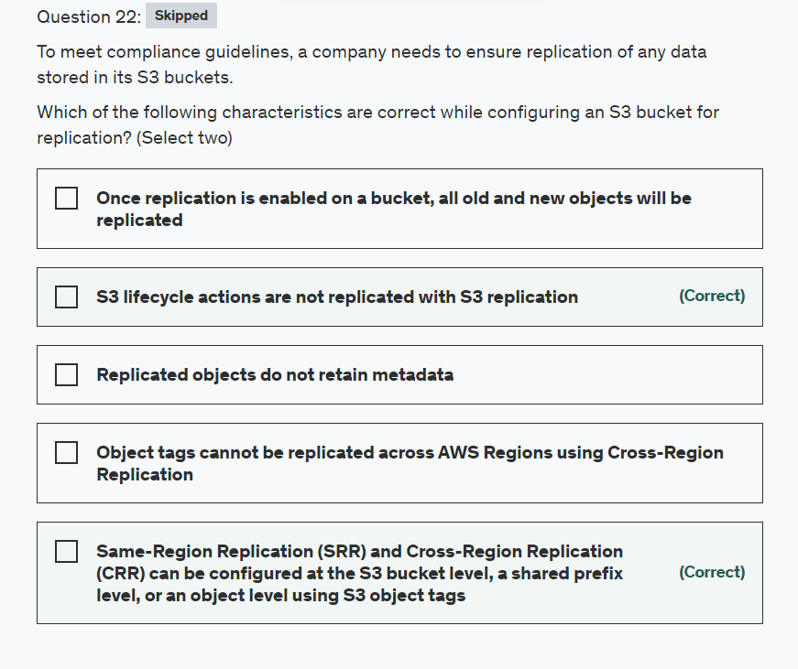

Explanation

Correct options:

**Same-Region Replication (SRR) and Cross-Region Replication (CRR) can be configured at the S3 bucket level, a shared prefix level, or an object level using S3 object tags** - Amazon S3 Replication (CRR and SRR) is configured at the S3 bucket level, a shared prefix level, or an object level using S3 object tags. You add a replication configuration on your source bucket by specifying a destination bucket in the same or different AWS region for replication.

**S3 lifecycle actions are not replicated with S3 replication** - With S3 Replication (CRR and SRR), you can establish replication rules to make copies of your objects into another storage class, in the same or a different region. Lifecycle actions are not replicated, and if you want the same lifecycle configuration applied to both source and destination buckets, enable the same lifecycle configuration on both.

Incorrect options:

**Object tags cannot be replicated across AWS Regions using Cross-Region Replication** - Object tags can be replicated across AWS Regions using Cross-Region Replication. For customers with Cross-Region Replication already enabled, new permissions are required for tags to replicate.

**Once replication is enabled on a bucket, all old and new objects will be replicated** - Replication only replicates the objects added to the bucket after replication is enabled on the bucket. Any objects present in the bucket before enabling replication are not replicated.

**Replicated objects do not retain metadata** - You can use replication to make copies of your objects that retain all metadata, such as the original object creation time and version IDs. This capability is important if you need to ensure that your replica is identical to the source object.

Reference:

<https://docs.amazonaws.cn/en_us/AmazonS3/latest/userguide/replication.html>

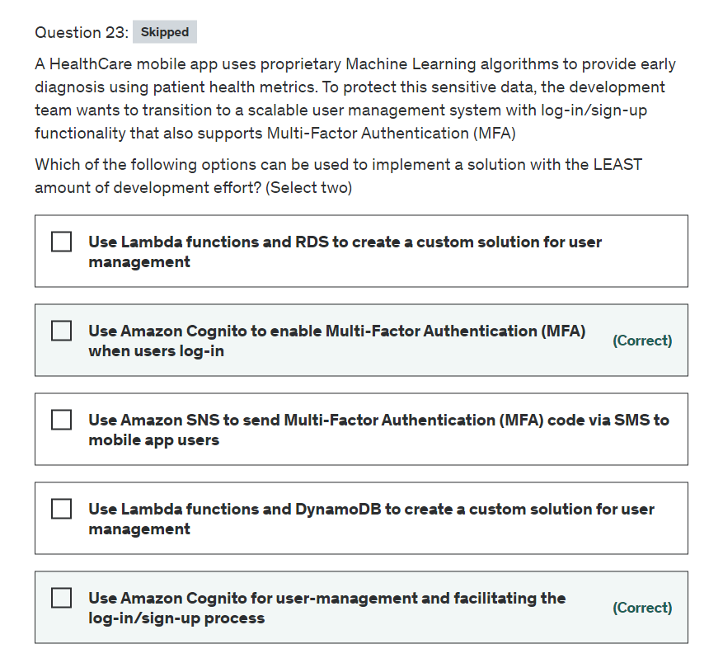

Explanation

Correct options:

**Use Amazon Cognito for user-management and facilitating the log-in/sign-up process**

**Use Amazon Cognito to enable Multi-Factor Authentication (MFA) when users log-in**

Amazon Cognito lets you add user sign-up, sign-in, and access control to your web and mobile apps quickly and easily. Amazon Cognito scales to millions of users and supports sign-in with social identity providers, such as Facebook, Google, and Amazon, and enterprise identity providers via SAML 2.0.

A Cognito user pool is a user directory in Amazon Cognito. With a user pool, your users can sign in to your web or mobile app through Amazon Cognito, or federate through a third-party identity provider (IdP). Whether your users sign-in directly or through a third party, all members of the user pool have a directory profile that you can access through an SDK.

Cognito user pools provide support for sign-up and sign-in services as well as security features such as multi-factor authentication (MFA).

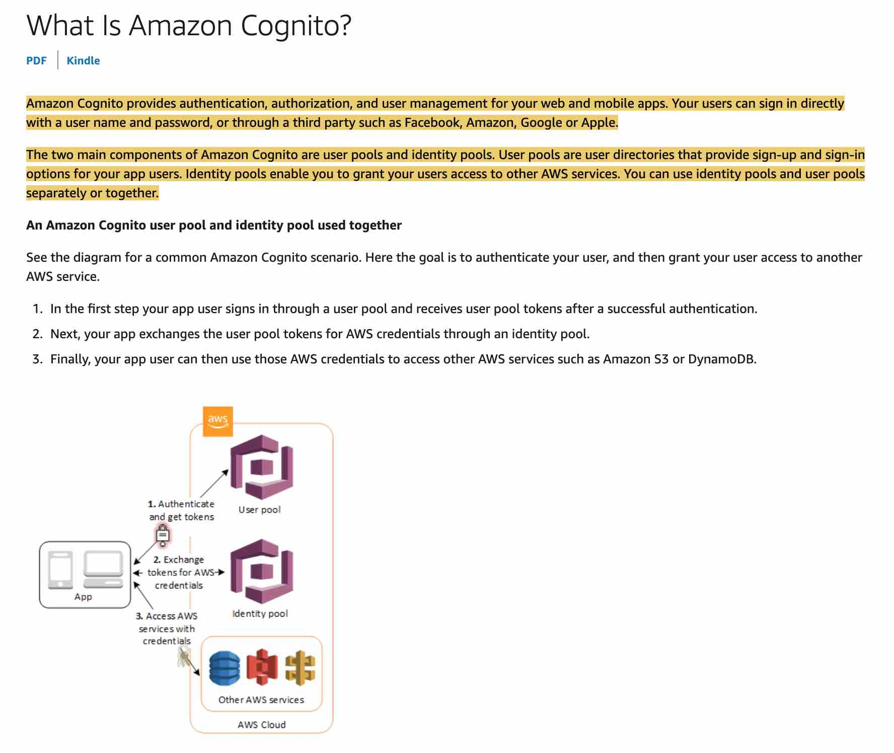 via - <https://docs.aws.amazon.com/cognito/latest/developerguide/what-is-amazon-cognito.html>

Exam Alert:

Please review the following note to understand the differences between Cognito User Pools and Cognito Identity Pools: 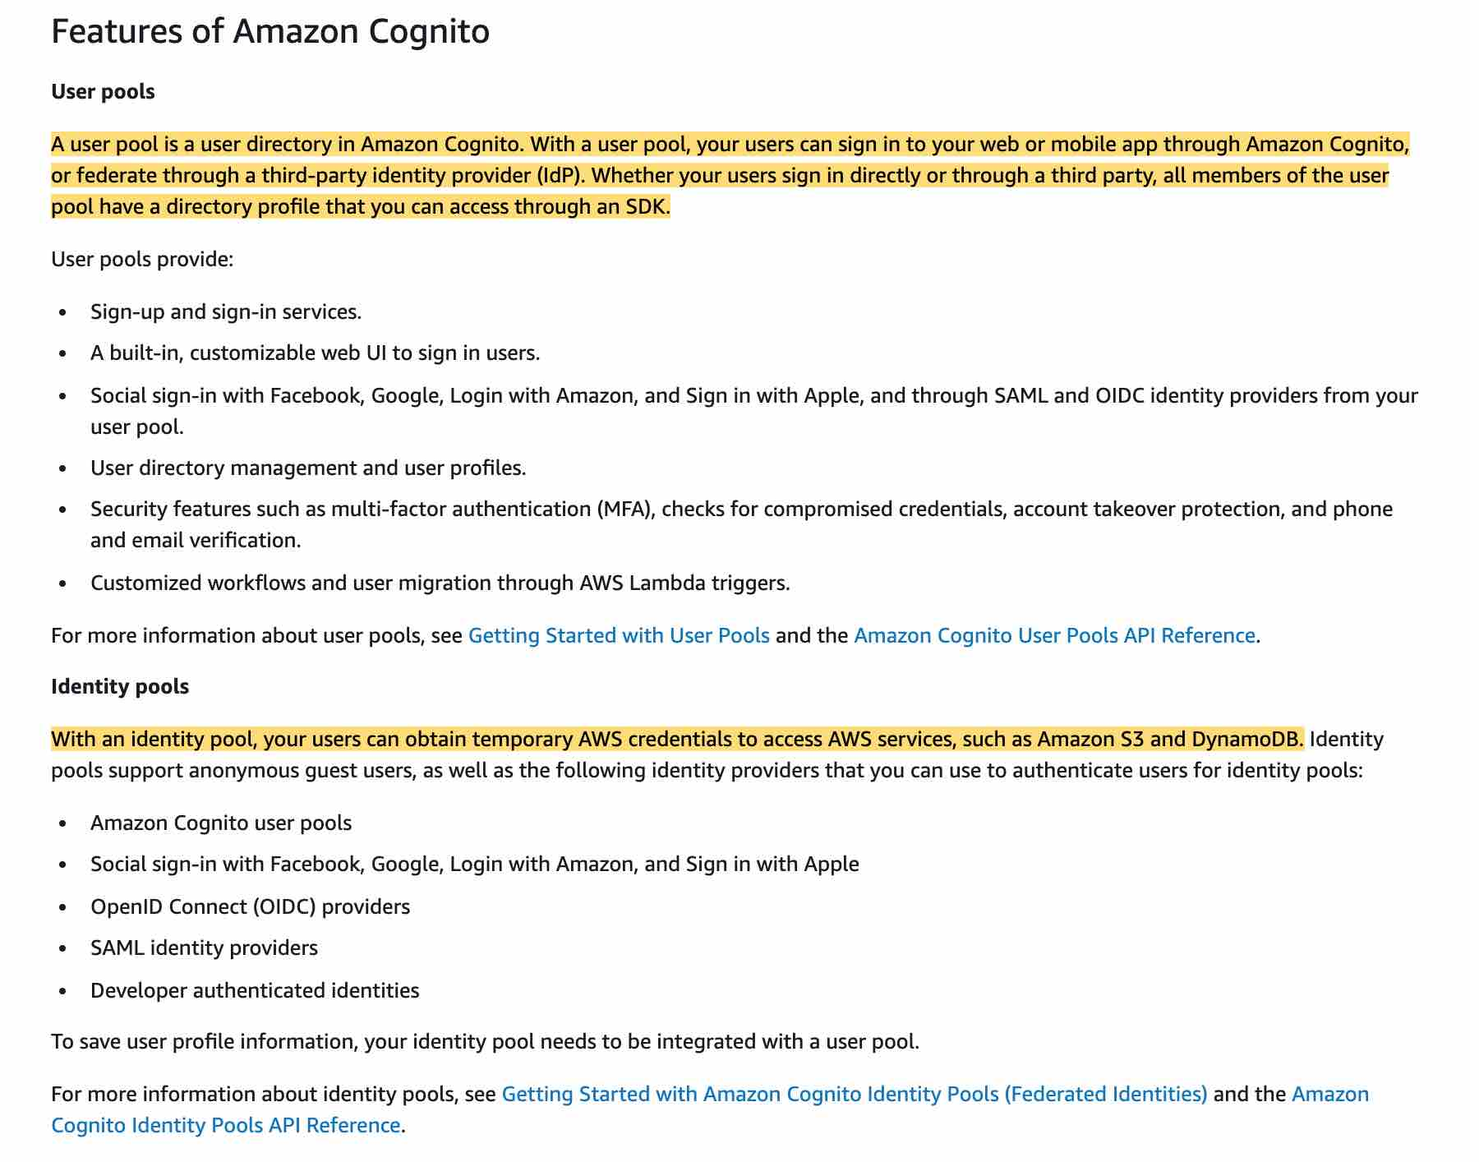 via - <https://docs.aws.amazon.com/cognito/latest/developerguide/what-is-amazon-cognito.html>

Incorrect options:

**Use Lambda functions and DynamoDB to create a custom solution for user management**

**Use Lambda functions and RDS to create a custom solution for user management**

As the problem statement mentions that the solution should require the least amount of development effort, so you cannot use Lambda functions with DynamoDB or RDS to create a custom solution. So both these options are incorrect.

**Use Amazon SNS to send Multi-Factor Authentication (MFA) code via SMS to mobile app users** - Amazon SNS cannot be used to send MFA codes via SMS to the user's mobile devices as this functionality is only meant to be used for IAM users. An SMS (short message service) MFA device can be any mobile device with a phone number that can receive standard SMS text messages. AWS will soon end support for SMS multi-factor authentication (MFA).

Please see this for more details:

<https://docs.aws.amazon.com/IAM/latest/UserGuide/id_credentials_mfa_enable_sms.html>

Reference:

<https://docs.aws.amazon.com/cognito/latest/developerguide/what-is-amazon-cognito.html>

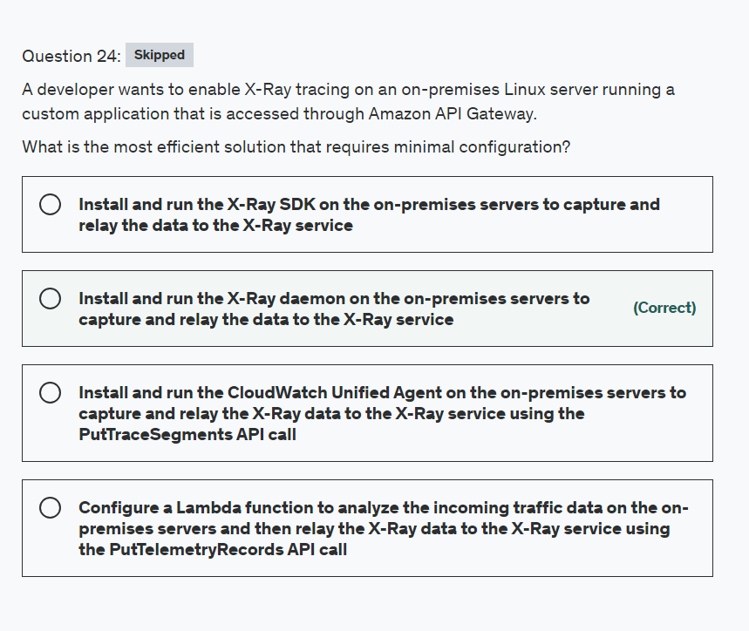

Explanation

Correct option:

**Install and run the X-Ray daemon on the on-premises servers to capture and relay the data to the X-Ray service**

The AWS X-Ray daemon is a software application that listens for traffic on UDP port 2000, gathers raw segment data, and relays it to the AWS X-Ray API. The daemon works in conjunction with the AWS X-Ray SDKs and must be running so that data sent by the SDKs can reach the X-Ray service.

To run the X-Ray daemon locally, on-premises, or on other AWS services, download it, run it, and then give it permission to upload segment documents to X-Ray.

Incorrect options:

**Install and run the X-Ray SDK on the on-premises servers to capture and relay the data to the X-Ray service** - As mentioned above, you need to run the X-Ray daemon on the on-premises servers and give it the required permission to upload X-Ray data to the X-Ray service. So this option is incorrect.

**Install and run the CloudWatch Unified Agent on the on-premises servers to capture and relay the X-Ray data to the X-Ray service using the PutTraceSegments API call** - This option has been added as a distractor. CloudWatch Agent cannot relay X-Ray data to the X-Ray service using the PutTraceSegments API call.

**Configure a Lambda function to analyze the incoming traffic data on the on-premises servers and then relay the X-Ray data to the X-Ray service using the PutTelemetryRecords API call** - This option is incorrect as the Lambda function cannot process the X-Ray data for an on-premises instance and then relay it to the X-Ray service.

Reference:

<https://docs.aws.amazon.com/xray/latest/devguide/xray-daemon.html>

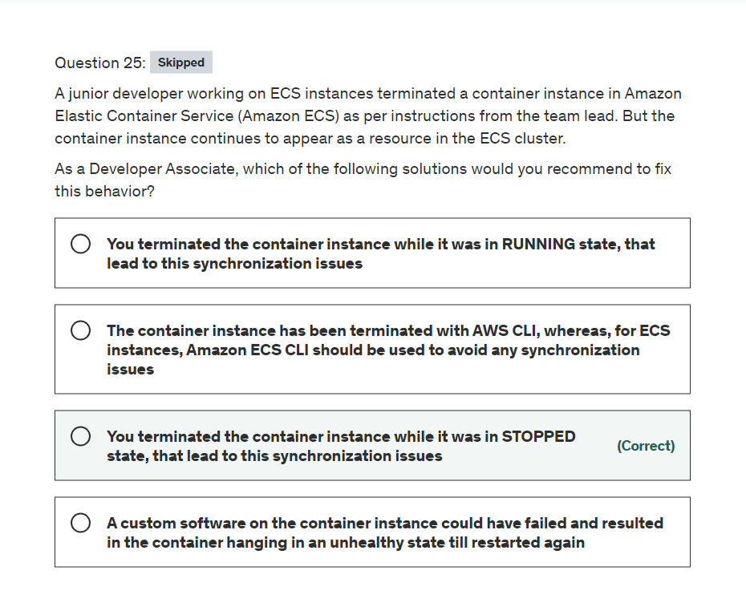

Explanation

Correct option:

**You terminated the container instance while it was in STOPPED state, that lead to this synchronization issues** - If you terminate a container instance while it is in the STOPPED state, that container instance isn't automatically removed from the cluster. You will need to deregister your container instance in the STOPPED state by using the Amazon ECS console or AWS Command Line Interface. Once deregistered, the container instance will no longer appear as a resource in your Amazon ECS cluster.

Incorrect options:

**You terminated the container instance while it was in RUNNING state, that lead to this synchronization issues** - This is an incorrect statement. If you terminate a container instance in the RUNNING state, that container instance is automatically removed, or deregistered, from the cluster.

**The container instance has been terminated with AWS CLI, whereas, for ECS instances, Amazon ECS CLI should be used to avoid any synchronization issues** - This is incorrect and has been added as a distractor.

**A custom software on the container instance could have failed and resulted in the container hanging in an unhealthy state till restarted again** - This is an incorrect statement. It is already mentioned in the question that the developer has terminated the instance.

References:

<https://aws.amazon.com/premiumsupport/knowledge-center/deregister-ecs-instance/>

<https://docs.aws.amazon.com/AmazonECS/latest/developerguide/ECS_instances.html>

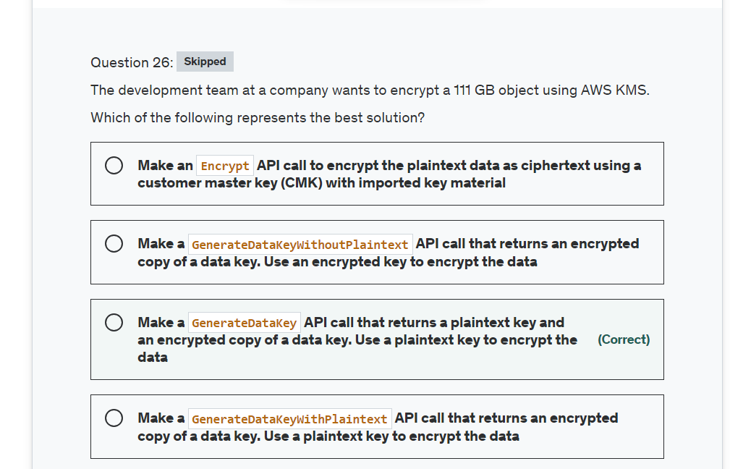

Explanation

Correct option:

**Make a GenerateDataKey API call that returns a plaintext key and an encrypted copy of a data key. Use a plaintext key to encrypt the data** - GenerateDataKey API, generates a unique symmetric data key for client-side encryption. This operation returns a plaintext copy of the data key and a copy that is encrypted under a customer master key (CMK) that you specify. You can use the plaintext key to encrypt your data outside of AWS KMS and store the encrypted data key with the encrypted data.

GenerateDataKey returns a unique data key for each request. The bytes in the plaintext key are not related to the caller or the CMK.

To encrypt data outside of AWS KMS:

Use the GenerateDataKey operation to get a data key.

Use the plaintext data key (in the Plaintext field of the response) to encrypt your data outside of AWS KMS. Then erase the plaintext data key from memory.

Store the encrypted data key (in the CiphertextBlob field of the response) with the encrypted data.

To decrypt data outside of AWS KMS:

Use the Decrypt operation to decrypt the encrypted data key. The operation returns a plaintext copy of the data key.

Use the plaintext data key to decrypt data outside of AWS KMS, then erase the plaintext data key from memory.

Incorrect options:

**Make a GenerateDataKeyWithPlaintext API call that returns an encrypted copy of a data key. Use a plaintext key to encrypt the data** - This is a made-up option, given only as a distractor.

**Make an Encrypt API call to encrypt the plaintext data as ciphertext using a customer master key (CMK) with imported key material** - Encrypt API is used to encrypt plaintext into ciphertext by using a customer master key (CMK). The Encrypt operation has two primary use cases:

To encrypt small amounts of arbitrary data, such as a personal identifier or database password, or other sensitive information.

To move encrypted data from one AWS Region to another.

Neither of the two is useful for the given scenario.

**Make a GenerateDataKeyWithoutPlaintext API call that returns an encrypted copy of a data key. Use an encrypted key to encrypt the data** - GenerateDataKeyWithoutPlaintext API, generates a unique symmetric data key. This operation returns a data key that is encrypted under a customer master key (CMK) that you specify.

GenerateDataKeyWithoutPlaintext is identical to the GenerateDataKey operation except that returns only the encrypted copy of the data key. This operation is useful for systems that need to encrypt data at some point, but not immediately. When you need to encrypt the data, you call the Decrypt operation on the encrypted copy of the key.

References:

<https://docs.aws.amazon.com/kms/latest/APIReference/API_GenerateDataKey.html>

<https://docs.aws.amazon.com/kms/latest/APIReference/API_Encrypt.html>

<https://docs.aws.amazon.com/kms/latest/APIReference/API_GenerateDataKeyWithoutPlaintext.html>

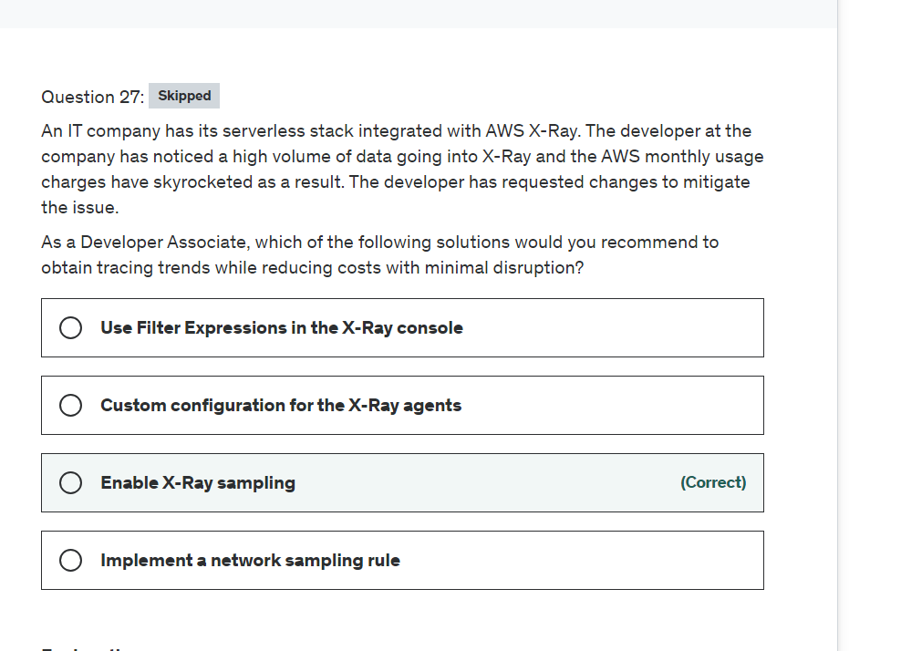

Explanation

Correct option:

AWS X-Ray helps developers analyze and debug production, distributed applications, such as those built using a microservices architecture. With X-Ray, you can understand how your application and its underlying services are performing to identify and troubleshoot the root cause of performance issues and errors. X-Ray provides an end-to-end view of requests as they travel through your application, and shows a map of your application’s underlying components.

How X-Ray Works: 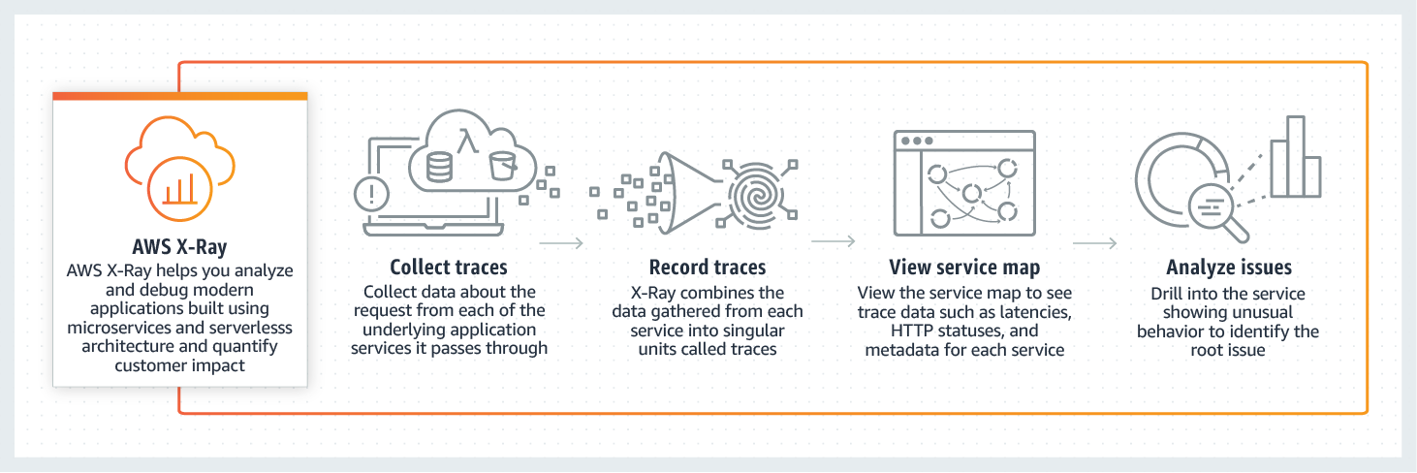 via - <https://aws.amazon.com/xray/>

**Enable X-Ray sampling**

To ensure efficient tracing and provide a representative sample of the requests that your application serves, the X-Ray SDK applies a sampling algorithm to determine which requests get traced. By default, the X-Ray SDK records the first request each second, and five percent of any additional requests. X-Ray sampling is enabled directly from the AWS console, hence your application code does not need to change.

You can also customize the X-Ray sampling rules: 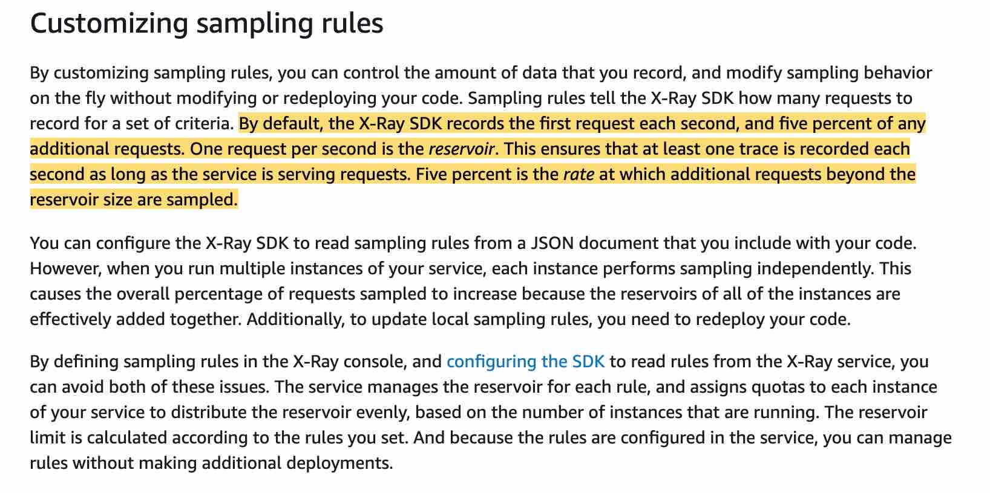 via - <https://docs.aws.amazon.com/xray/latest/devguide/xray-console-sampling.html>

Incorrect options:

**Use Filter Expressions in the X-Ray console** - When you choose a time period of traces to view in the X-Ray console, you might get more results than the console can display. You can narrow the results to just the traces that you want to find by using a filter expression. This option is not correct because it does not reduce the volume of data sent into the X-Ray console.

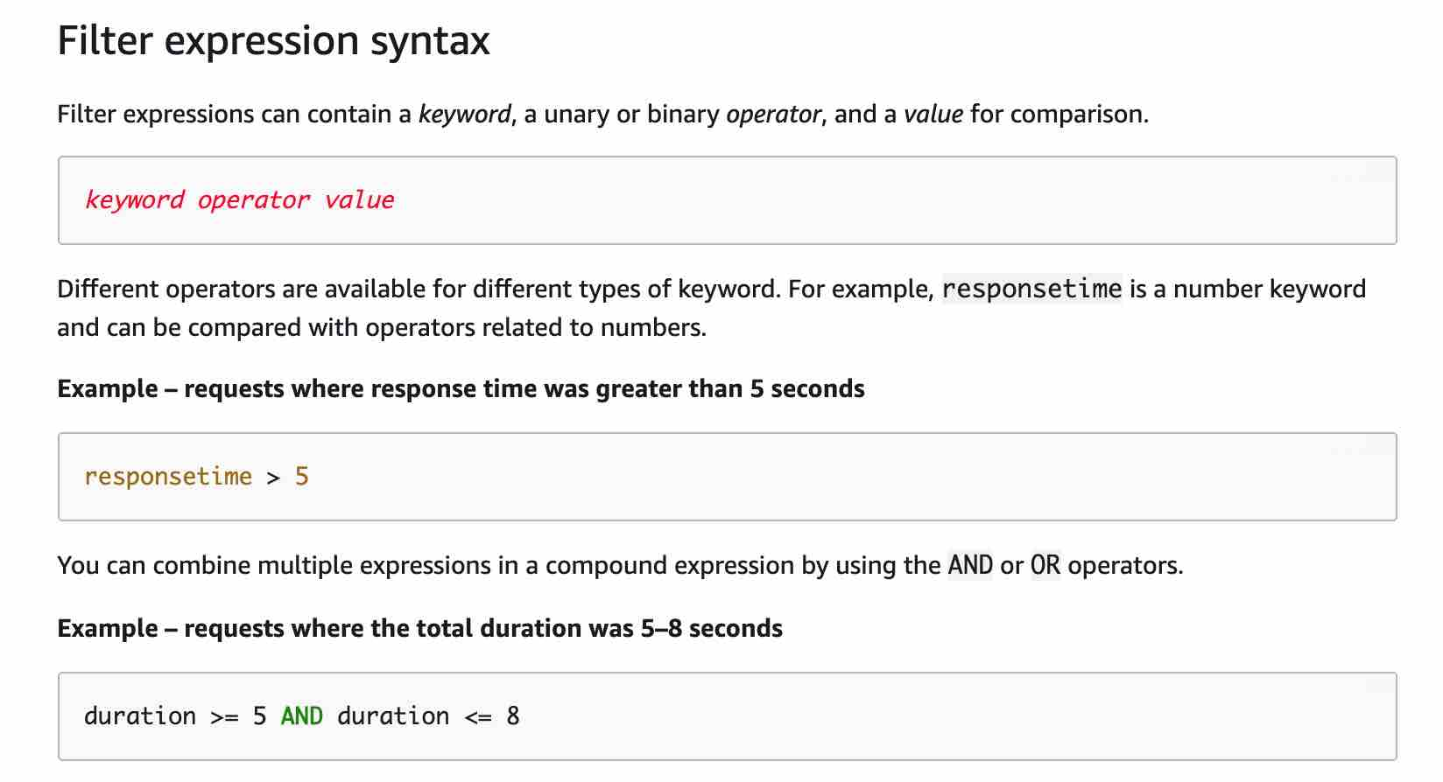 via - <https://docs.aws.amazon.com/xray/latest/devguide/xray-console-filters.html>

**Custom configuration for the X-Ray agents** - You cannot do a custom configuration, instead you can do custom sampling rules. So this option is incorrect.

**Implement a network sampling rule** - This option has been added as a distractor.

References:

<https://aws.amazon.com/xray/>

<https://docs.aws.amazon.com/xray/latest/devguide/xray-console-sampling.html>

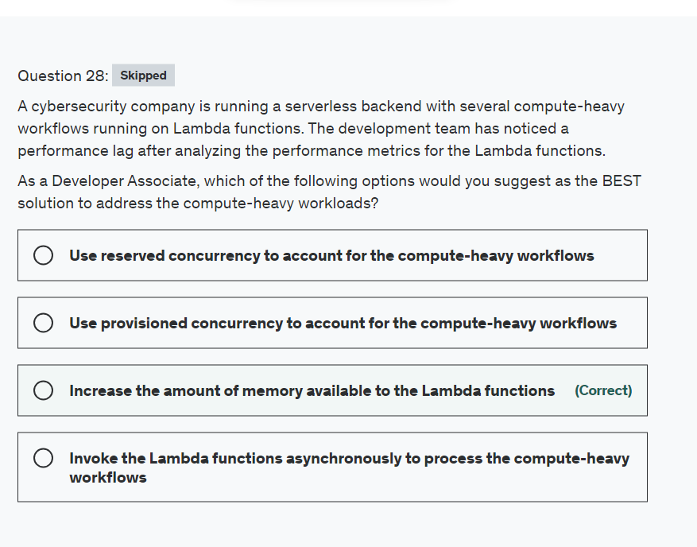

Explanation

Correct option:

**Increase the amount of memory available to the Lambda functions**

AWS Lambda lets you run code without provisioning or managing servers. You pay only for the compute time you consume.

In the AWS Lambda resource model, you choose the amount of memory you want for your function which allocates proportional CPU power and other resources. This means you will have access to more compute power when you choose one of the new larger settings. You can set your memory in 64MB increments from 128MB to 3008MB. You access these settings when you create a function or update its configuration. The settings are available using the AWS Management Console, AWS CLI, or SDKs.

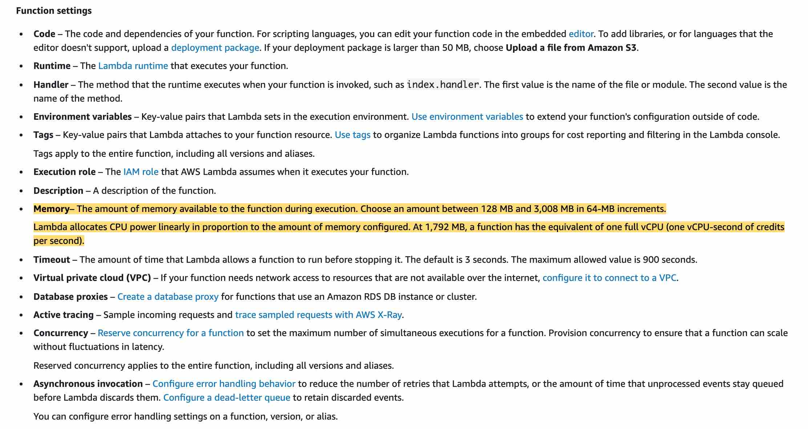 via - <https://docs.aws.amazon.com/lambda/latest/dg/configuration-console.html>

Therefore, by increasing the amount of memory available to the Lambda functions, you can run the compute-heavy workflows.

Incorrect options:

**Invoke the Lambda functions asynchronously to process the compute-heavy workflows** - When you invoke a function asynchronously, you don't wait for a response from the function code. You hand off the event to Lambda and Lambda handles the rest. You can configure how Lambda handles errors and can send invocation records to a downstream resource to chain together components of your application. The method of invocation has no bearing on the Lambda function's ability to process the compute-heavy workflows.

**Use reserved concurrency to account for the compute-heavy workflows**

**Use provisioned concurrency to account for the compute-heavy workflows**

Concurrency is the number of requests that your function is serving at any given time. When your function is invoked, Lambda allocates an instance of it to process the event. When the function code finishes running, it can handle another request. If the function is invoked again while a request is still being processed, another instance is allocated, which increases the function's concurrency. The type of concurrency has no bearing on the Lambda function's ability to process the compute-heavy workflows. So both these options are incorrect.

Reference:

<https://docs.aws.amazon.com/lambda/latest/dg/configuration-console.html>

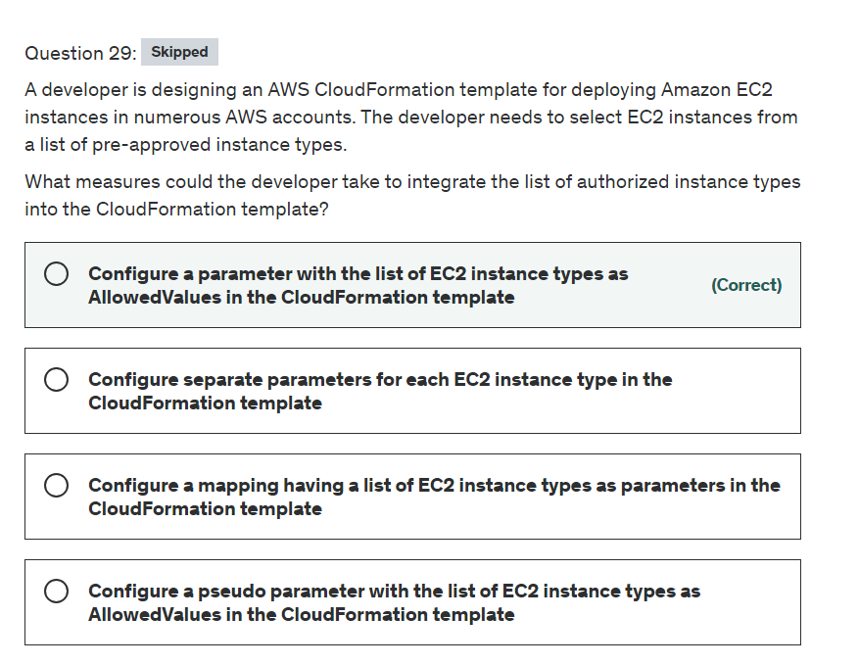

Explanation

Correct option:

**Configure a parameter with the list of EC2 instance types as AllowedValues in the CloudFormation template**

You can use the Parameters section to customize your templates. Parameters enable you to input custom values to your template each time you create or update a stack.

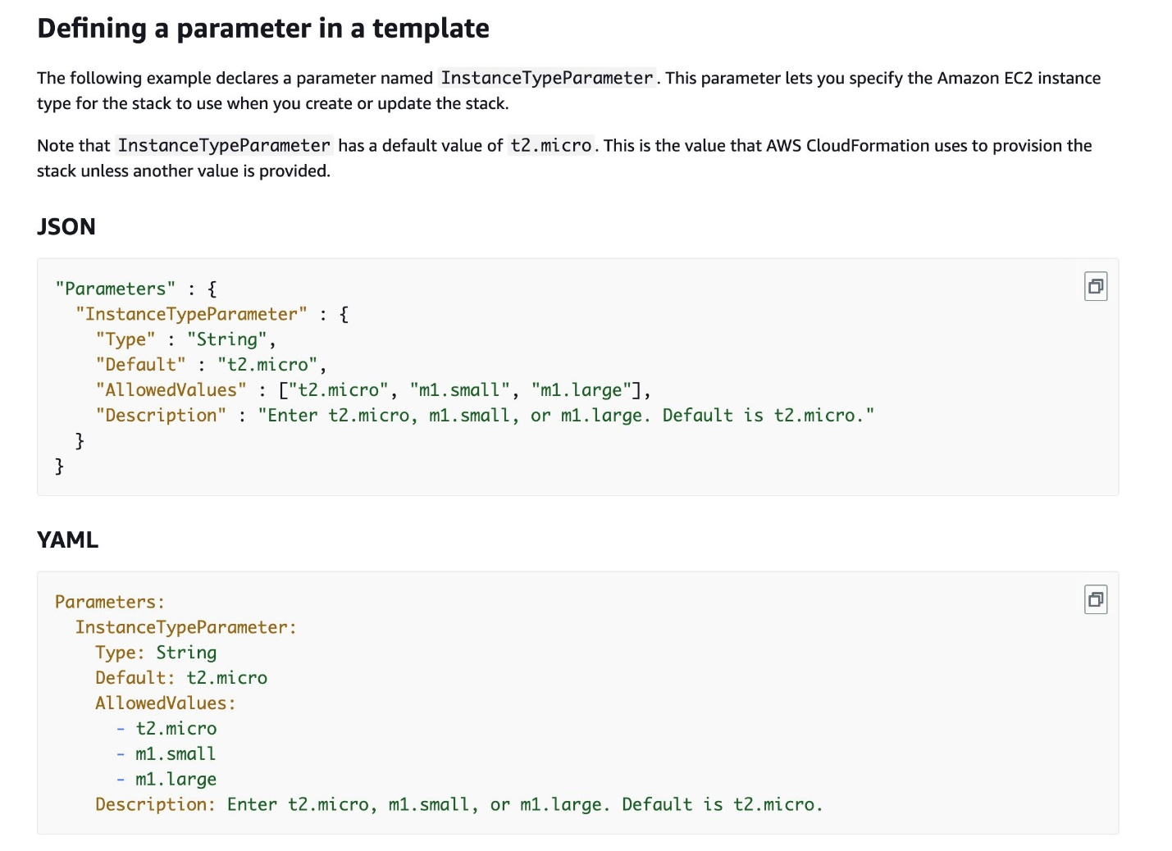 via - <https://docs.aws.amazon.com/AWSCloudFormation/latest/UserGuide/parameters-section-structure.html>

AllowedValues refers to an array containing the list of values allowed for the parameter. When applied to a parameter of type String, the parameter value must be one of the allowed values. When applied to a parameter of type CommaDelimitedList, each value in the list must be one of the specified allowed values.

Incorrect options:

**Configure separate parameters for each EC2 instance type in the CloudFormation template** - Creating separate parameters for each instance type is semantically incorrect as the underlying value will point to the same resource but have multiple inputs.

**Configure a mapping having a list of EC2 instance types as parameters in the CloudFormation template** - The Mappings section matches a key to a corresponding set of named values. For example, if you want to set values based on a region, you can create a mapping that uses the region name as a key and contains the values you want to specify for each specific region. You use the Fn::FindInMap intrinsic function to retrieve values in a map. A mapping is not a list, rather, it consists of key value pairs. You can't include parameters, pseudo parameters, or intrinsic functions in the Mappings section. So, this option is incorrect.

**Configure a pseudo parameter with the list of EC2 instance types as AllowedValues in the CloudFormation template** - Pseudo parameters are parameters that are predefined by AWS CloudFormation. You don't declare them in your template. So, this option is incorrect.

References:

<https://docs.aws.amazon.com/AWSCloudFormation/latest/UserGuide/parameters-section-structure.html>

<https://docs.aws.amazon.com/AWSCloudFormation/latest/UserGuide/mappings-section-structure.html>

<https://docs.aws.amazon.com/AWSCloudFormation/latest/UserGuide/pseudo-parameter-reference.html>

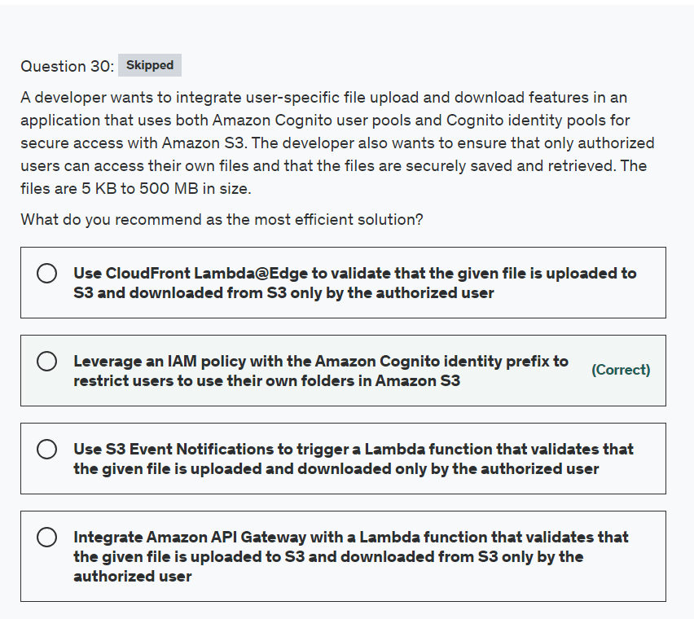

Explanation

Correct option:

**Leverage an IAM policy with the Amazon Cognito identity prefix to restrict users to use their own folders in Amazon S3**

Amazon Cognito identity pools (federated identities) enable you to create unique identities for your users and federate them with identity providers. With an identity pool, you can obtain temporary, limited-privilege AWS credentials to access other AWS services. Amazon Cognito identity pools support the following identity providers:

Public providers: Login with Amazon (identity pools), Facebook (identity pools), Google (identity pools), Sign in with Apple (identity pools).

Amazon Cognito user pools

OpenID Connect providers (identity pools)

SAML identity providers (identity pools)

Developer authenticated identities (identity pools)

You can create an identity-based policy that allows Amazon Cognito users to access objects in a specific S3 bucket. This policy allows access only to objects with a name that includes Cognito, the name of the application, and the federated user's ID, represented by the ${cognito-identity.amazonaws.com:sub} variable.

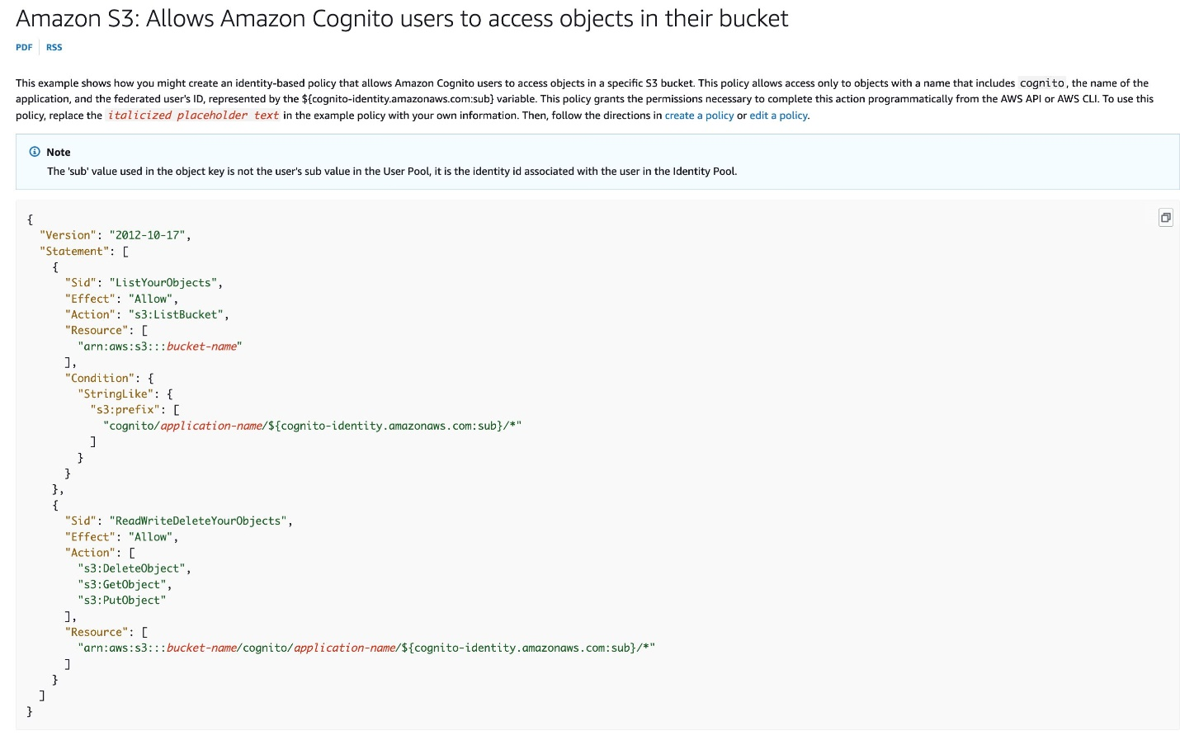 via - <https://docs.aws.amazon.com/IAM/latest/UserGuide/reference_policies_examples_s3_cognito-bucket.html>

Incorrect options:

**Use S3 Event Notifications to trigger a Lambda function that validates that the given file is uploaded and downloaded only by the authorized user** - While it is certainly possible to build this solution, however, it is not the most optimal solution as it does not prevent an invalid upload of a file into another user's designated folder. So this option is incorrect.

**Integrate Amazon API Gateway with a Lambda function that validates that the given file is uploaded to S3 and downloaded from S3 only by the authorized user** - Again, it is certainly possible to build this solution, however, it is not the most optimal solution as it does not prevent an invalid upload of a file into another user's designated folder. So this option is incorrect.

**Use CloudFront Lambda@Edge to validate that the given file is uploaded to S3 and downloaded from S3 only by the authorized user** - This option assumes that the solution comprises a CloudFront distribution. This introduces inefficiency in the solution, as one needs to pay for CloudFront/Lambda@Edge and adds unnecessary hops in the data flow for both uploads and downloads.

References:

<https://docs.aws.amazon.com/IAM/latest/UserGuide/reference_policies_examples_s3_cognito-bucket.html>

<https://docs.aws.amazon.com/cognito/latest/developerguide/amazon-cognito-integrating-user-pools-with-identity-pools.html>

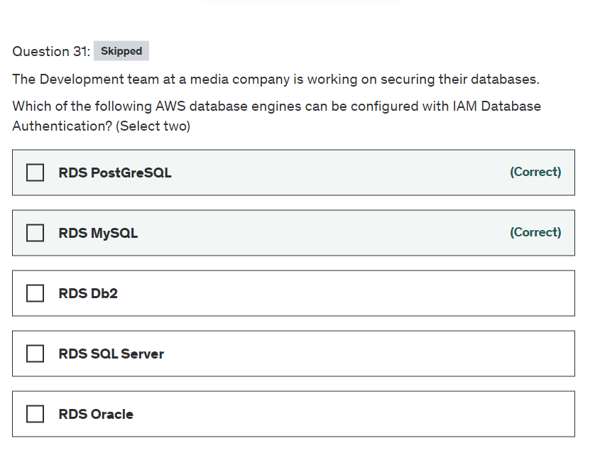

planation

Correct options:

You can authenticate to your DB instance using AWS Identity and Access Management (IAM) database authentication. With this authentication method, you don't need to use a password when you connect to a DB instance. Instead, you use an authentication token. An authentication token is a unique string of characters that Amazon RDS generates on request. Each token has a lifetime of 15 minutes. You don't need to store user credentials in the database, because authentication is managed externally using IAM.

**RDS MySQL** - IAM database authentication works with MySQL and PostgreSQL engines for Aurora as well as MySQL, MariaDB and RDS PostgreSQL engines for RDS.

**RDS PostGreSQL** - IAM database authentication works with MySQL and PostgreSQL engines for Aurora as well as MySQL, MariaDB and RDS PostgreSQL engines for RDS.

Incorrect options:

**RDS Oracle**

**RDS SQL Server**

These two options contradict the details in the explanation above, so these are incorrect.

**RDS Db2** - This option has been added as a distractor. Db2 is a family of data management products, including database servers, developed by IBM. RDS does not support Db2 database engine.

Reference:

<https://docs.aws.amazon.com/AmazonRDS/latest/UserGuide/UsingWithRDS.IAMDBAuth.html>

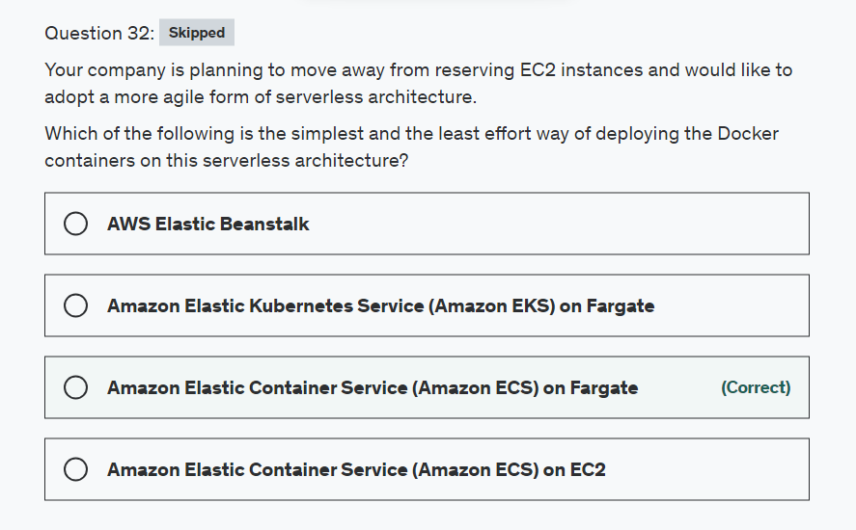

Explanation

Correct option:

**Amazon Elastic Container Service (Amazon ECS) on Fargate** - Amazon Elastic Container Service (Amazon ECS) is a highly scalable, fast, container management service that makes it easy to run, stop, and manage Docker containers on a cluster. You can host your cluster on a serverless infrastructure that is managed by Amazon ECS by launching your services or tasks using the Fargate launch type.

AWS Fargate is a serverless compute engine for containers that works with both Amazon Elastic Container Service (ECS) and Amazon Elastic Kubernetes Service (EKS). Fargate makes it easy for you to focus on building your applications. Fargate removes the need to provision and manage servers, lets you specify and pay for resources per application, and improves security through application isolation by design.

ECS Fargate Overview: 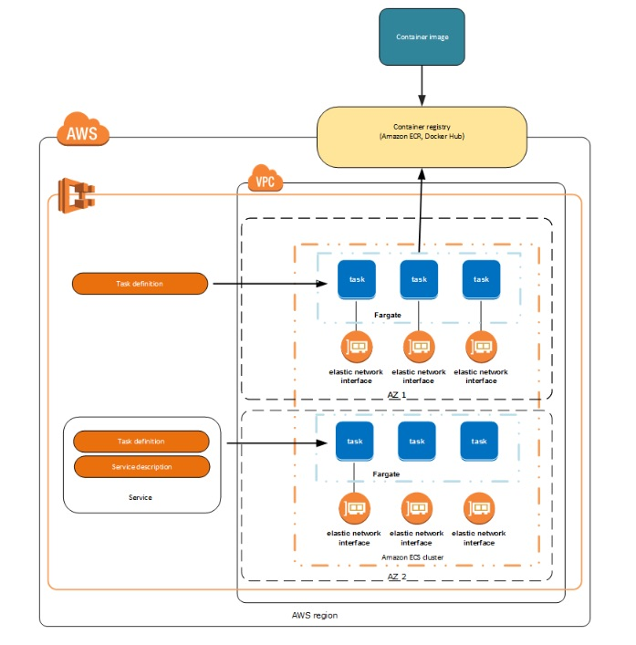 via - <https://docs.aws.amazon.com/AmazonECS/latest/developerguide/Welcome.html>

Incorrect options:

**Amazon Elastic Container Service (Amazon ECS) on EC2** - Amazon Elastic Container Service (Amazon ECS) is a highly scalable, fast, container management service that makes it easy to run, stop, and manage Docker containers on a cluster. ECS uses EC2 instances and hence cannot be called a serverless solution.

**Amazon Elastic Kubernetes Service (Amazon EKS) on Fargate** - Amazon Elastic Kubernetes Service (Amazon EKS) is a fully managed Kubernetes service. You can choose to run your EKS clusters using AWS Fargate, which is a serverless compute for containers. Since the use-case talks about the simplest and the least effort way to deploy Docker containers, EKS is not the best fit as you can use ECS Fargate to build a much easier solution. EKS is better suited to run Kubernetes on AWS without needing to install and operate your own Kubernetes control plane or worker nodes.

**AWS Elastic Beanstalk** - AWS Elastic Beanstalk is an easy-to-use service for deploying and scaling web applications and services. You can simply upload your code and Elastic Beanstalk automatically handles the deployment, from capacity provisioning, load balancing, auto-scaling to application health monitoring. At the same time, you retain full control over the AWS resources powering your application and can access the underlying resources at any time. Beanstalk uses EC2 instances for its deployment, hence cannot be called a serverless architecture.

References:

<https://docs.aws.amazon.com/AmazonECS/latest/developerguide/Welcome.html>

<https://aws.amazon.com/eks/>

<https://aws.amazon.com/elasticbeanstalk/>

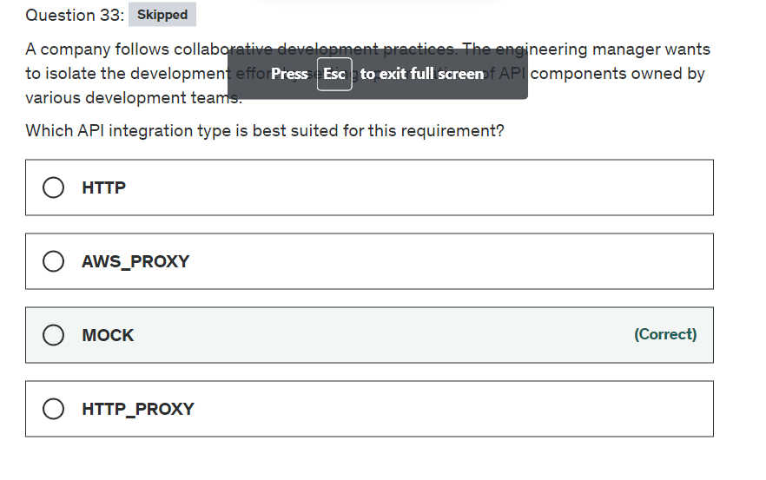

Explanation

Correct option:

**MOCK**

This type of integration lets API Gateway return a response without sending the request further to the backend. This is useful for API testing because it can be used to test the integration setup without incurring charges for using the backend and to enable collaborative development of an API.

In collaborative development, a team can isolate their development effort by setting up simulations of API components owned by other teams by using the MOCK integrations. It is also used to return CORS-related headers to ensure that the API method permits CORS access. In fact, the API Gateway console integrates the OPTIONS method to support CORS with a mock integration.

Incorrect options:

**AWS_PROXY** - This type of integration lets an API method be integrated with the Lambda function invocation action with a flexible, versatile, and streamlined integration setup. This integration relies on direct interactions between the client and the integrated Lambda function.

**HTTP_PROXY** - The HTTP proxy integration allows a client to access the backend HTTP endpoints with a streamlined integration setup on single API method. You do not set the integration request or the integration response. API Gateway passes the incoming request from the client to the HTTP endpoint and passes the outgoing response from the HTTP endpoint to the client.

**HTTP** - This type of integration lets an API expose HTTP endpoints in the backend. With the HTTP integration, you must configure both the integration request and integration response. You must set up necessary data mappings from the method request to the integration request, and from the integration response to the method response.

Reference:

<https://docs.aws.amazon.com/apigateway/latest/developerguide/api-gateway-api-integration-types.html>

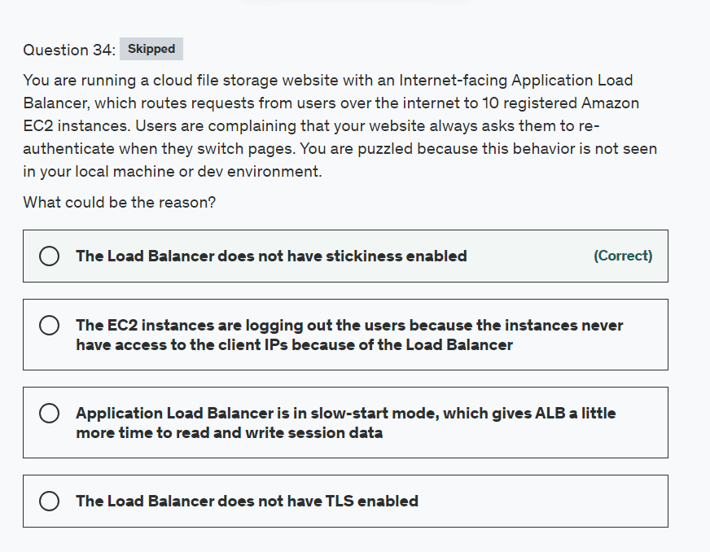

Explanation

Correct option:

**The Load Balancer does not have stickiness enabled** - Sticky sessions are a mechanism to route requests to the same target in a target group. This is useful for servers that maintain state information to provide a continuous experience to clients. To use sticky sessions, the clients must support cookies.

When a load balancer first receives a request from a client, it routes the request to a target, generates a cookie named AWSALB that encodes information about the selected target, encrypts the cookie, and includes the cookie in the response to the client. The client should include the cookie that it receives in subsequent requests to the load balancer. When the load balancer receives a request from a client that contains the cookie, if sticky sessions are enabled for the target group and the request goes to the same target group, the load balancer detects the cookie and routes the request to the same target.

More info here: 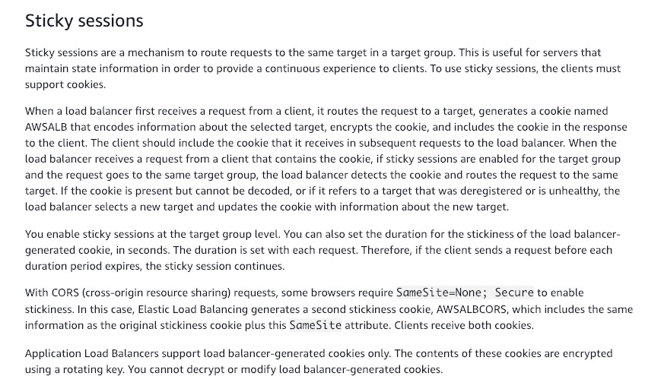 via - <https://docs.aws.amazon.com/elasticloadbalancing/latest/application/load-balancer-target-groups.html#sticky-sessions>

Incorrect options:

**Application Load Balancer is in slow-start mode, which gives ALB a little more time to read and write session data** - This is an invalid statement. The load balancer serves as a single point of contact for clients and distributes incoming traffic across its healthy registered targets. By default, a target starts to receive its full share of requests as soon as it is registered with a target group and passes an initial health check. Using slow start mode gives targets time to warm up before the load balancer sends them a full share of requests. This does not help in session management.

**The EC2 instances are logging out the users because the instances never have access to the client IPs because of the Load Balancer** - This is an incorrect statement. Elastic Load Balancing stores the IP address of the client in the X-Forwarded-For request header and passes the header to the server. If needed, the server can read IP addresses from this data.

**The Load Balancer does not have TLS enabled** - To use an HTTPS listener, you must deploy at least one SSL/TLS server certificate on your load balancer. The load balancer uses a server certificate to terminate the front-end connection and then decrypt requests from clients before sending them to the targets. This does not help in session management.

References:

<https://docs.aws.amazon.com/elasticloadbalancing/latest/application/load-balancer-target-groups.html#sticky-sessions>

<https://docs.aws.amazon.com/elasticloadbalancing/latest/application/load-balancer-target-groups.html#slow-start-mode>

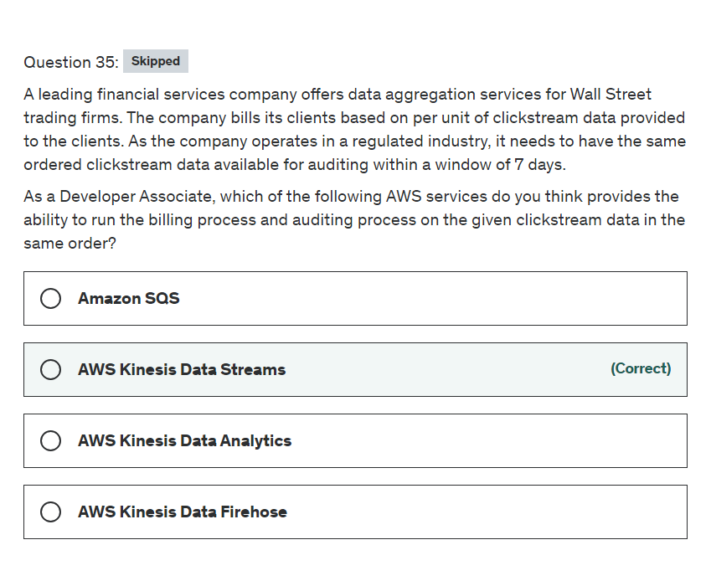

Explanation

Correct option:

**AWS Kinesis Data Streams**

Amazon Kinesis Data Streams (KDS) is a massively scalable and durable real-time data streaming service. KDS can continuously capture gigabytes of data per second from hundreds of thousands of sources such as website clickstreams, database event streams, financial transactions, social media feeds, IT logs, and location-tracking events. The data collected is available in milliseconds to enable real-time analytics use cases such as real-time dashboards, real-time anomaly detection, dynamic pricing, and more.

Amazon Kinesis Data Streams enables real-time processing of streaming big data. It provides ordering of records, as well as the ability to read and/or replay records in the same order to multiple Amazon Kinesis Applications. The Amazon Kinesis Client Library (KCL) delivers all records for a given partition key to the same record processor, making it easier to build multiple applications reading from the same Amazon Kinesis data stream (for example, to perform counting, aggregation, and filtering). Amazon Kinesis Data Streams is recommended when you need the ability to consume records in the same order a few hours later.

For example, you have a billing application and an audit application that runs a few hours behind the billing application. By default, records of a stream are accessible for up to 24 hours from the time they are added to the stream. You can raise this limit to a maximum of 365 days. For the given use-case, Amazon Kinesis Data Streams can be configured to store data for up to 7 days and you can run the audit application up to 7 days behind the billing application.

KDS provides the ability to consume records in the same order a few hours later 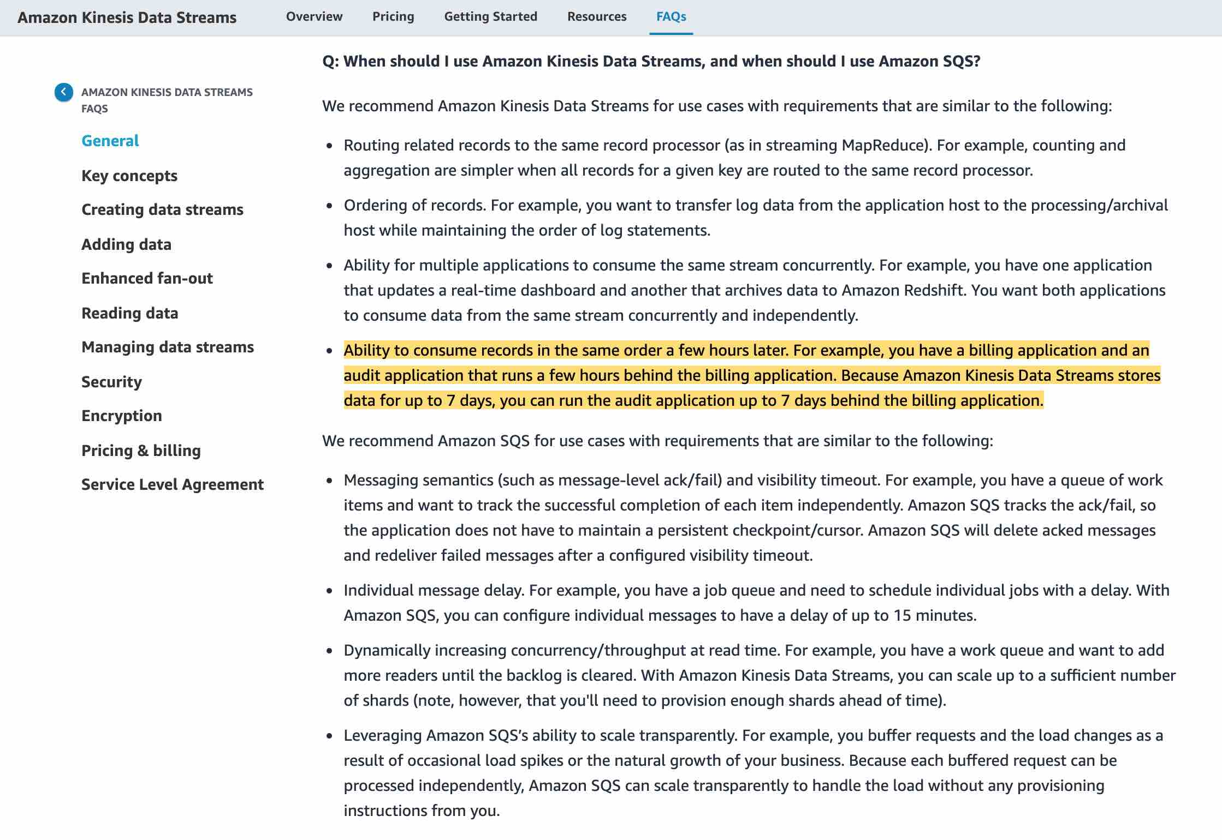 via - <https://aws.amazon.com/kinesis/data-streams/faqs/>

Incorrect options:

**AWS Kinesis Data Firehose** - Amazon Kinesis Data Firehose is the easiest way to load streaming data into data stores and analytics tools. It can capture, transform, and load streaming data into Amazon S3, Amazon Redshift, Amazon Elasticsearch Service, and Splunk, enabling near real-time analytics with existing business intelligence tools and dashboards you’re already using today. It is a fully managed service that automatically scales to match the throughput of your data and requires no ongoing administration. It can also batch, compress, and encrypt the data before loading it, minimizing the amount of storage used at the destination and increasing security. As Kinesis Data Firehose is used to load streaming data into data stores, therefore this option is incorrect.

**AWS Kinesis Data Analytics** - Amazon Kinesis Data Analytics is the easiest way to analyze streaming data in real-time. You can quickly build SQL queries and sophisticated Java applications using built-in templates and operators for common processing functions to organize, transform, aggregate, and analyze data at any scale. Kinesis Data Analytics enables you to easily and quickly build queries and sophisticated streaming applications in three simple steps: setup your streaming data sources, write your queries or streaming applications and set up your destination for processed data. As Kinesis Data Analytics is used to build SQL queries and sophisticated Java applications, therefore this option is incorrect.

**Amazon SQS** - Amazon Simple Queue Service (SQS) is a fully managed message queuing service that enables you to decouple and scale microservices, distributed systems, and serverless applications. SQS offers two types of message queues. Standard queues offer maximum throughput, best-effort ordering, and at-least-once delivery. SQS FIFO queues are designed to guarantee that messages are processed exactly once, in the exact order that they are sent. For SQS, you cannot have the same message being consumed by multiple consumers in the same order a few hours later, therefore this option is incorrect.

References:

<https://aws.amazon.com/kinesis/data-streams/faqs/>

<https://aws.amazon.com/kinesis/data-firehose/faqs/>

<https://aws.amazon.com/kinesis/data-analytics/faqs/>

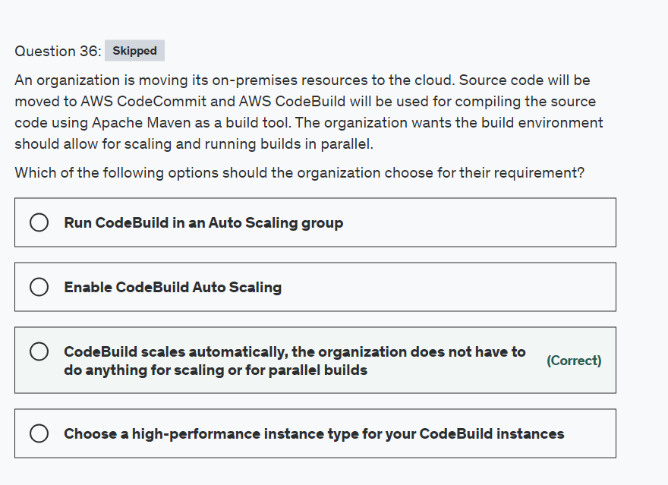

Explanation

Correct option:

**CodeBuild scales automatically, the organization does not have to do anything for scaling or for parallel builds** - AWS CodeBuild is a fully managed build service in the cloud. CodeBuild compiles your source code, runs unit tests, and produces artifacts that are ready to deploy. CodeBuild eliminates the need to provision, manage, and scale your own build servers. It provides prepackaged build environments for popular programming languages and build tools such as Apache Maven, Gradle, and more. You can also customize build environments in CodeBuild to use your own build tools. CodeBuild scales automatically to meet peak build requests.

Incorrect options:

**Choose a high-performance instance type for your CodeBuild instances** - For the current requirement, this is will not make any difference.

**Run CodeBuild in an Auto Scaling Group** - AWS CodeBuild is a managed service and scales automatically, does not need Auto Scaling Group to scale it up.

**Enable CodeBuild Auto Scaling** - This has been added as a distractor. CodeBuild scales automatically to meet peak build requests.

References:

<https://docs.aws.amazon.com/codebuild/latest/userguide/welcome.html>

<https://docs.aws.amazon.com/codebuild/latest/userguide/build-env-ref-compute-types.html>

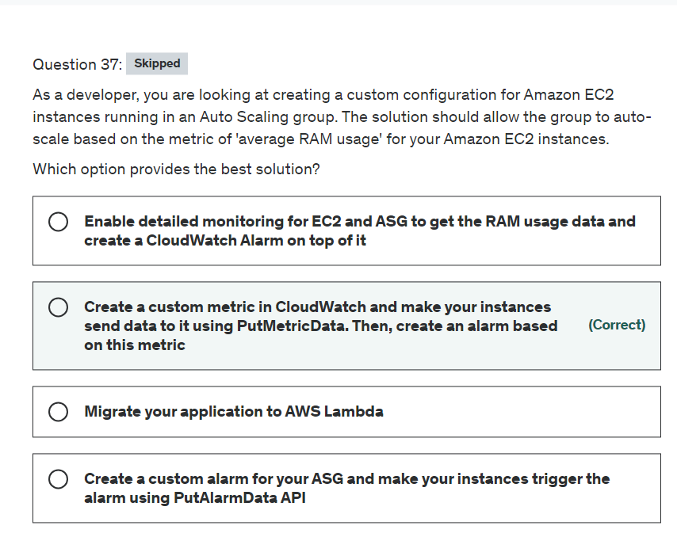

Explanation

Correct option:

**Create a custom metric in CloudWatch and make your instances send data to it using PutMetricData. Then, create an alarm based on this metric** - You can create a custom CloudWatch metric for your EC2 Linux instance statistics by creating a script through the AWS Command Line Interface (AWS CLI). Then, you can monitor that metric by pushing it to CloudWatch.

You can publish your own metrics to CloudWatch using the AWS CLI or an API. Metrics produced by AWS services are standard resolution by default. When you publish a custom metric, you can define it as either standard resolution or high resolution. When you publish a high-resolution metric, CloudWatch stores it with a resolution of 1 second, and you can read and retrieve it with a period of 1 second, 5 seconds, 10 seconds, 30 seconds, or any multiple of 60 seconds.

High-resolution metrics can give you more immediate insight into your application's sub-minute activity. But, every PutMetricData call for a custom metric is charged, so calling PutMetricData more often on a high-resolution metric can lead to higher charges.

Incorrect options:

**Create a custom alarm for your ASG and make your instances trigger the alarm using PutAlarmData API** - This solution will not work, your instances must be aware of each other's RAM utilization status, to know when the average RAM would be too high to trigger the alarm.

**Enable detailed monitoring for EC2 and ASG to get the RAM usage data and create a CloudWatch Alarm on top of it** - By enabling detailed monitoring you define the frequency at which the metric data has to be sent to CloudWatch, from 5 minutes to 1-minute frequency window. But, you still need to create and collect the custom metric you wish to track.

**Migrate your application to AWS Lambda** - This option has been added as a distractor. You cannot use Lambda for the given use-case.

References:

<https://docs.aws.amazon.com/AmazonCloudWatch/latest/monitoring/publishingMetrics.html>

<https://docs.aws.amazon.com/autoscaling/ec2/userguide/as-instance-monitoring.html#CloudWatchAlarm>

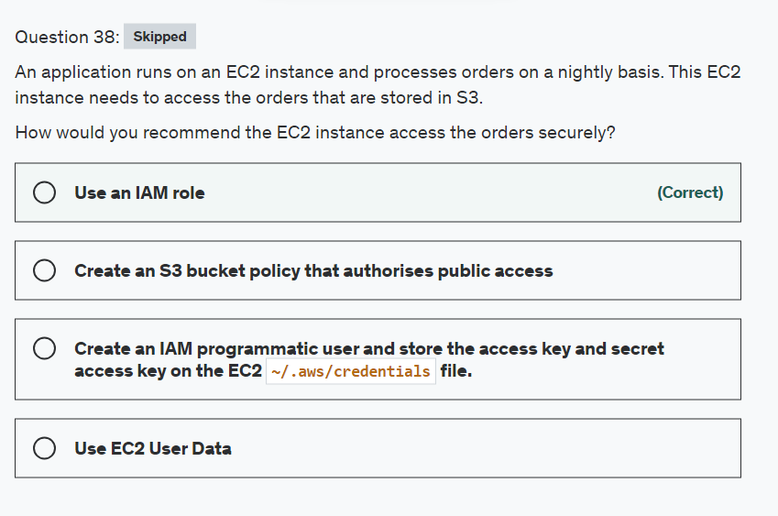

Explanation

Correct option:

**Use an IAM role**

IAM roles have been incorporated so that your applications can securely make API requests from your instances, without requiring you to manage the security credentials that the applications use. Instead of creating and distributing your AWS credentials, you can delegate permission to make API requests using IAM roles.

Amazon EC2 uses an instance profile as a container for an IAM role. When you create an IAM role using the IAM console, the console creates an instance profile automatically and gives it the same name as the role to which it corresponds.

This is the most secure option as the role assigned to EC2 can be used to access S3 without storing any credentials onto the EC2 instance.

Incorrect options:

**Create an IAM programmatic user and store the access key and secret access key on the EC2 ~/.aws/credentials file.** - While this would work, this is highly insecure as anyone gaining access to the EC2 instance would be able to steal the credentials stored in that file.

**Use EC2 User Data** - EC2 User Data is used to run bootstrap scripts at an instance's first launch. This option is not the right fit for the given use-case.

**Create an S3 bucket policy that authorizes public access** - While this would work, it would allow anyone to access your S3 bucket files. So this option is ruled out.

Reference:

<https://docs.aws.amazon.com/AWSEC2/latest/UserGuide/iam-roles-for-amazon-ec2.html>

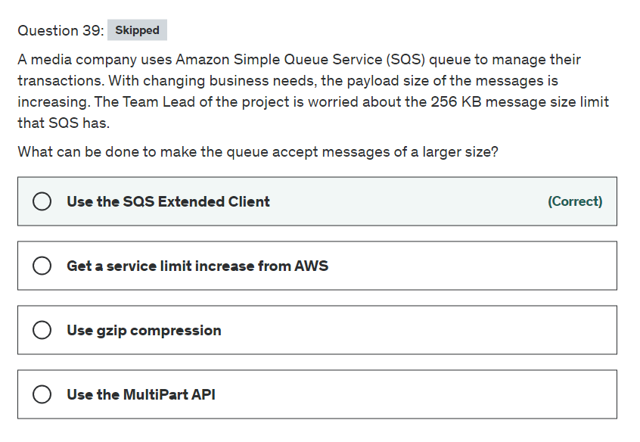

Explanation

Correct option:

**Use the SQS Extended Client** - To manage large Amazon Simple Queue Service (Amazon SQS) messages, you can use Amazon Simple Storage Service (Amazon S3) and the Amazon SQS Extended Client Library for Java. This is especially useful for storing and consuming messages up to 2 GB. Unless your application requires repeatedly creating queues and leaving them inactive or storing large amounts of data in your queues, consider using Amazon S3 for storing your data.

Incorrect options:

**Use the MultiPart API** - This is an incorrect statement. There is no multi-part API for Amazon Simple Queue Service.

**Get a service limit increase from AWS** - While it is possible to get service limits extended for certain AWS services, AWS already offers Extended Client to deal with queues that have larger messages.

**Use gzip compression** - You can compress the messages before sending them to the queue. The messages also need to be encoded after this to cater to SQS message standards. This adds bulk to the messages and will not be an optimal solution for the current scenario.

Reference:

<https://docs.aws.amazon.com/AWSSimpleQueueService/latest/SQSDeveloperGuide/sqs-s3-messages.html>

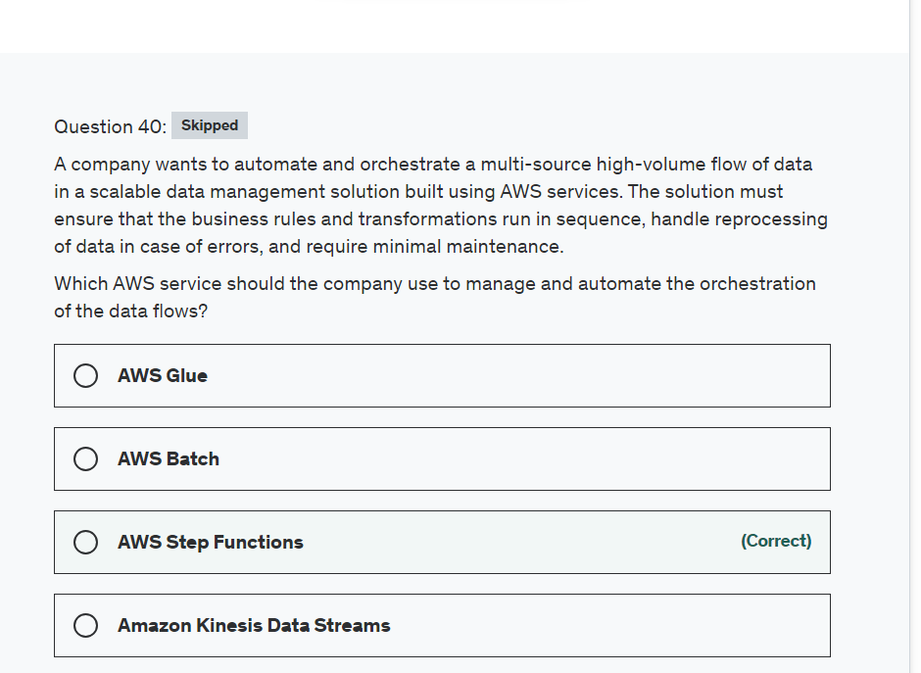

Explanation

Correct option:

**AWS Step Functions**

AWS Step Functions is a visual workflow service that helps developers use AWS services to build distributed applications, automate processes, orchestrate microservices, and create data and machine learning (ML) pipelines.

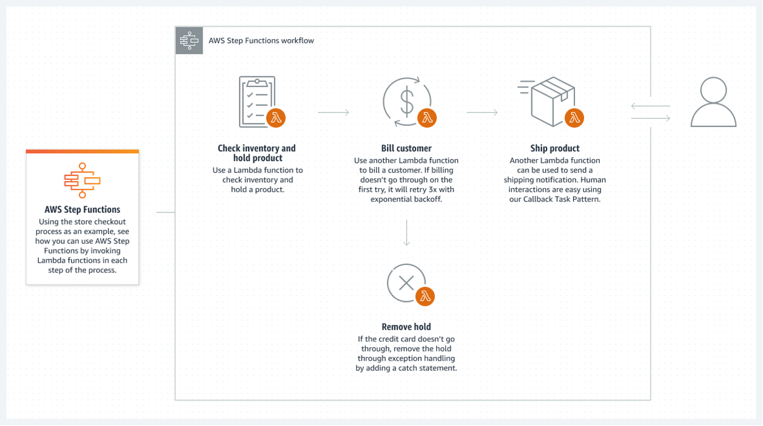 via - <https://aws.amazon.com/step-functions/>

Incorrect options:

**Amazon Kinesis Data Streams** - Amazon Kinesis Data Streams is a serverless streaming data service that makes it easy to capture, process, and store data streams at any scale.

**AWS Glue** - AWS Glue is a serverless data integration service that makes it easier to discover, prepare, move, and integrate data from multiple sources for analytics, machine learning (ML), and application development.

**AWS Batch** - AWS Batch is a set of batch management capabilities that enables developers, scientists, and engineers to easily and efficiently run hundreds of thousands of batch computing jobs on AWS. AWS Batch dynamically provisions the optimal quantity and type of compute resources (e.g., CPU or memory optimized compute resources) based on the volume and specific resource requirements of the batch jobs submitted.

References:

<https://aws.amazon.com/step-functions/>

<https://aws.amazon.com/kinesis/data-streams/>

<https://aws.amazon.com/glue/>

<https://aws.amazon.com/batch/faqs/>

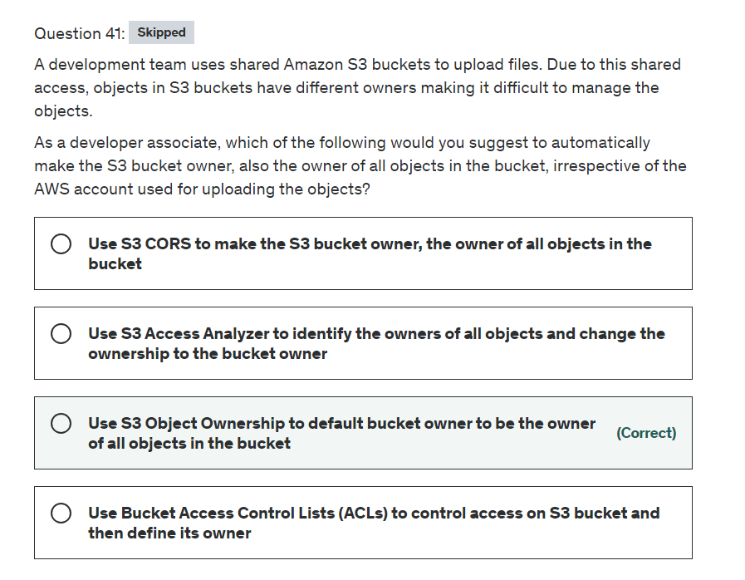

Explanation

Correct option:

**Use S3 Object Ownership to default bucket owner to be the owner of all objects in the bucket**

S3 Object Ownership is an Amazon S3 bucket setting that you can use to control ownership of new objects that are uploaded to your buckets. By default, when other AWS accounts upload objects to your bucket, the objects remain owned by the uploading account. With S3 Object Ownership, any new objects that are written by other accounts with the bucket-owner-full-control canned access control list (ACL) automatically become owned by the bucket owner, who then has full control of the objects.

S3 Object Ownership has two settings: 1. Object writer – The uploading account will own the object. 2. Bucket owner preferred – The bucket owner will own the object if the object is uploaded with the bucket-owner-full-control canned ACL. Without this setting and canned ACL, the object is uploaded and remains owned by the uploading account.

Incorrect options:

**Use S3 CORS to make the S3 bucket owner, the owner of all objects in the bucket** - Cross-origin resource sharing (CORS) defines a way for client web applications that are loaded in one domain to interact with resources in a different domain.

**Use S3 Access Analyzer to identify the owners of all objects and change the ownership to the bucket owner** - Access Analyzer for S3 helps review all buckets that have bucket access control lists (ACLs), bucket policies, or access point policies that grant public or shared access. Access Analyzer for S3 alerts you to buckets that are configured to allow access to anyone on the internet or other AWS accounts, including AWS accounts outside of your organization.

**Use Bucket Access Control Lists (ACLs) to control access on S3 bucket and then define its owner** - Amazon S3 access control lists (ACLs) enable you to manage access to buckets and objects. Each bucket and object has an ACL attached to it as a subresource. A bucket ACLs allow you to control access at bucket level.

None of the above features are useful for the current scenario and hence are incorrect options.

References:

<https://docs.aws.amazon.com/AmazonS3/latest/userguide/about-object-ownership.html>

<https://docs.aws.amazon.com/AmazonS3/latest/userguide/cors.html>

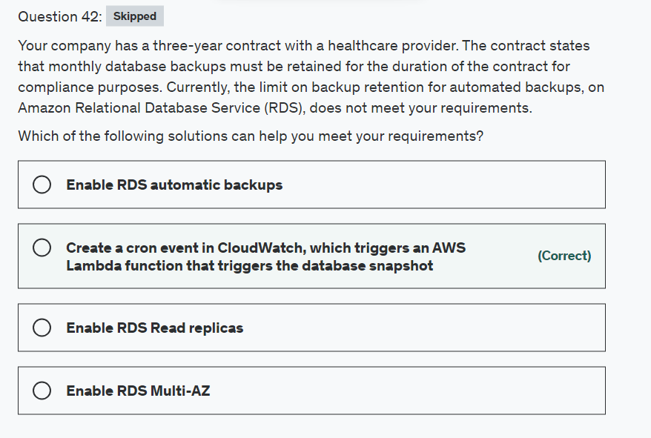

Explanation

Correct option:

**Create a cron event in CloudWatch, which triggers an AWS Lambda function that triggers the database snapshot** - There are multiple ways to run periodic jobs in AWS. CloudWatch Events with Lambda is the simplest of all solutions. To do this, create a CloudWatch Rule and select “Schedule” as the Event Source. You can either use a cron expression or provide a fixed rate (such as every 5 minutes). Next, select “Lambda Function” as the Target. Your Lambda will have the necessary code for snapshot functionality.

Incorrect options:

**Enable RDS automatic backups** - You can enable automatic backups but as of 2020, the retention period is 0 to 35 days.

**Enable RDS Read replicas** - Amazon RDS server's built-in replication functionality to create a special type of DB instance called a read replica from a source DB instance. Updates made to the source DB instance are asynchronously copied to the read replica. Read replicas are useful for heavy read-only data workloads. These are not suitable for the given use-case.

**Enable RDS Multi-AZ** - Multi-AZ allows you to create a highly available application with RDS. It does not directly help in database backups or retention periods.

Reference:

<https://docs.aws.amazon.com/AmazonRDS/latest/UserGuide/USER_CreateSnapshot.html>

<https://docs.aws.amazon.com/lambda/latest/dg/with-scheduled-events.html>

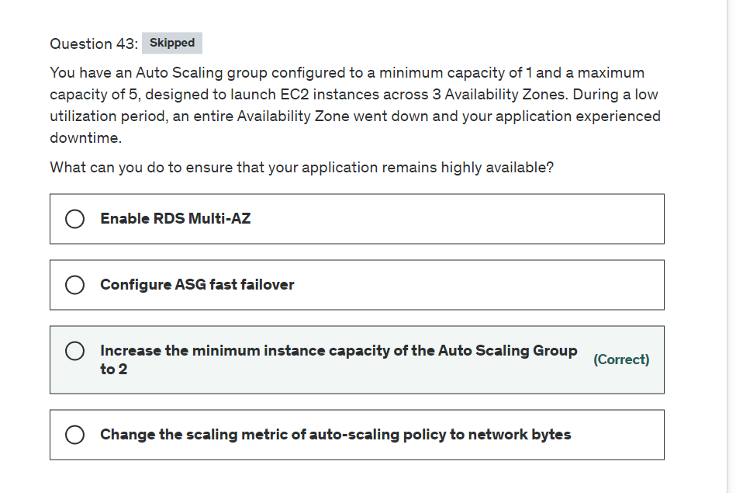

Explanation

Correct option:

**Increase the minimum instance capacity of the Auto Scaling Group to 2** -

You configure the size of your Auto Scaling group by setting the minimum, maximum, and desired capacity. The minimum and maximum capacity are required to create an Auto Scaling group, while the desired capacity is optional. If you do not define your desired capacity upfront, it defaults to your minimum capacity.

Since a minimum capacity of 1 was defined, an instance was launched in only one AZ. This AZ went down, taking the application with it. If the minimum capacity is set to 2. As per Auto Scale AZ configuration, it would have launched 2 instances- one in each AZ, making the architecture disaster-proof and hence highly available.

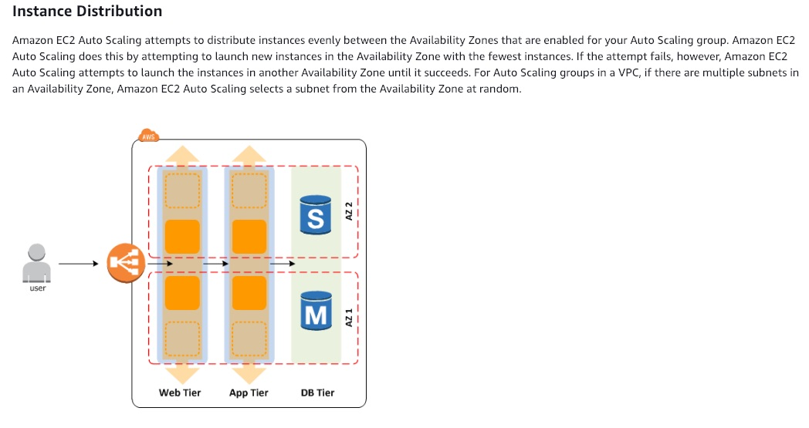 via - <https://docs.aws.amazon.com/autoscaling/ec2/userguide/auto-scaling-benefits.html>

Incorrect options:

**Change the scaling metric of auto-scaling policy to network bytes** - With target tracking scaling policies, you select a scaling metric and set a target value. You can use predefined customized metrics. Setting the metric to network bytes will not help in this context since the instances have to be spread across different AZs for high availability. The optimized way of doing it, is by defining minimum and maximum instance capacities, as discussed above.

**Configure ASG fast failover** - This is a made-up option, given as a distractor.

**Enable RDS Multi-AZ** - This configuration will make your database highly available. But for the current scenario, you will need to have more than 1 instance in separate availability zones to keep the application highly available.

References:

<https://docs.aws.amazon.com/autoscaling/ec2/userguide/asg-capacity-limits.html>

<https://docs.aws.amazon.com/autoscaling/ec2/userguide/as-maintain-instance-levels.html>

<https://docs.aws.amazon.com/autoscaling/ec2/userguide/as-scaling-target-tracking.html>

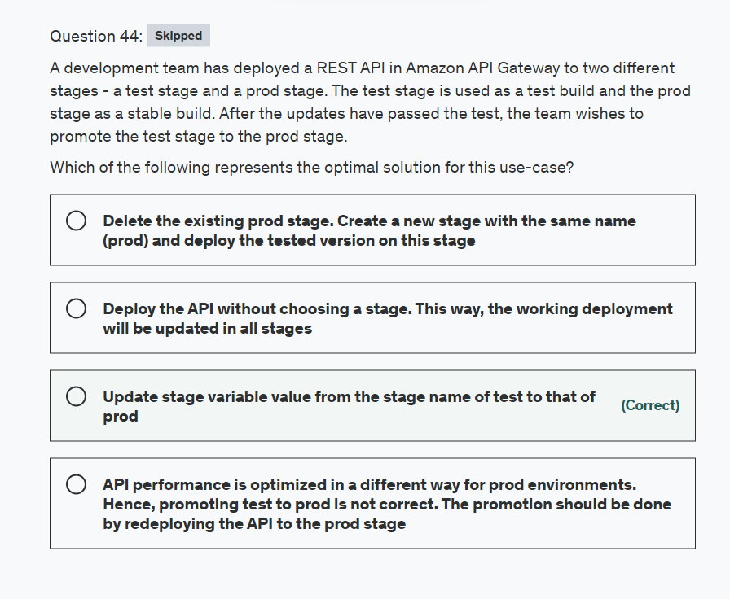

Explanation

Correct option:

**Update stage variable value from the stage name of test to that of prod**

After creating your API, you must deploy it to make it callable by your users. To deploy an API, you create an API deployment and associate it with a stage. A stage is a logical reference to a lifecycle state of your API (for example, dev, prod, beta, v2). API stages are identified by the API ID and stage name. They're included in the URL that you use to invoke the API. Each stage is a named reference to a deployment of the API and is made available for client applications to call.

Stages enable robust version control of your API. In our current use-case, after the updates pass the test, you can promote the test stage to the prod stage. The promotion can be done by redeploying the API to the prod stage or updating a stage variable value from the stage name of test to that of prod.

Incorrect options:

**Deploy the API without choosing a stage. This way, the working deployment will be updated in all stages** - An API can only be deployed to a stage. Hence, it is not possible to deploy an API without choosing a stage.

Delete the existing prod stage. Create a new stage with the same name (prod) and deploy the tested version on this stage* - This is possible, but not an optimal way of deploying a change. Also, as prod refers to real production system, this option will result in downtime.

**API performance is optimized in a different way for prod environments. Hence, promoting test to prod is not correct. The promotion should be done by redeploying the API to the prod stage** - For each stage, you can optimize API performance by adjusting the default account-level request throttling limits and enabling API caching. And these settings can be changed/updated at any time.

Reference:

<https://docs.aws.amazon.com/apigateway/latest/developerguide/how-to-deploy-api.html>

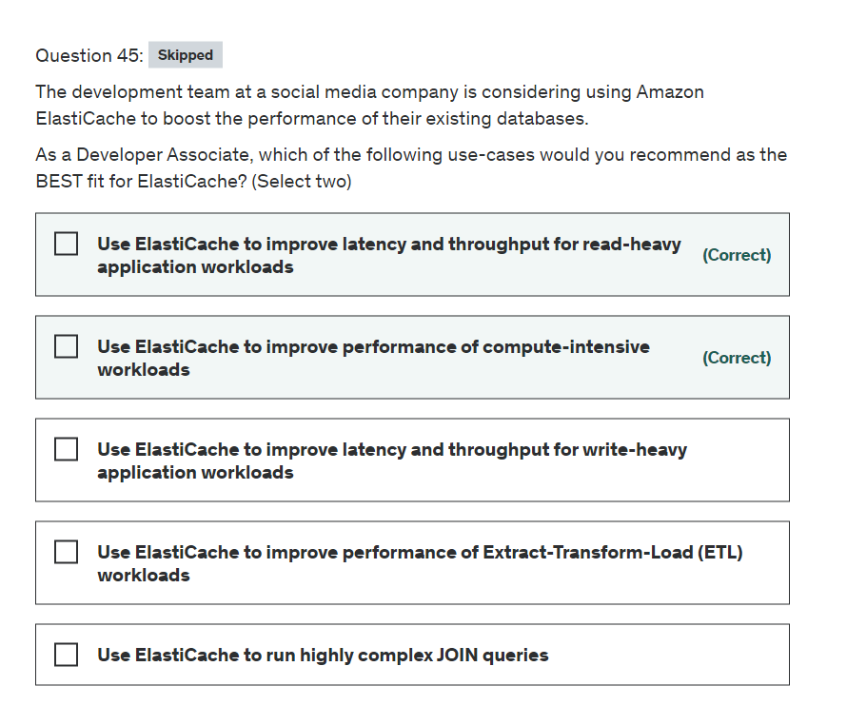

Explanation

Correct option:

**Use ElastiCache to improve latency and throughput for read-heavy application workloads**

**Use ElastiCache to improve performance of compute-intensive workloads**

Amazon ElastiCache allows you to run in-memory data stores in the AWS cloud. Amazon ElastiCache is a popular choice for real-time use cases like Caching, Session Stores, Gaming, Geospatial Services, Real-Time Analytics, and Queuing.

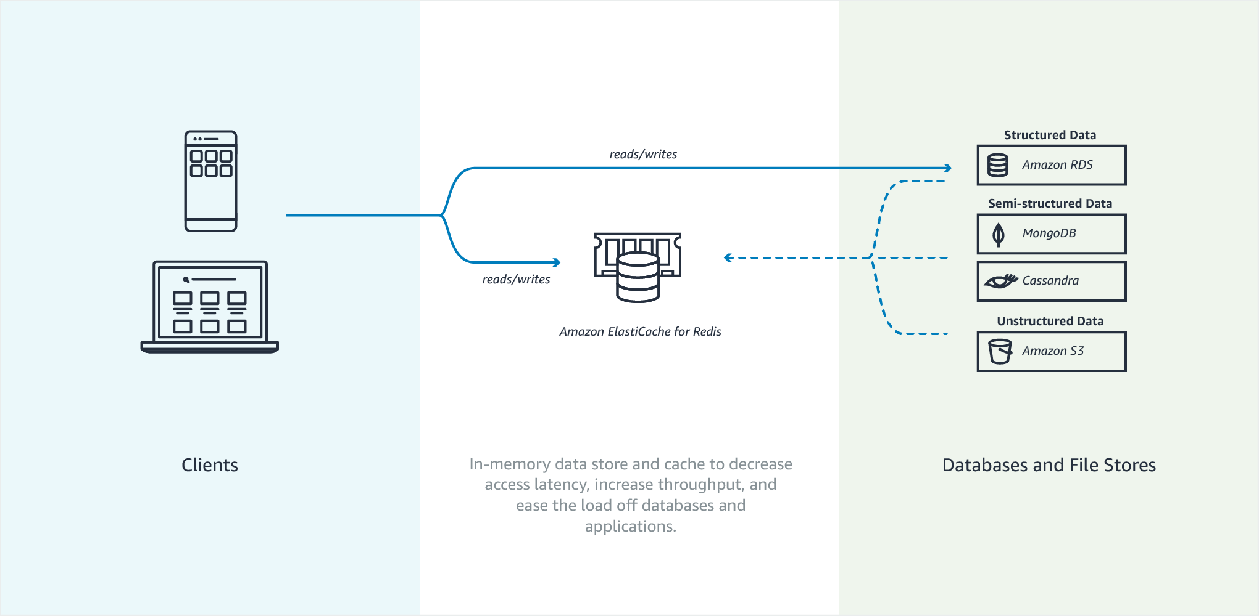 via - <https://docs.aws.amazon.com/AmazonElastiCache/latest/mem-ug/elasticache-use-cases.html>

Amazon ElastiCache can be used to significantly improve latency and throughput for many read-heavy application workloads (such as social networking, gaming, media sharing, and Q&A portals) or compute-intensive workloads (such as a recommendation engine) by allowing you to store the objects that are often read in the cache.

Overview of Amazon ElastiCache features: 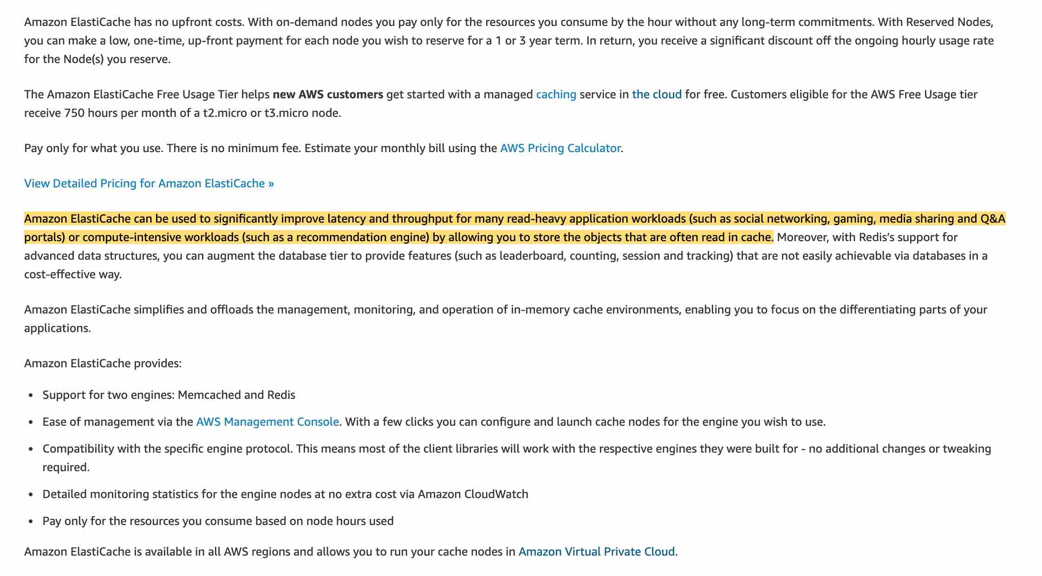 via - <https://aws.amazon.com/elasticache/features/>

Incorrect options:

**Use ElastiCache to improve latency and throughput for write-heavy application workloads** - As mentioned earlier in the explanation, Amazon ElastiCache can be used to significantly improve latency and throughput for many read-heavy application workloads. Caching is not a good fit for write-heavy applications as the cache goes stale at a very fast rate.

**Use ElastiCache to improve performance of Extract-Transform-Load (ETL) workloads** - ETL workloads involve reading and transforming high volume data which is not a good fit for caching. You should use AWS Glue or Amazon EMR to facilitate ETL workloads.

**Use ElastiCache to run highly complex JOIN queries** - Complex JSON queries can be run on relational databases such as RDS or Aurora. ElastiCache is not a good fit for this use-case.

References:

<https://docs.aws.amazon.com/AmazonElastiCache/latest/mem-ug/elasticache-use-cases.html>

<https://aws.amazon.com/elasticache/features/>

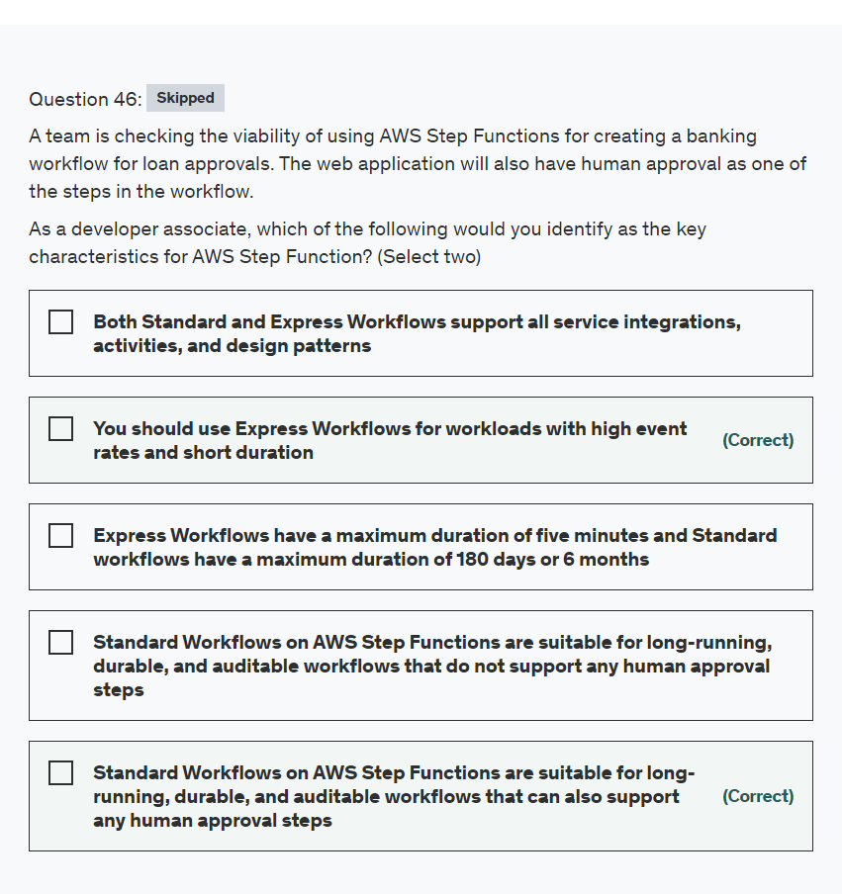

Explanation

Correct options:

**Standard Workflows on AWS Step Functions are suitable for long-running, durable, and auditable workflows that can also support any human approval steps** - Standard Workflows on AWS Step Functions are more suitable for long-running, durable, and auditable workflows where repeating workflow steps is expensive (e.g., restarting a long-running media transcode) or harmful (e.g., charging a credit card twice). Example workloads include training and deploying machine learning models, report generation, billing, credit card processing, and ordering and fulfillment processes. Step functions also support any human approval steps.

You should use Express Workflows for workloads with high event rates and short duration* - You should use Express Workflows for workloads with high event rates and short durations. Express Workflows support event rates of more than 100,000 per second.

Incorrect options:

**Standard Workflows on AWS Step Functions are suitable for long-running, durable, and auditable workflows that do not support any human approval steps** - As Step functions support any human approval steps, so this option is incorrect.

**Express Workflows have a maximum duration of five minutes and Standard workflows have a maximum duration of 180 days or 6 months** - Express Workflows have a maximum duration of five minutes and Standard workflows have a maximum duration of one year.

**Both Standard and Express Workflows support all service integrations, activities, and design patterns** - Standard Workflows support all service integrations, activities, and design patterns. Express Workflows do not support activities, job-run (.sync), and Callback patterns.

Reference:

<https://aws.amazon.com/step-functions/features/>

<https://aws.amazon.com/blogs/compute/implementing-serverless-manual-approval-steps-in-aws-step-functions-and-amazon-api-gateway/>

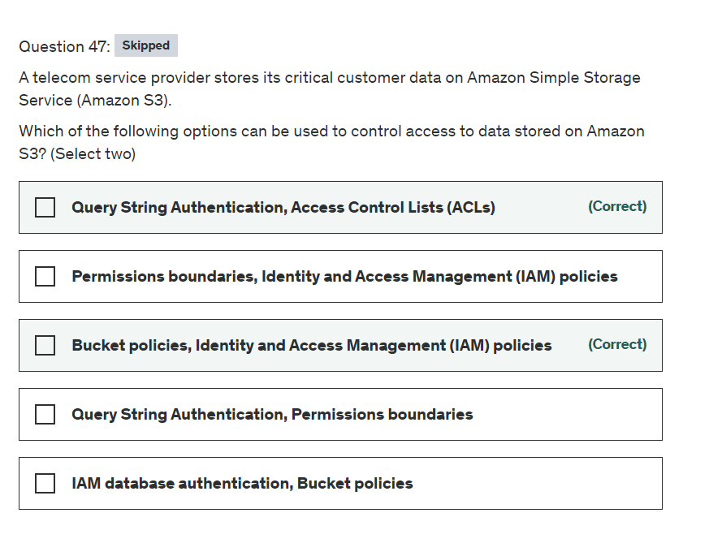

Explanation

Correct options:

**Bucket policies, Identity and Access Management (IAM) policies**

**Query String Authentication, Access Control Lists (ACLs)**

Customers may use four mechanisms for controlling access to Amazon S3 resources: Identity and Access Management (IAM) policies, bucket policies, Access Control Lists (ACLs), and Query String Authentication.

IAM enables organizations with multiple employees to create and manage multiple users under a single AWS account. With IAM policies, customers can grant IAM users fine-grained control to their Amazon S3 bucket or objects while also retaining full control over everything the users do.

With bucket policies, customers can define rules which apply broadly across all requests to their Amazon S3 resources, such as granting write privileges to a subset of Amazon S3 resources. Customers can also restrict access based on an aspect of the request, such as HTTP referrer and IP address.

With ACLs, customers can grant specific permissions (i.e. READ, WRITE, FULL_CONTROL) to specific users for an individual bucket or object.

With Query String Authentication, customers can create a URL to an Amazon S3 object which is only valid for a limited time. Using query parameters to authenticate requests is useful when you want to express a request entirely in a URL. This method is also referred as presigning a URL.

Incorrect options:

**Permissions boundaries, Identity and Access Management (IAM) policies**

**Query String Authentication, Permissions boundaries**

**IAM database authentication, Bucket policies**

Permissions boundary - A Permissions boundary is an advanced feature for using a managed policy to set the maximum permissions that an identity-based policy can grant to an IAM entity. An entity's permissions boundary allows it to perform only the actions that are allowed by both its identity-based policies and its permissions boundaries. When you use a policy to set the permissions boundary for a user, it limits the user's permissions but does not provide permissions on its own.

IAM database authentication - IAM database authentication works with MySQL and PostgreSQL. With this authentication method, you don't need to use a password when you connect to a DB instance. Instead, you use an authentication token. It is a database authentication technique and cannot be used to authenticate for S3.

Therefore, all three options are incorrect.

References:

<https://docs.aws.amazon.com/AmazonS3/latest/userguide/access-control-overview.html>

<https://docs.aws.amazon.com/AmazonRDS/latest/UserGuide/UsingWithRDS.IAMDBAuth.html>

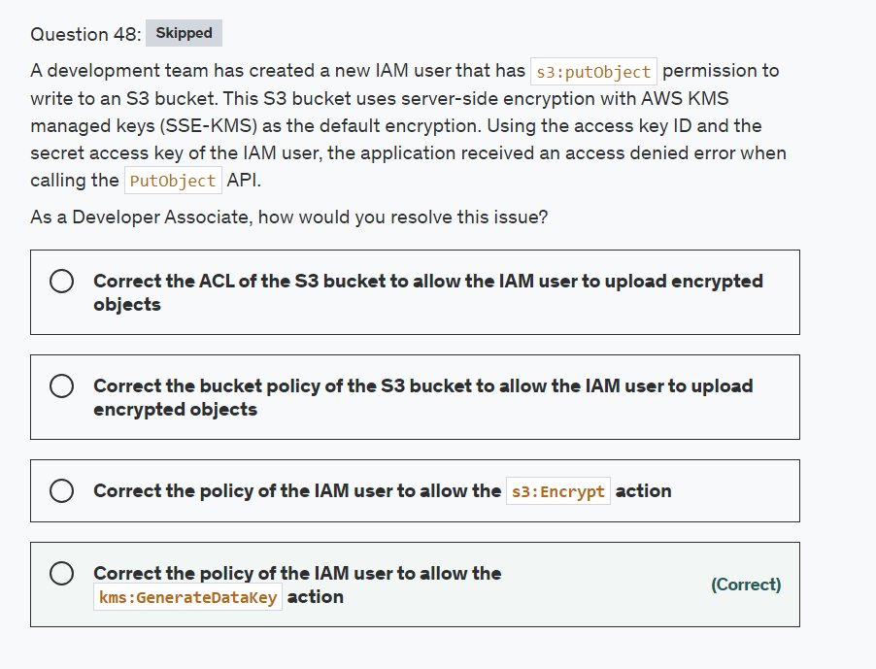

Explanation

Correct option:

**Correct the policy of the IAM user to allow the kms:GenerateDataKey action** - You can protect data at rest in Amazon S3 by using three different modes of server-side encryption: SSE-S3, SSE-C, or SSE-KMS. SSE-KMS requires that AWS manage the data key but you manage the customer master key (CMK) in AWS KMS. You can choose a customer managed CMK or the AWS managed CMK for Amazon S3 in your account. If you choose to encrypt your data using the standard features, AWS KMS and Amazon S3 perform the following actions:

Amazon S3 requests a plaintext data key and a copy of the key encrypted under the specified CMK.

AWS KMS generates a data key, encrypts it under the CMK, and sends both the plaintext data key and the encrypted data key to Amazon S3.

Amazon S3 encrypts the data using the data key and removes the plaintext key from memory as soon as possible after use.

Amazon S3 stores the encrypted data key as metadata with the encrypted data.

The error message indicates that your IAM user or role needs permission for the kms:GenerateDataKey action. This permission is required for buckets that use default encryption with a custom AWS KMS key.

In the JSON policy documents, look for policies related to AWS KMS access. Review statements with "Effect": "Allow" to check if the user or role has permissions for the kms:GenerateDataKey action on the bucket's AWS KMS key. If this permission is missing, then add the permission to the appropriate policy.

In the JSON policy documents, look for statements with "Effect": "Deny". Then, confirm that those statements don't deny the s3:PutObject action on the bucket. The statements must also not deny the IAM user or role access to the kms:GenerateDataKey action on the key used to encrypt the bucket. Additionally, make sure the necessary KMS and S3 permissions are not restricted using a VPC endpoint policy, service control policy, permissions boundary, or session policy.

Incorrect options:

**Correct the policy of the IAM user to allow the s3:Encrypt action** - This is an invalid action given only as a distractor.

**Correct the bucket policy of the S3 bucket to allow the IAM user to upload encrypted objects** - The user already has access to the bucket. What the user lacks is access to generate a KMS key, which is mandatory when a bucket is enabled for default encryption.

**Correct the ACL of the S3 bucket to allow the IAM user to upload encrypted objects** - Amazon S3 access control lists (ACLs) enable you to manage access to buckets and objects. Each bucket and object has an ACL attached to it as a subresource. It defines which AWS accounts or groups are granted access and the type of access. ACL is another way of giving access to S3 bucket objects. Permissions to use KMS keys will still be needed.

References:

<https://aws.amazon.com/premiumsupport/knowledge-center/s3-access-denied-error-kms/>

<https://docs.aws.amazon.com/kms/latest/developerguide/services-s3.html>

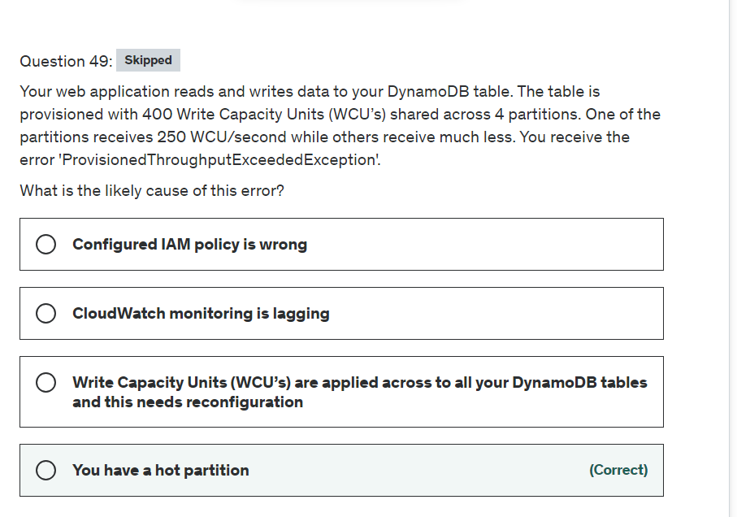

Explanation

Correct option:

**You have a hot partition**

It's not always possible to distribute read and write activity evenly. When data access is imbalanced, a "hot" partition can receive a higher volume of read and write traffic compared to other partitions. To better accommodate uneven access patterns, DynamoDB adaptive capacity enables your application to continue reading and writing to hot partitions without being throttled, provided that traffic does not exceed your table’s total provisioned capacity or the partition maximum capacity.

ProvisionedThroughputExceededException explained: 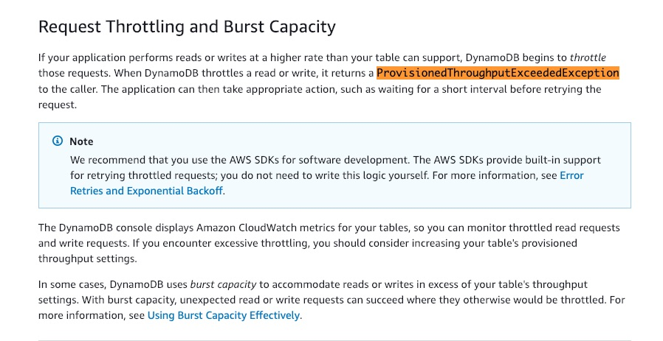 via - <https://docs.aws.amazon.com/amazondynamodb/latest/developerguide/ProvisionedThroughput.html>

Hot partition explained: 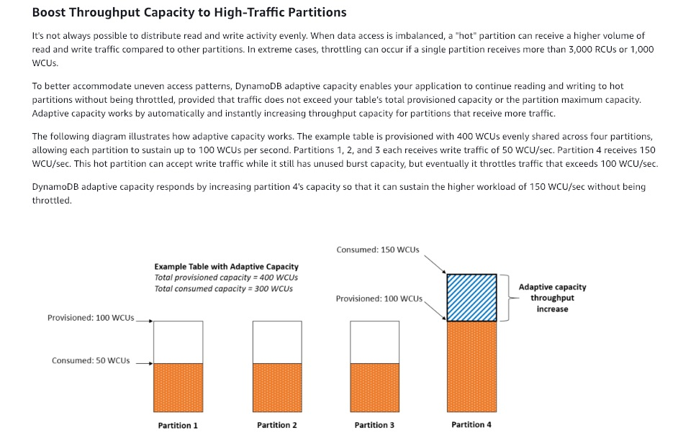 via - <https://docs.aws.amazon.com/amazondynamodb/latest/developerguide/bp-partition-key-design.html>

Incorrect options:

**CloudWatch monitoring is lagging** - The error is specific to DynamoDB itself and not to any connected service. CloudWatch is a fully managed service from AWS and does not result in throttling.

**Configured IAM policy is wrong** - The error is not associated with authorization but to exceeding something pre-configured value. So, it's clearly not a permissions issue.

**Write-capacity units (WCU’s) are applied across to all your DynamoDB tables and this needs reconfiguration** - This statement is incorrect. Read Capacity Units and Write Capacity Units are specific to one table.

Reference:

<https://docs.aws.amazon.com/amazondynamodb/latest/developerguide/ProvisionedThroughput.html>

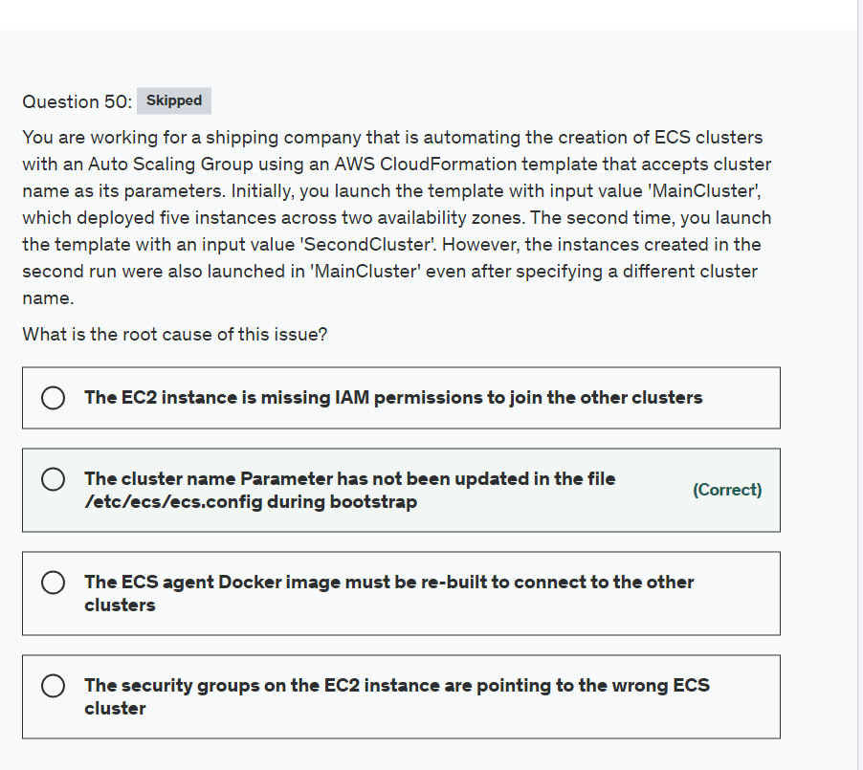

Explanation

Correct option:

**The cluster name Parameter has not been updated in the file /etc/ecs/ecs.config during bootstrap** - In the ecs.config file you have to configure the parameter ECS_CLUSTER='your_cluster_name' to register the container instance with a cluster named 'your_cluster_name'.

Sample config for ECS Container Agent: 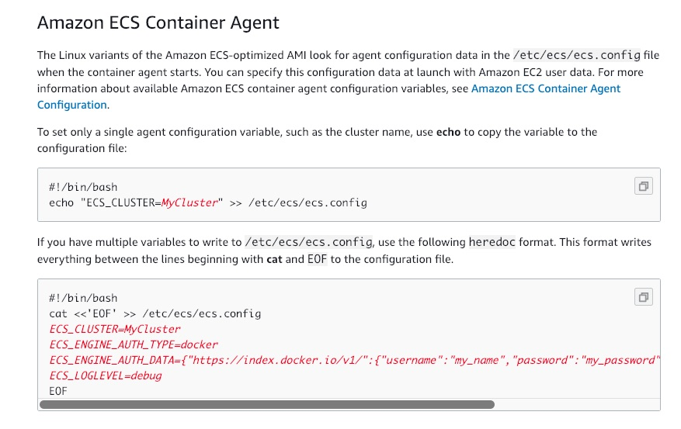 via - <https://docs.aws.amazon.com/AmazonECS/latest/developerguide/bootstrap_container_instance.html>

Incorrect options:

**The EC2 instance is missing IAM permissions to join the other clusters** - EC2 instances are getting registered to the first cluster, so permissions are not an issue here and hence this statement is an incorrect choice for the current use case.

**The ECS agent Docker image must be re-built to connect to the other clusters** - Since the first set of instances got created from the template without any issues, there is no issue with the ECS agent here.

**The security groups on the EC2 instance are pointing to the wrong ECS cluster** - Security groups govern the rules about the incoming network traffic to your ECS containers. The issue here is not about user access and hence is a wrong choice for the current use case.

References:

<https://docs.aws.amazon.com/AmazonECS/latest/developerguide/bootstrap_container_instance.html>

<https://docs.aws.amazon.com/AmazonECS/latest/developerguide/launch_container_instance.html>

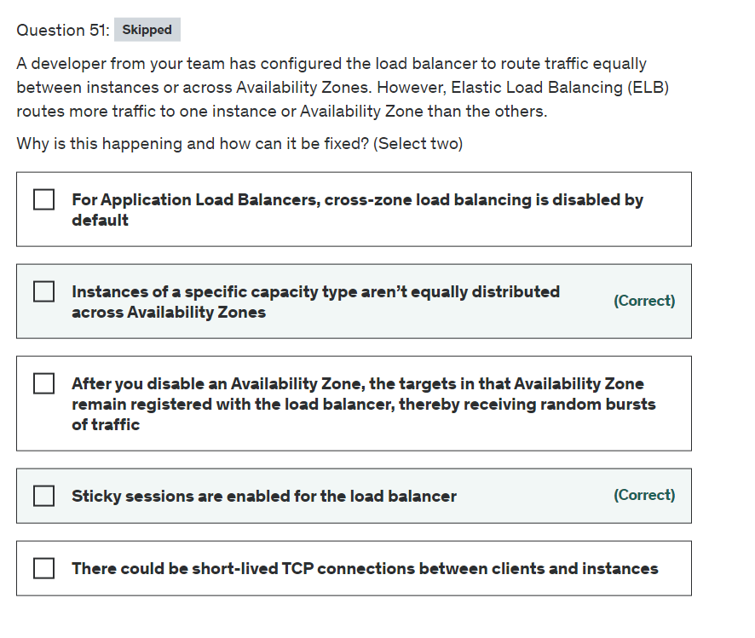

Explanation

Correct option:

**Sticky sessions are enabled for the load balancer** - This can be the reason for potential unequal traffic routing by the load balancer. Sticky sessions are a mechanism to route requests to the same target in a target group. This is useful for servers that maintain state information in order to provide a continuous experience to clients. To use sticky sessions, the clients must support cookies.

When a load balancer first receives a request from a client, it routes the request to a target, generates a cookie named AWSALB that encodes information about the selected target, encrypts the cookie, and includes the cookie in the response to the client. The client should include the cookie that it receives in subsequent requests to the load balancer. When the load balancer receives a request from a client that contains the cookie, if sticky sessions are enabled for the target group and the request goes to the same target group, the load balancer detects the cookie and routes the request to the same target.

If you use duration-based session stickiness, configure an appropriate cookie expiration time for your specific use case. If you set session stickiness from individual applications, use session cookies instead of persistent cookies where possible.

**Instances of a specific capacity type aren’t equally distributed across Availability Zones** - A Classic Load Balancer with HTTP or HTTPS listeners might route more traffic to higher-capacity instance types. This distribution aims to prevent lower-capacity instance types from having too many outstanding requests. It’s a best practice to use similar instance types and configurations to reduce the likelihood of capacity gaps and traffic imbalances.

A traffic imbalance might also occur if you have instances of similar capacities running on different Amazon Machine Images (AMIs). In this scenario, the imbalance of the traffic in favor of higher-capacity instance types is desirable.

Incorrect options:

**There could be short-lived TCP connections between clients and instances** - This is an incorrect statement. Long-lived TCP connections between clients and instances can potentially lead to unequal distribution of traffic by the load balancer. Long-lived TCP connections between clients and instances cause uneven traffic load distribution by design. As a result, new instances take longer to reach connection equilibrium. Be sure to check your metrics for long-lived TCP connections that might be causing routing issues in the load balancer.

**For Application Load Balancers, cross-zone load balancing is disabled by default** - This is an incorrect statement. With Application Load Balancers, cross-zone load balancing is always enabled.

**After you disable an Availability Zone, the targets in that Availability Zone remain registered with the load balancer, thereby receiving random bursts of traffic** - This is an incorrect statement. After you disable an Availability Zone, the targets in that Availability Zone remain registered with the load balancer. However, even though they remain registered, the load balancer does not route traffic to them.

References:

<https://docs.aws.amazon.com/elasticloadbalancing/latest/application/load-balancer-target-groups.html#sticky-sessions>

<https://aws.amazon.com/premiumsupport/knowledge-center/elb-fix-unequal-traffic-routing/>

<https://docs.aws.amazon.com/elasticloadbalancing/latest/userguide/how-elastic-load-balancing-works.html#availability-zones>

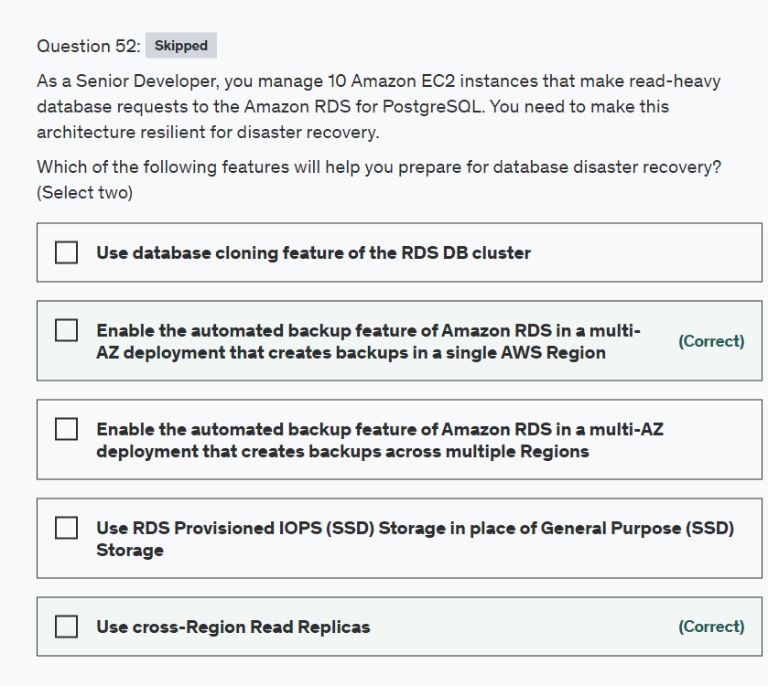

Explanation

Correct option:

**Use cross-Region Read Replicas**

In addition to using Read Replicas to reduce the load on your source DB instance, you can also use Read Replicas to implement a DR solution for your production DB environment. If the source DB instance fails, you can promote your Read Replica to a standalone source server. Read Replicas can also be created in a different Region than the source database. Using a cross-Region Read Replica can help ensure that you get back up and running if you experience a regional availability issue.

**Enable the automated backup feature of Amazon RDS in a multi-AZ deployment that creates backups in a single AWS Region**

Amazon RDS provides high availability and failover support for DB instances using Multi-AZ deployments. Amazon RDS uses several different technologies to provide failover support. Multi-AZ deployments for MariaDB, MySQL, Oracle, and PostgreSQL DB instances use Amazon's failover technology.

The automated backup feature of Amazon RDS enables point-in-time recovery for your database instance. Amazon RDS will backup your database and transaction logs and store both for a user-specified retention period. If it’s a Multi-AZ configuration, backups occur on the standby to reduce I/O impact on the primary. Automated backups are limited to a single AWS Region while manual snapshots and Read Replicas are supported across multiple Regions.

Incorrect options:

**Enable the automated backup feature of Amazon RDS in a multi-AZ deployment that creates backups across multiple Regions** - This is an incorrect statement. Automated backups are limited to a single AWS Region while manual snapshots and Read Replicas are supported across multiple Regions.

**Use RDS Provisioned IOPS (SSD) Storage in place of General Purpose (SSD) Storage** - Amazon RDS Provisioned IOPS Storage is an SSD-backed storage option designed to deliver fast, predictable, and consistent I/O performance. This storage type enhances the performance of the RDS database, but this isn't a disaster recovery option.

**Use database cloning feature of the RDS DB cluster** - This option has been added as a distractor. Database cloning is only available for Aurora and not for RDS.

References:

<https://aws.amazon.com/rds/features/>

<https://aws.amazon.com/blogs/database/implementing-a-disaster-recovery-strategy-with-amazon-rds/>

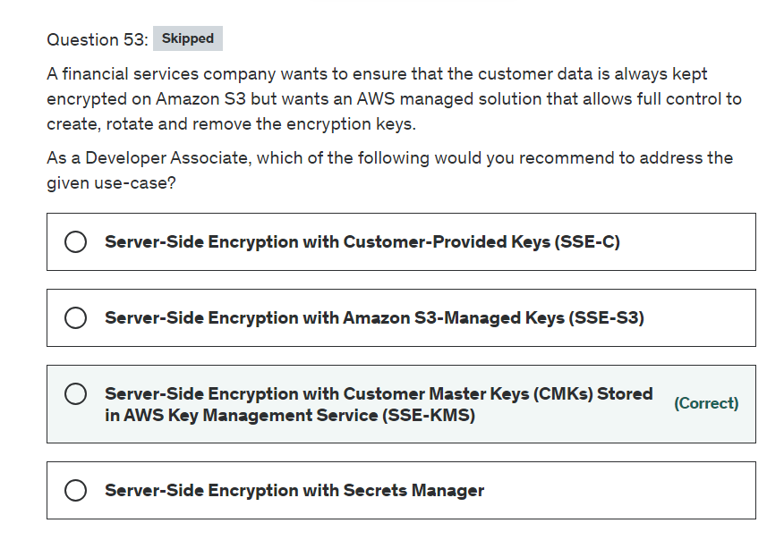

Explanation

Correct option:

**Server-Side Encryption with Customer Master Keys (CMKs) Stored in AWS Key Management Service (SSE-KMS)**

You have the following options for protecting data at rest in Amazon S3:

Server-Side Encryption – Request Amazon S3 to encrypt your object before saving it on disks in its data centers and then decrypt it when you download the objects.

Client-Side Encryption – Encrypt data client-side and upload the encrypted data to Amazon S3. In this case, you manage the encryption process, the encryption keys, and related tools.

When you use server-side encryption with AWS KMS (SSE-KMS), you can use the default AWS managed CMK, or you can specify a customer-managed CMK that you have already created.

Creating your own customer-managed CMK gives you more flexibility and control over the CMK. For example, you can create, rotate, and disable customer-managed CMKs. You can also define access controls and audit the customer-managed CMKs that you use to protect your data.

Please see this note for more details: 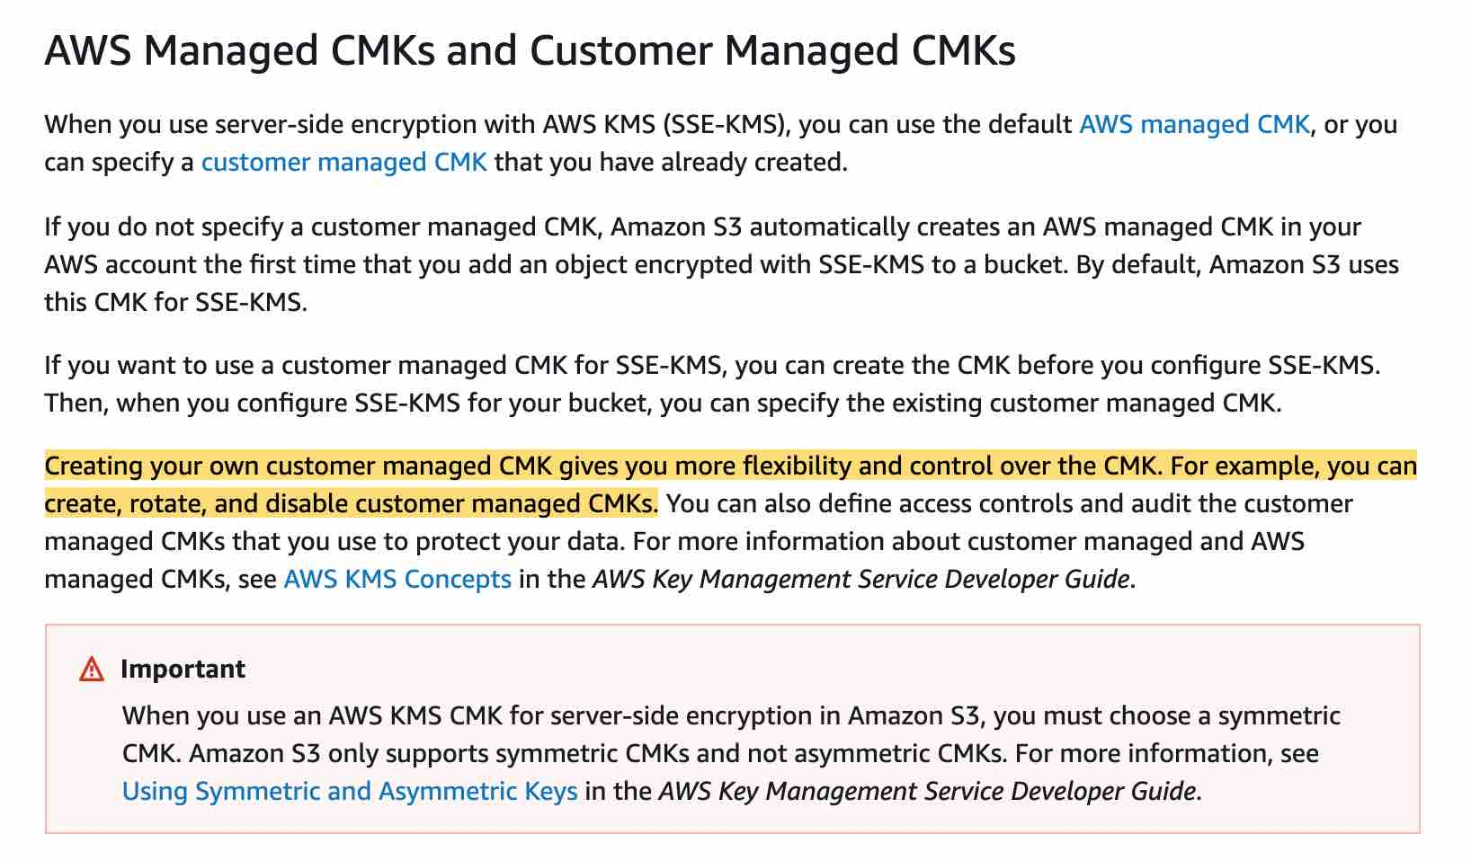 via - <https://docs.aws.amazon.com/AmazonS3/latest/dev/UsingKMSEncryption.html>

Incorrect options:

**Server-Side Encryption with Amazon S3-Managed Keys (SSE-S3)** - When you use Server-Side Encryption with Amazon S3-Managed Keys (SSE-S3), each object is encrypted with a unique key. As an additional safeguard, AWS encrypts the key itself with a master key that it regularly rotates. So this option is incorrect for the given use-case.

**Server-Side Encryption with Customer-Provided Keys (SSE-C)** - With Server-Side Encryption with Customer-Provided Keys (SSE-C), you will need to create the encryption keys as well as manage the corresponding process to rotate and remove the encryption keys. Amazon S3 manages the data encryption, as it writes to disks, as well as the data decryption when you access your objects. So this option is incorrect for the given use-case.

**Server-Side Encryption with Secrets Manager** - AWS Secrets Manager helps you protect secrets needed to access your applications, services, and IT resources. The service enables you to easily rotate, manage, and retrieve database credentials, API keys, and other secrets throughout their lifecycle. You cannot combine Server-Side Encryption with Secrets Manager to create, rotate, or disable the encryption keys.

Reference:

<https://docs.aws.amazon.com/AmazonS3/latest/dev/UsingKMSEncryption.html>

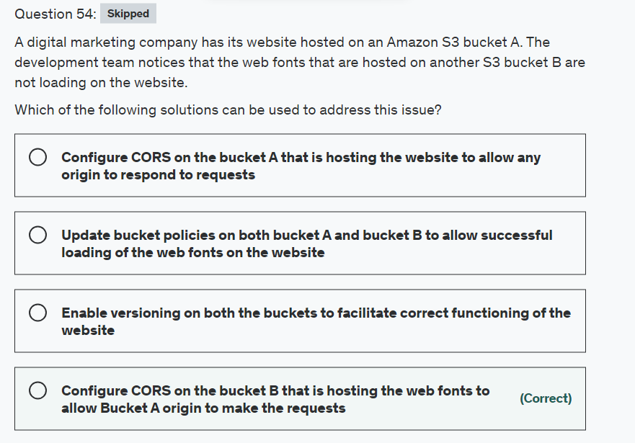

Explanation

Correct option:

**Configure CORS on the bucket B that is hosting the web fonts to allow Bucket A origin to make the requests**

Cross-origin resource sharing (CORS) defines a way for client web applications that are loaded in one domain to interact with resources in a different domain.

To configure your bucket to allow cross-origin requests, you create a CORS configuration, which is an XML document with rules that identify the origins that you will allow to access your bucket, the operations (HTTP methods) that will support for each origin, and other operation-specific information.

For the given use-case, you would create a <CORSRule> in <CORSConfiguration> for bucket B to allow access from the S3 website origin hosted on bucket A.

Please see this note for more details: 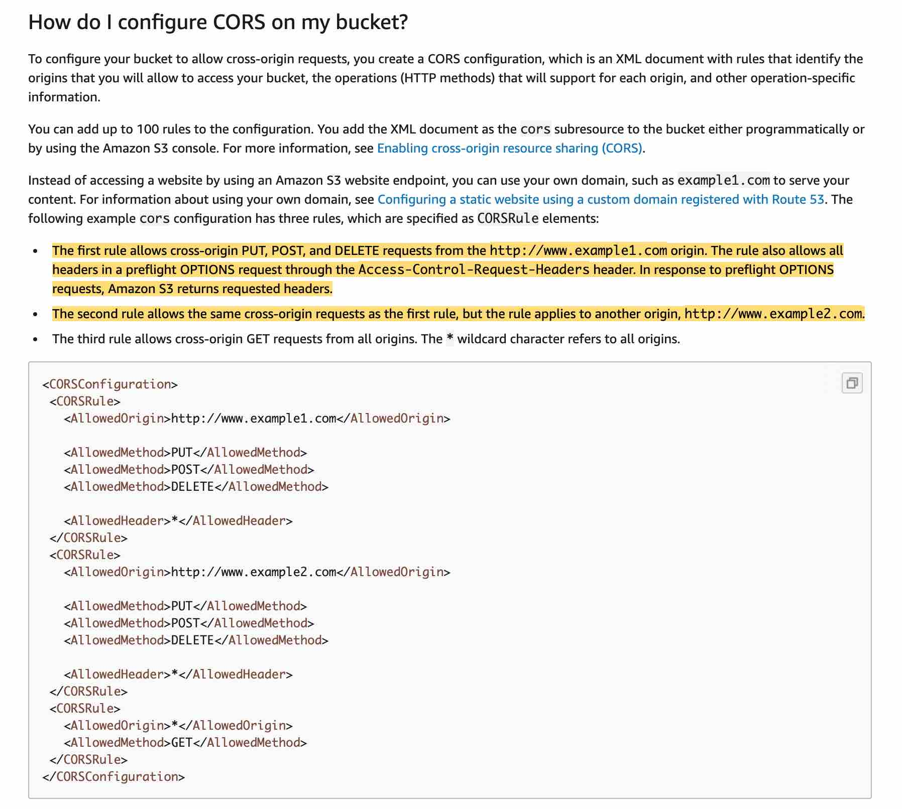 via - <https://docs.aws.amazon.com/AmazonS3/latest/dev/cors.html>

Incorrect options:

**Enable versioning on both the buckets to facilitate the correct functioning of the website** - This option is a distractor and versioning will not help to address the web fonts loading issue on the website.

**Update bucket policies on both bucket A and bucket B to allow successful loading of the web fonts on the website** - It's not the bucket policies but the CORS configuration on bucket B that needs to be updated to allow web fonts to be loaded on the website. Updating bucket policies will not help to address the web fonts loading issue on the website.

**Configure CORS on the bucket A that is hosting the website to allow any origin to respond to requests** - The CORS configuration needs to be updated on bucket B to allow web fonts to be loaded on the website hosted on bucket A. So this option in incorrect.

Reference:

<https://docs.aws.amazon.com/AmazonS3/latest/dev/cors.html>

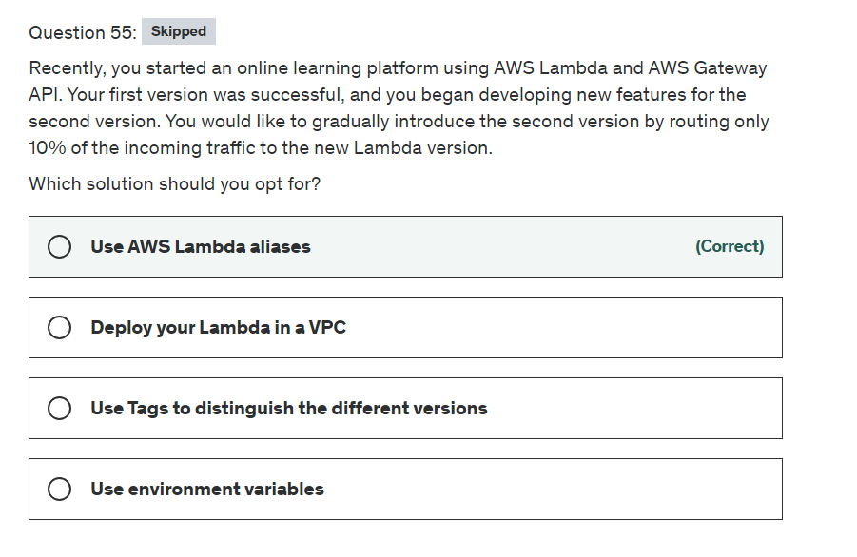

Explanation

Correct option:

**Use AWS Lambda aliases** - A Lambda alias is like a pointer to a specific Lambda function version. You can create one or more aliases for your AWS Lambda function. Users can access the function version using the alias ARN. An alias can only point to a function version, not to another alias. You can update an alias to point to a new version of the function. Event sources such as Amazon S3 invoke your Lambda function. These event sources maintain a mapping that identifies the function to invoke when events occur. If you specify a Lambda function alias in the mapping configuration, you don't need to update the mapping when the function version changes. This is the right choice for the current requirement.

Incorrect options:

**Use Tags to distinguish the different versions** - You can tag Lambda functions to organize them by owner, project or department. Tags are freeform key-value pairs that are supported across AWS services for use in filtering resources and adding detail to billing reports. This does not address the given use-case.

**Use environment variables** - You can use environment variables to store secrets securely and adjust your function's behavior without updating code. An environment variable is a pair of strings that are stored in a function's version-specific configuration. The Lambda runtime makes environment variables available to your code and sets additional environment variables that contain information about the function and invocation request. For example, you can use environment variables to point to test, development or production databases by passing it as an environment variable during runtime. This option does not address the given use-case.

**Deploy your Lambda in a VPC** - Amazon Virtual Private Cloud (Amazon VPC) enables you to launch AWS resources into a virtual network that you've defined. This adds another layer of security for your entire architecture. Not the right choice for the given scenario.

References:

<https://docs.aws.amazon.com/lambda/latest/dg/configuration-aliases.html>

<https://docs.aws.amazon.com/lambda/latest/dg/configuration-tags.html>

<https://docs.aws.amazon.com/lambda/latest/dg/configuration-envvars.html>

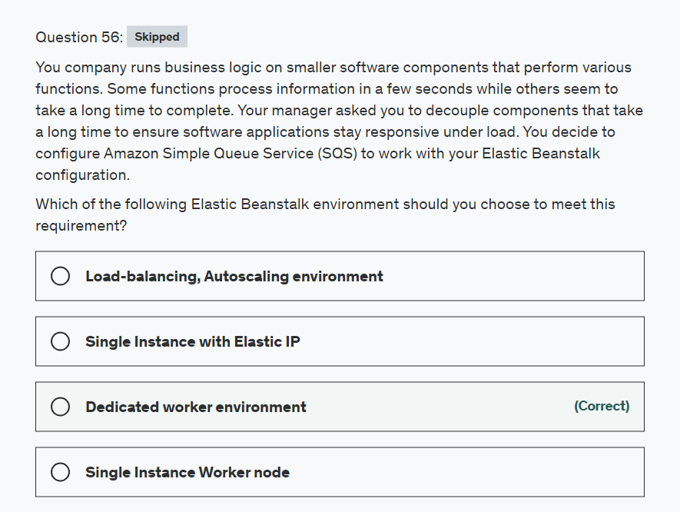

Explanation

Correct option:

With Elastic Beanstalk, you can quickly deploy and manage applications in the AWS Cloud without having to learn about the infrastructure that runs those applications. Elastic Beanstalk reduces management complexity without restricting choice or control. You simply upload your application, and Elastic Beanstalk automatically handles the details of capacity provisioning, load balancing, scaling, and application health monitoring.

Elastic BeanStalk Key Concepts: 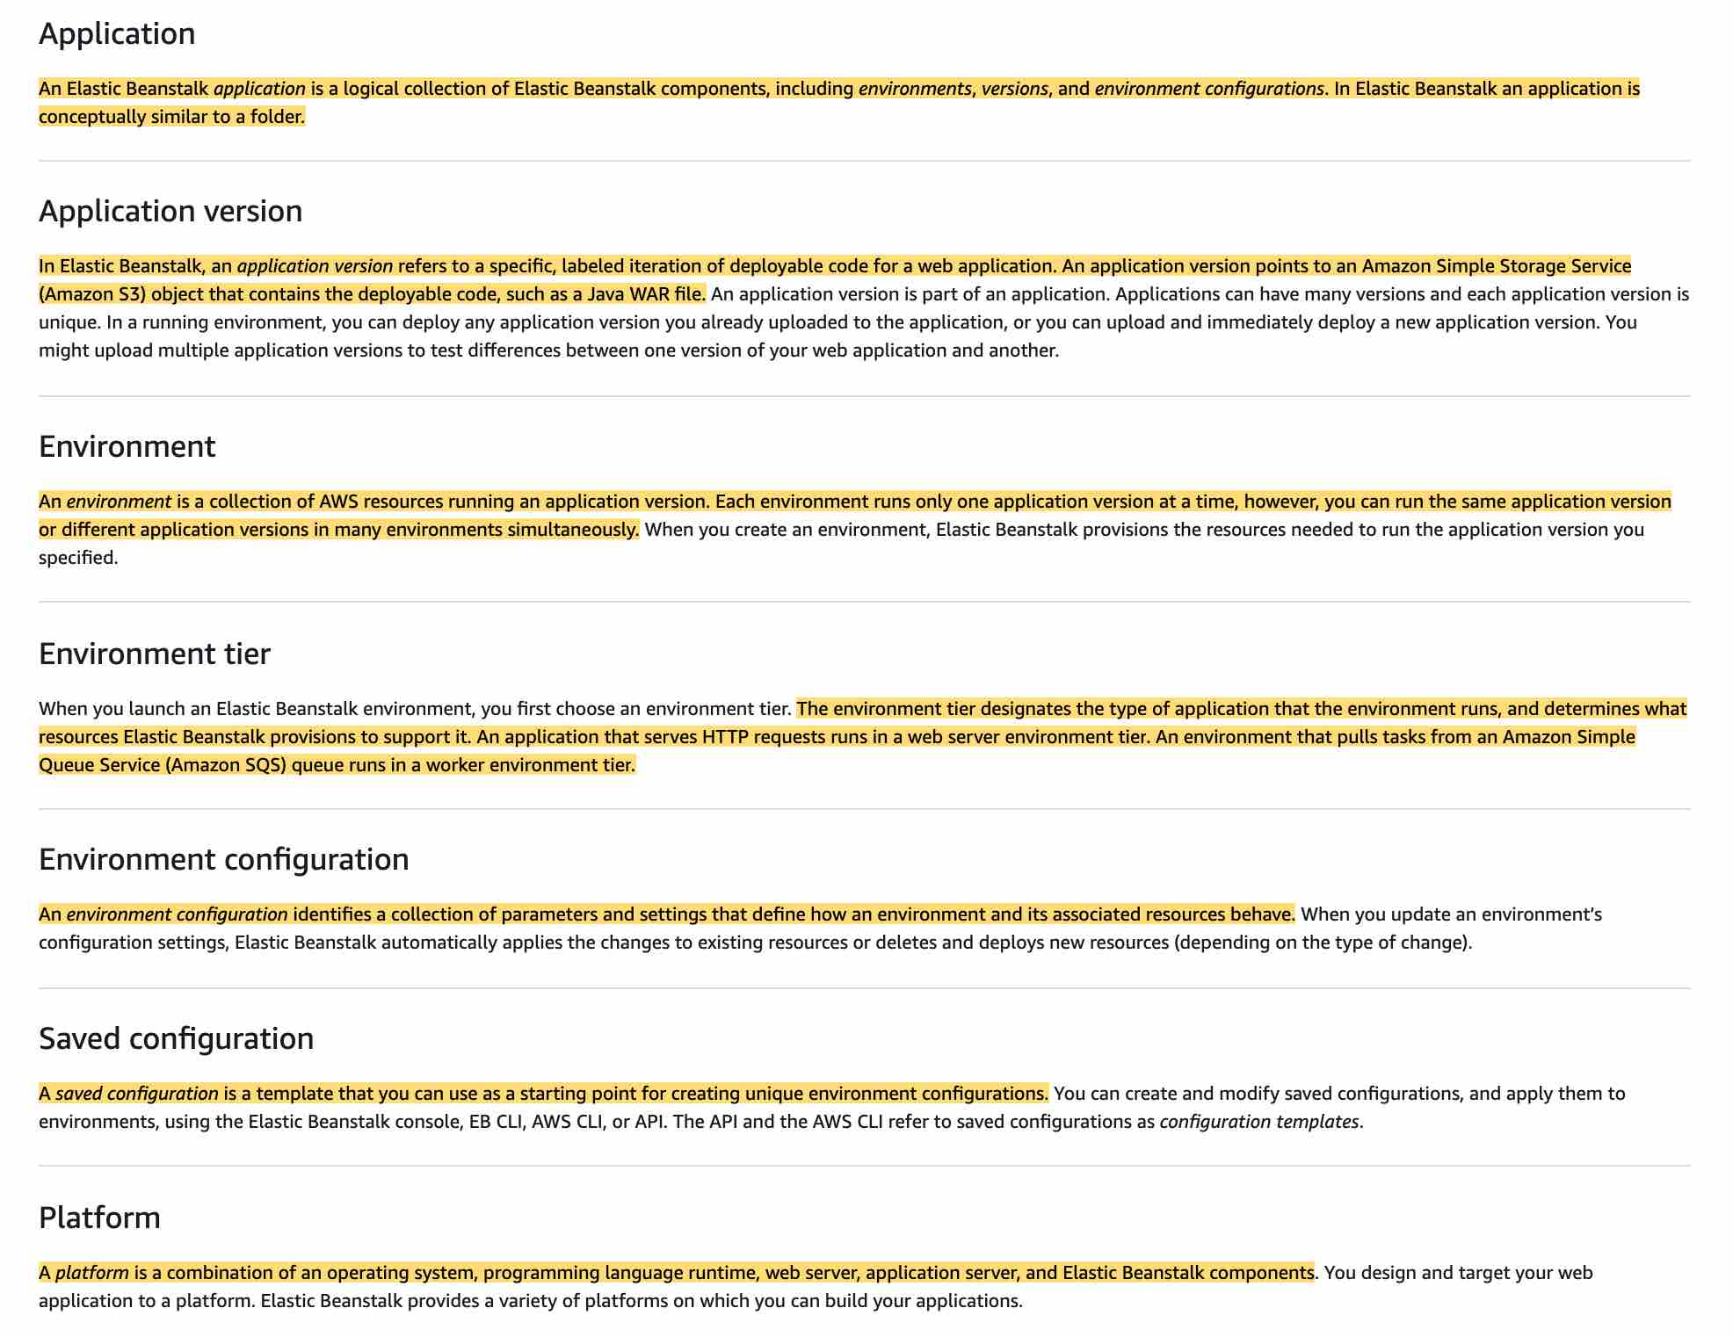 via - <https://docs.aws.amazon.com/elasticbeanstalk/latest/dg/concepts.html>

**Dedicated worker environment** - If your AWS Elastic Beanstalk application performs operations or workflows that take a long time to complete, you can offload those tasks to a dedicated worker environment. Decoupling your web application front end from a process that performs blocking operations is a common way to ensure that your application stays responsive under load.

A long-running task is anything that substantially increases the time it takes to complete a request, such as processing images or videos, sending emails, or generating a ZIP archive. These operations can take only a second or two to complete, but a delay of a few seconds is a lot for a web request that would otherwise complete in less than 500 ms.

 via - <https://docs.aws.amazon.com/elasticbeanstalk/latest/dg/using-features-managing-env-tiers.html>

Incorrect options:

**Single Instance Worker node** - Worker machines in Kubernetes are called nodes. Amazon EKS worker nodes are standard Amazon EC2 instances. EKS worker nodes are not to be confused with the Elastic Beanstalk worker environment. Since we are talking about the Elastic Beanstalk environment, this is not the correct choice.

**Load-balancing, Autoscaling environment** - A load-balancing and autoscaling environment uses the Elastic Load Balancing and Amazon EC2 Auto Scaling services to provision the Amazon EC2 instances that are required for your deployed application. Amazon EC2 Auto Scaling automatically starts additional instances to accommodate increasing load on your application. If your application requires scalability with the option of running in multiple Availability Zones, use a load-balancing, autoscaling environment. This is not the right environment for the given use-case since it will add costs to the overall solution.

**Single Instance with Elastic IP** - A single-instance environment contains one Amazon EC2 instance with an Elastic IP address. A single-instance environment doesn't have a load balancer, which can help you reduce costs compared to a load-balancing, autoscaling environment. This is not a highly available architecture, because if that one instance goes down then your application is down. This is not recommended for production environments.

Reference:

<https://docs.aws.amazon.com/elasticbeanstalk/latest/dg/using-features-managing-env-types.html>

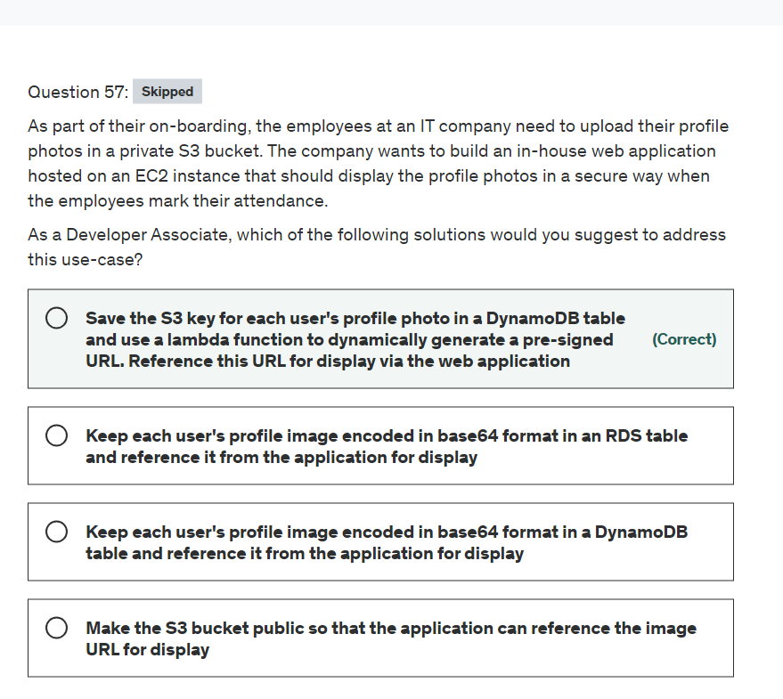

Explanation

Correct option:

"Save the S3 key for each user's profile photo in a DynamoDB table and use a lambda function to dynamically generate a pre-signed URL. Reference this URL for display via the web application"

On Amazon S3, all objects by default are private. Only the object owner has permission to access these objects. However, the object owner can optionally share objects with others by creating a pre-signed URL, using their own security credentials, to grant time-limited permission to download the objects.

You can also use an IAM instance profile to create a pre-signed URL. When you create a pre-signed URL for your object, you must provide your security credentials, specify a bucket name, an object key, specify the HTTP method (GET to download the object), and expiration date and time. The pre-signed URLs are valid only for the specified duration. So for the given use-case, the object key can be retrieved from the DynamoDB table, and then the application can generate the pre-signed URL using the IAM instance profile.

Please see this note for more details: 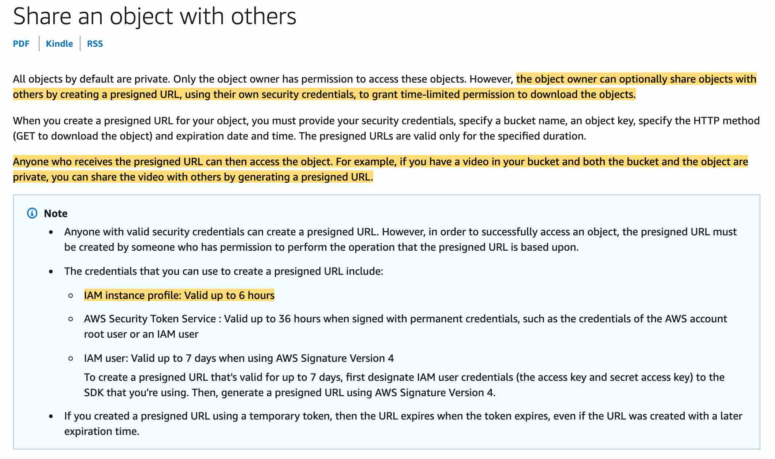 via - <https://docs.aws.amazon.com/AmazonS3/latest/dev/ShareObjectPreSignedURL.html>

Incorrect options:

"Make the S3 bucket public so that the application can reference the image URL for display" - Making the S3 bucket public would violate the security and privacy requirements for the use-case, so this option is incorrect.

"Keep each user's profile image encoded in base64 format in a DynamoDB table and reference it from the application for display"

"Keep each user's profile image encoded in base64 format in an RDS table and reference it from the application for display"

It's a bad practice to keep the raw image data in the database itself. Also, it would not be possible to create a secure access URL for the image without a significant development effort. Hence both these options are incorrect.

Reference:

<https://docs.aws.amazon.com/AmazonS3/latest/dev/ShareObjectPreSignedURL.html>

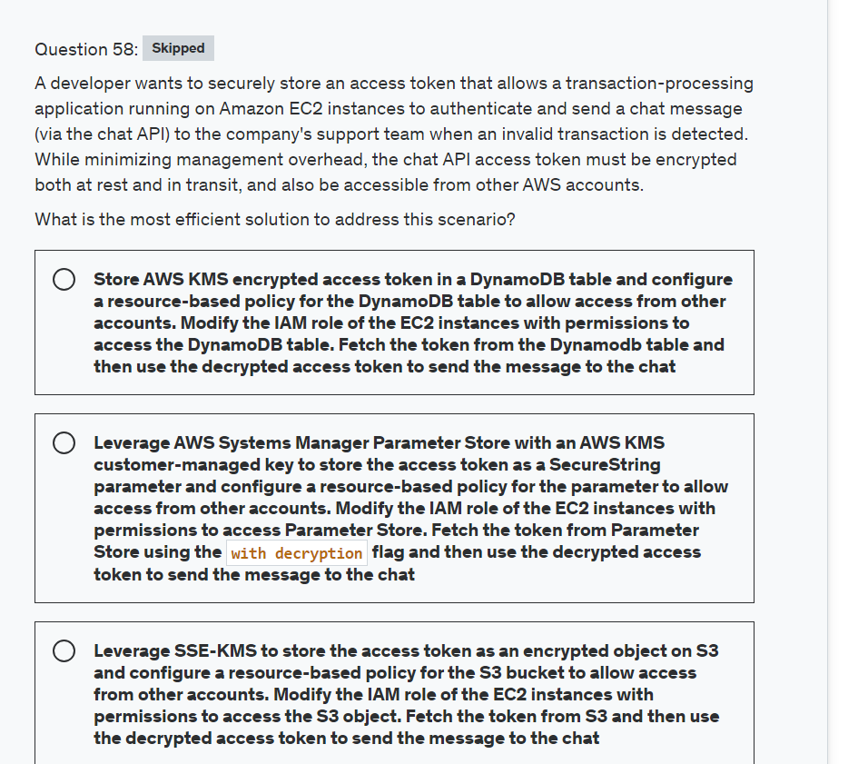

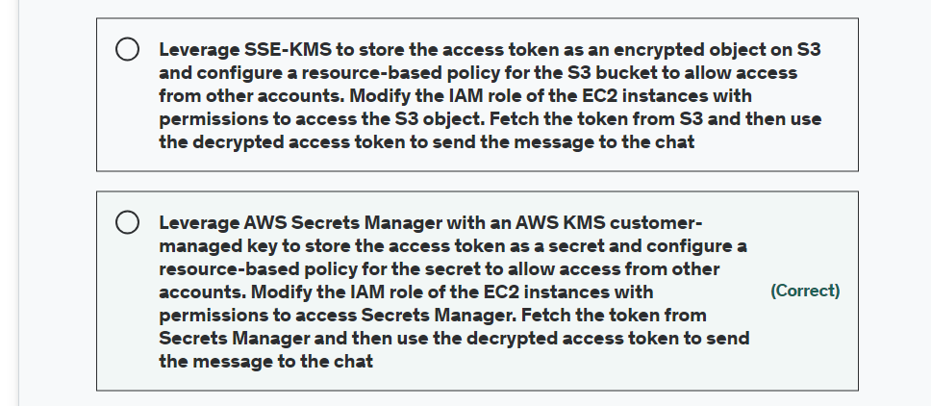

Explanation

Correct option:

**Leverage AWS Secrets Manager with an AWS KMS customer-managed key to store the access token as a secret and configure a resource-based policy for the secret to allow access from other accounts. Modify the IAM role of the EC2 instances with permissions to access Secrets Manager. Fetch the token from Secrets Manager and then use the decrypted access token to send the message to the chat**

AWS Secrets Manager is an AWS service that encrypts and stores your secrets, and transparently decrypts and returns them to you in plaintext. It's designed especially to store application secrets, such as login credentials, that change periodically and should not be hard-coded or stored in plaintext in the application. In place of hard-coded credentials or table lookups, your application calls Secrets Manager.

Secrets Manager also supports features that periodically rotate the secrets associated with commonly used databases. It always encrypts newly rotated secrets before they are stored.

Secrets Manager integrates with AWS Key Management Service (AWS KMS) to encrypt every version of every secret value with a unique data key that is protected by an AWS KMS key. This integration protects your secrets under encryption keys that never leave AWS KMS unencrypted. It also enables you to set custom permissions on the KMS key and audit the operations that generate, encrypt, and decrypt the data keys that protect your secrets.

To grant permission to retrieve secret values, you can attach policies to secrets or identities.

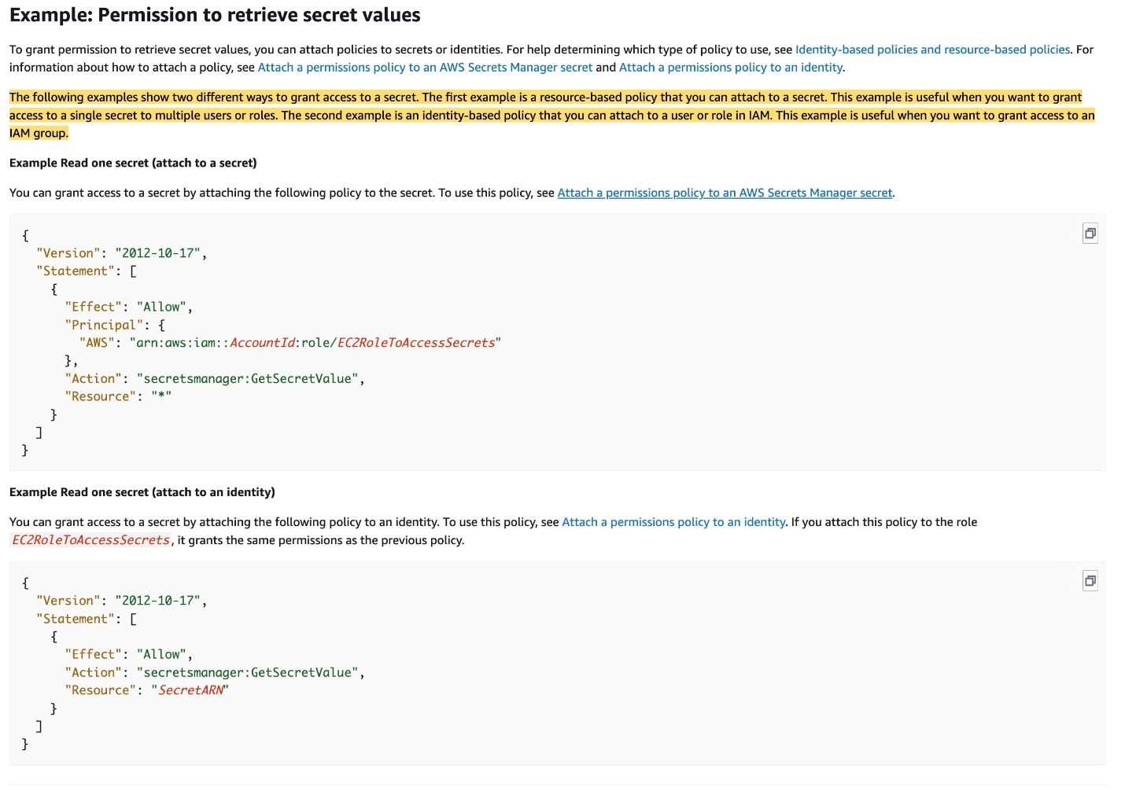 via - <https://docs.aws.amazon.com/secretsmanager/latest/userguide/auth-and-access_examples.html>

For the given use case, you can use the resource-based policy to the secret to allow access from other accounts. Then you need to update the IAM role of the EC2 instances with permissions to access Secrets Manager which will retrieve the token from Secrets Manager and use the decrypted access token to send the message to the support team via the chat API.

Incorrect options:

**Leverage AWS Systems Manager Parameter Store with an AWS KMS customer-managed key to store the access token as a SecureString parameter and configure a resource-based policy for the parameter to allow access from other accounts. Modify the IAM role of the EC2 instances with permissions to access Parameter Store. Fetch the token from Parameter Store using the with decryption flag and then use the decrypted access token to send the message to the chat** - You cannot use a resource-based policy with a parameter in the Parameter Store. Parameter Store supports parameter policies that are available for parameters that use the advanced parameters tier. Parameter policies help you manage a growing set of parameters by allowing you to assign specific criteria to a parameter such as an expiration date or time to live. Parameter policies are especially helpful in forcing you to update or delete passwords and configuration data stored in Parameter Store, a capability of AWS Systems Manager. So this option is incorrect.

**Store AWS KMS encrypted access token in a DynamoDB table and configure a resource-based policy for the DynamoDB table to allow access from other accounts. Modify the IAM role of the EC2 instances with permissions to access the DynamoDB table. Fetch the token from the Dynamodb table and then use the decrypted access token to send the message to the chat** - You should note that DynamoDB does not support resource-based policies. Moreover, it's a security bad practice to keep sensitive access credentials in code, database or a flat file on a file system or object storage. Therefore, this option is incorrect.

**Leverage SSE-KMS to store the access token as an encrypted object on S3 and configure a resource-based policy for the S3 bucket to allow access from other accounts. Modify the IAM role of the EC2 instances with permissions to access the S3 object. Fetch the token from S3 and then use the decrypted access token to send the message to the chat** - It is considered a security bad practice to keep sensitive access credentials in code, database, or a flat file on a file system or object storage. Therefore, this option is incorrect.

References:

<https://docs.aws.amazon.com/secretsmanager/latest/userguide/auth-and-access_examples.html>

<https://docs.aws.amazon.com/systems-manager/latest/userguide/parameter-store-policies.html>

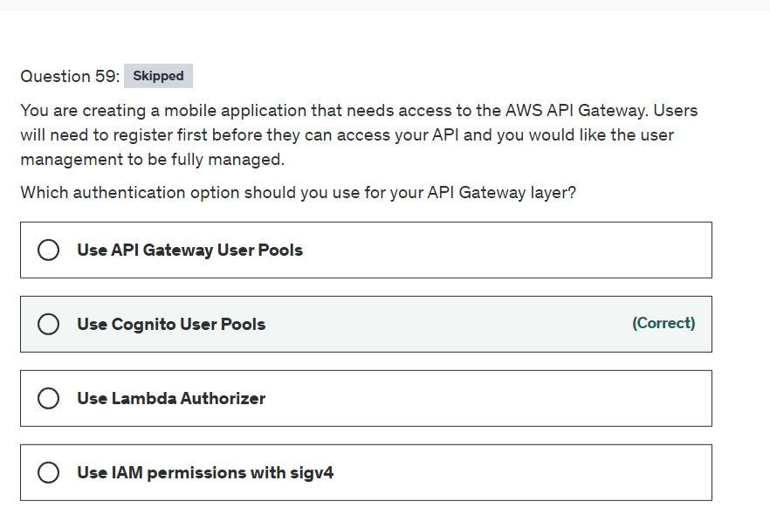

Explanation

Correct option:

**Use Cognito User Pools** - As an alternative to using IAM roles and policies or Lambda authorizers, you can use an Amazon Cognito user pool to control who can access your API in Amazon API Gateway. To use an Amazon Cognito user pool with your API, you must first create an authorizer of the COGNITO_USER_POOLS type and then configure an API method to use that authorizer. After the API is deployed, the client must first sign the user into the user pool, obtain an identity or access token for the user, and then call the API method with one of the tokens, which are typically set to the request's Authorization header. The API call succeeds only if the required token is supplied and the supplied token is valid, otherwise, the client isn't authorized to make the call because the client did not have credentials that could be authorized.

Incorrect options:

**Use Lambda Authorizer**- A Lambda authorizer (formerly known as a custom authorizer) is an API Gateway feature that uses a Lambda function to control access to your API. A Lambda authorizer is useful if you want to implement a custom authorization scheme that uses a bearer token authentication strategy such as OAuth or SAML, or that uses request parameters to determine the caller's identity. This won't be a fully managed user management solution but it would allow you to check for access at the AWS API Gateway level.

**Use IAM permissions with sigv4** - Signature Version 4 is the process to add authentication information to AWS requests sent by HTTP. For security, most requests to AWS must be signed with an access key, which consists of an access key ID and secret access key. These two keys are commonly referred to as your security credentials. But, we cannot possibly create an IAM user for every visitor of the site, so this is where social identity providers come in to help.

**Use API Gateway User Pools** - This is a made-up option.

References:

<https://docs.aws.amazon.com/apigateway/latest/developerguide/apigateway-integrate-with-cognito.html>

<https://docs.aws.amazon.com/apigateway/latest/developerguide/apigateway-use-lambda-authorizer.html>

<https://docs.aws.amazon.com/general/latest/gr/signature-version-4.html>

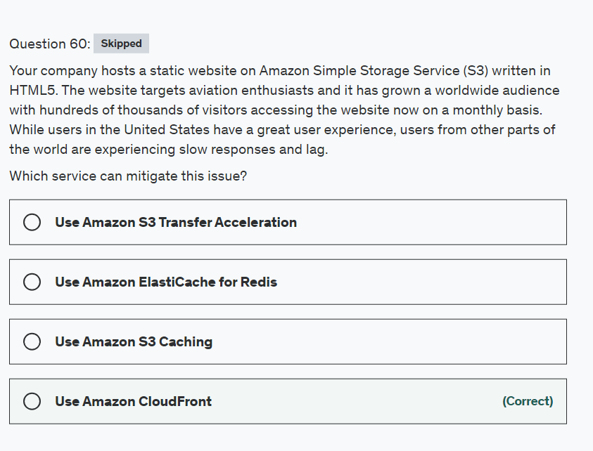

Explanation

Correct option:

**Use Amazon CloudFront**

Storing your static content with S3 provides a lot of advantages. But to help optimize your application’s performance and security while effectively managing cost, AWS recommends that you also set up Amazon CloudFront to work with your S3 bucket to serve and protect the content. CloudFront is a content delivery network (CDN) service that delivers static and dynamic web content, video streams, and APIs around the world, securely and at scale. By design, delivering data out of CloudFront can be more cost-effective than delivering it from S3 directly to your users.

By caching your content in Edge Locations, CloudFront reduces the load on your S3 bucket and helps ensure a faster response for your users when they request content. In addition, data transfer out for content by using CloudFront is often more cost-effective than serving files directly from S3, and there is no data transfer fee from S3 to CloudFront.

A security feature of CloudFront is Origin Access Identity (OAI), which restricts access to an S3 bucket and its content to only CloudFront and operations it performs.

CloudFront Overview: 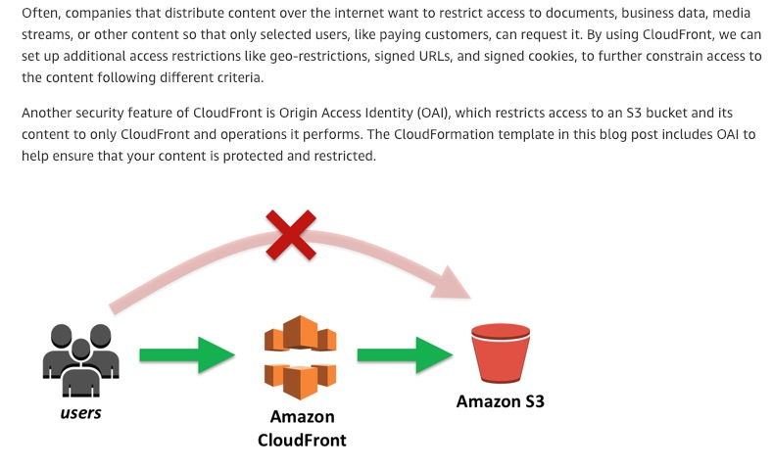 via - <https://aws.amazon.com/blogs/networking-and-content-delivery/amazon-s3-amazon-cloudfront-a-match-made-in-the-cloud/>

Incorrect options:

**Use Amazon ElastiCache for Redis** - Amazon ElastiCache can be used to significantly improve latency and throughput for many read-heavy application workloads (such as social networking, gaming, media sharing, and Q&A portals). ElastiCache is often used with databases that need millisecond latency. For the current scenario, we do not need a caching layer since the data load is not that heavy.

**Use Amazon S3 Caching** - This is a made-up option, given as a distractor.

**Use Amazon S3 Transfer Acceleration** - Amazon S3 Transfer Acceleration enables fast, easy, and secure transfers of files over long distances between your client and your Amazon S3 bucket. However, S3 Transfer Acceleration leverages Amazon CloudFront’s globally distributed AWS Edge Locations. Each time S3 Transfer Acceleration is used to upload an object, AWS checks whether S3 Transfer Acceleration is likely to be faster than a regular Amazon S3 transfer. If it finds that S3 Transfer Acceleration might not be significantly faster, AWS shifts back to normal Amazon S3 transfer mode. So, this is not the right option for our use case.

References:

<https://aws.amazon.com/blogs/networking-and-content-delivery/amazon-s3-amazon-cloudfront-a-match-made-in-the-cloud/>

<https://aws.amazon.com/elasticache/>

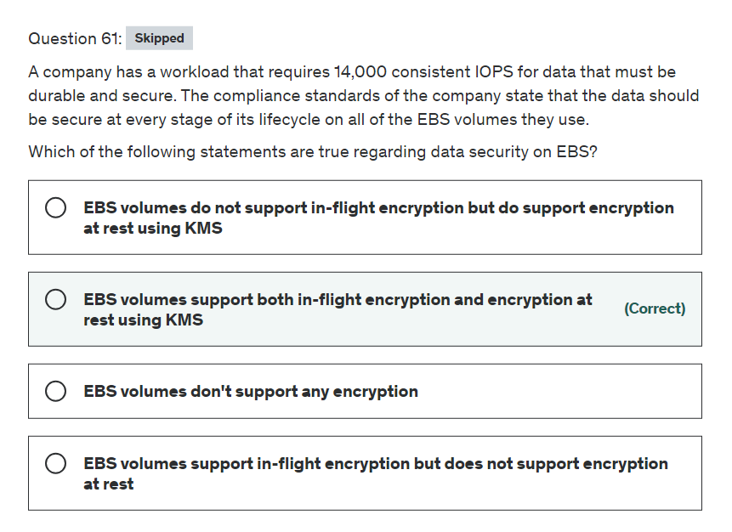

Explanation

Correct option:

Amazon EBS works with AWS KMS to encrypt and decrypt your EBS volume. You can encrypt both the boot and data volumes of an EC2 instance. When you create an encrypted EBS volume and attach it to a supported instance type, the following types of data are encrypted:

Data at rest inside the volume

All data moving between the volume and the instance

All snapshots created from the volume

All volumes created from those snapshots

**EBS volumes support both in-flight encryption and encryption at rest using KMS** - This is a correct statement. Encryption operations occur on the servers that host EC2 instances, ensuring the security of both data-at-rest and data-in-transit between an instance and its attached EBS storage.

Incorrect options:

**EBS volumes support in-flight encryption but do not support encryption at rest** - This is an incorrect statement. As discussed above, all data moving between the volume and the instance is encrypted.

**EBS volumes do not support in-flight encryption but do support encryption at rest using KMS** - This is an incorrect statement. As discussed above, data at rest is also encrypted.

**EBS volumes don't support any encryption** - This is an incorrect statement. Amazon EBS encryption offers a straight-forward encryption solution for your EBS resources associated with your EC2 instances. With Amazon EBS encryption, you aren't required to build, maintain, and secure your own key management infrastructure.

Reference:

<https://docs.aws.amazon.com/AWSEC2/latest/UserGuide/EBSEncryption.html>

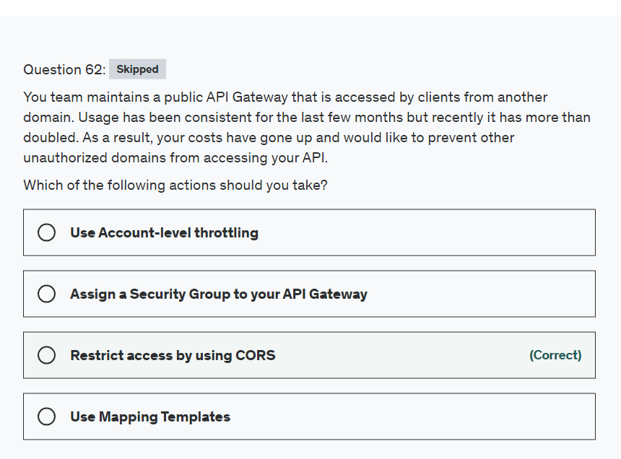

Explanation

Correct option:

**Restrict access by using CORS** - Cross-origin resource sharing (CORS) defines a way for client web applications that are loaded in one domain to interact with resources in a different domain. When your API's resources receive requests from a domain other than the API's own domain and you want to restrict servicing these requests, you must disable cross-origin resource sharing (CORS) for selected methods on the resource.

Incorrect options:

**Use Account-level throttling** - To prevent your API from being overwhelmed by too many requests, Amazon API Gateway throttles requests to your API. By default, API Gateway limits the steady-state request rate to 10,000 requests per second (rps). It limits the burst (that is, the maximum bucket size) to 5,000 requests across all APIs within an AWS account. This is Account-level throttling. As you see, this is about limit on the number of requests and is not a suitable answer for the current scenario.

**Use Mapping Templates** - A mapping template is a script expressed in Velocity Template Language (VTL) and applied to the payload using JSONPath expressions. Mapping templates help format/structure the data in a way that it is easily readable, unlike a server response that might always be easy to ready. Mapping Templates have nothing to do with access and are not useful for the current scenario.

**Assign a Security Group to your API Gateway** - API Gateway does not use security groups but uses resource policies, which are JSON policy documents that you attach to an API to control whether a specified principal (typically an IAM user or role) can invoke the API. You can restrict IP address using this, the downside being, an IP address can be changed by the accessing user. So, this is not an optimal solution for the current use case.

References:

<https://docs.aws.amazon.com/AmazonS3/latest/dev/cors.html>

<https://docs.aws.amazon.com/apigateway/latest/developerguide/http-api-protect.html>

<https://docs.aws.amazon.com/apigateway/latest/developerguide/rest-api-data-transformations.html>

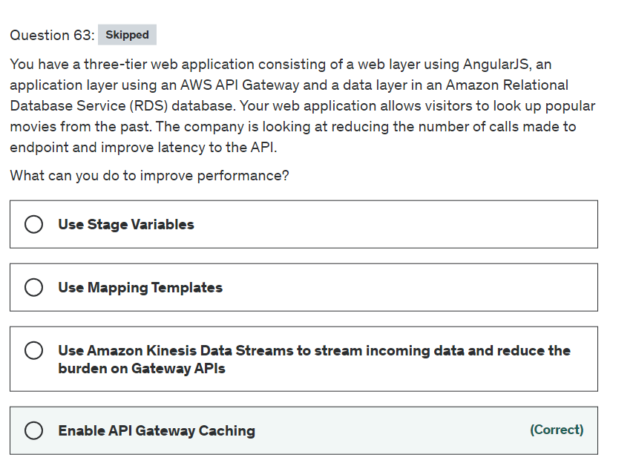

Explanation

Correct option:

**Enable API Gateway Caching** - You can enable API caching in Amazon API Gateway to cache your endpoint's responses. With caching, you can reduce the number of calls made to your endpoint and also improve the latency of requests to your API. When you enable caching for a stage, API Gateway caches responses from your endpoint for a specified time-to-live (TTL) period, in seconds. API Gateway then responds to the request by looking up the endpoint response from the cache instead of making a request to your endpoint. The default TTL value for API caching is 300 seconds. The maximum TTL value is 3600 seconds. TTL=0 means caching is disabled.

Incorrect options:

**Use Mapping Templates** - A mapping template is a script expressed in Velocity Template Language (VTL) and applied to the payload using JSONPath expressions. Mapping templates help format/structure the data in a way that it is easily readable, unlike a server response that might always be easy to ready. Mapping Templates do not help in latency issues of the APIs.

**Use Stage Variables** - Stage variables act like environment variables and can be used to change the behavior of your API Gateway methods for each deployment stage; for example, making it possible to reach a different back end depending on which stage the API is running on. Stage variables do not help in latency issues.

**Use Amazon Kinesis Data Streams to stream incoming data and reduce the burden on Gateway APIs** - Amazon Kinesis Data Streams (KDS) is a massively scalable and durable real-time data streaming service. KDS can continuously capture gigabytes of data per second from hundreds of thousands of sources such as website clickstreams, database event streams, financial transactions, social media feeds, IT logs, and location-tracking events.

Reference:

<https://docs.aws.amazon.com/apigateway/latest/developerguide/api-gateway-caching.html>

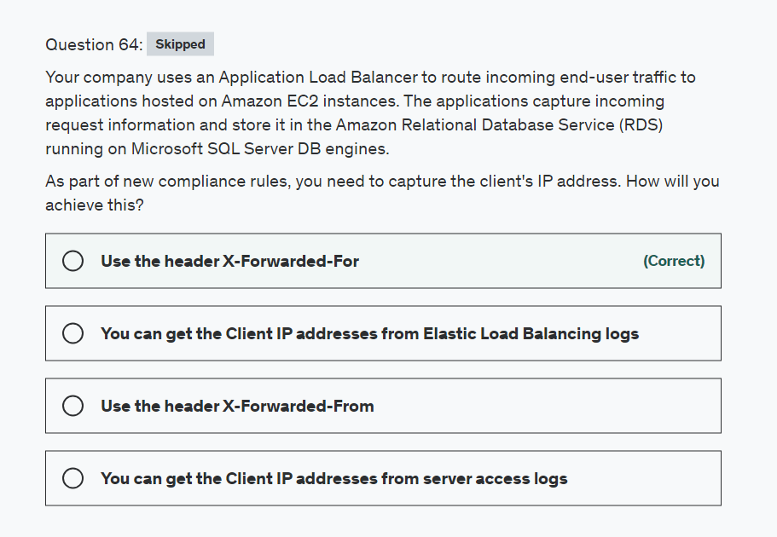

Explanation

Correct option:

**Use the header X-Forwarded-For** - The X-Forwarded-For request header helps you identify the IP address of a client when you use an HTTP or HTTPS load balancer. Because load balancers intercept traffic between clients and servers, your server access logs contain only the IP address of the load balancer. To see the IP address of the client, use the X-Forwarded-For request header. Elastic Load Balancing stores the IP address of the client in the X-Forwarded-For request header and passes the header to your server.

Incorrect options:

**You can get the Client IP addresses from server access logs** - As discussed above, Load Balancers intercept traffic between clients and servers, so server access logs will contain only the IP address of the load balancer.

**Use the header X-Forwarded-From** - This is a made-up option and given as a distractor.

**You can get the Client IP addresses from Elastic Load Balancing logs** - Elastic Load Balancing logs requests sent to the load balancer, including requests that never made it to the targets. For example, if a client sends a malformed request, or there are no healthy targets to respond to the request, the request is still logged. So, this is not the right option if we wish to collect the IP addresses of the clients that have access to the instances.

References:

<https://docs.aws.amazon.com/elasticloadbalancing/latest/classic/x-forwarded-headers.html>

<https://docs.aws.amazon.com/elasticloadbalancing/latest/application/load-balancer-access-logs.html>

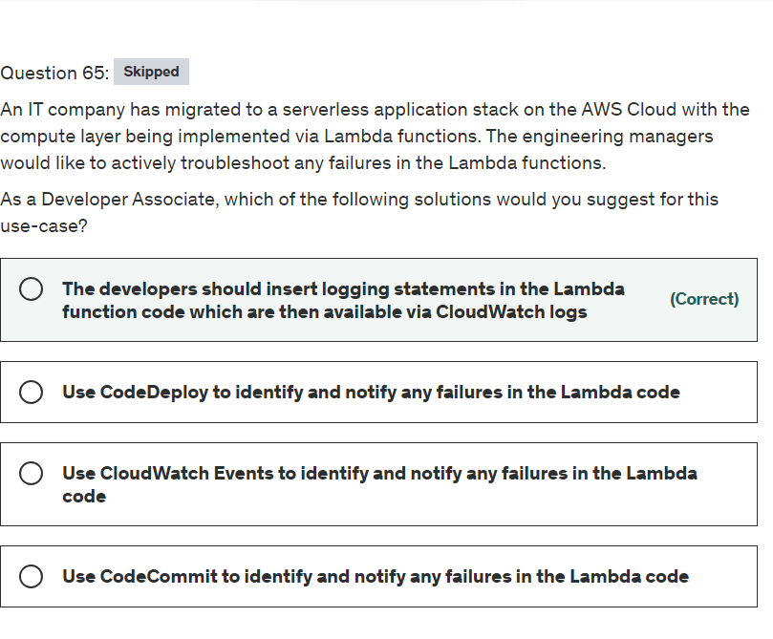

Explanation

Correct option:

"The developers should insert logging statements in the Lambda function code which are then available via CloudWatch logs"

When you invoke a Lambda function, two types of error can occur. Invocation errors occur when the invocation request is rejected before your function receives it. Function errors occur when your function's code or runtime returns an error. Depending on the type of error, the type of invocation, and the client or service that invokes the function, the retry behavior, and the strategy for managing errors varies.

Lambda function failures are commonly caused by:

Permissions issues Code issues Network issues Throttling Invoke API 500 and 502 errors

You can insert logging statements into your code to help you validate that your code is working as expected. Lambda automatically integrates with CloudWatch Logs and pushes all logs from your code to a CloudWatch Logs group associated with a Lambda function, which is named /aws/lambda/<function name>.

Please see this note for more details: 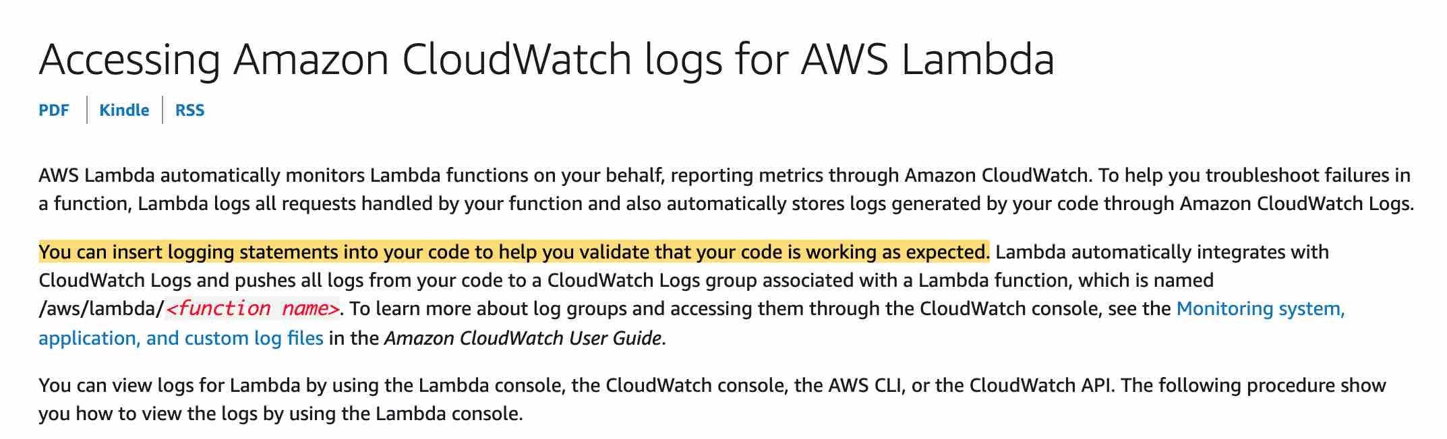 via - <https://docs.aws.amazon.com/lambda/latest/dg/monitoring-cloudwatchlogs.html>

Incorrect options:

"Use CloudWatch Events to identify and notify any failures in the Lambda code" - Typically Lambda functions are triggered as a response to a CloudWatch Event. CloudWatch Events cannot identify and notify failures in the Lambda code.

"Use CodeCommit to identify and notify any failures in the Lambda code"

"Use CodeDeploy to identify and notify any failures in the Lambda code"

AWS CodeCommit is a fully-managed source control service that hosts secure Git-based repositories. It makes it easy for teams to collaborate on code in a secure and highly scalable ecosystem.

AWS CodeDeploy is a fully managed deployment service that automates software deployments to a variety of compute services such as Amazon EC2, AWS Fargate, AWS Lambda, and your on-premises servers.

Neither CodeCommit nor CodeDeploy can identify and notify failures in the Lambda code.

Reference:

<https://docs.aws.amazon.com/lambda/latest/dg/monitoring-cloudwatchlogs.html>



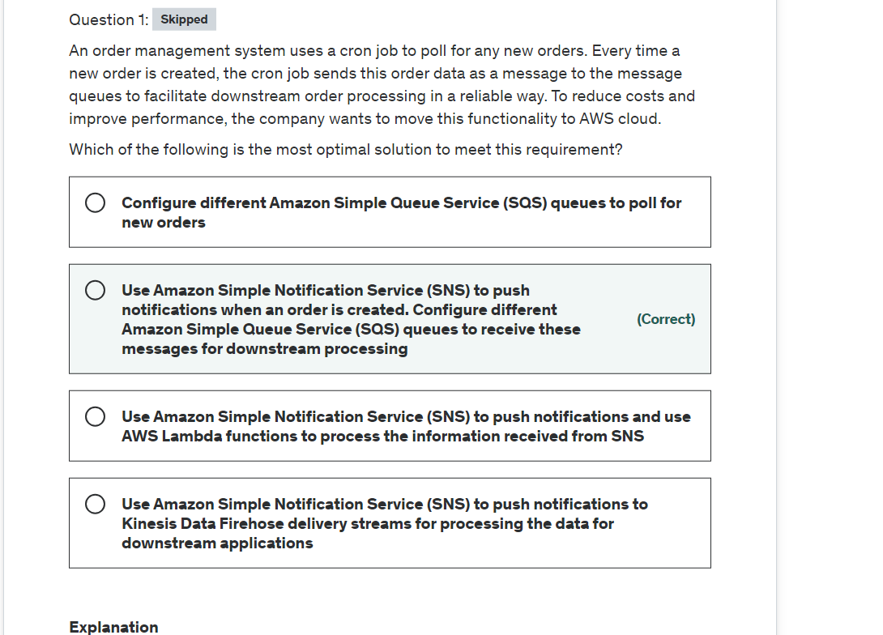

Explanation

Correct option:

**Use Amazon Simple Notification Service (SNS) to push notifications when an order is created. Configure different Amazon Simple Queue Service (SQS) queues to receive these messages for downstream processing**

Amazon SNS works closely with Amazon Simple Queue Service (Amazon SQS). These services provide different benefits for developers. Amazon SNS allows applications to send time-critical messages to multiple subscribers through a “push” mechanism, eliminating the need to periodically check or “poll” for updates. Amazon SQS is a message queue service used by distributed applications to exchange messages through a polling model, and can be used to decouple sending and receiving components—without requiring each component to be concurrently available.

Using Amazon SNS and Amazon SQS together, messages can be delivered to applications that require immediate notification of an event, and also stored in an Amazon SQS queue for other applications to process at a later time.

When you subscribe an Amazon SQS queue to an Amazon SNS topic, you can publish a message to the topic and Amazon SNS sends an Amazon SQS message to the subscribed queue. The Amazon SQS message contains the subject and message that were published to the topic along with metadata about the message in a JSON document.

SNS-SQS fanout is the right solution for this use case.

Sample SNS-SQS Fanout message: 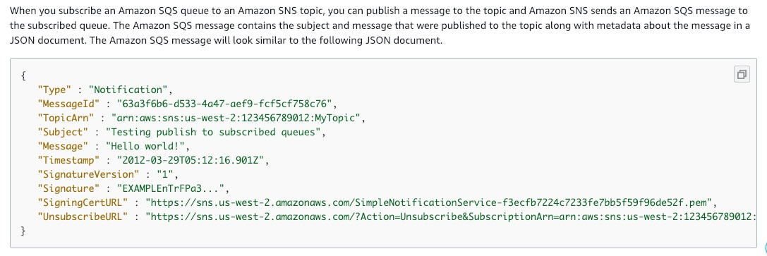 via - <https://docs.aws.amazon.com/sns/latest/dg/sns-sqs-as-subscriber.html>

Incorrect options:

**Configure different Amazon Simple Queue Service (SQS) queues to poll for new orders** - Amazon SQS cannot be used as a polling service, as messages need to be pushed to the queue, which are then handled by the queue consumers.

**Use Amazon Simple Notification Service (SNS) to push notifications and use AWS Lambda functions to process the information received from SNS** - Amazon SNS and AWS Lambda are integrated so you can invoke Lambda functions with Amazon SNS notifications. When a message is published to an SNS topic that has a Lambda function subscribed to it, the Lambda function is invoked with the payload of the published message. For the given scenario, we need a service that can store the message data pushed by SNS, for further processing. AWS Lambda does not have capacity to store the message data. In case a Lambda function is unable to process a specific message, it will be left unprocessed. Hence this option is not correct.

**Use Amazon Simple Notification Service (SNS) to push notifications to Kinesis Data Firehose delivery streams for processing the data for downstream applications** - You can subscribe Amazon Kinesis Data Firehose delivery streams to SNS topics, which allows you to send notifications to additional storage and analytics endpoints. However, Kinesis is built for real-time processing of big data. Whereas, SQS is meant for decoupling dependent systems with easy methods to transmit data/messages. SQS also is a cheaper option when compared to Firehose. Therefore this option is not the right fit for the given use case.

References:

<https://docs.aws.amazon.com/sns/latest/dg/sns-sqs-as-subscriber.html>

<https://docs.aws.amazon.com/sns/latest/dg/sns-lambda-as-subscriber.html>

<https://docs.aws.amazon.com/sns/latest/dg/sns-firehose-as-subscriber.html>

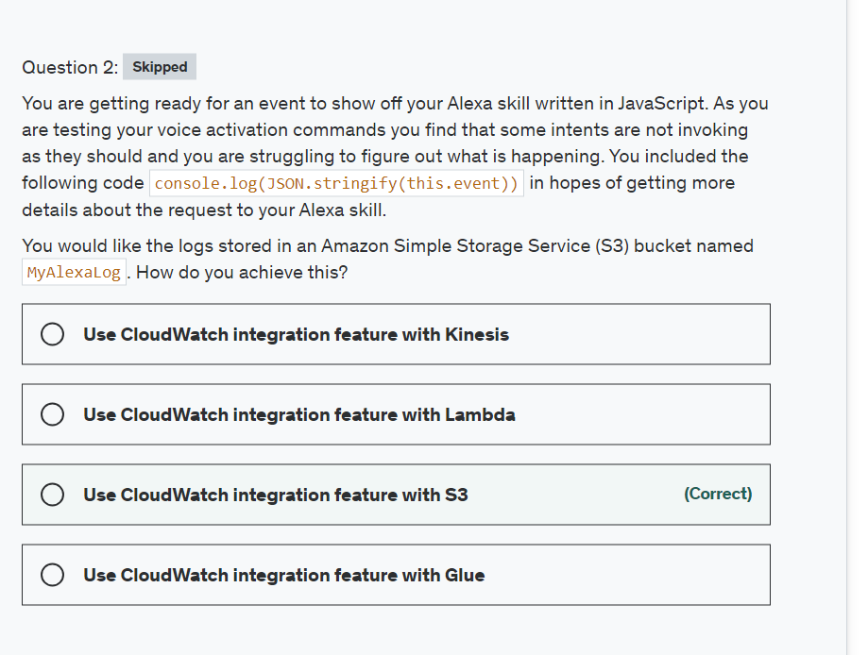

Explanation

Correct option:

**Use CloudWatch integration feature with S3**

You can export log data from your CloudWatch log groups to an Amazon S3 bucket and use this data in custom processing and analysis, or to load onto other systems.

Exporting CloudWatch Log Data to Amazon S3: 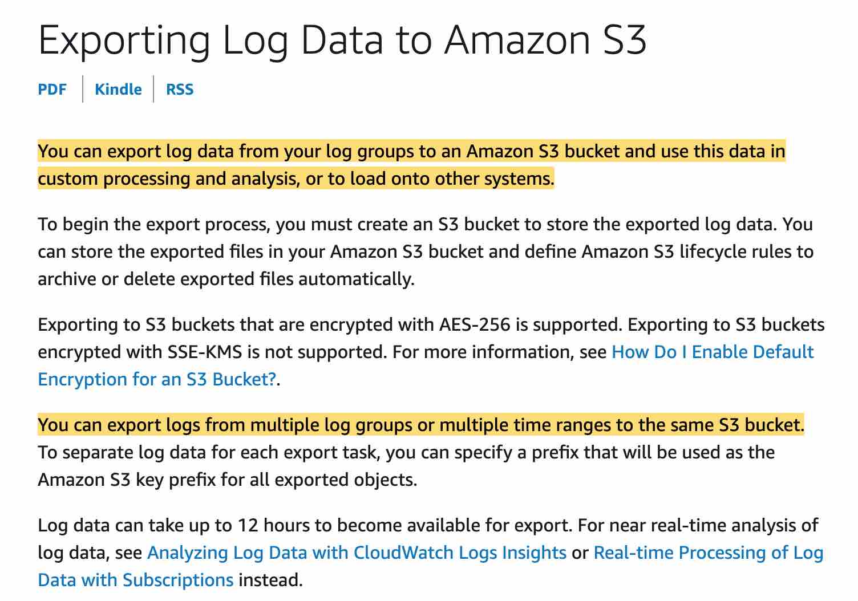 via - <https://docs.aws.amazon.com/AmazonCloudWatch/latest/logs/S3Export.html>

Incorrect options:

**Use CloudWatch integration feature with Kinesis** - You can use both to do custom processing or analysis but with S3 you don't have to process anything. Instead, you configure the CloudWatch settings to send logs to S3.

**Use CloudWatch integration feature with Lambda** - You can use both to do custom processing or analysis but with S3 you don't have to process anything. Instead, you configure the CloudWatch settings to send logs to S3.

**Use CloudWatch integration feature with Glue** - AWS Glue is a fully managed extract, transform, and load (ETL) service that makes it easy for customers to prepare and load their data for analytics. Glue is not the right fit for the given use-case.

Reference:

<https://docs.aws.amazon.com/AmazonCloudWatch/latest/logs/S3Export.html>

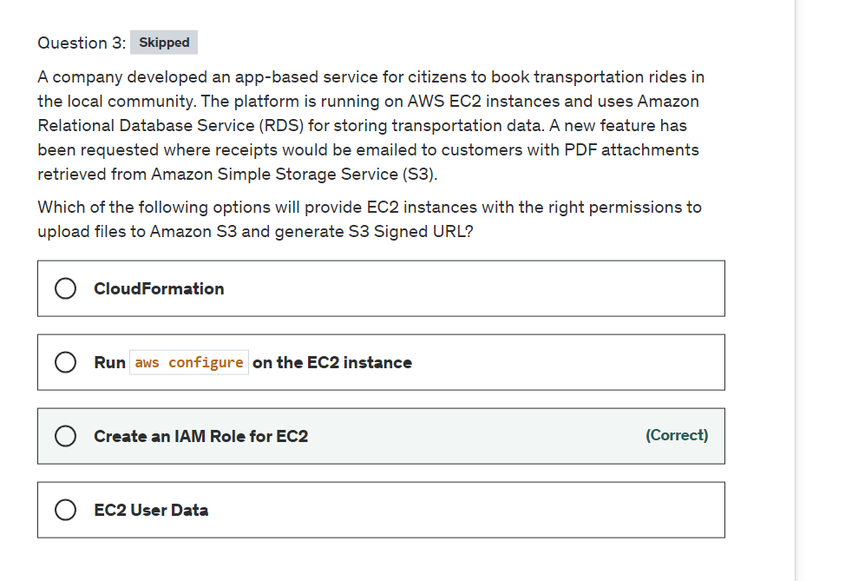

Explanation

Correct option:

**Create an IAM Role for EC2**

IAM roles have been incorporated so that your applications can securely make API requests from your instances, without requiring you to manage the security credentials that the applications use. Instead of creating and distributing your AWS credentials, you can delegate permission to make API requests using IAM roles.

Amazon EC2 uses an instance profile as a container for an IAM role. When you create an IAM role using the IAM console, the console creates an instance profile automatically and gives it the same name as the role to which it corresponds.

Incorrect options:

**EC2 User Data** - You can specify user data when you launch an instance and you would not want to hard code the AWS credentials in the user data.

**Run aws configure on the EC2 instance** - When you first configure the CLI you have to run this command, afterward you should not need to if you want to obtain credentials to authenticate to other AWS services. An IAM role will receive temporary credentials for you so you can focus on using the CLI to get access to other AWS services if you have the permissions.

**CloudFormation** - AWS CloudFormation gives developers and businesses an easy way to create a collection of related AWS and third-party resources and provision them in an orderly and predictable fashion.

How CloudFormation Works: 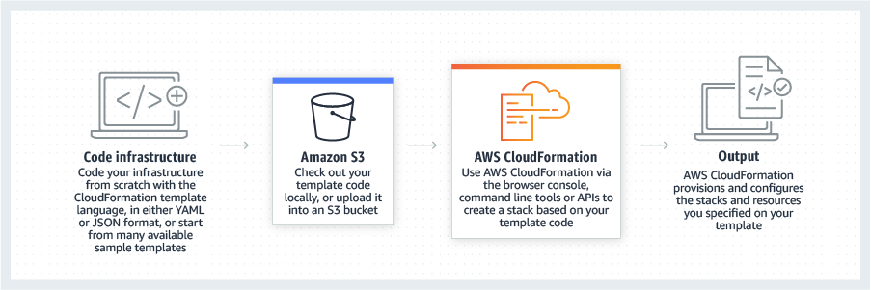 via - <https://aws.amazon.com/cloudformation/>

Reference:

<https://docs.aws.amazon.com/AWSEC2/latest/UserGuide/iam-roles-for-amazon-ec2.html>

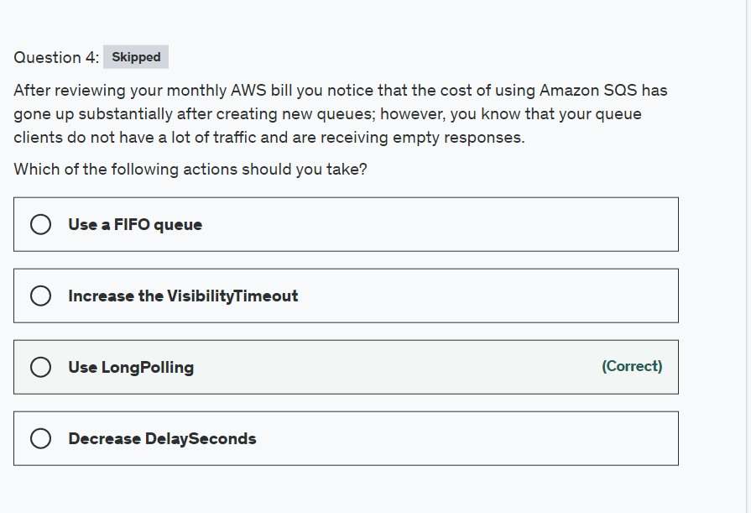

Explanation

Correct option:

**Use LongPolling**

Amazon Simple Queue Service (SQS) is a fully managed message queuing service that enables you to decouple and scale microservices, distributed systems, and serverless applications.

Amazon SQS provides short polling and long polling to receive messages from a queue. By default, queues use short polling. With short polling, Amazon SQS sends the response right away, even if the query found no messages. With long polling, Amazon SQS sends a response after it collects at least one available message, up to the maximum number of messages specified in the request. Amazon SQS sends an empty response only if the polling wait time expires.

Long polling makes it inexpensive to retrieve messages from your Amazon SQS queue as soon as the messages are available. Long polling helps reduce the cost of using Amazon SQS by eliminating the number of empty responses (when there are no messages available for a ReceiveMessage request) and false empty responses (when messages are available but aren't included in a response). When the wait time for the ReceiveMessage API action is greater than 0, long polling is in effect. The maximum long polling wait time is 20 seconds.

Exam Alert:

Please review the differences between Short Polling vs Long Polling:  via - <https://docs.aws.amazon.com/AWSSimpleQueueService/latest/SQSDeveloperGuide/sqs-short-and-long-polling.html>

 via - <https://docs.aws.amazon.com/AWSSimpleQueueService/latest/SQSDeveloperGuide/sqs-short-and-long-polling.html>

Incorrect options:

**Increase the VisibilityTimeout** - Because there is no guarantee that a consumer received a message, the consumer must delete it. To prevent other consumers from processing the message again, Amazon SQS sets a visibility timeout. Visibility timeout will not help with cost reduction.

**Use a FIFO queue** - FIFO queues are designed to enhance messaging between applications when the order of operations and events has to be enforced. FIFO queues will not help with cost reduction. In fact, they are costlier than standard queues.

**Decrease DelaySeconds** - This is similar to VisibilityTimeout. The difference is that a message is hidden when it is first added to a queue for DelaySeconds, whereas for visibility timeouts a message is hidden only after it is consumed from the queue. DelaySeconds will not help with cost reduction.

Reference:

<https://docs.aws.amazon.com/AWSSimpleQueueService/latest/SQSDeveloperGuide/sqs-short-and-long-polling.html>

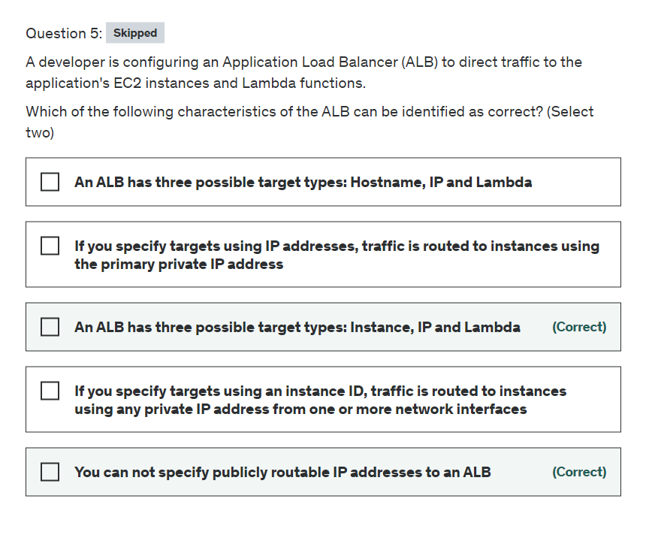

Explanation

Correct options:

**An ALB has three possible target types: Instance, IP and Lambda**

When you create a target group, you specify its target type, which determines the type of target you specify when registering targets with this target group. After you create a target group, you cannot change its target type. The following are the possible target types:

Instance - The targets are specified by instance ID

IP - The targets are IP addresses

Lambda - The target is a Lambda function

**You can not specify publicly routable IP addresses to an ALB**

When the target type is IP, you can specify IP addresses from specific CIDR blocks only. You can't specify publicly routable IP addresses.

Incorrect options:

**If you specify targets using an instance ID, traffic is routed to instances using any private IP address from one or more network interfaces** - If you specify targets using an instance ID, traffic is routed to instances using the primary private IP address specified in the primary network interface for the instance.

**If you specify targets using IP addresses, traffic is routed to instances using the primary private IP address** - If you specify targets using IP addresses, you can route traffic to an instance using any private IP address from one or more network interfaces. This enables multiple applications on an instance to use the same port.

**An ALB has three possible target types: Hostname, IP and Lambda** - This is incorrect, as described in the correct explanation above.

Reference:

<https://docs.aws.amazon.com/elasticloadbalancing/latest/application/load-balancer-target-groups.html>

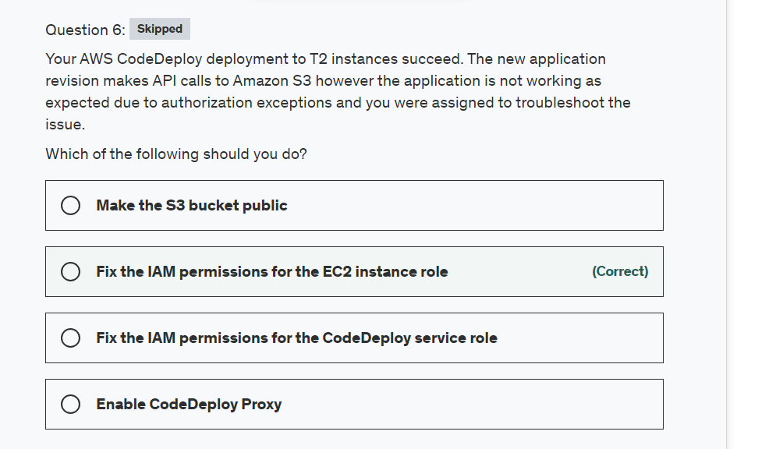

Explanation

Correct option:

**Fix the IAM permissions for the EC2 instance role**

You should use an IAM role to manage temporary credentials for applications that run on an EC2 instance. When you use a role, you don't have to distribute long-term credentials (such as a user name and password or access keys) to an EC2 instance. Instead, the role supplies temporary permissions that applications can use when they make calls to other AWS resources. In this case, make sure your role has access to the S3 bucket.

Incorrect options:

**Fix the IAM permissions for the CodeDeploy service role** - The fact that CodeDeploy deployed the application to EC2 instances tells us that there was no issue between those two. The actual issue is between the EC2 instances and S3.

**Make the S3 bucket public** - This is not a good practice, you should strive to provide least privilege access. You may have files in here that should not be allowed public access and you are opening the door to security breaches.

**Enable CodeDeploy Proxy** - This is not correct as we don't need to look into CodeDeploy settings but rather between EC2 and S3 permissions.

Reference:

<https://docs.aws.amazon.com/IAM/latest/UserGuide/id_roles_use_switch-role-ec2.html>

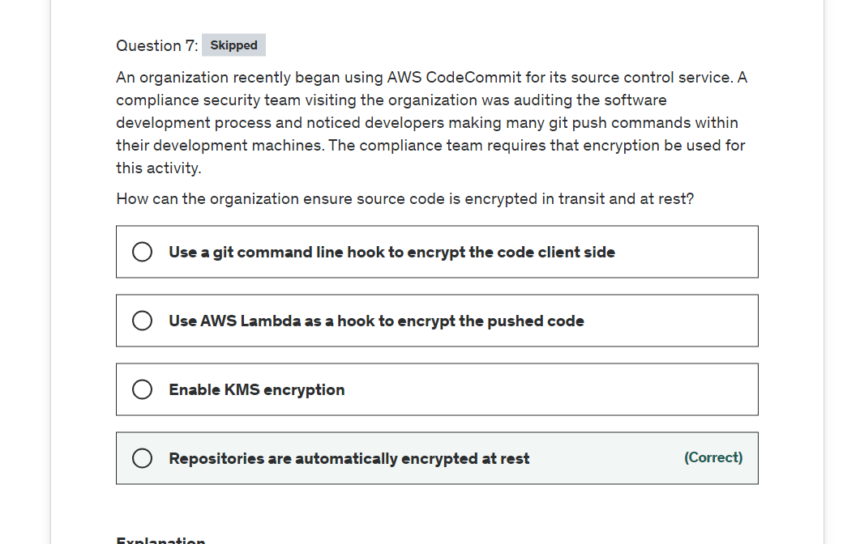

Explanation

Correct option:

**Repositories are automatically encrypted at rest**

Data in AWS CodeCommit repositories is encrypted in transit and at rest. When data is pushed into an AWS CodeCommit repository (for example, by calling git push), AWS CodeCommit encrypts the received data as it is stored in the repository.

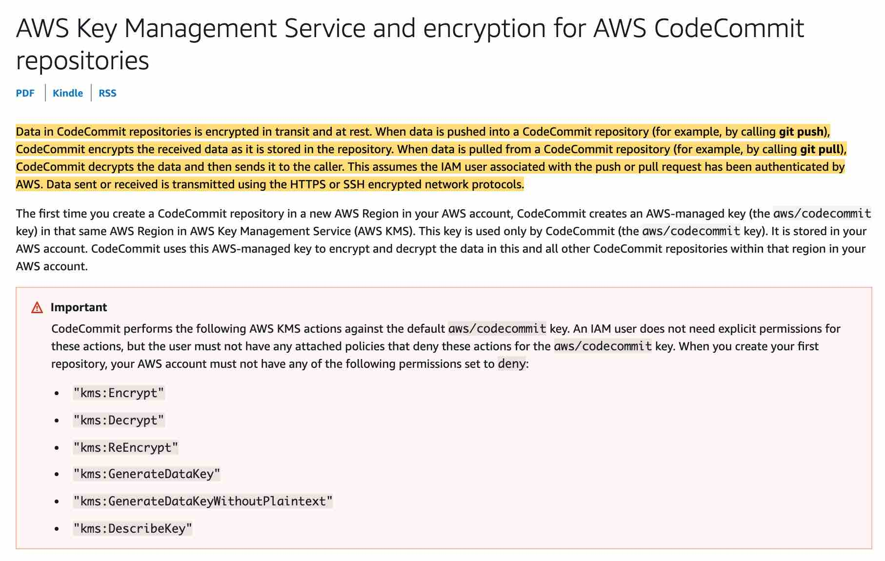 via - <https://docs.aws.amazon.com/codecommit/latest/userguide/encryption.html>

Incorrect options:

**Enable KMS encryption** - You don't have to. The first time you create an AWS CodeCommit repository in a new region in your AWS account, CodeCommit creates an AWS-managed key in that same region in AWS Key Management Service (AWS KMS) that is used only by CodeCommit.

**Use AWS Lambda as a hook to encrypt the pushed code** - This is not needed as CodeCommit handles it for you.

**Use a git command line hook to encrypt the code client-side** - This is not needed as CodeCommit handles it for you.

Reference:

<https://docs.aws.amazon.com/codecommit/latest/userguide/encryption.html>

For more information visit https://docs.aws.amazon.com/codecommit/latest/userguide/encryption.html

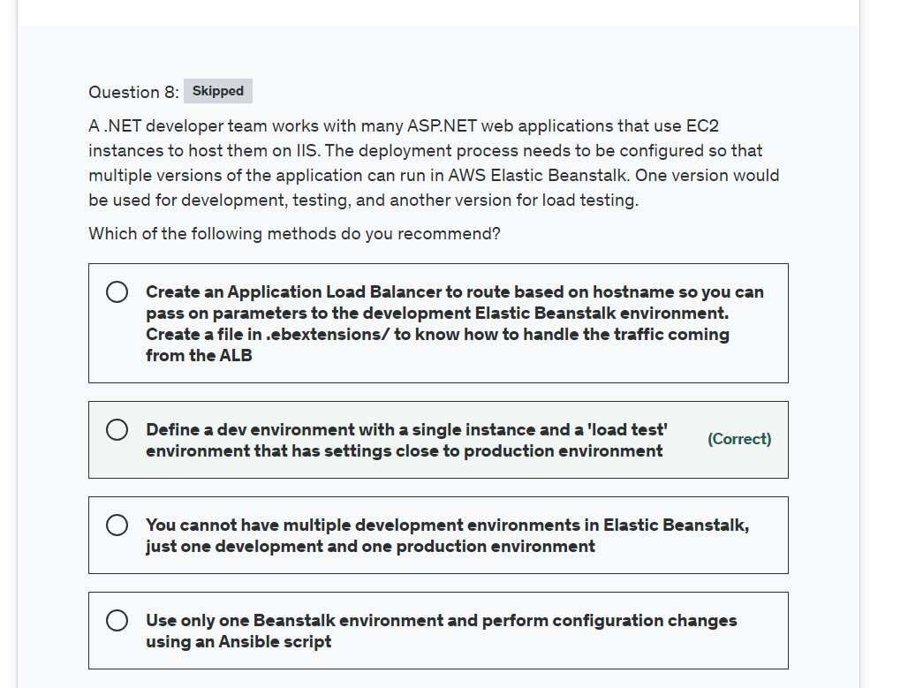

Explanation

Correct option:

**Define a dev environment with a single instance and a 'load test' environment that has settings close to production environment**

AWS Elastic Beanstalk makes it easy to create new environments for your application. You can create and manage separate environments for development, testing, and production use, and you can deploy any version of your application to any environment. Environments can be long-running or temporary. When you terminate an environment, you can save its configuration to recreate it later.

It is common practice to have many environments for the same application. You can deploy multiple environments when you need to run multiple versions of an application. So for the given use-case, you can set up 'dev' and 'load test' environment.

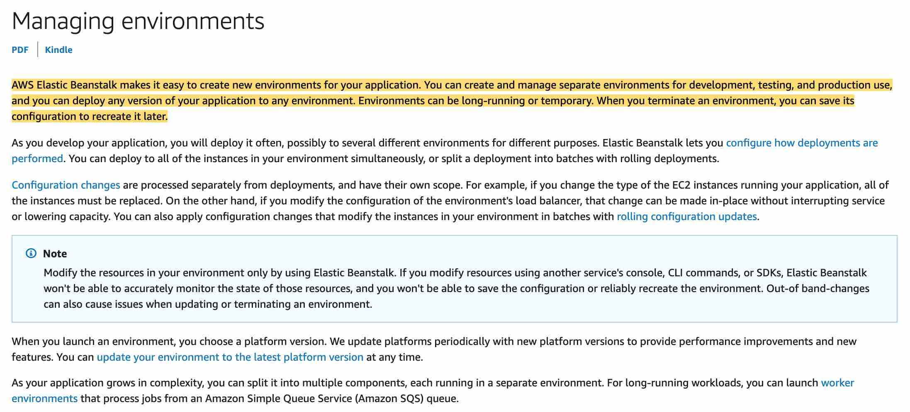 via - <https://docs.aws.amazon.com/elasticbeanstalk/latest/dg/using-features.managing.html>

**You cannot have multiple development environments in Elastic Beanstalk, just one development, and one production environment** - Incorrect, use the Create New Environment wizard in the AWS Management Console for BeanStalk to guide you on this.

**Use only one Beanstalk environment and perform configuration changes using an Ansible script** - Ansible is an open-source deployment tool that integrates with AWS. It allows us to deploy the infrastructure. Elastic Beanstalk provisions the servers that you need for hosting the application and it also handles multiple environments, so Beanstalk is a better option.

**Create an Application Load Balancer to route based on hostname so you can pass on parameters to the development Elastic Beanstalk environment. Create a file in .ebextensions/ to know how to handle the traffic coming from the ALB** - This is not a good design if you need to load test because you will have two versions on the same instances and may not be able to access resources in the system due to the load testing.

Reference:

<https://docs.aws.amazon.com/elasticbeanstalk/latest/dg/using-features.environments.html>

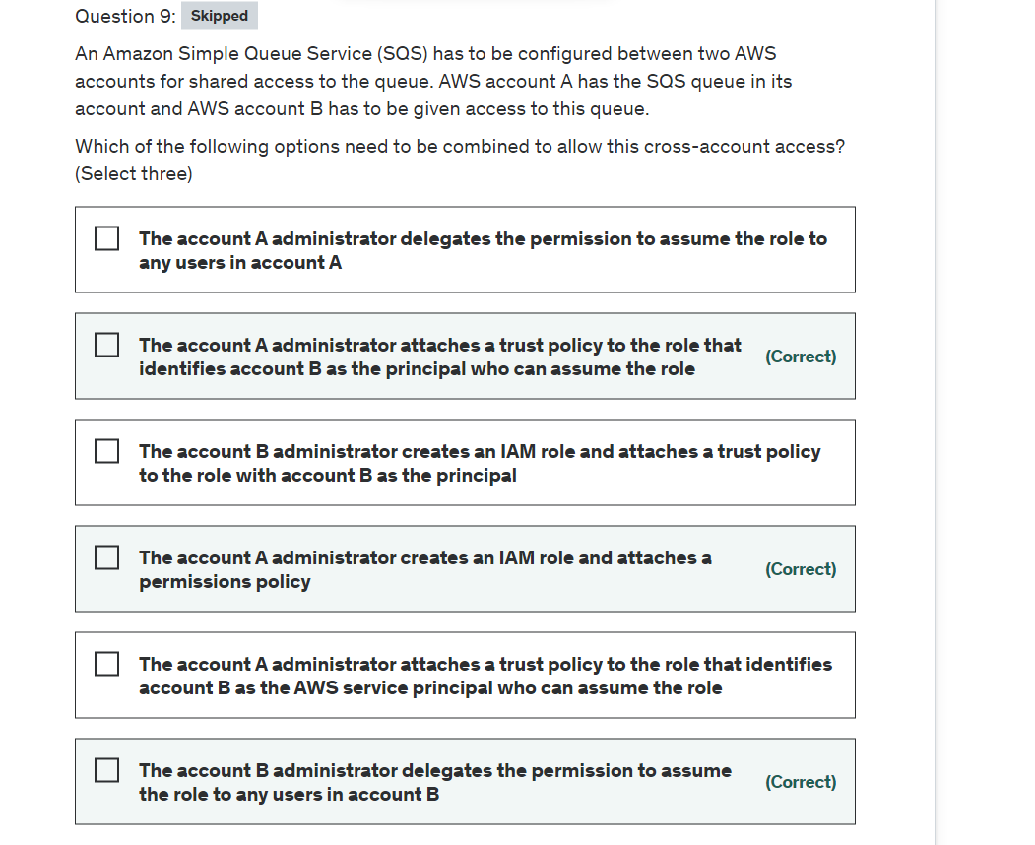

Explanation

Correct options:

**The account A administrator creates an IAM role and attaches a permissions policy**

**The account A administrator attaches a trust policy to the role that identifies account B as the principal who can assume the role**

**The account B administrator delegates the permission to assume the role to any users in account B**

To grant cross-account permissions, you need to attach an identity-based permissions policy to an IAM role. For example, the AWS account A administrator can create a role to grant cross-account permissions to AWS account B as follows:

The account A administrator creates an IAM role and attaches a permissions policy—that grants permissions on resources in account A—to the role.

The account A administrator attaches a trust policy to the role that identifies account B as the principal who can assume the role.

The account B administrator delegates the permission to assume the role to any users in account B. This allows users in account B to create or access queues in account A.

Incorrect options:

**The account B administrator creates an IAM role and attaches a trust policy to the role with account B as the principal** - As mentioned above, the account A administrator needs to create an IAM role and then attach a permissions policy. So, this option is incorrect.

**The account A administrator delegates the permission to assume the role to any users in account A** - This is irrelevant, as users in account B need to be given access.

**The account A administrator attaches a trust policy to the role that identifies account B as the AWS service principal who can assume the role** - AWS service principal is given as principal in the trust policy when you need to grant the permission to assume the role to an AWS service. The given use case talks about giving permission to another account. So, service principal is not an option here.

Reference:

<https://docs.aws.amazon.com/AWSSimpleQueueService/latest/SQSDeveloperGuide/sqs-overview-of-managing-access.html>

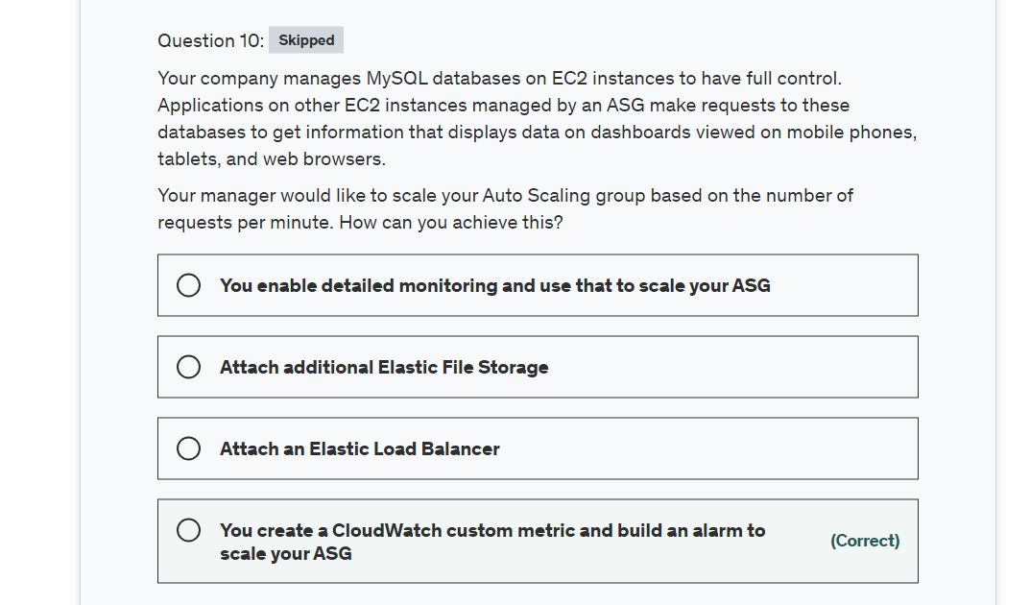

Explanation

Correct option:

**You create a CloudWatch custom metric and build an alarm to scale your ASG**

Here we need to scale on the metric "number of requests per minute", which is a custom metric we need to create, as it's not readily available in CloudWatch.

Metrics produced by AWS services are standard resolution by default. When you publish a custom metric, you can define it as either standard resolution or high resolution. When you publish a high-resolution metric, CloudWatch stores it with a resolution of 1 second, and you can read and retrieve it with a period of 1 second, 5 seconds, 10 seconds, 30 seconds, or any multiple of 60 seconds.

Incorrect options:

**Attach an Elastic Load Balancer** - This is not what you need for auto-scaling. An Elastic Load Balancer distributes workloads across multiple compute resources and checks your instances' health status to name a few, but it does not automatically increase and decrease the number of instances based on the application requirement.

**Attach additional Elastic File Storage** - This is a file storage service designed for performance. Amazon Elastic File System (Amazon EFS) provides a simple, scalable, fully managed elastic NFS file system for use with AWS Cloud services and on-premises resources. It is built to scale on-demand to petabytes without disrupting applications, growing and shrinking automatically as you add and remove files, eliminating the need to provision and manage capacity to accommodate growth. This cannot be used to facilitate auto-scaling.

How EFS Works: 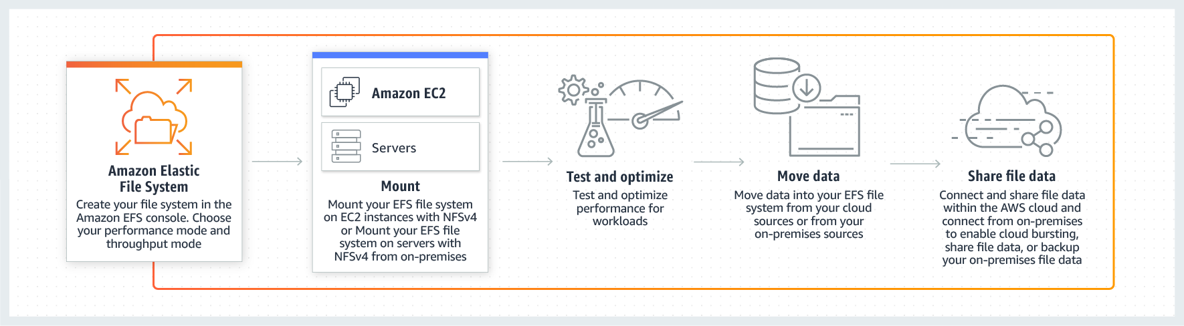 via - <https://aws.amazon.com/efs/>

**You enable detailed monitoring and use that to scale your ASG** - The detailed monitoring metrics won't provide information about database /application-level requests per minute, so this option is not correct.

Reference:

<https://docs.aws.amazon.com/AmazonCloudWatch/latest/monitoring/publishingMetrics.html>

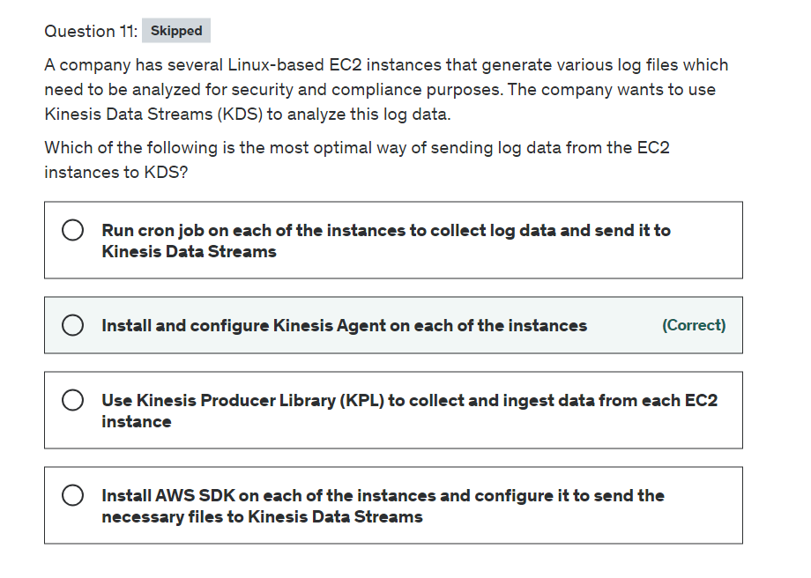

Explanation

Correct option:

**Install and configure Kinesis Agent on each of the instances**

Kinesis Agent is a stand-alone Java software application that offers an easy way to collect and send data to Kinesis Data Streams. The agent continuously monitors a set of files and sends new data to your stream. The agent handles file rotation, checkpointing, and retry upon failures. It delivers all of your data in a reliable, timely, and simple manner. It also emits Amazon CloudWatch metrics to help you better monitor and troubleshoot the streaming process.

You can install the agent on Linux-based server environments such as web servers, log servers, and database servers. After installing the agent, configure it by specifying the files to monitor and the stream for the data. After the agent is configured, it durably collects data from the files and reliably sends it to the stream.

The agent can also pre-process the records parsed from monitored files before sending them to your stream. You can enable this feature by adding the dataProcessingOptions configuration setting to your file flow. One or more processing options can be added and they will be performed in the specified order.

Incorrect options:

**Run cron job on each of the instances to collect log data and send it to Kinesis Data Streams** - This solution is possible, though not an optimal one. This solution requires writing custom code and tracking file/log changes, retry failures and so on. Kinesis Agent is built to handle all these requirements and integrates with Data Streams.

**Install AWS SDK on each of the instances and configure it to send the necessary files to Kinesis Data Streams** - Kinesis Data Streams APIs that are available in the AWS SDKs, helps you manage many aspects of Kinesis Data Streams, including creating streams, resharding, and putting and getting records. You will need to write custom code to handle new data in the log files and send it over to your stream. Kinesis Agent does it easily, as it is designed to continuously monitor a set of files and send new data to your stream.

**Use Kinesis Producer Library (KPL) to collect and ingest data from each EC2 instance** - The KPL is an easy-to-use, highly configurable library that helps you write to a Kinesis data stream. It acts as an intermediary between your producer application code and the Kinesis Data Streams API actions. This is not optimal compared to Kinesis Agent which is designed to continuously monitor a set of files and send new data to your stream.

Reference:

<https://docs.aws.amazon.com/streams/latest/dev/writing-with-agents.html>

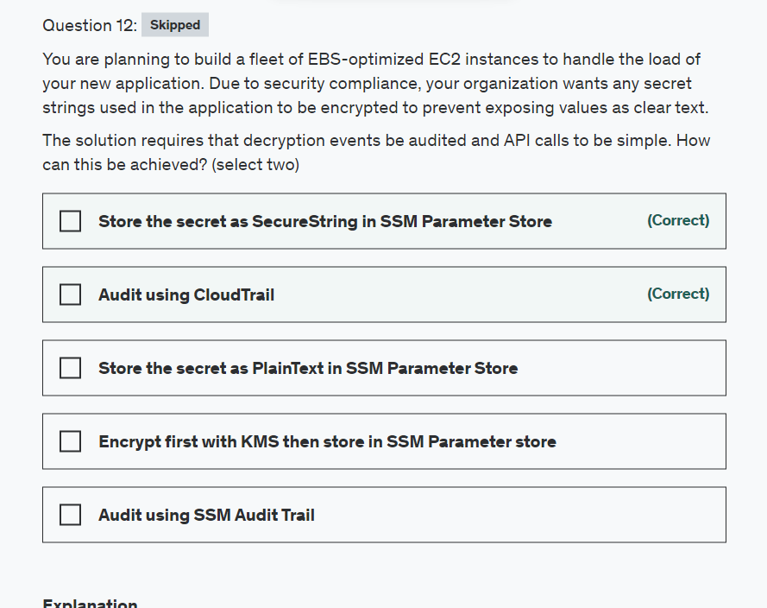

Explanation

Correct options:

**Store the secret as SecureString in SSM Parameter Store**

With AWS Systems Manager Parameter Store, you can create SecureString parameters, which are parameters that have a plaintext parameter name and an encrypted parameter value. Parameter Store uses AWS KMS to encrypt and decrypt the parameter values of Secure String parameters. Also, if you are using customer-managed CMKs, you can use IAM policies and key policies to manage to encrypt and decrypt permissions. To retrieve the decrypted value you only need to do one API call.

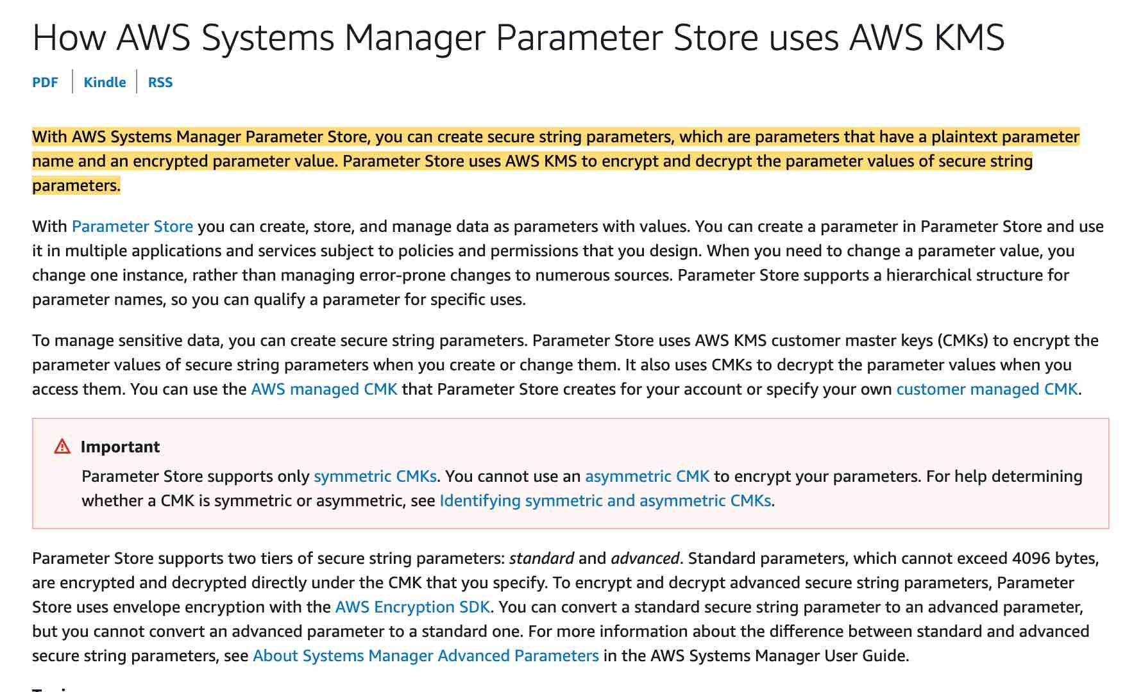 via - <https://docs.aws.amazon.com/kms/latest/developerguide/services-parameter-store.html>

**Audit using CloudTrail**

AWS CloudTrail is a service that enables governance, compliance, operational auditing, and risk auditing of your AWS account. With CloudTrail, you can log, continuously monitor, and retain account activity related to actions across your AWS infrastructure. CloudTrail provides an event history of your AWS account activity, including actions taken through the AWS Management Console, AWS SDKs, command-line tools, and other AWS services.

CloudTrail will allow you to see all API calls made to SSM and KMS.

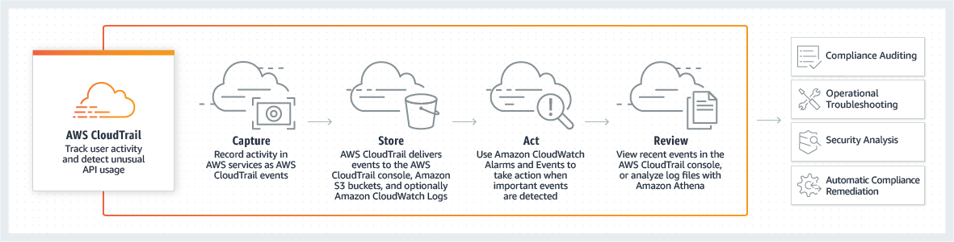

Incorrect options:

**Encrypt first with KMS then store in SSM Parameter store** - This could work but will require two API calls to get the decrypted value instead of one. So this is not the right option.

**Store the secret as PlainText in SSM Parameter Store** - Plaintext parameters are not secure and shouldn't be used to store secrets.

**Audit using SSM Audit Trail** - This is a made-up option and has been added as a distractor.

Reference:

<https://docs.aws.amazon.com/kms/latest/developerguide/services-parameter-store.html>

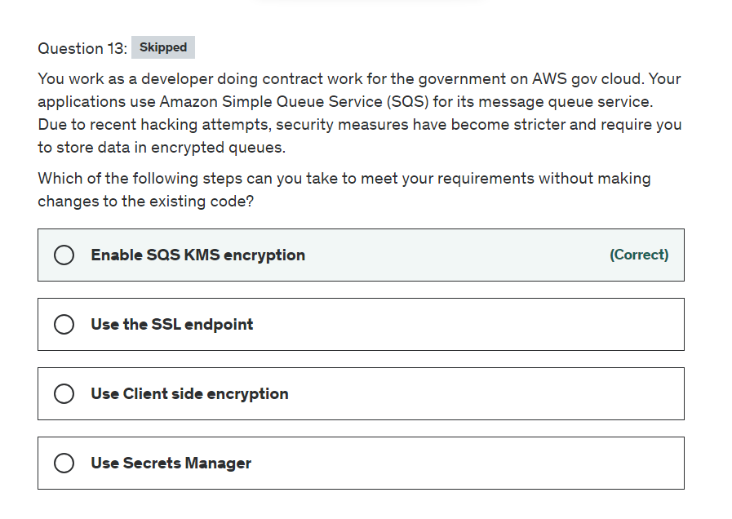

Explanation

Correct option:

**Enable SQS KMS encryption**

Server-side encryption (SSE) lets you transmit sensitive data in encrypted queues. SSE protects the contents of messages in queues using keys managed in AWS Key Management Service (AWS KMS).

AWS KMS combines secure, highly available hardware and software to provide a key management system scaled for the cloud. When you use Amazon SQS with AWS KMS, the data keys that encrypt your message data are also encrypted and stored with the data they protect.

You can choose to have SQS encrypt messages stored in both Standard and FIFO queues using an encryption key provided by AWS Key Management Service (KMS).

Incorrect options:

**Use the SSL endpoint** - The given use-case needs encryption at rest. When using SSL, the data is encrypted during transit, but the data needs to be encrypted at rest as well, so this option is incorrect.

**Use Client-side encryption** - For additional security, you can build your application to encrypt messages before they are placed in a message queue but will require a code change, so this option is incorrect.

*Use Secrets Manager * - AWS Secrets Manager enables you to easily rotate, manage, and retrieve database credentials, API keys, and other secrets throughout their lifecycle. Users and applications retrieve secrets with a call to Secrets Manager APIs, eliminating the need to hardcode sensitive information in plain text. Secrets Manager offers secret rotation with built-in integration for Amazon RDS, Amazon Redshift, and Amazon DocumentDB. Secrets Manager cannot be used for encrypting data at rest.

Reference:

<https://docs.aws.amazon.com/AWSSimpleQueueService/latest/SQSDeveloperGuide/sqs-server-side-encryption.html>

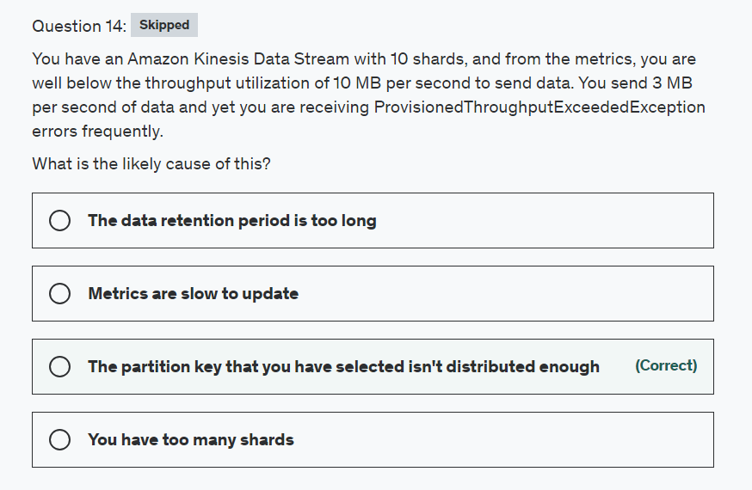

Explanation

Correct option:

**The partition key that you have selected isn't distributed enough**

Amazon Kinesis Data Streams enables you to build custom applications that process or analyze streaming data for specialized needs.

A Kinesis data stream is a set of shards. A shard is a uniquely identified sequence of data records in a stream. A stream is composed of one or more shards, each of which provides a fixed unit of capacity.

The partition key is used by Kinesis Data Streams to distribute data across shards. Kinesis Data Streams segregates the data records that belong to a stream into multiple shards, using the partition key associated with each data record to determine the shard to which a given data record belongs.

Kinesis Data Streams Overview: 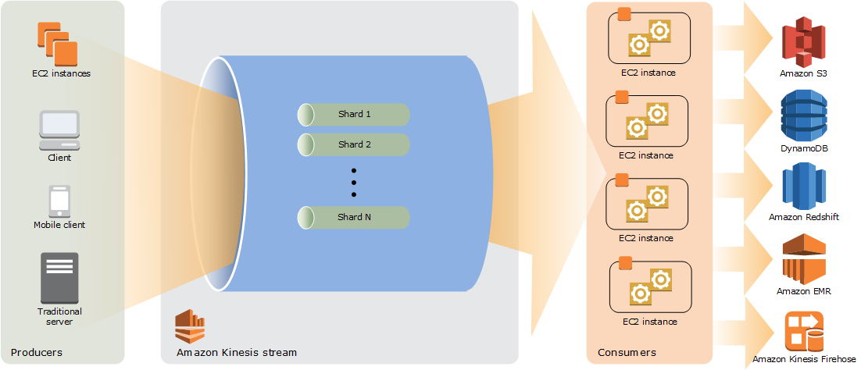 via - <https://docs.aws.amazon.com/streams/latest/dev/key-concepts.html>

For the given use-case, as the partition key is not distributed enough, all the data is getting skewed at a few specific shards and not leveraging the entire cluster of shards.

You can also use metrics to determine which are your "hot" or "cold" shards, that is, shards that are receiving much more data, or much less data, than expected. You could then selectively split the hot shards to increase capacity for the hash keys that target those shards. Similarly, you could merge cold shards to make better use of their unused capacity.

Incorrect options:

**Metrics are slow to update** - Metrics are a CloudWatch concept. This option has been added as a distractor.

**You have too many shards** - Too many shards is not the issue as you would see a LimitExceededException in that case.

**The data retention period is too long** - Your streaming data is retained for up to 365 days. The data retention period is not an issue causing this error.

References:

<https://docs.aws.amazon.com/streams/latest/dev/key-concepts.html>

<https://docs.aws.amazon.com/streams/latest/dev/kinesis-using-sdk-java-resharding-strategies.html>

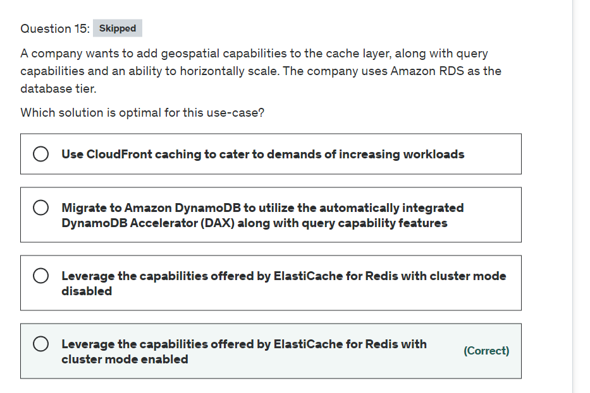

Explanation

Correct option:

**Leverage the capabilities offered by ElastiCache for Redis with cluster mode enabled**

You can use Amazon ElastiCache to accelerate your high volume application workloads by caching your data in-memory providing sub-millisecond data retrieval performance. When used in conjunction with any database including Amazon RDS or Amazon DynamoDB, ElastiCache can alleviate the pressure associated with heavy request loads, increase overall application performance and reduce costs associated with scaling for throughput on other databases.

Amazon ElastiCache makes it easy to deploy and manage a highly available and scalable in-memory data store in the cloud. Among the open source in-memory engines available for use with ElastiCache is Redis, which added powerful geospatial capabilities in its newer versions.

You can leverage ElastiCache for Redis with cluster mode enabled to enhance reliability and availability with little change to your existing workload. Cluster Mode comes with the primary benefit of horizontal scaling up and down of your Redis cluster, with almost zero impact on the performance of the cluster.

Enabling Cluster Mode provides a number of additional benefits in scaling your cluster. In short, it allows you to scale in or out the number of shards (horizontal scaling) versus scaling up or down the node type (vertical scaling). This means that Cluster Mode can scale to very large amounts of storage (potentially 100s of terabytes) across up to 90 shards, whereas a single node can only store as much data in memory as the instance type has capacity for.

Cluster Mode also allows for more flexibility when designing new workloads with unknown storage requirements or heavy write activity. In a read-heavy workload, one can scale a single shard by adding read replicas, up to five, but a write-heavy workload can benefit from additional write endpoints when cluster mode is enabled.

Geospatial on Amazon ElastiCache for Redis: 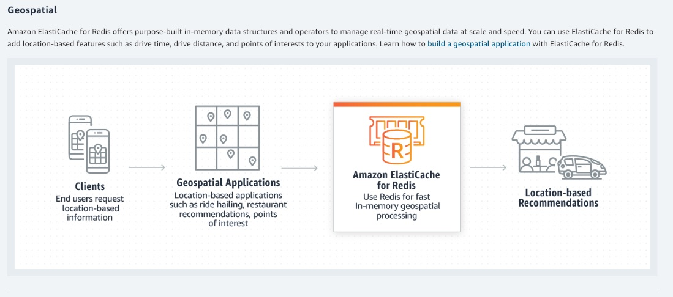 via - <https://aws.amazon.com/blogs/database/work-with-cluster-mode-on-amazon-elasticache-for-redis/>

Incorrect options:

**Leverage the capabilities offered by ElastiCache for Redis with cluster mode disabled** - For a production workload, you should consider using a configuration that includes replication to enhance the protection of your data. Also, only vertical scaling is possible when cluster mode is disabled. The use case mentions horizontal scaling as a requirement, hence disabling cluster mode is not an option.

**Use CloudFront caching to cater to demands of increasing workloads** - One of the purposes of using CloudFront is to reduce the number of requests that your origin server must respond to directly. With CloudFront caching, more objects are served from CloudFront edge locations, which are closer to your users. This reduces the load on your origin server and reduces latency. However, the use case mentions that in-memory caching is needed for enhancing the performance of the application. So, this option is incorrect.

**Migrate to Amazon DynamoDB to utilize the automatically integrated DynamoDB Accelerator (DAX) along with query capability features** - Amazon DynamoDB Accelerator (DAX) is a fully managed, highly available, in-memory cache for DynamoDB that delivers up to a 10x performance improvement – from milliseconds to microseconds – even at millions of requests per second. Database migration is a more elaborate effort compared to implementing and optimizing the caching layer.

References:

<https://aws.amazon.com/blogs/database/work-with-cluster-mode-on-amazon-elasticache-for-redis/>

<https://aws.amazon.com/blogs/database/amazon-elasticache-utilizing-redis-geospatial-capabilities/>

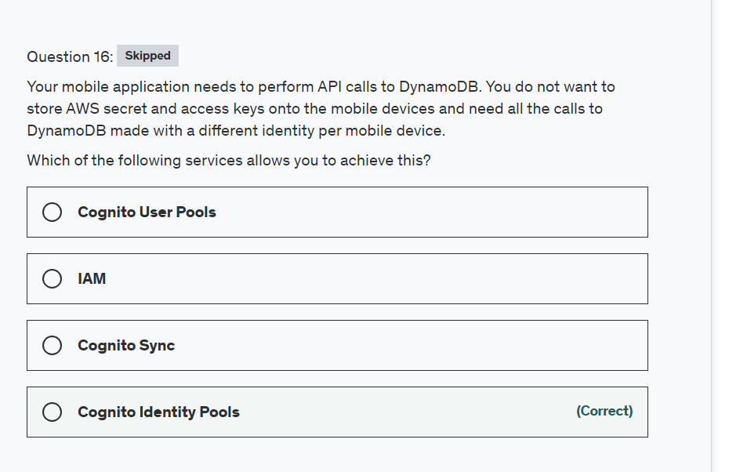

Explanation

Correct option:

"Cognito Identity Pools"

Amazon Cognito identity pools provide temporary AWS credentials for users who are guests (unauthenticated) and for users who have been authenticated and received a token. Identity pools provide AWS credentials to grant your users access to other AWS services.

Cognito Overview:  via - <https://docs.aws.amazon.com/cognito/latest/developerguide/what-is-amazon-cognito.html>

Incorrect options:

"Cognito User Pools" - AWS Cognito User Pools is there to authenticate users for your applications which looks similar to Cognito Identity Pools. The difference is that Identity Pools allows a way to authorize your users to use the various AWS services and User Pools is not about authorizing to AWS services but to provide add sign-up and sign-in functionality to web and mobile applications.

"Cognito Sync" - You can use it to synchronize user profile data across mobile devices and the web without requiring your own backend. The client libraries cache data locally so your app can read and write data regardless of device connectivity status.

"IAM" - This is not a good solution because it would require you to have an IAM user for each mobile device which is not a good practice or manageable way of handling deployment.

Exam Alert:

Please review the following note to understand the differences between Cognito User Pools and Cognito Identity Pools:  via - <https://docs.aws.amazon.com/cognito/latest/developerguide/what-is-amazon-cognito.html>

Reference:

<https://docs.aws.amazon.com/cognito/latest/developerguide/what-is-amazon-cognito.html>

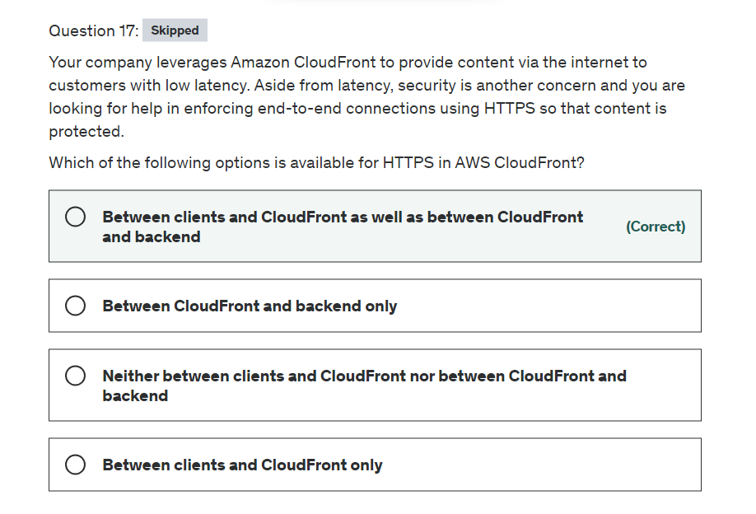

Explanation

Correct option:

**Between clients and CloudFront as well as between CloudFront and backend**

For web distributions, you can configure CloudFront to require that viewers use HTTPS to request your objects, so connections are encrypted when CloudFront communicates with viewers.

Requiring HTTPS for Communication Between Viewers and CloudFront: 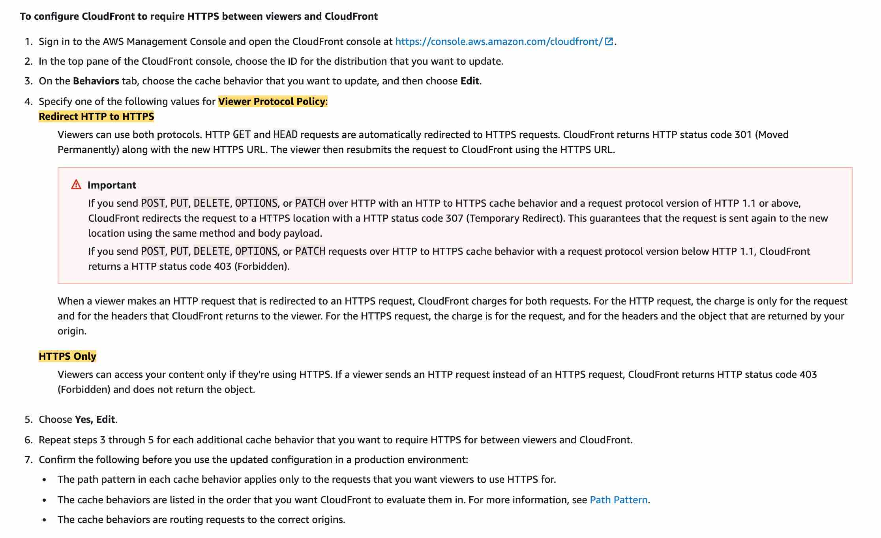 via - <https://docs.aws.amazon.com/AmazonCloudFront/latest/DeveloperGuide/using-https-viewers-to-cloudfront.html>

You also can configure CloudFront to use HTTPS to get objects from your origin, so connections are encrypted when CloudFront communicates with your origin.

Requiring HTTPS for Communication Between CloudFront and Your Custom Origin: 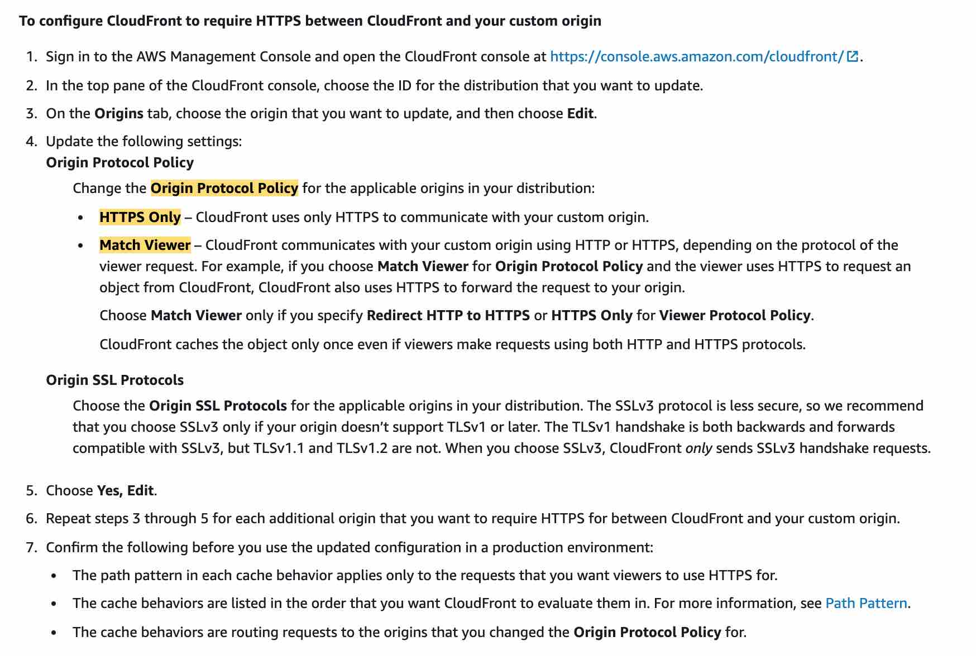 via - <https://docs.aws.amazon.com/AmazonCloudFront/latest/DeveloperGuide/using-https-cloudfront-to-custom-origin.html>

Incorrect options:

**Between clients and CloudFront only** - This is incorrect as you can choose to require HTTPS between CloudFront and your origin.

**Between CloudFront and backend only** - This is incorrect as you can choose to require HTTPS between viewers and CloudFront.

**Neither between clients and CloudFront nor between CloudFront and backend** - This is incorrect as you can choose HTTPS settings both for communication between viewers and CloudFront as well as between CloudFront and your origin.

References:

<https://docs.aws.amazon.com/AmazonCloudFront/latest/DeveloperGuide/secure-connections-supported-viewer-protocols-ciphers.html#secure-connections-supported-ciphers-cloudfront-to-origin>

<https://docs.aws.amazon.com/AmazonCloudFront/latest/DeveloperGuide/using-https-viewers-to-cloudfront.html>

<https://docs.aws.amazon.com/AmazonCloudFront/latest/DeveloperGuide/using-https-cloudfront-to-custom-origin.html>

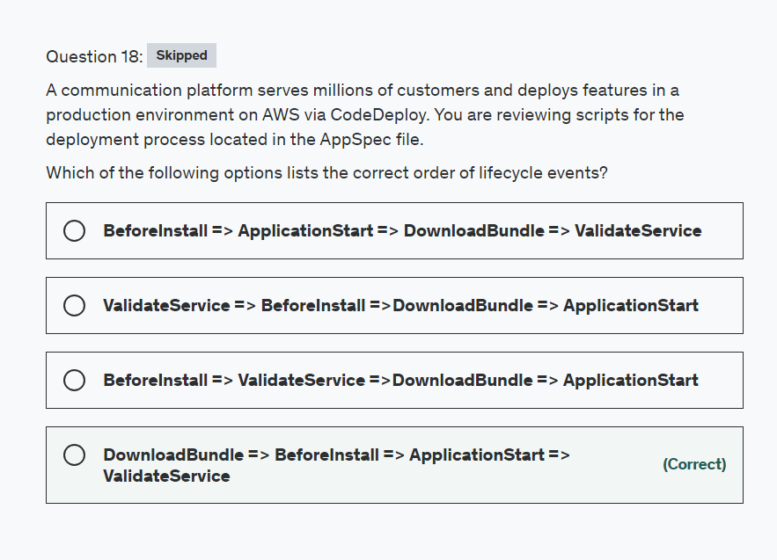

Explanation

Correct option:

**DownloadBundle => BeforeInstall => ApplicationStart => ValidateService**

AWS CodeDeploy is a fully managed deployment service that automates software deployments to a variety of compute services such as Amazon EC2, AWS Fargate, AWS Lambda, and your on-premises servers. AWS CodeDeploy makes it easier for you to rapidly release new features, helps you avoid downtime during application deployment, and handles the complexity of updating your applications.

You can specify one or more scripts to run in a hook. Each hook for a lifecycle event is specified with a string on a separate line.

Please review the correct order of lifecycle events: 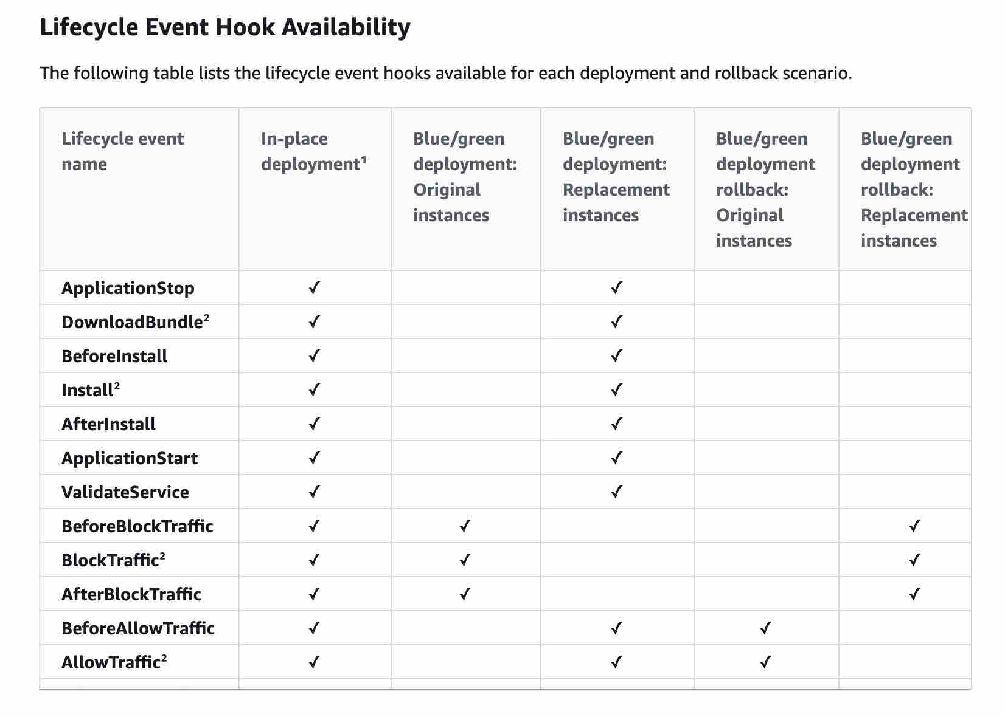 via - <https://docs.aws.amazon.com/codedeploy/latest/userguide/reference-appspec-file-structure-hooks.html#reference-appspec-file-structure-hooks-run-order>

Incorrect options:

**BeforeInstall => ApplicationStart => DownloadBundle => ValidateService**

**ValidateService => BeforeInstall =>DownloadBundle => ApplicationStart**

**BeforeInstall => ValidateService =>DownloadBundle => ApplicationStart**

These three options contradict the details provided in the explanation above, so these options are not correct.

Reference:

<https://docs.aws.amazon.com/codedeploy/latest/userguide/reference-appspec-file-structure-hooks.html#reference-appspec-file-structure-hooks-run-order>

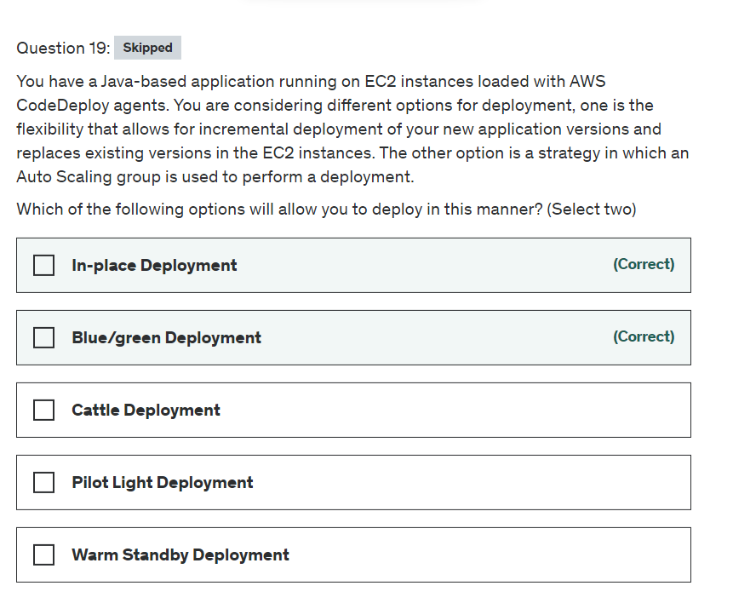

Explanation

Correct options:

**In-place Deployment**

The application on each instance in the deployment group is stopped, the latest application revision is installed, and the new version of the application is started and validated. You can use a load balancer so that each instance is deregistered during its deployment and then restored to service after the deployment is complete.

**Blue/green Deployment**

With a blue/green deployment, you provision a new set of instances on which CodeDeploy installs the latest version of your application. CodeDeploy then re-routes load balancer traffic from an existing set of instances running the previous version of your application to the new set of instances running the latest version. After traffic is re-routed to the new instances, the existing instances can be terminated.

CodeDeploy Deployment Types: 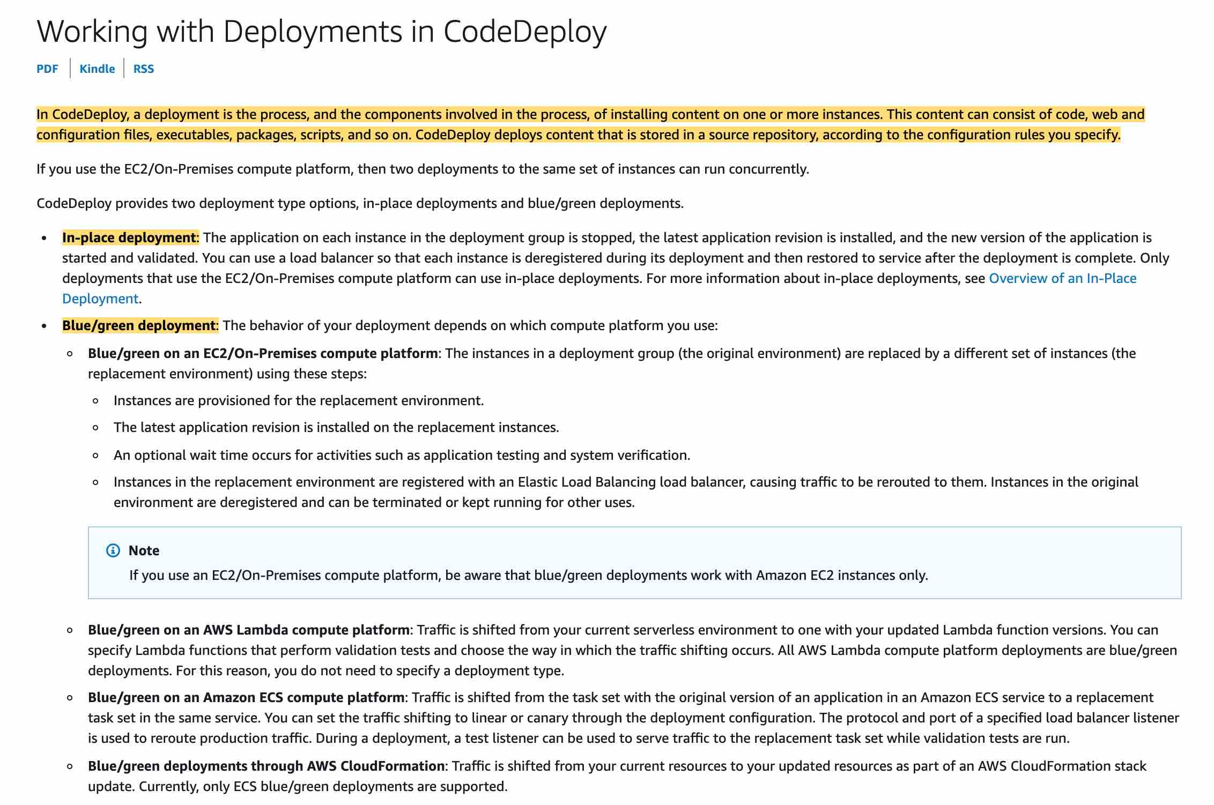 via - <https://docs.aws.amazon.com/codedeploy/latest/userguide/deployments.html>

Incorrect options:

**Cattle Deployment** - This is a good option if you have cattle in a farm

**Warm Standby Deployment** - This is not a valid CodeDeploy deployment option. The term "Warm Standby" is used to describe a Disaster Recovery scenario in which a scaled-down version of a fully functional environment is always running in the cloud.

**Pilot Light Deployment** - This is not a valid CodeDeploy deployment option. "Pilot Light" is a Disaster Recovery approach where you simply replicate part of your IT structure for a limited set of core services so that the AWS cloud environment seamlessly takes over in the event of a disaster.

References:

<https://docs.aws.amazon.com/codedeploy/latest/userguide/deployments.html>

<https://aws.amazon.com/blogs/publicsector/rapidly-recover-mission-critical-systems-in-a-disaster/>

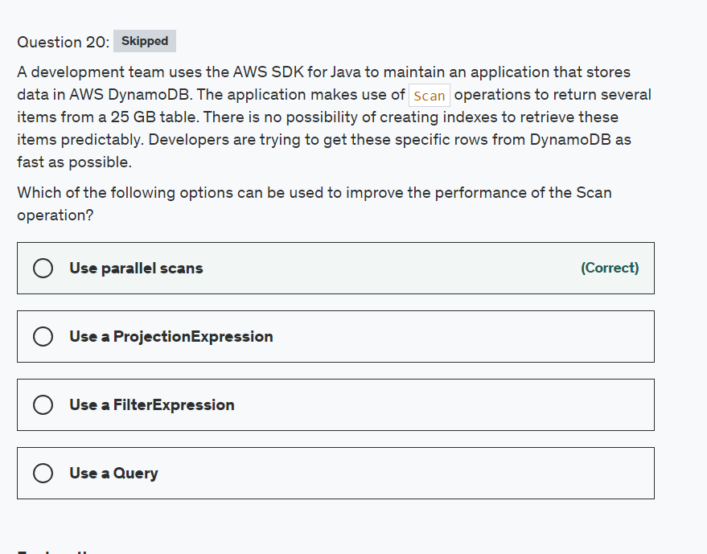

Explanation

Correct option:

**Use parallel scans**

By default, the Scan operation processes data sequentially. Amazon DynamoDB returns data to the application in 1 MB increments, and an application performs additional Scan operations to retrieve the next 1 MB of data. The larger the table or index being scanned, the more time the Scan takes to complete. To address these issues, the Scan operation can logically divide a table or secondary index into multiple segments, with multiple application workers scanning the segments in parallel.

To make use of a parallel Scan feature, you will need to run multiple worker threads or processes in parallel. Each worker will be able to scan a separate partition of a table concurrently with the other workers.

How DynamoDB parallel Scan works: 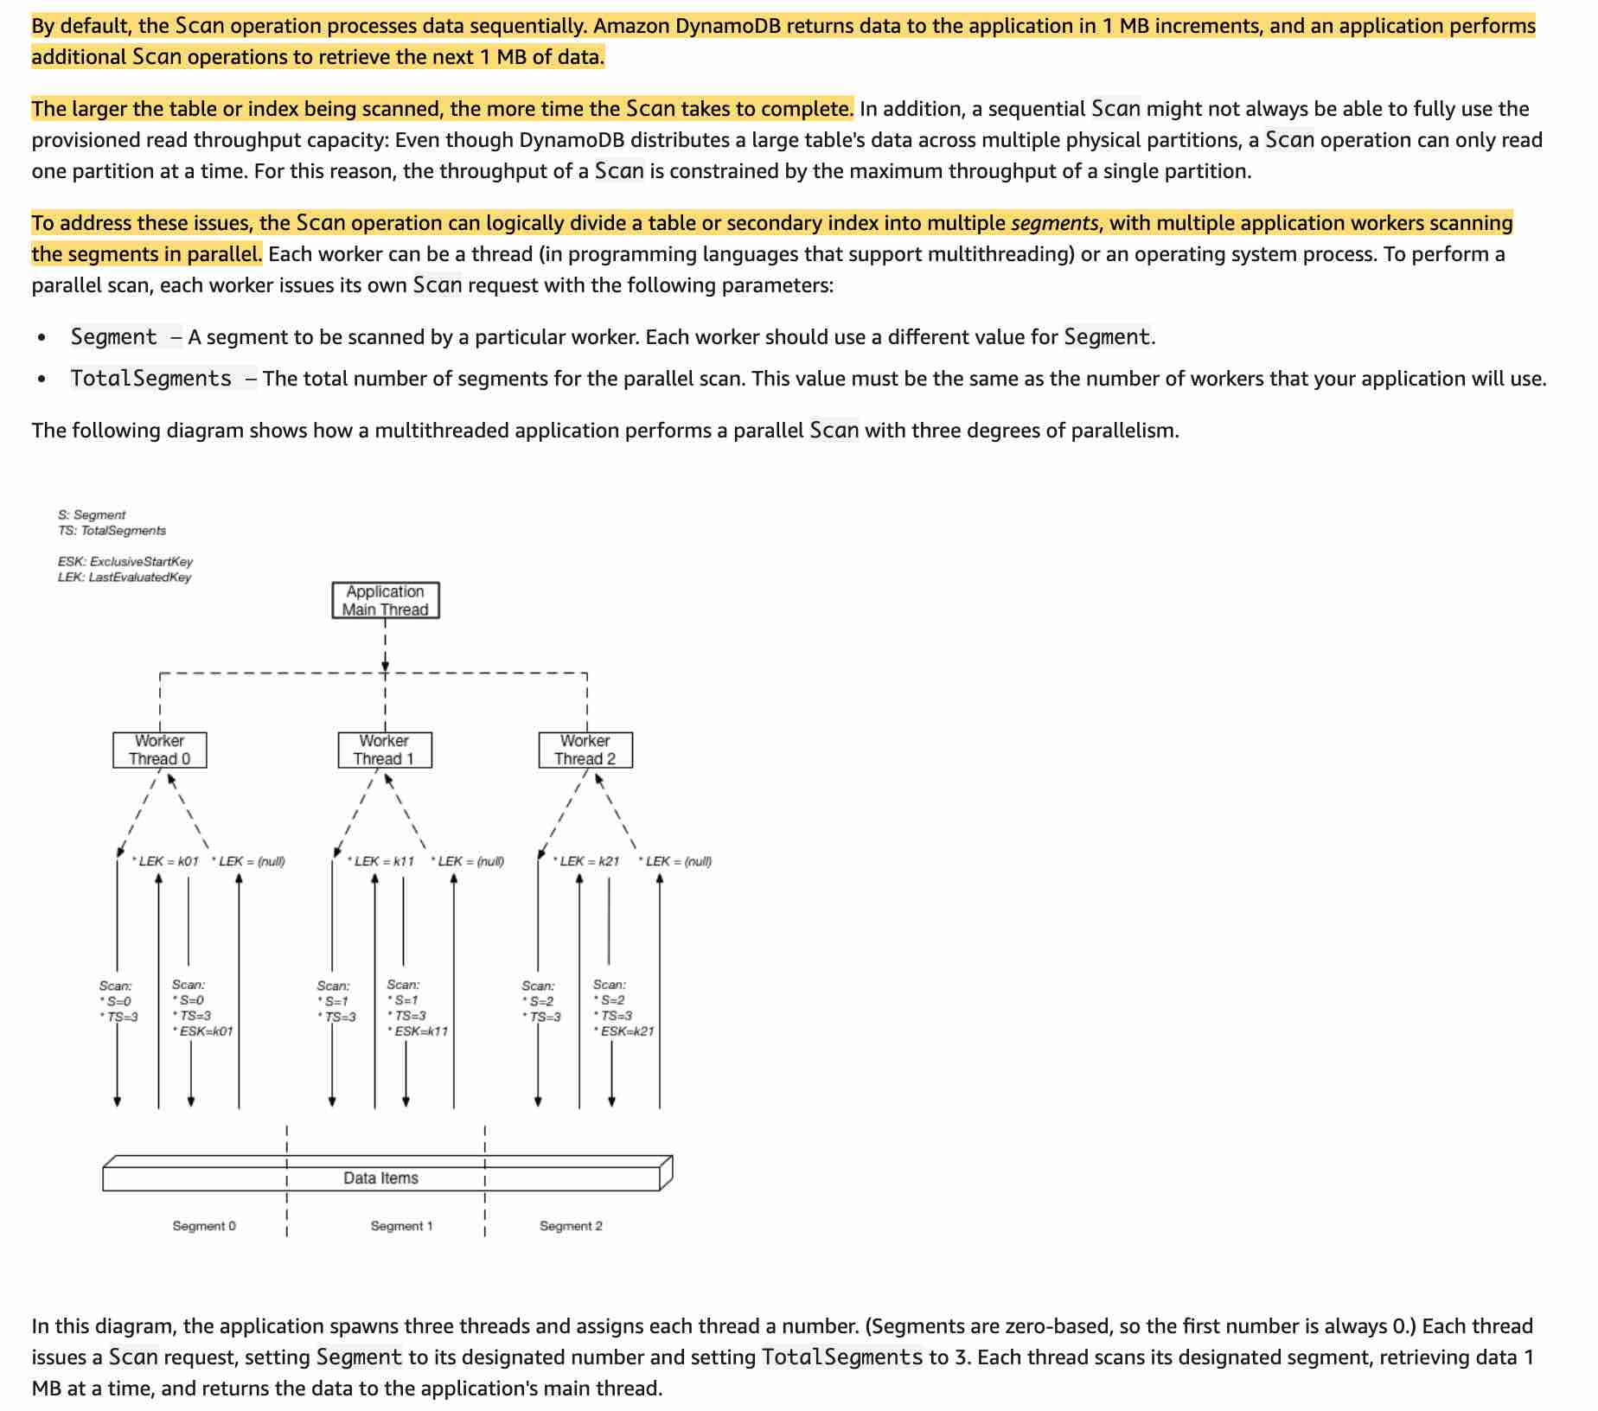 via - <https://docs.aws.amazon.com/amazondynamodb/latest/developerguide/Scan.html#Scan.ParallelScan>

Incorrect options:

**Use a ProjectionExpression** - A projection expression is a string that identifies the attributes you want. To retrieve a single attribute, specify its name. For multiple attributes, the names must be comma-separated

**Use a FilterExpression** - If you need to further refine the Scan results, you can optionally provide a filter expression. A filter expression determines which items within the Scan results should be returned to you. All of the other results are discarded.

A filter expression is applied after a Scan finishes, but before the results are returned. Therefore, a Scan consumes the same amount of read capacity, regardless of whether a filter expression is present.

**Use a Query** - This could work if we were able to create an index, but the question says: "There is no possibility of creating indexes to retrieve these items predictably". As such, we cannot use a Query.

Reference:

<https://docs.aws.amazon.com/amazondynamodb/latest/developerguide/Scan.html#Scan.ParallelScan>

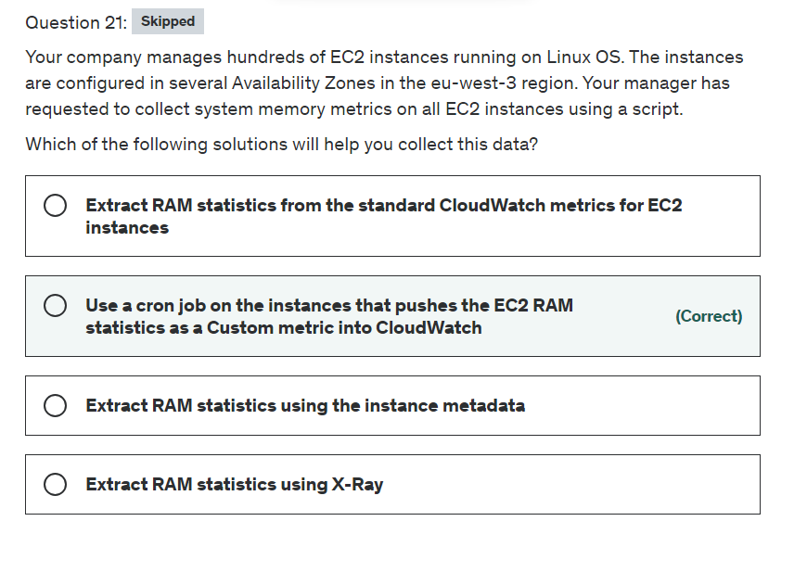

Explanation

Correct option:

"Use a cron job on the instances that pushes the EC2 RAM statistics as a Custom metric into CloudWatch"

The Amazon CloudWatch Monitoring Scripts for Amazon Elastic Compute Cloud (Amazon EC2) Linux-based instances demonstrate how to produce and consume Amazon CloudWatch custom metrics. These Perl scripts comprise a fully functional example that reports memory, swap, and disk space utilization metrics for a Linux instance. You can set a cron schedule for metrics reported to CloudWatch and report memory utilization to CloudWatch every x minutes.

Incorrect options:

"Extract RAM statistics using the instance metadata" - Instance metadata is data about your instance that you can use to configure or manage the running instance. Instance metadata is divided into categories, for example, hostname, events, and security groups. The instance metadata can only provide the ID of the RAM disk specified at launch time. So this option is incorrect.

"Extract RAM statistics from the standard CloudWatch metrics for EC2 instances" - Amazon EC2 sends metrics to Amazon CloudWatch. By default, each data point covers the 5 minutes that follow the start time of activity for the instance. If you've enabled detailed monitoring, each data point covers the next minute of activity from the start time. The standard CloudWatch metrics don't have any metrics for memory utilization details.

"Extract RAM statistics using X-Ray" - AWS X-Ray helps developers analyze and debug production, distributed applications, such as those built using a microservices architecture. With X-Ray, you can understand how your application and its underlying services are performing to identify and troubleshoot the root cause of performance issues and errors. X-Ray provides an end-to-end view of requests as they travel through your application, and shows a map of your application’s underlying components.

How X-Ray Works:  via - <https://aws.amazon.com/xray/>

X-Ray cannot be used to extract RAM statistics for EC2 instances.

For more information visit https://docs.aws.amazon.com/AWSEC2/latest/UserGuide/mon-scripts.html

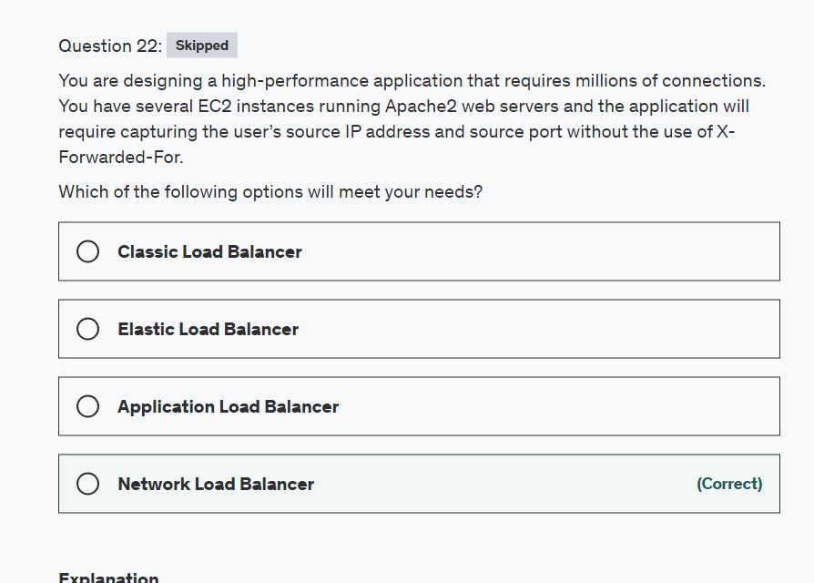

Explanation

Correct option:

**Network Load Balancer**

A Network Load Balancer functions at the fourth layer of the Open Systems Interconnection (OSI) model. It can handle millions of requests per second. After the load balancer receives a connection request, it selects a target from the target group for the default rule. It attempts to open a TCP connection to the selected target on the port specified in the listener configuration. Incoming connections remain unmodified, so application software need not support X-Forwarded-For.

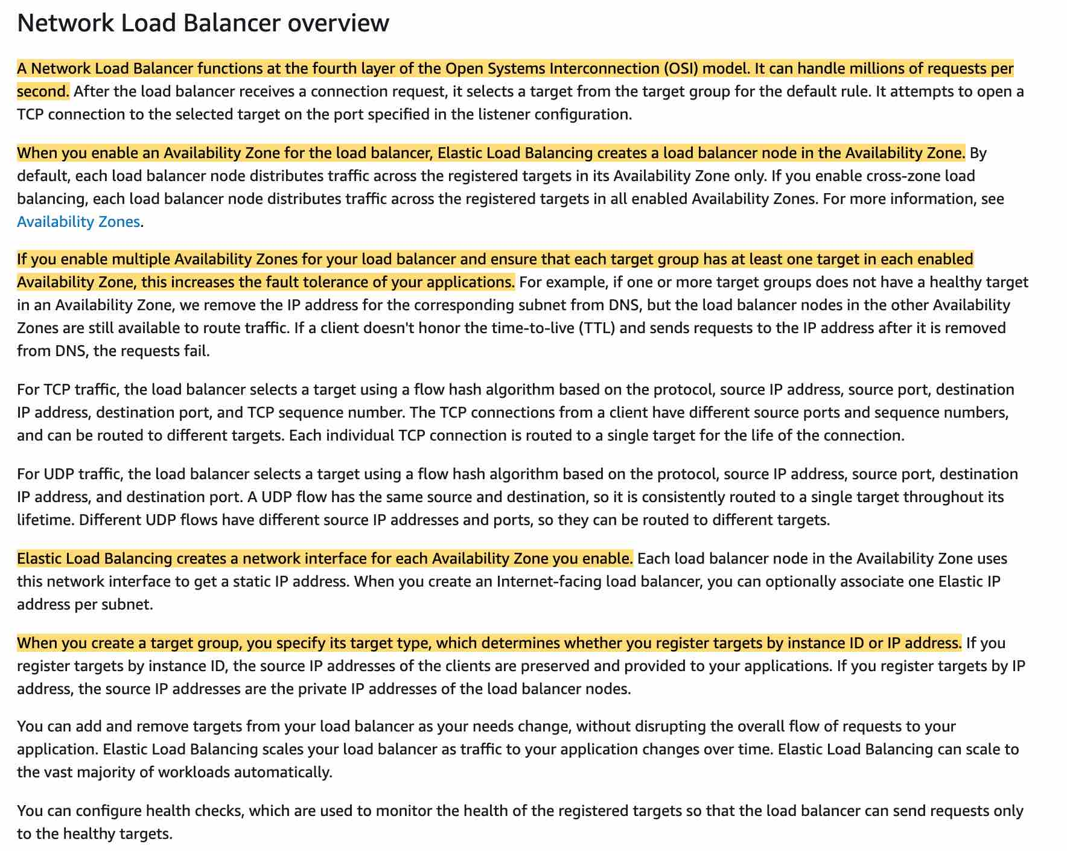 via - <https://docs.aws.amazon.com/elasticloadbalancing/latest/network/introduction.html>

Incorrect options:

**Application Load Balancer** - An Application Load Balancer functions at the application layer, the seventh layer of the Open Systems Interconnection (OSI) model. After the load balancer receives a request, it evaluates the listener rules in priority order to determine which rule to apply and then selects a target from the target group for the rule action.

One of many benefits of the Application Load Balancer is its support for path-based routing. You can configure rules for your listener that forward requests based on the URL in the request. This enables you to structure your application as smaller services, and route requests to the correct service based on the content of the URL. For needs relating to network traffic go with Network Load Balancer.

**Elastic Load Balancer** - Elastic Load Balancing is the service itself that offers different types of load balancers.

**Classic Load Balancer** - It is a basic load balancer that distributes traffic. If your account was created before 2013-12-04, your account supports EC2-Classic instances and you will benefit in using this type of load balancer. The classic load balancer can be used regardless of when your account was created and whether you use EC2-Classic or whether your instances are in a VPC but just remember its the basic load balancer AWS offers and not advanced as the others.

Reference:

<https://docs.aws.amazon.com/elasticloadbalancing/latest/network/introduction.html>

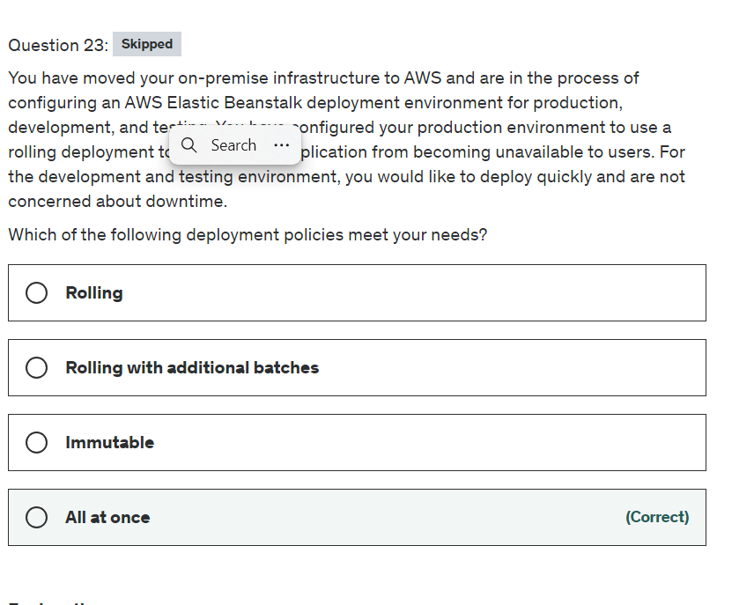

Explanation

Correct option:

**All at once**

This is the quickest deployment method. Suitable if you can accept a short loss of service, and if quick deployments are important to you. With this method, Elastic Beanstalk deploys the new application version to each instance. Then, the web proxy or application server might need to restart. As a result, your application might be unavailable to users (or have low availability) for a short time.

Overview of Elastic Beanstalk Deployment Policies: 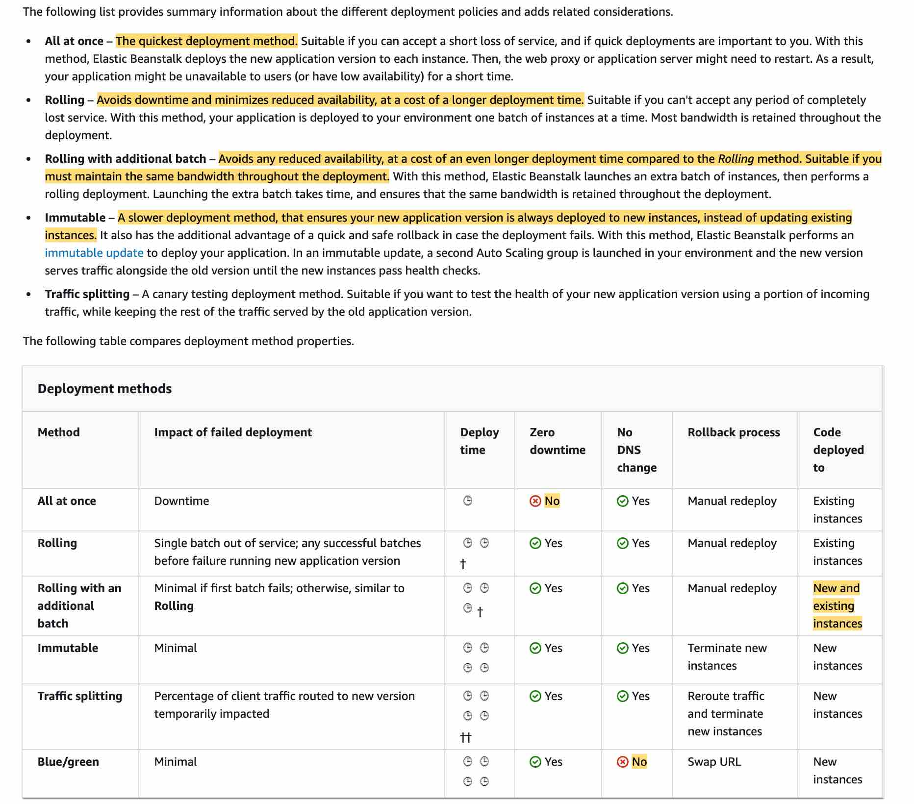 via - <https://docs.aws.amazon.com/elasticbeanstalk/latest/dg/using-features.deploy-existing-version.html>

Incorrect options:

**Rolling** - With this method, your application is deployed to your environment one batch of instances at a time. Most bandwidth is retained throughout the deployment. Avoids downtime and minimizes reduced availability, at a cost of a longer deployment time. Suitable if you can't accept any period of completely lost service.

**Rolling with additional batches** - With this method, Elastic Beanstalk launches an extra batch of instances, then performs a rolling deployment. Launching the extra batch takes time, and ensures that the same bandwidth is retained throughout the deployment. This policy also avoids any reduced availability, although at a cost of an even longer deployment time compared to the Rolling method. Finally, this option is suitable if you must maintain the same bandwidth throughout the deployment.

**Immutable** - A slower deployment method, that ensures your new application version is always deployed to new instances, instead of updating existing instances. It also has the additional advantage of a quick and safe rollback in case the deployment fails. With this method, Elastic Beanstalk performs an immutable update to deploy your application. In an immutable update, a second Auto Scaling group is launched in your environment and the new version serves traffic alongside the old version until the new instances pass health checks.

Reference:

<https://docs.aws.amazon.com/elasticbeanstalk/latest/dg/using-features.deploy-existing-version.html>

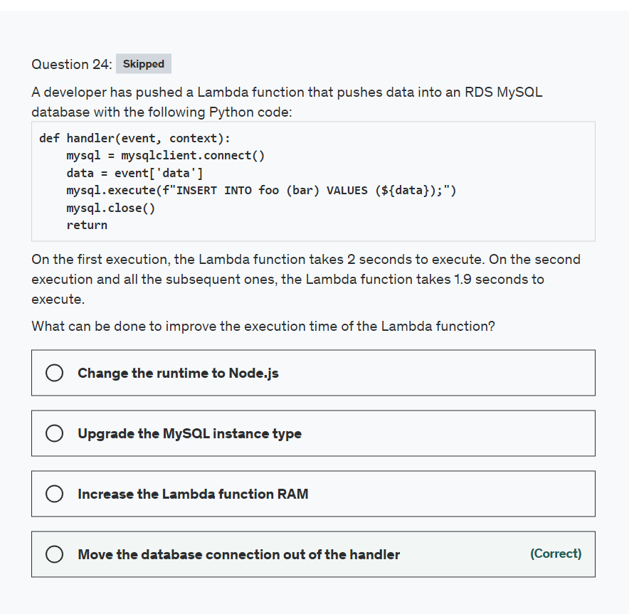

Explanation

Correct option:

**Move the database connection out of the handler**

Here at every Lambda function execution, the database connection handler will be created, and then closed. These connections steps are expensive in terms of time, and thus should be moved out of the handler function so that they are kept in the function execution context, and re-used across function calls. This is what the function should look like in the end:

mysql = mysqlclient.connect()

def handler(event, context):

data = event['data']

mysql.execute(f"INSERT INTO foo (bar) VALUES (${data});")

return

Incorrect options:

**Upgrade the MySQL instance type** - The bottleneck here is the MySQL connection object, not the MySQL instance itself.

**Change the runtime to Node.js** - Re-writing the function in another runtime won't improve the performance.

**Increase the Lambda function RAM** - While this may help speed-up the Lambda function, as increasing the RAM also increases the CPU allocated to your function, it only makes sense if RAM or CPU is a critical factor in the Lambda function performance. Here, the connection object is at fault.

Reference:

<https://docs.aws.amazon.com/lambda/latest/dg/running-lambda-code.html>

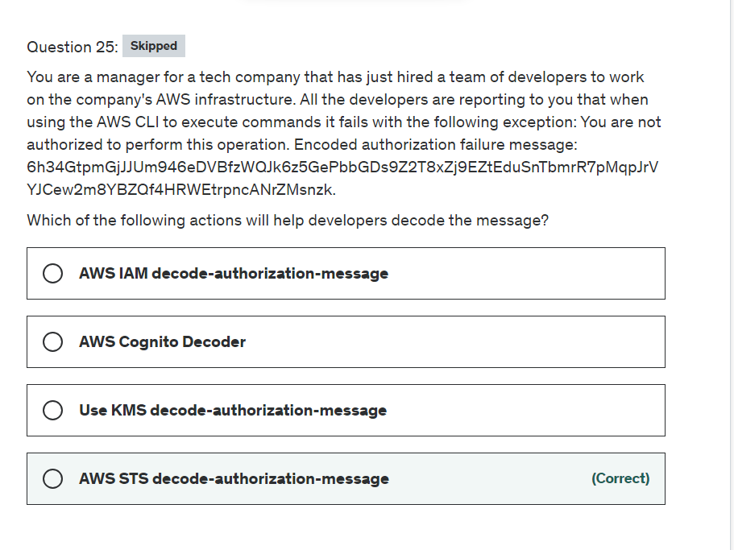

Explanation

Correct option:

**AWS STS decode-authorization-message**

Use decode-authorization-message to decode additional information about the authorization status of a request from an encoded message returned in response to an AWS request. If a user is not authorized to perform an action that was requested, the request returns a Client.UnauthorizedOperation response (an HTTP 403 response). The message is encoded because the details of the authorization status can constitute privileged information that the user who requested the operation should not see. To decode an authorization status message, a user must be granted permissions via an IAM policy to request the DecodeAuthorizationMessage (sts:DecodeAuthorizationMessage) action.

Incorrect options:

**AWS IAM decode-authorization-message** - The IAM service does not have this command, as it's a made-up option.

**Use KMS decode-authorization-message** - The KMS service does not have this command, as it's a made-up option.

**AWS Cognito Decoder** - The Cognito service does not have this command, as it's a made-up option.

Reference:

<https://docs.aws.amazon.com/cli/latest/reference/sts/decode-authorization-message.html>

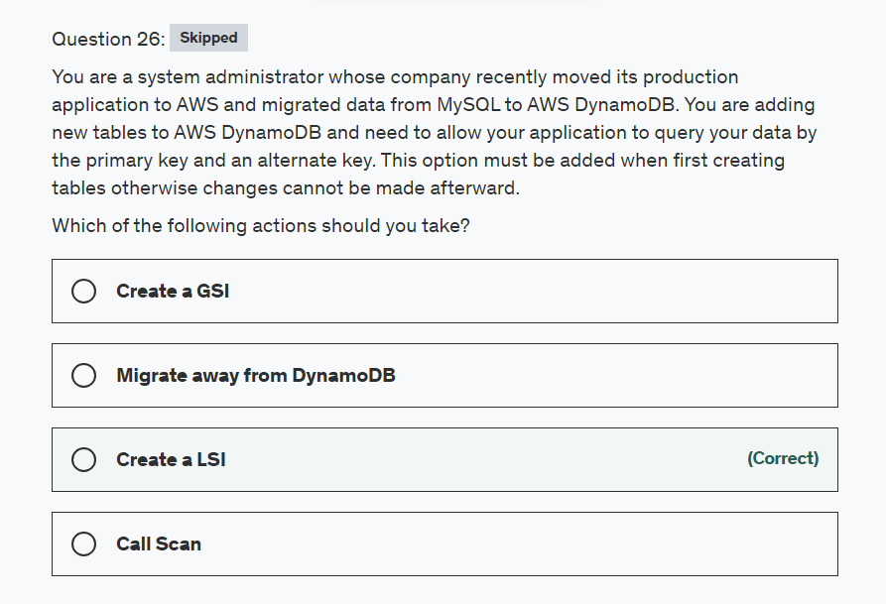

Explanation

Correct option:

**Create an LSI**

LSI stands for Local Secondary Index. Some applications only need to query data using the base table's primary key; however, there may be situations where an alternate sort key would be helpful. To give your application a choice of sort keys, you can create one or more local secondary indexes on a table and issue Query or Scan requests against these indexes.

Differences between GSI and LSI: 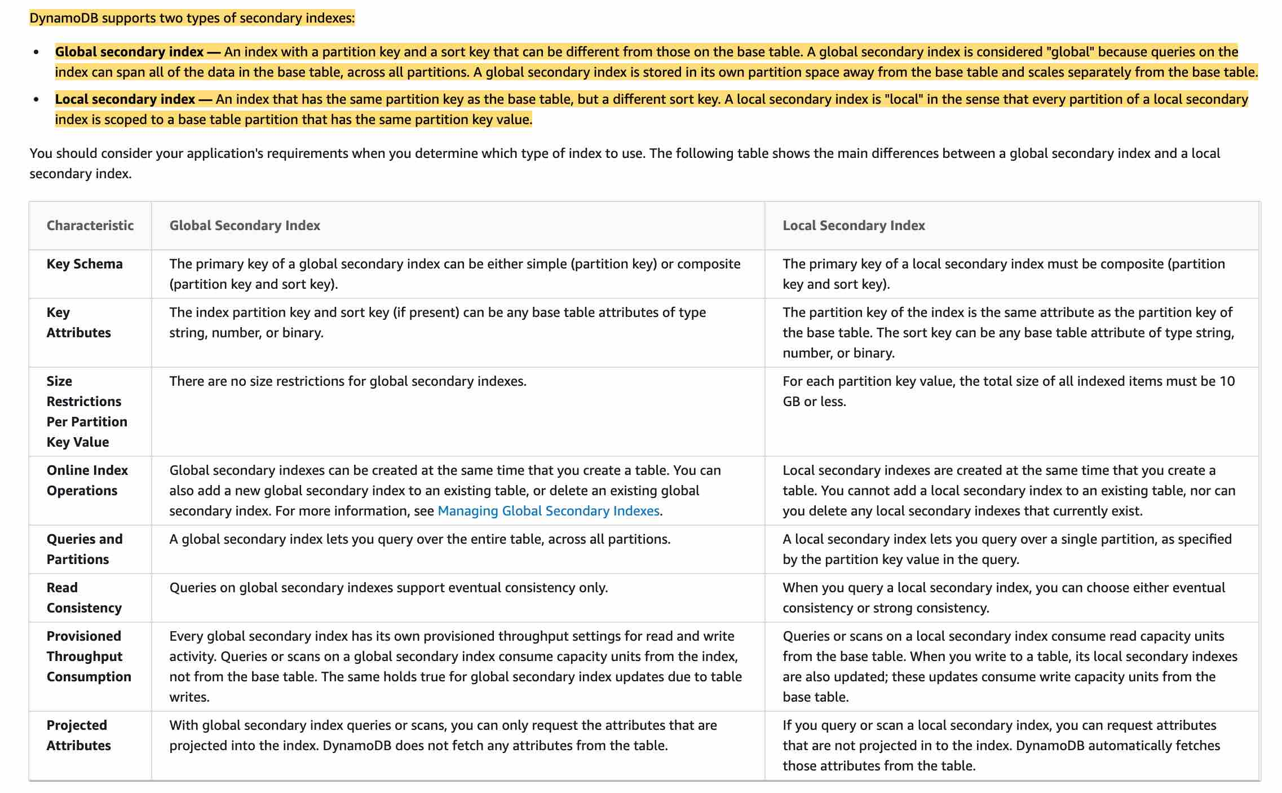 via - <https://docs.aws.amazon.com/amazondynamodb/latest/developerguide/SecondaryIndexes.html>

Incorrect options:

**Call Scan** - Scan is an operation on the data. Once you create your local secondary indexes on a table you can then issue Scan requests again.

**Create a GSI** - GSI (Global Secondary Index) is an index with a partition key and a sort key that can be different from those on the base table.

**Migrate away from DynamoDB** - Migrating to another database that is not NoSQL may cause you to make changes that require substantial code changes.

Reference:

<https://docs.aws.amazon.com/amazondynamodb/latest/developerguide/SecondaryIndexes.html>

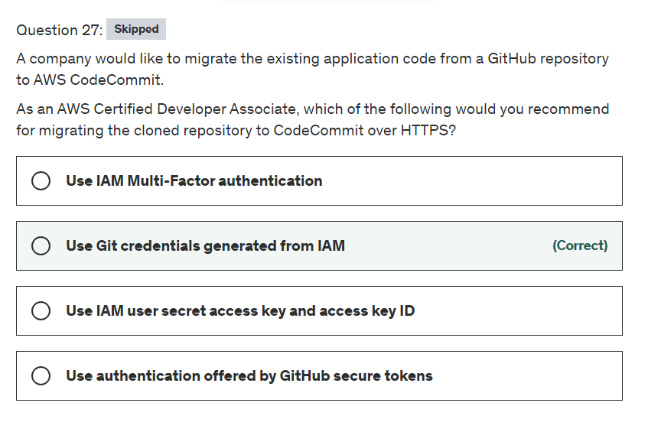

Explanation

Correct option:

**Use Git credentials generated from IAM** - CodeCommit repositories are Git-based and support the basic functionalities of Git such as Git credentials. AWS recommends that you use an IAM user when working with CodeCommit. You can access CodeCommit with other identity types, but the other identity types are subject to limitations.

The simplest way to set up connections to AWS CodeCommit repositories is to configure Git credentials for CodeCommit in the IAM console, and then use those credentials for HTTPS connections. You can also use these same credentials with any third-party tool or individual development environment (IDE) that supports HTTPS authentication using a static user name and password.

An IAM user is an identity within your Amazon Web Services account that has specific custom permissions. For example, an IAM user can have permissions to create and manage Git credentials for accessing CodeCommit repositories. This is the recommended user type for working with CodeCommit. You can use an IAM user name and password to sign in to secure AWS webpages like the AWS Management Console, AWS Discussion Forums, or the AWS Support Center.

Authentication and access control for AWS CodeCommit: 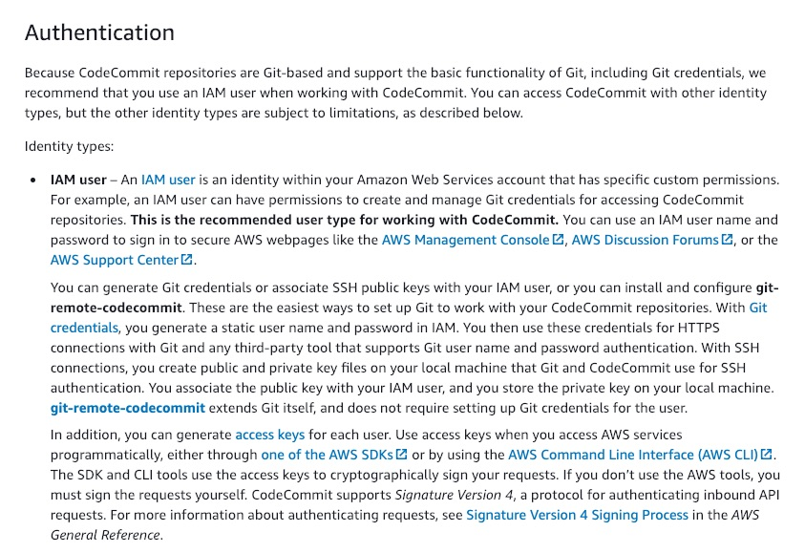 via - <https://docs.aws.amazon.com/codecommit/latest/userguide/auth-and-access-control.html>

Incorrect options:

**Use IAM Multi-Factor authentication** - AWS Multi-Factor Authentication (MFA) is a simple best practice that adds an extra layer of protection on top of your user name and password. With MFA enabled, when a user signs in to an AWS Management Console, they will be prompted for their user name and password (the first factor—what they know), as well as for an authentication code from their AWS MFA device (the second factor—what they have). Taken together, these multiple factors provide increased security for your AWS account settings and resources.

**Use IAM user secret access key and access key ID** - Access keys are long-term credentials for an IAM user or the AWS account root user. You can use access keys to sign programmatic requests to the AWS CLI or AWS API (directly or using the AWS SDK). As a best practice, AWS suggests using temporary security credentials (IAM roles) instead of access keys.

**Use authentication offered by GitHub secure tokens** - Personal access tokens (PATs) are an alternative to using passwords for authentication to GitHub when using the GitHub API or the command line. This option is specific to GitHub only and hence not useful for the given use case.

References:

<https://docs.aws.amazon.com/codecommit/latest/userguide/auth-and-access-control.html>

<https://docs.aws.amazon.com/codecommit/latest/userguide/setting-up-gc.html>

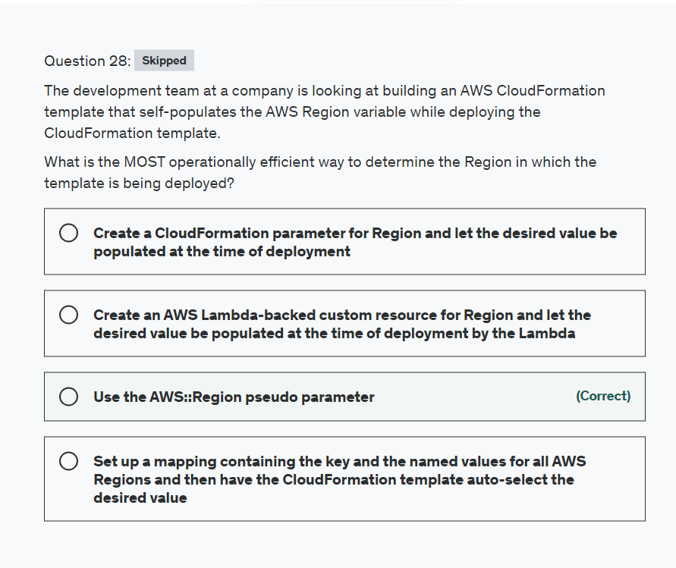

Explanation

Correct option:

**Use the AWS::Region pseudo parameter**

Pseudo parameters are parameters that are predefined by AWS CloudFormation. You don't declare them in your template. Use them the same way as you would a parameter, as the argument for the Ref function.

You can access pseudo parameters in a CloudFormation template like so:

Outputs:

MyStacksRegion:

Value: !Ref "AWS::Region"

The AWS::Region pseudo parameter returns a string representing the Region in which the encompassing resource is being created, such as us-west-2.

Incorrect options:

**Create a CloudFormation parameter for Region and let the desired value be populated at the time of deployment** - Although it is certainly possible to use a CloudFormation parameter to populate the desired value of the Region at the time of deployment, however, this is not operationally efficient, as you can directly use the AWS::Region pseudo parameter for this.

**Set up a mapping containing the key and the named values for all AWS Regions and then have the CloudFormation template auto-select the desired value** - The Mappings section matches a key to a corresponding set of named values. For example, if you want to set values based on a Region, you can create a mapping that uses the Region name as a key and contains the values you want to specify for each specific Region. You use the Fn::FindInMap intrinsic function to retrieve values in a map. This option is incorrect as the CloudFormation template cannot auto-select the desired value of the Region from a mapping.

**Create an AWS Lambda-backed custom resource for Region and let the desired value be populated at the time of deployment by the Lambda** - Custom resources enable you to write custom provisioning logic in templates that AWS CloudFormation runs anytime you create, update (if you changed the custom resource), or delete stacks. When you associate a Lambda function with a custom resource, the function is invoked whenever the custom resource is created, updated, or deleted. This option is a distractor, as Region is not a custom resource that needs to be provisioned.

References:

<https://docs.aws.amazon.com/AWSCloudFormation/latest/UserGuide/pseudo-parameter-reference.html>

<https://docs.aws.amazon.com/AWSCloudFormation/latest/UserGuide/template-custom-resources.html>

<https://docs.aws.amazon.com/AWSCloudFormation/latest/UserGuide/mappings-section-structure.html>

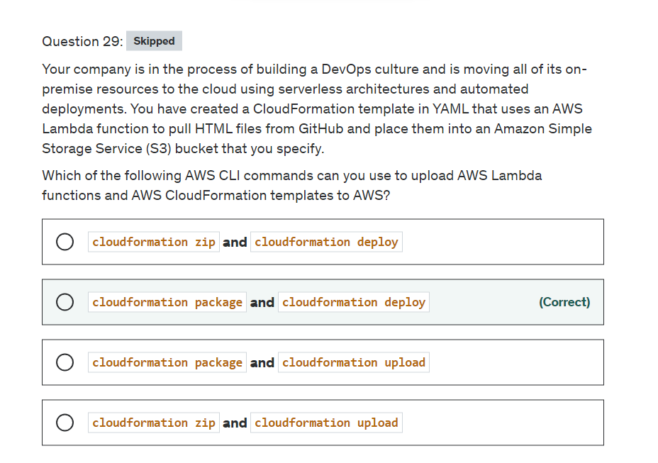

Explanation

Correct option:

**cloudformation package and cloudformation deploy**

AWS CloudFormation gives developers and businesses an easy way to create a collection of related AWS and third-party resources and provision them in an orderly and predictable fashion.

How CloudFormation Works:  via - <https://aws.amazon.com/cloudformation/>

The cloudformation package command packages the local artifacts (local paths) that your AWS CloudFormation template references. The command will upload local artifacts, such as your source code for your AWS Lambda function.

The cloudformation deploy command deploys the specified AWS CloudFormation template by creating and then executing a changeset.

Incorrect options:

**cloudformation package and cloudformation upload** - The cloudformation upload command does not exist.

**cloudformation zip and cloudformation upload** - Both commands do not exist, this is a made-up option.

**cloudformation zip and cloudformation deploy** - The cloudformation zip command does not exist, this is a made-up option.

Reference:

<https://docs.aws.amazon.com/cli/latest/reference/cloudformation/package.html>

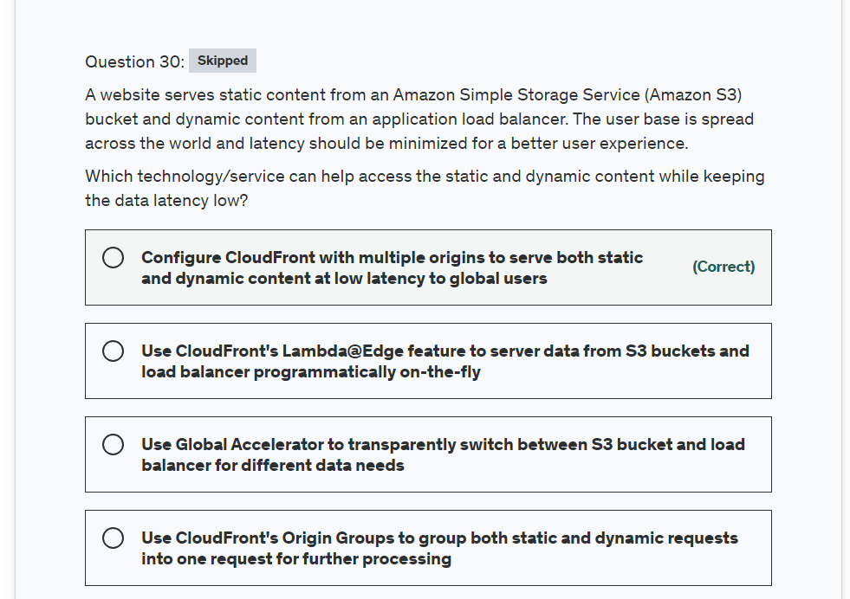

Explanation

Correct option:

**Configure CloudFront with multiple origins to serve both static and dynamic content at low latency to global users**

Amazon CloudFront is a web service that speeds up distribution of your static and dynamic web content, such as .html, .css, .js, and image files, to your users. CloudFront delivers your content through a worldwide network of data centers called edge locations. When a user requests content that you're serving with CloudFront, the request is routed to the edge location that provides the lowest latency (time delay), so that content is delivered with the best possible performance.

You can configure a single CloudFront web distribution to serve different types of requests from multiple origins.

Steps to configure CLoudFront for multiple origins: 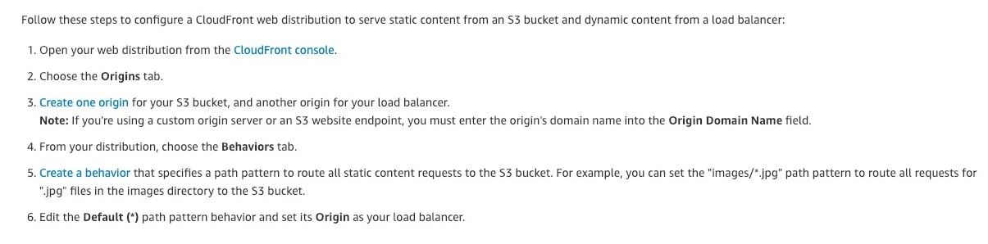 via - <https://aws.amazon.com/premiumsupport/knowledge-center/cloudfront-distribution-serve-content/>

Incorrect options:

**Use CloudFront's Lambda@Edge feature to server data from S3 buckets and load balancer programmatically on-the-fly** - AWS Lambda@Edge is a general-purpose serverless compute feature that supports a wide range of computing needs and customizations. Lambda@Edge is best suited for computationally intensive operations. This is not relevant for the given use case.

**Use Global Accelerator to transparently switch between S3 bucket and load balancer for different data needs** - AWS Global Accelerator is a networking service that improves the performance of your users’ traffic by up to 60% using Amazon Web Services’ global network infrastructure.

With Global Accelerator, you are provided two global static public IPs that act as a fixed entry point to your application, improving availability. On the back end, add or remove your AWS application endpoints, such as Application Load Balancers, Network Load Balancers, EC2 Instances, and Elastic IPs without making user-facing changes. Global Accelerator automatically re-routes your traffic to your nearest healthy available endpoint to mitigate endpoint failure.

CloudFront improves performance for both cacheable content (such as images and videos) and dynamic content (such as API acceleration and dynamic site delivery). Global Accelerator is a good fit for non-HTTP use cases, such as gaming (UDP), IoT (MQTT), or Voice over IP, as well as for HTTP use cases that specifically require static IP addresses or deterministic, fast regional failover.

Global Accelerator is not relevant for the given use-case.

**Use CloudFront's Origin Groups to group both static and dynamic requests into one request for further processing** - You can set up CloudFront with origin failover for scenarios that require high availability. To get started, you create an Origin Group with two origins: a primary and a secondary. If the primary origin is unavailable or returns specific HTTP response status codes that indicate a failure, CloudFront automatically switches to the secondary origin. Origin Groups are for origin failure scenarios and not for request routing.

References:

<https://docs.aws.amazon.com/AmazonCloudFront/latest/DeveloperGuide/distribution-overview.html>

<https://docs.aws.amazon.com/AmazonCloudFront/latest/DeveloperGuide/high_availability_origin_failover.html>

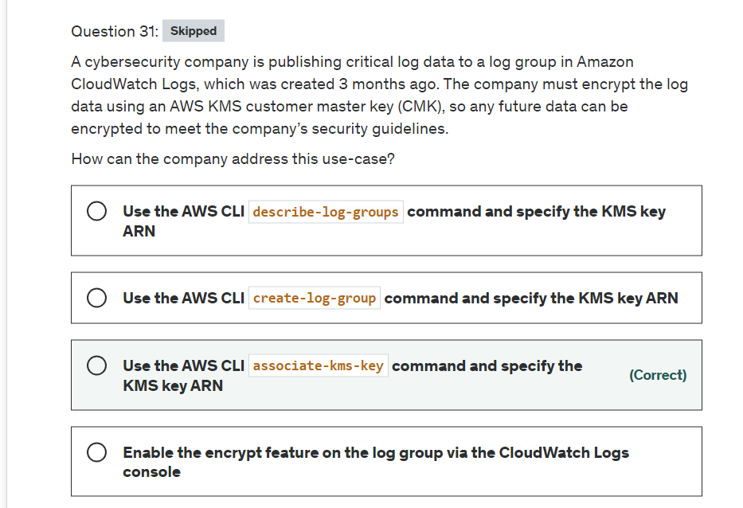

Explanation

Correct option:

**Use the AWS CLI associate-kms-key command and specify the KMS key ARN**

Log group data is always encrypted in CloudWatch Logs. You can optionally use AWS AWS Key Management Service for this encryption. If you do, the encryption is done using an AWS KMS (AWS KMS) customer master key (CMK). Encryption using AWS KMS is enabled at the log group level, by associating a CMK with a log group, either when you create the log group or after it exists.

After you associate a CMK with a log group, all newly ingested data for the log group is encrypted using the CMK. This data is stored in an encrypted format throughout its retention period. CloudWatch Logs decrypts this data whenever it is requested. CloudWatch Logs must have permissions for the CMK whenever encrypted data is requested.

To associate the CMK with an existing log group, you can use the associate-kms-key command.

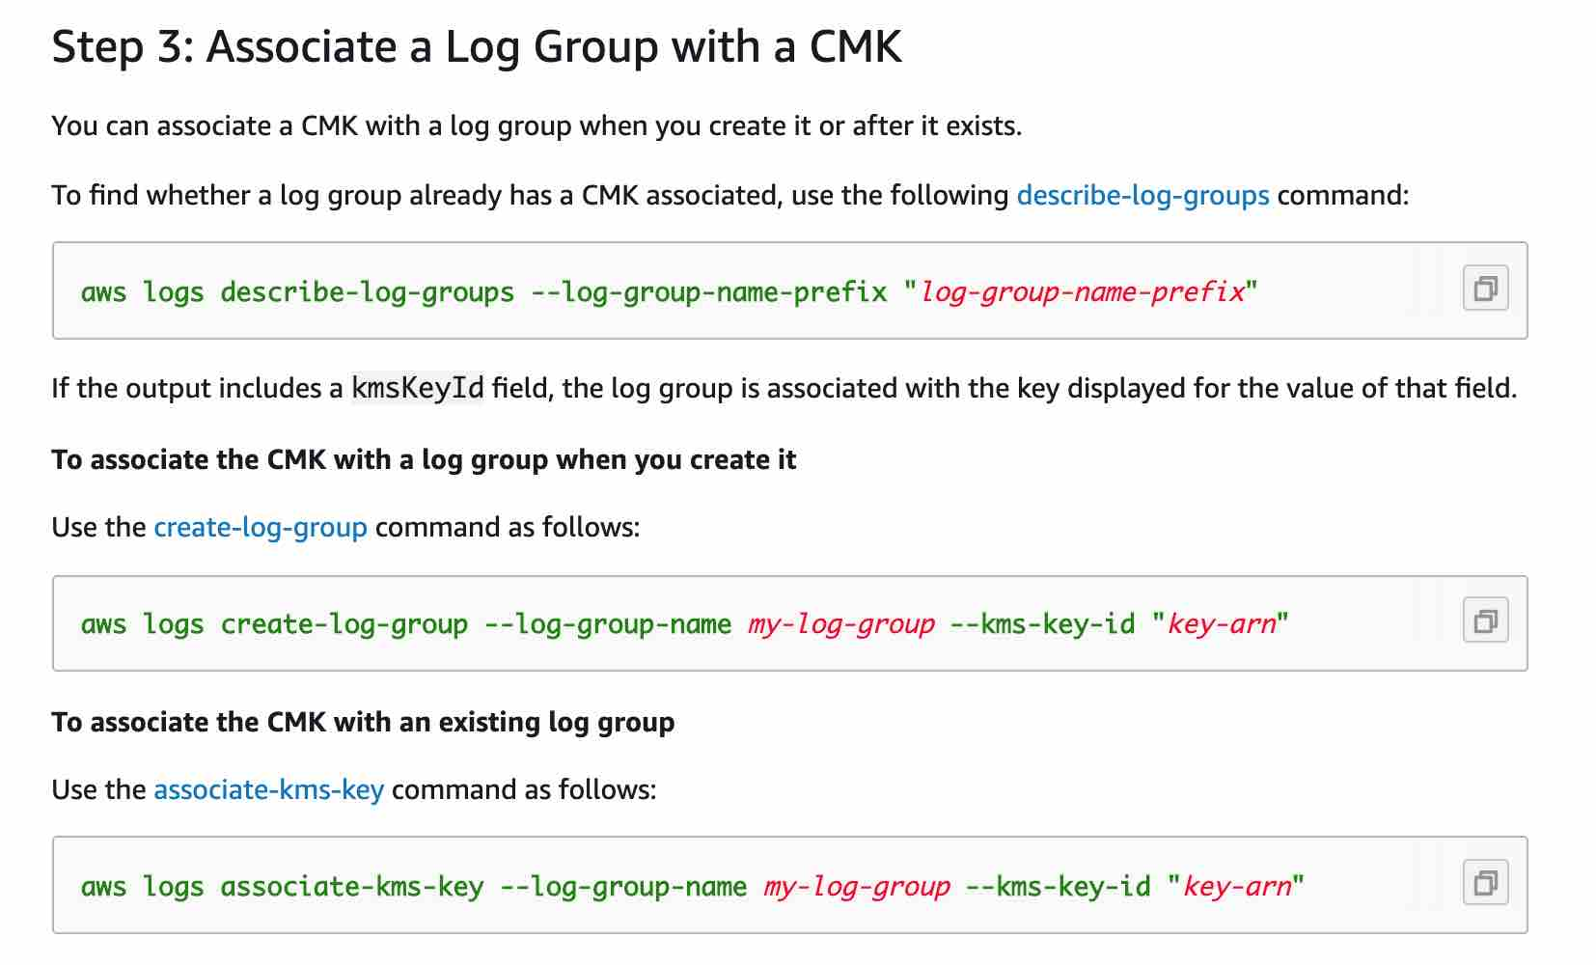 via - <https://docs.aws.amazon.com/AmazonCloudWatch/latest/logs/encrypt-log-data-kms.html>

Incorrect options:

**Enable the encrypt feature on the log group via the CloudWatch Logs console** - CloudWatch Logs console does not have an option to enable encryption for a log group.

**Use the AWS CLI describe-log-groups command and specify the KMS key ARN** - You can use the describe-log-groups command to find whether a log group already has a CMK associated with it.

**Use the AWS CLI create-log-group command and specify the KMS key ARN** - You can use the create-log-group command to associate the CMK with a log group when you create it.

Reference:

<https://docs.aws.amazon.com/AmazonCloudWatch/latest/logs/encrypt-log-data-kms.html>

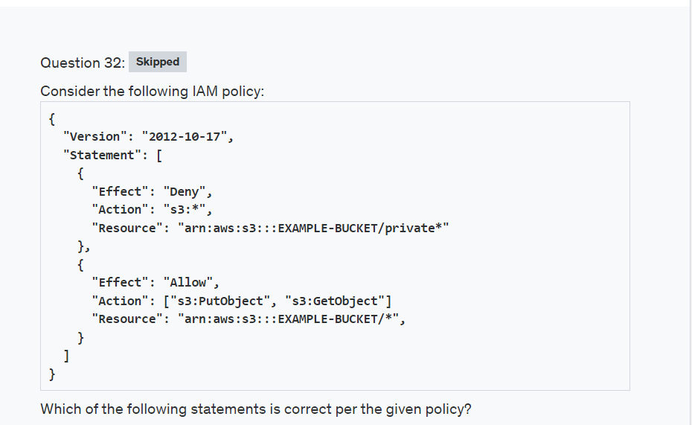

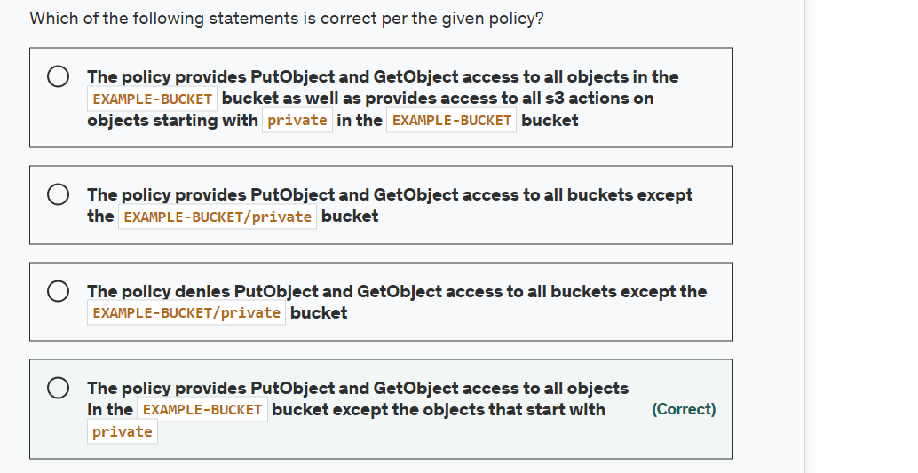

Explanation

Correct option:

**The policy provides PutObject and GetObject access to all objects in the EXAMPLE-BUCKET bucket except the objects that start with private**

The first statement denies access to any objects that start with private in the EXAMPLE-BUCKET bucket. The second statement allows PutObject and GetObject access to all objects in the EXAMPLE-BUCKET bucket. So the net effect is to allow PutObject and GetObject access to all objects in the EXAMPLE-BUCKET bucket except the objects that start with private.

Incorrect options:

**The policy provides PutObject and GetObject access to all buckets except the EXAMPLE-BUCKET/private bucket**

**The policy provides PutObject and GetObject access to all objects in the EXAMPLE-BUCKET bucket as well as provides access to all s3 actions on objects starting with private in the EXAMPLE-BUCKET bucket**

**The policy denies PutObject and GetObject access to all buckets except the EXAMPLE-BUCKET/private bucket**

These three options contradict the explanation provided above, so these options are incorrect.

Reference:

<https://docs.aws.amazon.com/IAM/latest/UserGuide/access_policies.html>

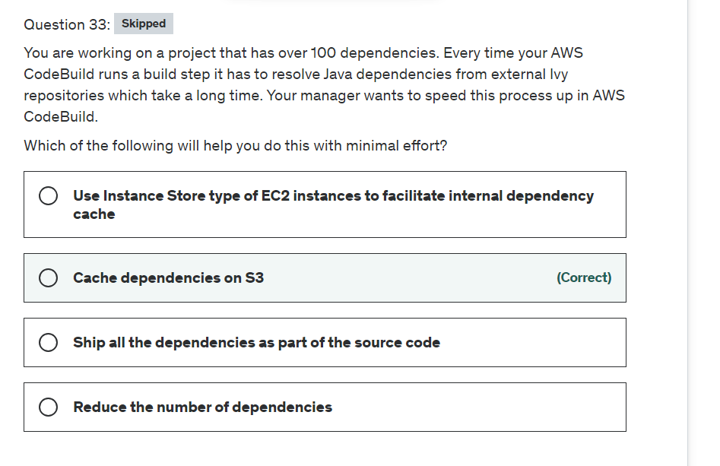

Explanation

Correct option:

**Cache dependencies on S3**

AWS CodeBuild is a fully managed continuous integration service that compiles source code, runs tests, and produces software packages that are ready to deploy. With CodeBuild, you don’t need to provision, manage, and scale your build servers.

Downloading dependencies is a critical phase in the build process. These dependent files can range in size from a few KBs to multiple MBs. Because most of the dependent files do not change frequently between builds, you can noticeably reduce your build time by caching dependencies in S3.

Best Practices for Caching Dependencies: 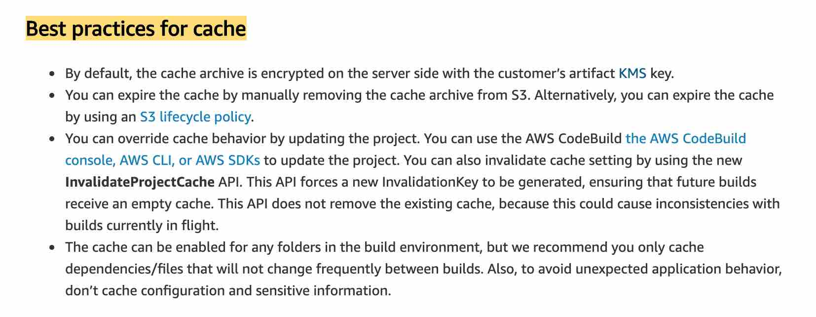 via - <https://aws.amazon.com/blogs/devops/how-to-enable-caching-for-aws-codebuild/>

Incorrect options:

**Reduce the number of dependencies** - This is ideal but sometimes you may not have control over this as your application needs those dependencies, so this option is ruled out.

**Ship all the dependencies as part of the source code** - This is not a good practice as doing this will increase your build time. If your dependencies are not changing then its best to cache them.

**Use Instance Store type of EC2 instances to facilitate internal dependency cache** - An instance store provides temporary block-level storage for your instance. This storage is located on disks that are physically attached to the host computer. Instance store is ideal for the temporary storage of information that changes frequently, such as buffers, caches, scratch data, and other temporary content, or for data that is replicated across a fleet of instances, such as a load-balanced pool of web servers.

Instance Store cannot be used to facilitate the internal dependency cache for the code build process.

Reference:

<https://aws.amazon.com/blogs/devops/how-to-enable-caching-for-aws-codebuild/>

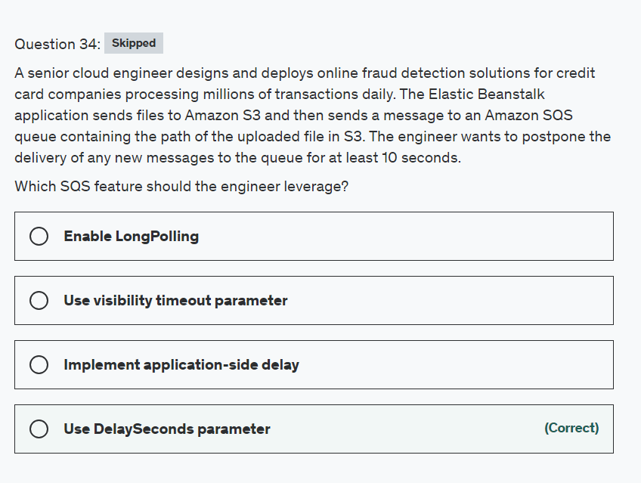

Explanation

Correct option:

**Use DelaySeconds parameter**

Amazon Simple Queue Service (SQS) is a fully managed message queuing service that enables you to decouple and scale microservices, distributed systems, and serverless applications. SQS offers two types of message queues. Standard queues offer maximum throughput, best-effort ordering, and at-least-once delivery. SQS FIFO queues are designed to guarantee that messages are processed exactly once, in the exact order that they are sent.

Delay queues let you postpone the delivery of new messages to a queue for several seconds, for example, when your consumer application needs additional time to process messages. If you create a delay queue, any messages that you send to the queue remain invisible to consumers for the duration of the delay period. The default (minimum) delay for a queue is 0 seconds. The maximum is 15 minutes.

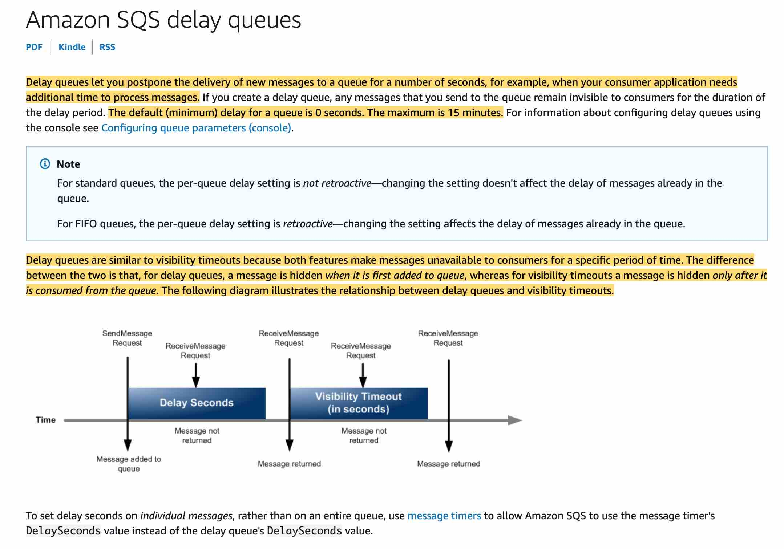 via - <https://docs.aws.amazon.com/AWSSimpleQueueService/latest/SQSDeveloperGuide/sqs-delay-queues.html>

Incorrect options:

**Implement application-side delay** - You can customize your application to delay sending messages but it is not a robust solution. You can run into a scenario where your application crashes before sending a message, then that message would be lost.

**Use visibility timeout parameter** - Visibility timeout is a period during which Amazon SQS prevents other consumers from receiving and processing a given message. The default visibility timeout for a message is 30 seconds. The minimum is 0 seconds. The maximum is 12 hours. You cannot use visibility timeout to postpone the delivery of new messages to the queue for a few seconds.

**Enable LongPolling** - Long polling makes it inexpensive to retrieve messages from your Amazon SQS queue as soon as the messages are available. Long polling helps reduce the cost of using Amazon SQS by eliminating the number of empty responses (when there are no messages available for a ReceiveMessage request) and false empty responses (when messages are available but aren't included in a response). When the wait time for the ReceiveMessage API action is greater than 0, long polling is in effect. The maximum long polling wait time is 20 seconds. You cannot use LongPolling to postpone the delivery of new messages to the queue for a few seconds.

Reference:

<https://docs.aws.amazon.com/AWSSimpleQueueService/latest/SQSDeveloperGuide/sqs-delay-queues.html>

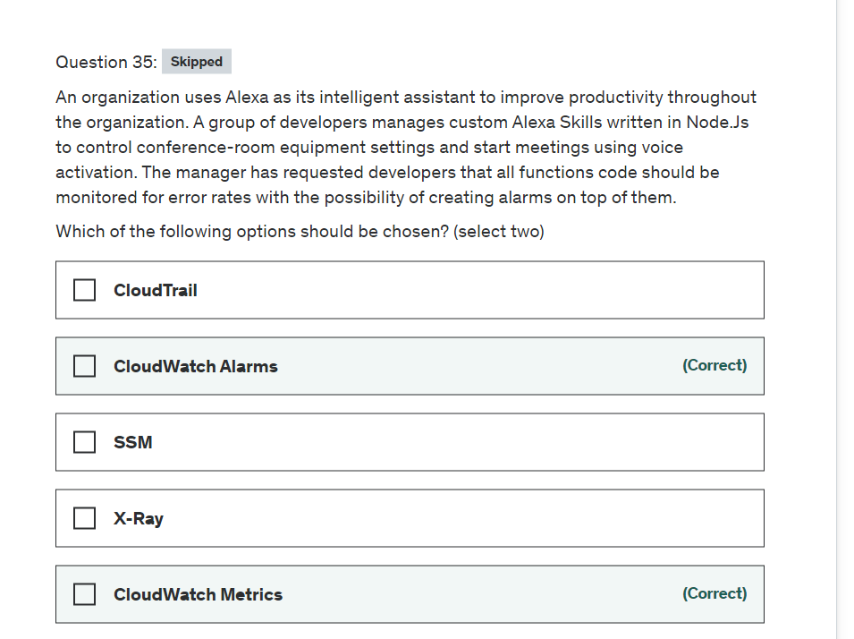

Explanation

Correct options:

CloudWatch collects monitoring and operational data in the form of logs, metrics, and events, and visualizes it using automated dashboards so you can get a unified view of your AWS resources, applications, and services that run in AWS and on-premises. You can correlate your metrics and logs to better understand the health and performance of your resources. You can also create alarms based on metric value thresholds you specify, or that can watch for anomalous metric behavior based on machine learning algorithms.

How CloudWatch works: 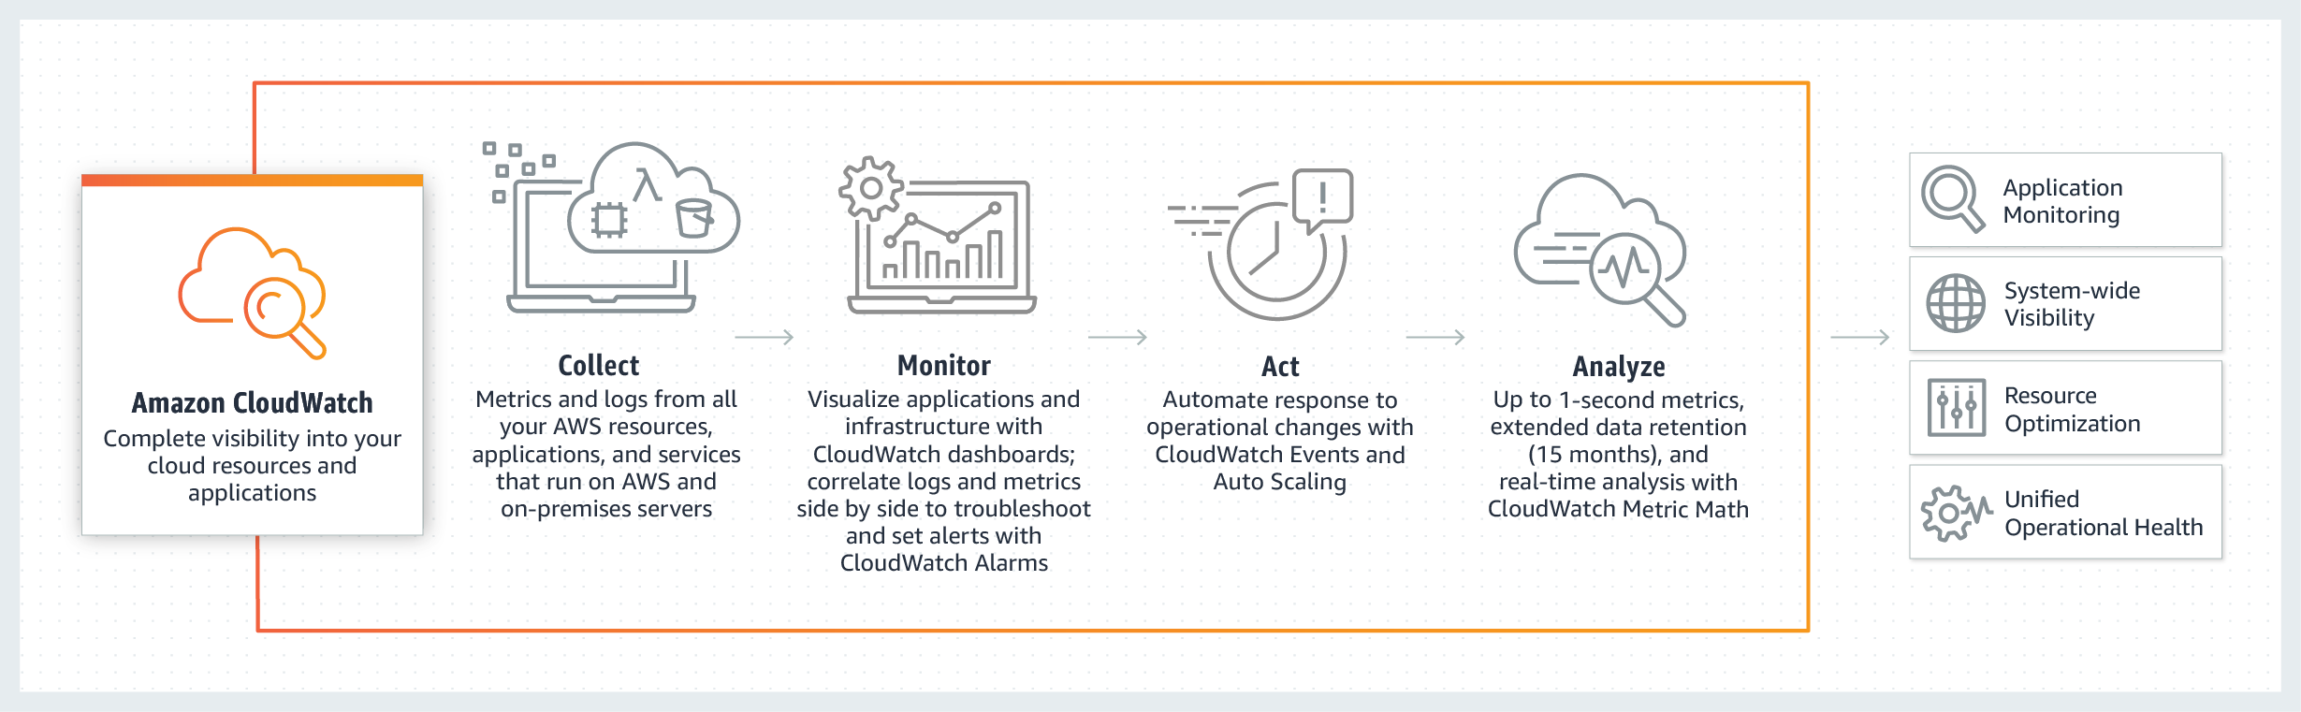 via - <https://aws.amazon.com/cloudwatch/>

**CloudWatch Metrics**

Amazon CloudWatch monitors your Amazon Web Services (AWS) resources and the applications you run on AWS in real-time. You can use CloudWatch to collect and track metrics, which are variables you can measure for your resources and applications. Metric data is kept for 15 months, enabling you to view both up-to-the-minute data and historical data.

CloudWatch retains metric data as follows:

Data points with a period of less than 60 seconds are available for 3 hours. These data points are high-resolution custom metrics. Data points with a period of 60 seconds (1 minute) are available for 15 days Data points with a period of 300 seconds (5 minute) are available for 63 days Data points with a period of 3600 seconds (1 hour) are available for 455 days (15 months)

**CloudWatch Alarms**

You can use an alarm to automatically initiate actions on your behalf. An alarm watches a single metric over a specified time, and performs one or more specified actions, based on the value of the metric relative to a threshold over time. The action is a notification sent to an Amazon SNS topic or an Auto Scaling policy. You can also add alarms to dashboards.

CloudWatch alarms send notifications or automatically make changes to the resources you are monitoring based on rules that you define. Alarms work together with CloudWatch Metrics.

A metric alarm has the following possible states:

OK – The metric or expression is within the defined threshold.

ALARM – The metric or expression is outside of the defined threshold.

INSUFFICIENT_DATA – The alarm has just started, the metric is not available, or not enough data is available for the metric to determine the alarm state.

Incorrect options:

**X-Ray** - AWS X-Ray helps developers analyze and debug production, distributed applications, such as those built using a microservices architecture. With X-Ray, you can understand how your application and its underlying services are performing to identify and troubleshoot the root cause of performance issues and errors. X-Ray provides an end-to-end view of requests as they travel through your application, and shows a map of your application’s underlying components.

How X-Ray Works:  via - <https://aws.amazon.com/xray/>

X-Ray cannot be used to capture metrics and set up alarms as per the given use-case, so this option is incorrect.

**CloudTrail** - CloudWatch is a monitoring service whereas CloudTrail is more of an audit service where you can find API calls made on services and by whom.

How CloudTrail Works:  via - <https://aws.amazon.com/cloudtrail/>

**Systems Manager** - Using AWS Systems Manager, you can group resources, like Amazon EC2 instances, Amazon S3 buckets, or Amazon RDS instances, by application, view operational data for monitoring and troubleshooting, and take action on your groups of resources. Systems Manager cannot be used to capture metrics and set up alarms as per the given use-case, so this option is incorrect.

References:

<https://aws.amazon.com/cloudwatch/>

<https://aws.amazon.com/cloudtrail/>

<https://docs.aws.amazon.com/AmazonCloudWatch/latest/monitoring/cloudwatch_concepts.html>

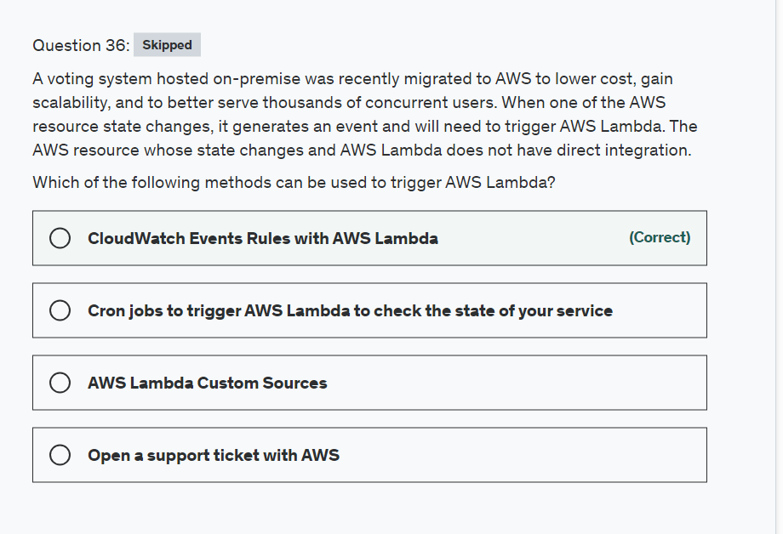

Explanation

Correct option:

**CloudWatch Events Rules with AWS Lambda**

You can create a Lambda function and direct CloudWatch Events to execute it on a regular schedule. You can specify a fixed rate (for example, execute a Lambda function every hour or 15 minutes), or you can specify a Cron expression.

CloudWatch Events Key Concepts: 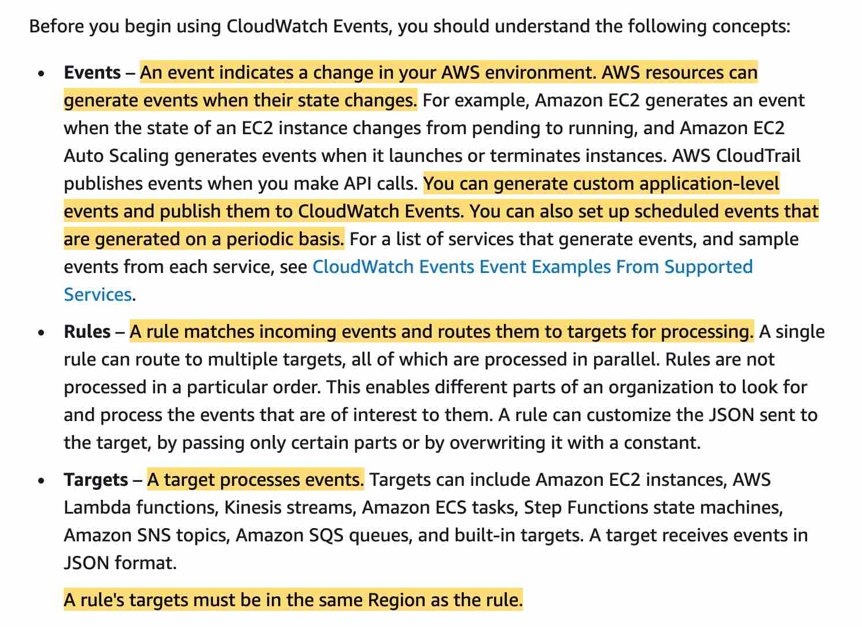 via - <https://docs.aws.amazon.com/AmazonCloudWatch/latest/events/WhatIsCloudWatchEvents.html>

Schedule Expressions for CloudWatch Events Rules: 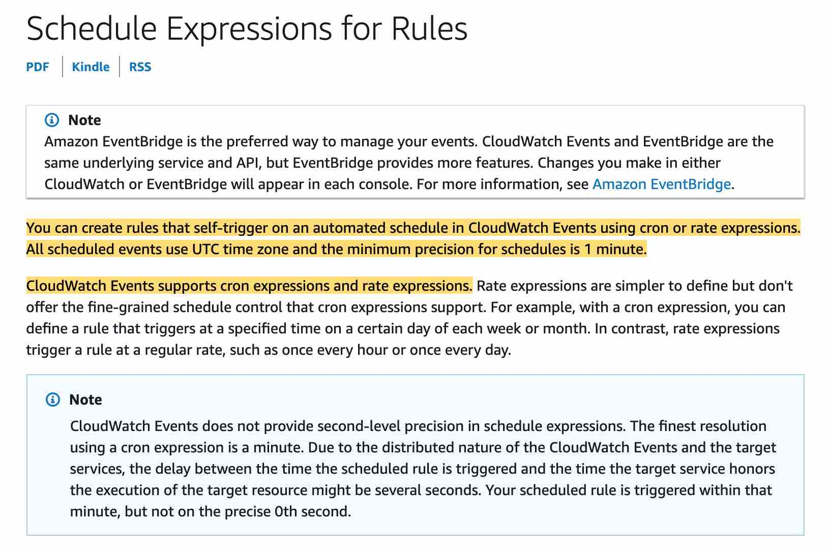 via - <https://docs.aws.amazon.com/AmazonCloudWatch/latest/events/ScheduledEvents.html>

Incorrect options:

**AWS Lambda Custom Sources** - This is a made-up option and has been added as a distractor.

**Open a support ticket with AWS** - You can, although the AWS support team will not add a custom configuration for you, they will step you through creating event rule with Lambda.

**Cron jobs to trigger AWS Lambda to check the state of your service** - You would need an additional server for your cron job instead you should consider using a cron expression with CloudWatch.

References:

<https://docs.aws.amazon.com/AmazonCloudWatch/latest/events/WhatIsCloudWatchEvents.html>

<https://docs.aws.amazon.com/AmazonCloudWatch/latest/events/ScheduledEvents.html>

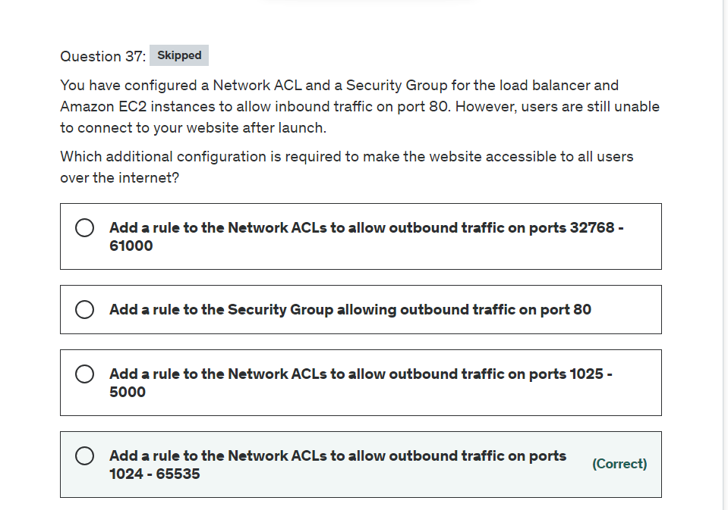

Explanation

Correct option:

**Add a rule to the Network ACLs to allow outbound traffic on ports 1024 - 65535**

A Network Access Control List (ACL) is an optional layer of security for your VPC that acts as a firewall for controlling traffic in and out of one or more subnets. You might set up network ACLs with rules similar to your security groups in order to add an additional layer of security to your VPC.

When you create a custom Network ACL and associate it with a subnet, by default, this custom Network ACL denies all inbound and outbound traffic until you add rules. A network ACL has separate inbound and outbound rules, and each rule can either allow or deny traffic. Network ACLs are stateless, which means that responses to allowed inbound traffic are subject to the rules for outbound traffic (and vice versa).

The client that initiates the request chooses the ephemeral port range. The range varies depending on the client's operating system. Requests originating from Elastic Load Balancing use ports 1024-65535. List of ephemeral port ranges:

Many Linux kernels (including the Amazon Linux kernel) use ports 32768-61000.

Requests originating from Elastic Load Balancing use ports 1024-65535.

Windows operating systems through Windows Server 2003 use ports 1025-5000.

Windows Server 2008 and later versions use ports 49152-65535.

A NAT gateway uses ports 1024-65535.

AWS Lambda functions use ports 1024-65535.

Incorrect options:

**Add a rule to the Network ACLs to allow outbound traffic on ports 1025 - 5000** - As discussed above, Windows operating systems through Windows Server 2003 use ports 1025-5000. ELB uses the port range 1024-65535.

**Add a rule to the Network ACLs to allow outbound traffic on ports 32768 - 61000** - As discussed above, Linux kernels (including the Amazon Linux kernel) use ports 1025-5000. ELB uses the port range 1024-65535.

**Add a rule to the Security Group allowing outbound traffic on port 80** - A security group acts as a virtual firewall for your instance to control inbound and outbound traffic. Security groups act at the instance level, not the subnet level. Security groups are stateful — if you send a request from your instance, the response traffic for that request is allowed to flow in regardless of inbound security group rules. Responses to allowed inbound traffic are allowed to flow out, regardless of outbound rules.

References:

<https://docs.aws.amazon.com/vpc/latest/userguide/vpc-network-acls.html>

<https://docs.aws.amazon.com/vpc/latest/userguide/VPC_SecurityGroups.html>

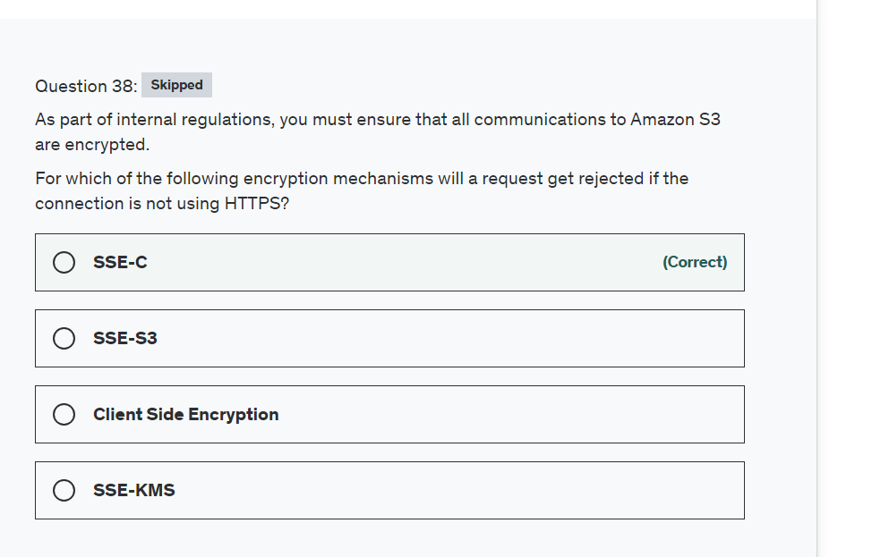

Explanation

Correct option:

**SSE-C**

Server-side encryption is about protecting data at rest. Server-side encryption encrypts only the object data, not object metadata. Using server-side encryption with customer-provided encryption keys (SSE-C) allows you to set your encryption keys.

When you upload an object, Amazon S3 uses the encryption key you provide to apply AES-256 encryption to your data and removes the encryption key from memory. When you retrieve an object, you must provide the same encryption key as part of your request. Amazon S3 first verifies that the encryption key you provided matches and then decrypts the object before returning the object data to you.

Amazon S3 will reject any requests made over HTTP when using SSE-C. For security considerations, AWS recommends that you consider any key you send erroneously using HTTP to be compromised.

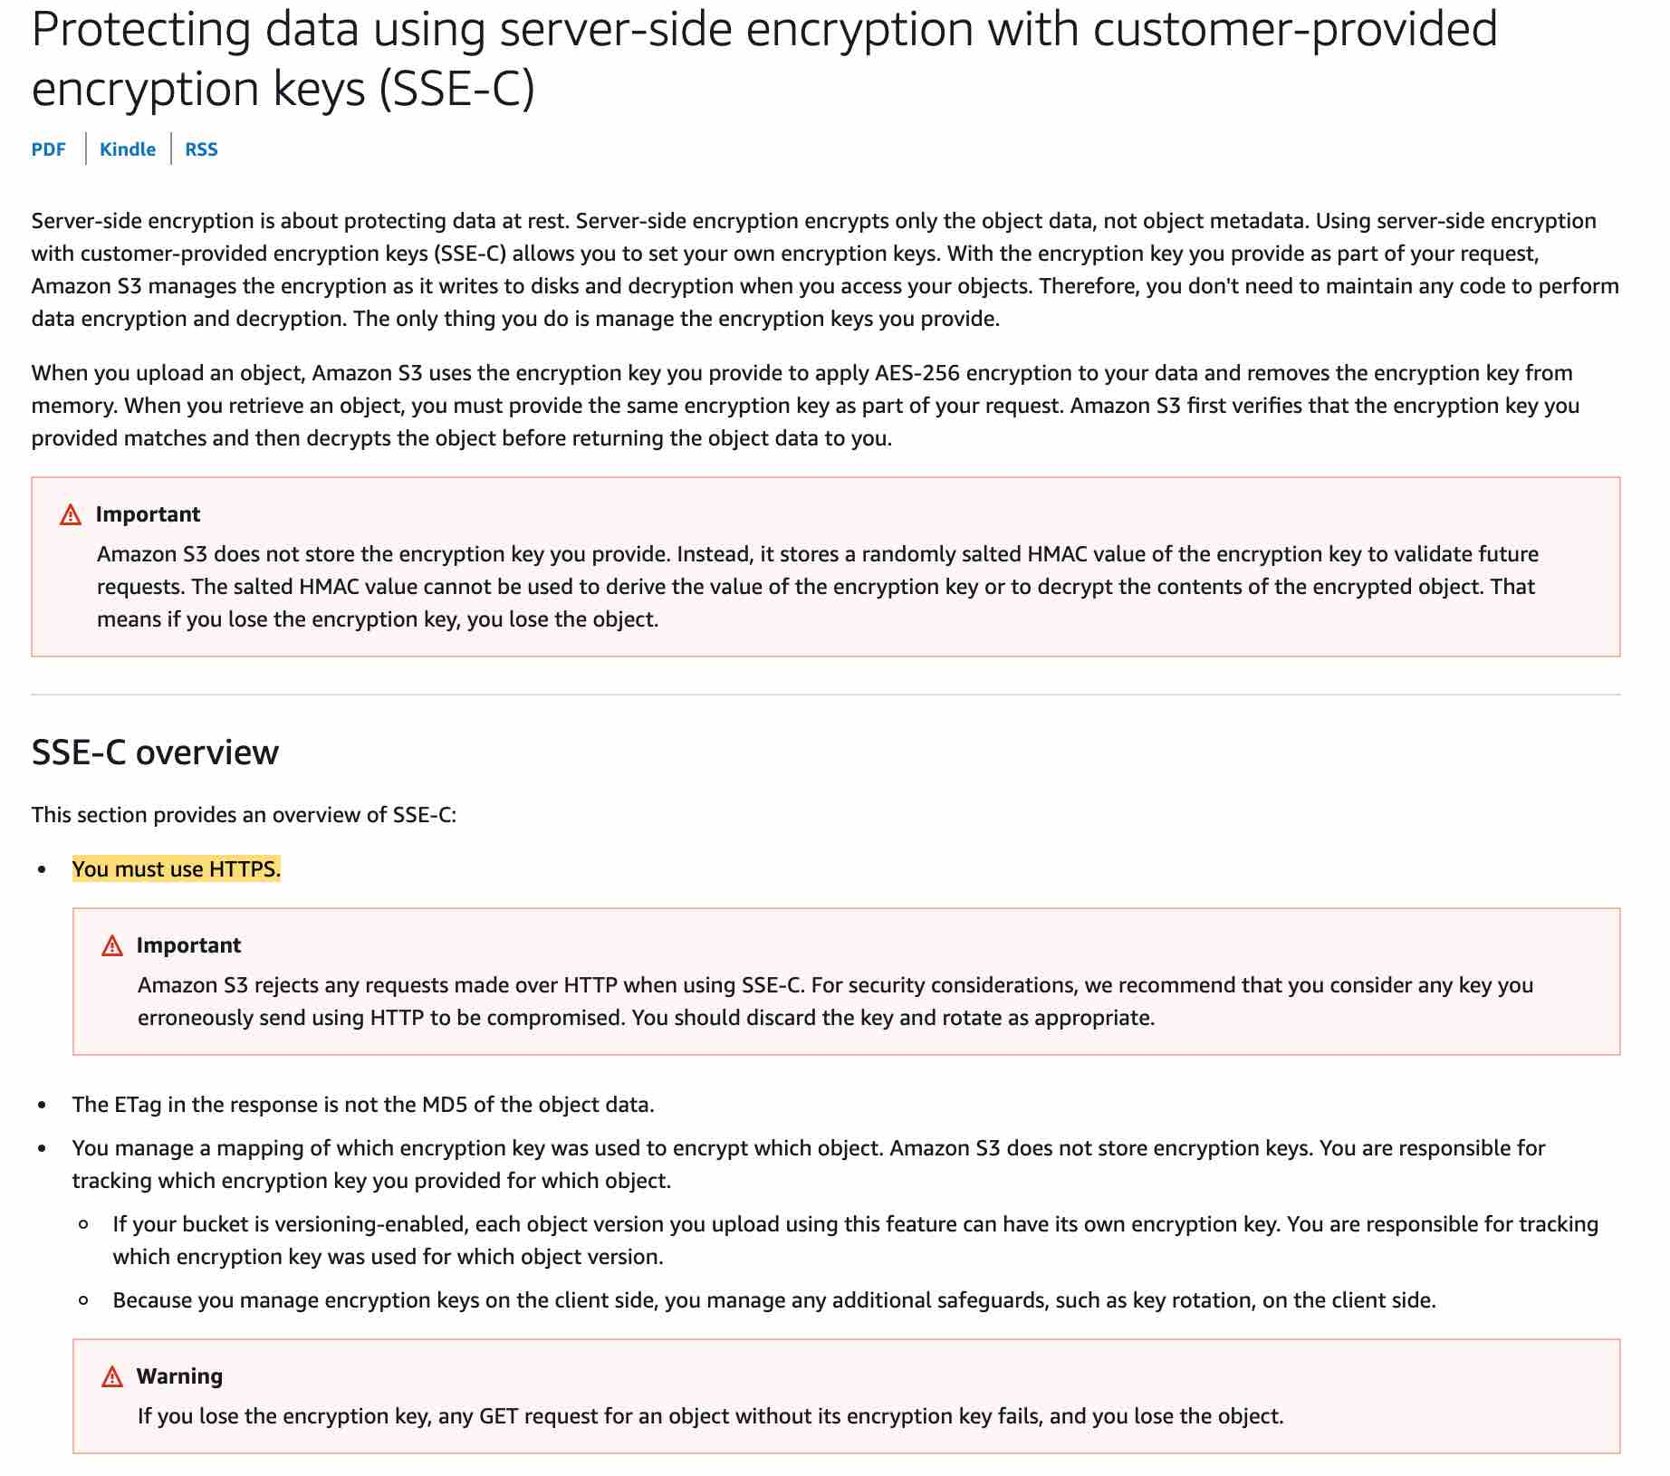 via - <https://docs.aws.amazon.com/AmazonS3/latest/dev/ServerSideEncryptionCustomerKeys.html>

Incorrect options:

**SSE-KMS** - It is not mandatory to use HTTPS.

**Client-Side Encryption** - Client-side encryption is the act of encrypting data before sending it to Amazon S3. It is not mandatory to use HTTPS for this.

**SSE-S3** - It is not mandatory to use HTTPS. Amazon S3 encrypts your data at the object level as it writes it to disks in its data centers.

References:

<https://docs.aws.amazon.com/AmazonS3/latest/dev/ServerSideEncryptionCustomerKeys.html>

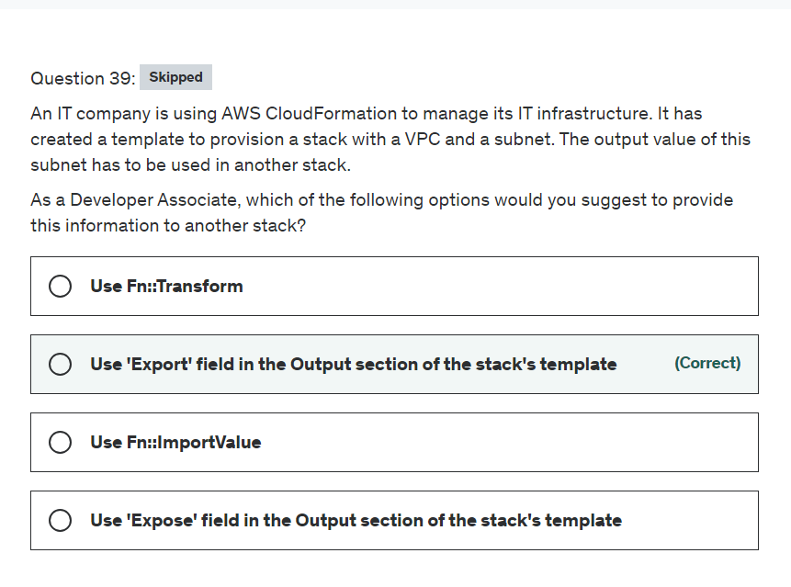

Explanation

Correct option:

**Use 'Export' field in the Output section of the stack's template**

To share information between stacks, export a stack's output values. Other stacks that are in the same AWS account and region can import the exported values.

To export a stack's output value, use the Export field in the Output section of the stack's template. To import those values, use the Fn::ImportValue function in the template for the other stacks.

Incorrect options:

**Use 'Expose' field in the Output section of the stack's template** - 'Expose' is a made-up option, and only given as a distractor.

**Use Fn::ImportValue** - To import the values exported by another stack, we use the Fn::ImportValue function in the template for the other stacks. This function is not useful for the current scenario.

**Use Fn::Transform** - The intrinsic function Fn::Transform specifies a macro to perform custom processing on part of a stack template. Macros enable you to perform custom processing on templates, from simple actions like find-and-replace operations to extensive transformations of entire templates. This function is not useful for the current scenario.

Reference:

<https://docs.aws.amazon.com/AWSCloudFormation/latest/UserGuide/using-cfn-stack-exports.html>

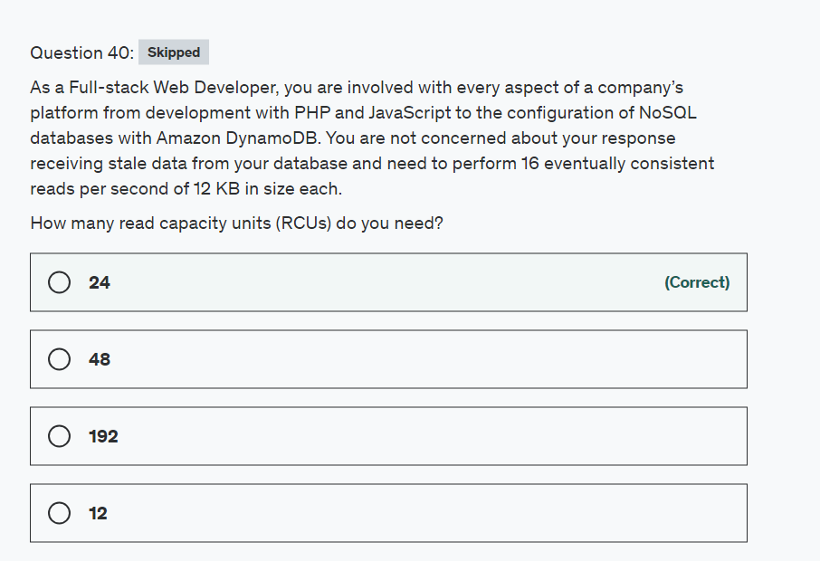

Explanation

Correct option:

Before proceeding with the calculations, please review the following:

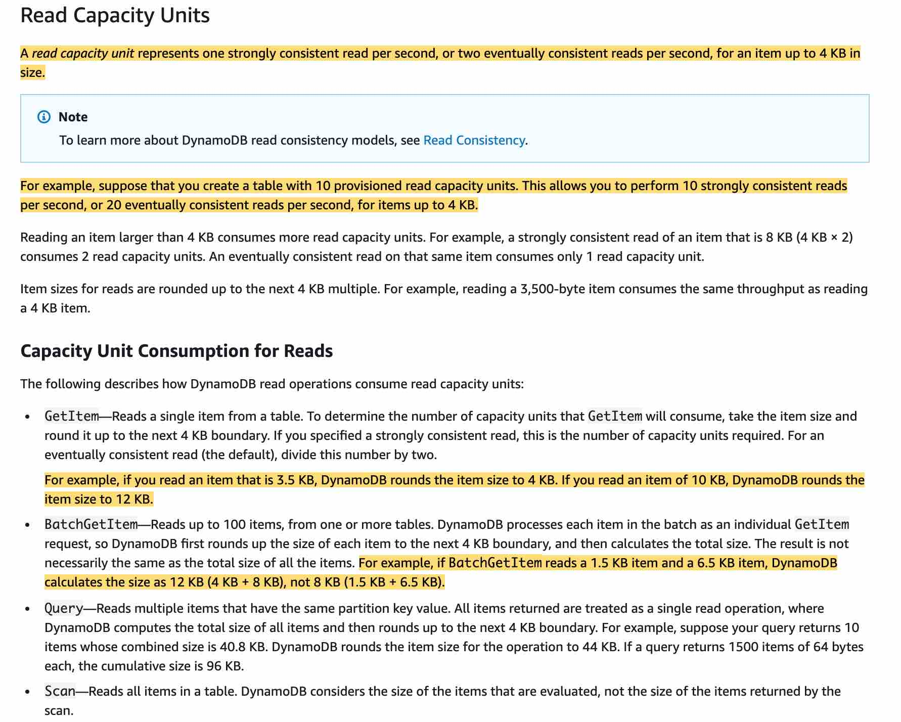

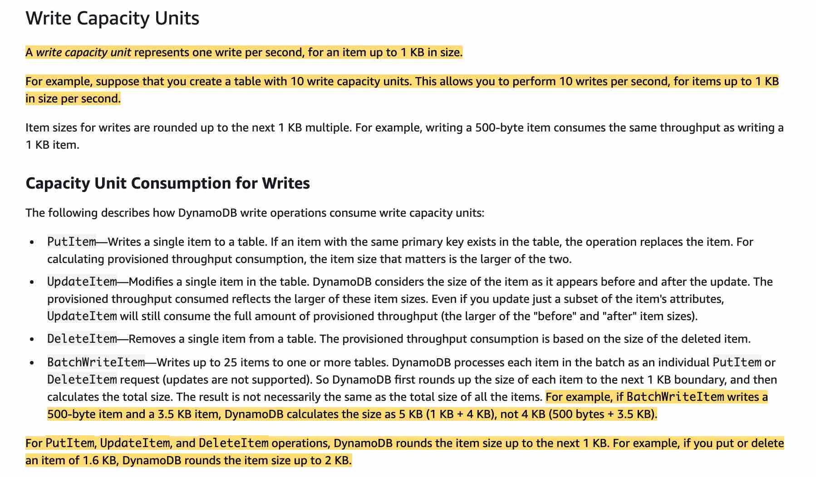

via - <https://docs.aws.amazon.com/amazondynamodb/latest/developerguide/ProvisionedThroughput.html>

**24**

One read capacity unit represents **two** eventually consistent reads per second, for an item up to **4 KB** in size. So that means that for an item of 12KB in size, we need 3 RCU (12 KB / 4 KB) for **two** eventually consistent reads per second. As we need 16 eventually consistent reads per second, we need 3 * (16 / 2) = 24 RCU.

Incorrect options:

**12**

**192**

**48**

These three options contradict the details provided in the explanation above, so these are incorrect.

Reference:

<https://docs.aws.amazon.com/amazondynamodb/latest/developerguide/HowItWorks.ProvisionedThroughput.html>

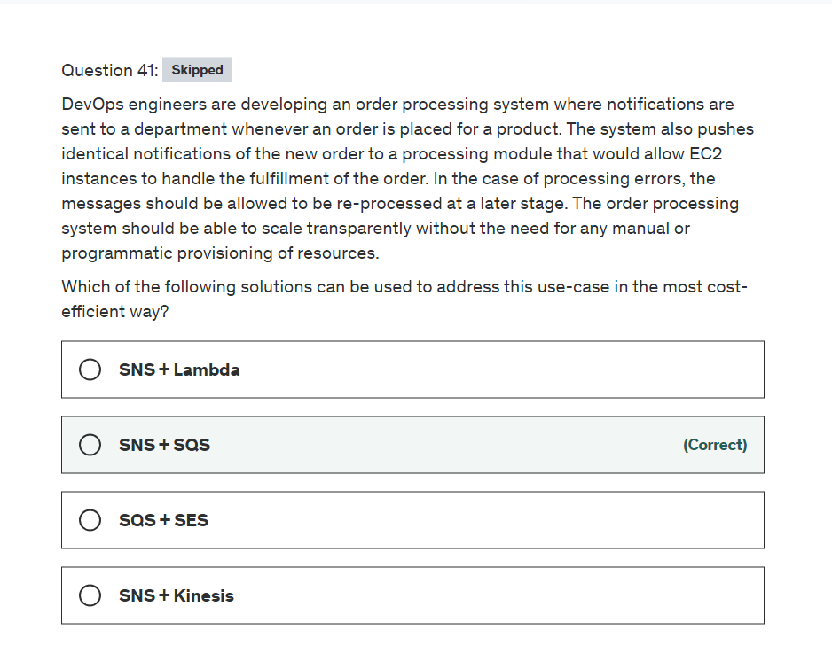

Explanation

Correct option:

**SNS + SQS**

Amazon SNS enables message filtering and fanout to a large number of subscribers, including serverless functions, queues, and distributed systems. Additionally, Amazon SNS fans out notifications to end users via mobile push messages, SMS, and email.

How SNS Works: 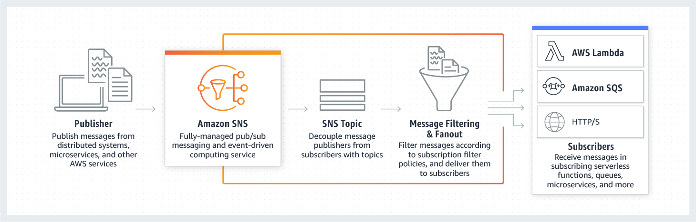 via - <https://aws.amazon.com/sns/>

Amazon Simple Queue Service (SQS) is a fully managed message queuing service that enables you to decouple and scale microservices, distributed systems, and serverless applications. SQS offers two types of message queues. Standard queues offer maximum throughput, best-effort ordering, and at-least-once delivery. SQS FIFO queues are designed to guarantee that messages are processed exactly once, in the exact order that they are sent.

Because each buffered request can be processed independently, Amazon SQS can scale transparently to handle the load without any provisioning instructions from you.

SNS and SQS can be used to create a fanout messaging scenario in which messages are "pushed" to multiple subscribers, which eliminates the need to periodically check or poll for updates and enables parallel asynchronous processing of the message by the subscribers. SQS can allow for later re-processing and dead letter queues. This is called the fan-out pattern.

Incorrect options:

**SNS + Kinesis** - You can use Amazon Kinesis Data Streams to collect and process large streams of data records in real-time. Kinesis Data Streams stores records from 24 hours (by default) to 8760 hours (365 days). However, you need to manually provision shards in case the load increases or you need to use CloudWatch alarms to set up auto scaling for the shards. Since Kinesis only supports transparent scaling in the on-demand mode, however, it is not cost efficient for the given use case, so this option is not the right fit for the given use case.

**SNS + Lambda** - Amazon SNS and AWS Lambda are integrated so you can invoke Lambda functions with Amazon SNS notifications. The Lambda function receives the message payload as an input parameter and can manipulate the information in the message, publish the message to other SNS topics, or send the message to other AWS services. However, your EC2 instances cannot "poll" from Lambda functions and as such, this would not work.

**SQS + SES** - This will not work as the messages need to be processed twice (once for sending the notification and later for order fulfillment) and SQS only allows for one consuming application.

References:

<https://aws.amazon.com/sns/>

<https://aws.amazon.com/getting-started/tutorials/send-fanout-event-notifications/>

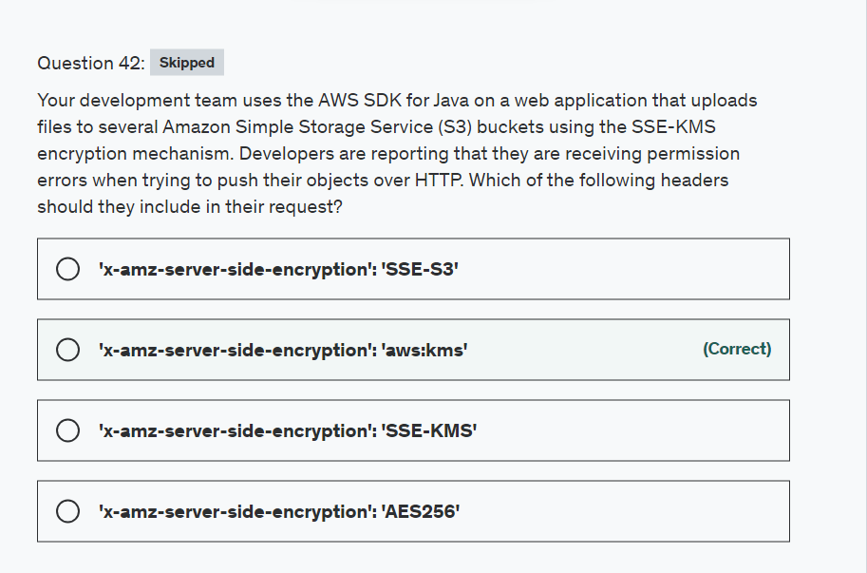

Explanation

Correct option:

**'x-amz-server-side-encryption': 'aws:kms'**

Server-side encryption is the encryption of data at its destination by the application or service that receives it. AWS Key Management Service (AWS KMS) is a service that combines secure, highly available hardware and software to provide a key management system scaled for the cloud. Amazon S3 uses AWS KMS customer master keys (CMKs) to encrypt your Amazon S3 objects. AWS KMS encrypts only the object data. Any object metadata is not encrypted.

If the request does not include the x-amz-server-side-encryption header, then the request is denied.

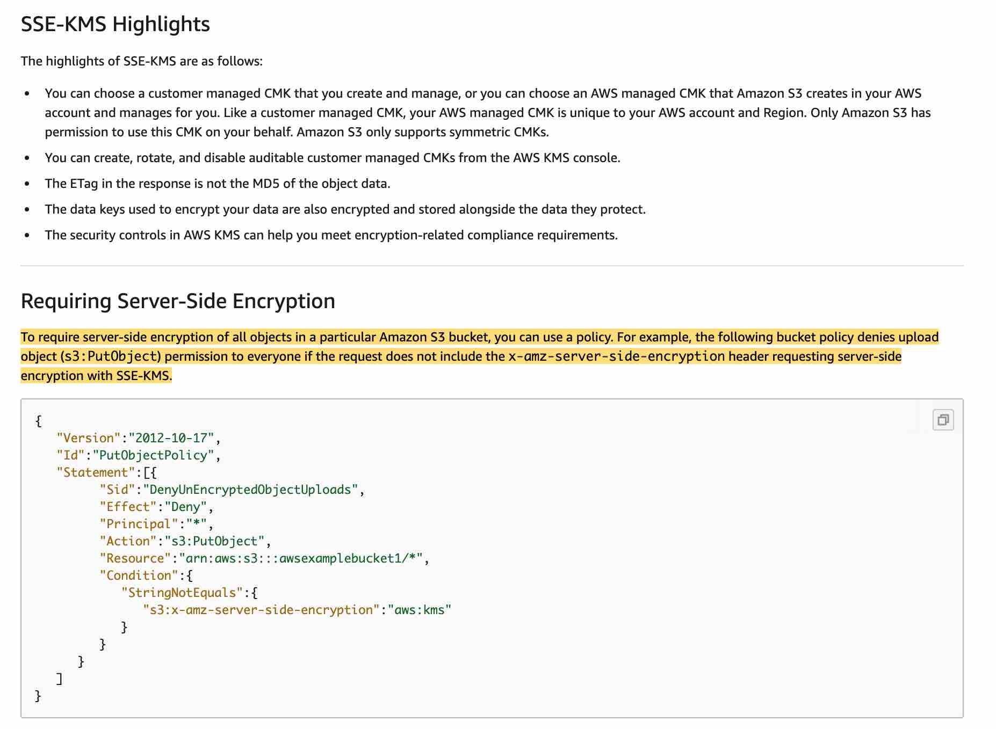 via - <https://docs.aws.amazon.com/AmazonS3/latest/dev/UsingKMSEncryption.html>

Incorrect options:

**'x-amz-server-side-encryption': 'SSE-S3'** - This is an invalid header value. The correct value is 'x-amz-server-side-encryption': 'AES256'. This refers to Server-Side Encryption with Amazon S3-Managed Encryption Keys (SSE-S3).

**'x-amz-server-side-encryption': 'SSE-KMS'** - Invalid header value. SSE-KMS is an encryption option.

**'x-amz-server-side-encryption': 'AES256'** - This is the correct header value if you are using SSE-S3 server-side encryption.

Reference:

<https://docs.aws.amazon.com/AmazonS3/latest/dev/UsingKMSEncryption.html>

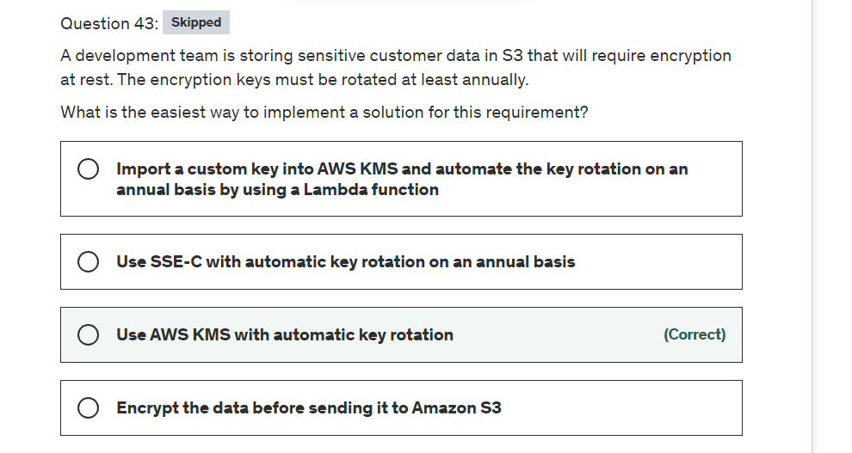

Explanation

Correct option:

**Use AWS KMS with automatic key rotation** - Server-side encryption is the encryption of data at its destination by the application or service that receives it. Amazon S3 encrypts your data at the object level as it writes it to disks in its data centers and decrypts it for you when you access it. You have three mutually exclusive options, depending on how you choose to manage the encryption keys: Server-Side Encryption with Amazon S3-Managed Keys (SSE-S3), Server-Side Encryption with Customer Master Keys (CMKs) Stored in AWS Key Management Service (SSE-KMS), Server-Side Encryption with Customer-Provided Keys (SSE-C).

When you use server-side encryption with AWS KMS (SSE-KMS), you can use the default AWS managed CMK, or you can specify a customer managed CMK that you have already created. If you don't specify a customer managed CMK, Amazon S3 automatically creates an AWS managed CMK in your AWS account the first time that you add an object encrypted with SSE-KMS to a bucket. By default, Amazon S3 uses this CMK for SSE-KMS.

You can choose to have AWS KMS automatically rotate CMKs every year, provided that those keys were generated within AWS KMS HSMs.

Incorrect options:

**Encrypt the data before sending it to Amazon S3** - The act of encrypting data before sending it to Amazon S3 is called Client-Side encryption. You will have to handle the key generation, maintenance and rotation process. Hence, this is not the right choice here.

**Import a custom key into AWS KMS and automate the key rotation on an annual basis by using a Lambda function** - When you import a custom key, you are responsible for maintaining a copy of your imported keys in your key management infrastructure so that you can re-import them at any time. Also, automatic key rotation is not supported for imported keys. Using Lambda functions to rotate keys is a possible solution, but not an optimal one for the current use case.

**Use SSE-C with automatic key rotation on an annual basis** - With Server-Side Encryption with Customer-Provided Keys (SSE-C), you manage the encryption keys and Amazon S3 manages the encryption, as it writes to disks, and decryption, when you access your objects. The keys are not stored anywhere in Amazon S3. There is no automatic key rotation facility for this option.

Reference:

<https://docs.aws.amazon.com/AmazonS3/latest/userguide/UsingKMSEncryption.html>

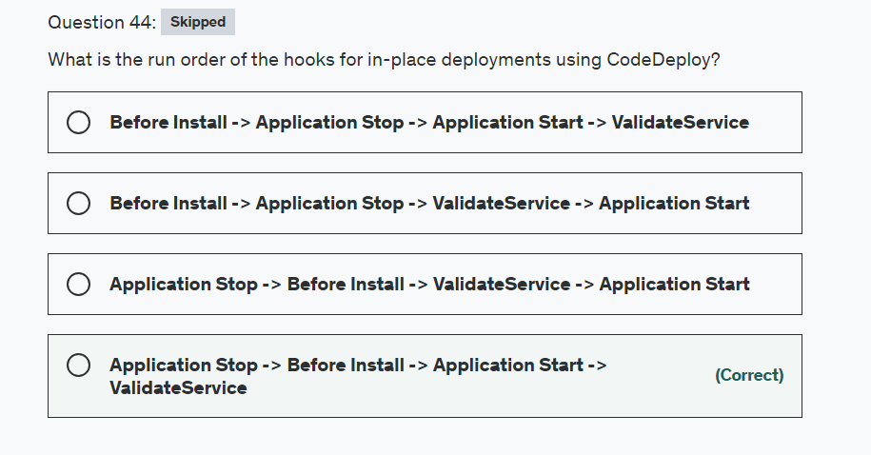

Explanation

Correct option:

**Application Stop -> Before Install -> Application Start -> ValidateService**

In CodeDeploy, a deployment is a process of installing content on one or more instances. This content can consist of code, web and configuration files, executables, packages, scripts, and so on. CodeDeploy deploys content that is stored in a source repository, according to the configuration rules you specify.

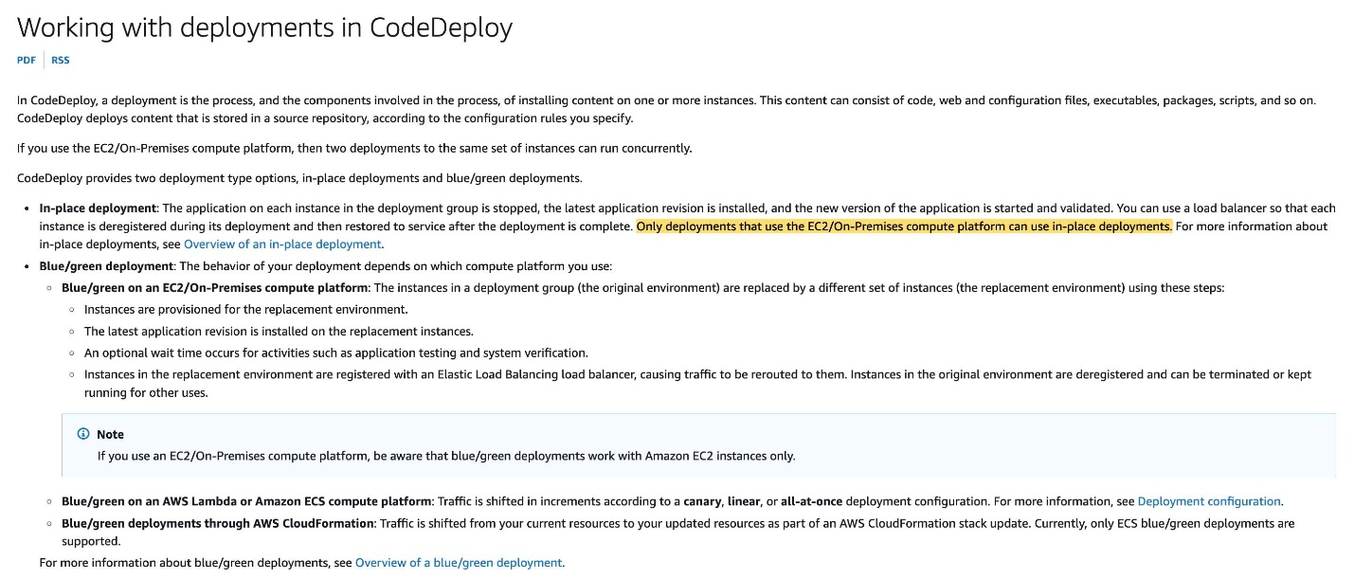 via - <https://docs.aws.amazon.com/codedeploy/latest/userguide/deployments.html>

The content in the 'hooks' section of the AppSpec file varies, depending on the compute platform for your deployment. The 'hooks' section for an EC2/On-Premises deployment contains mappings that link deployment lifecycle event hooks to one or more scripts. The 'hooks' section for a Lambda or an Amazon ECS deployment specifies Lambda validation functions to run during a deployment lifecycle event. If an event hook is not present, no operation is executed for that event.

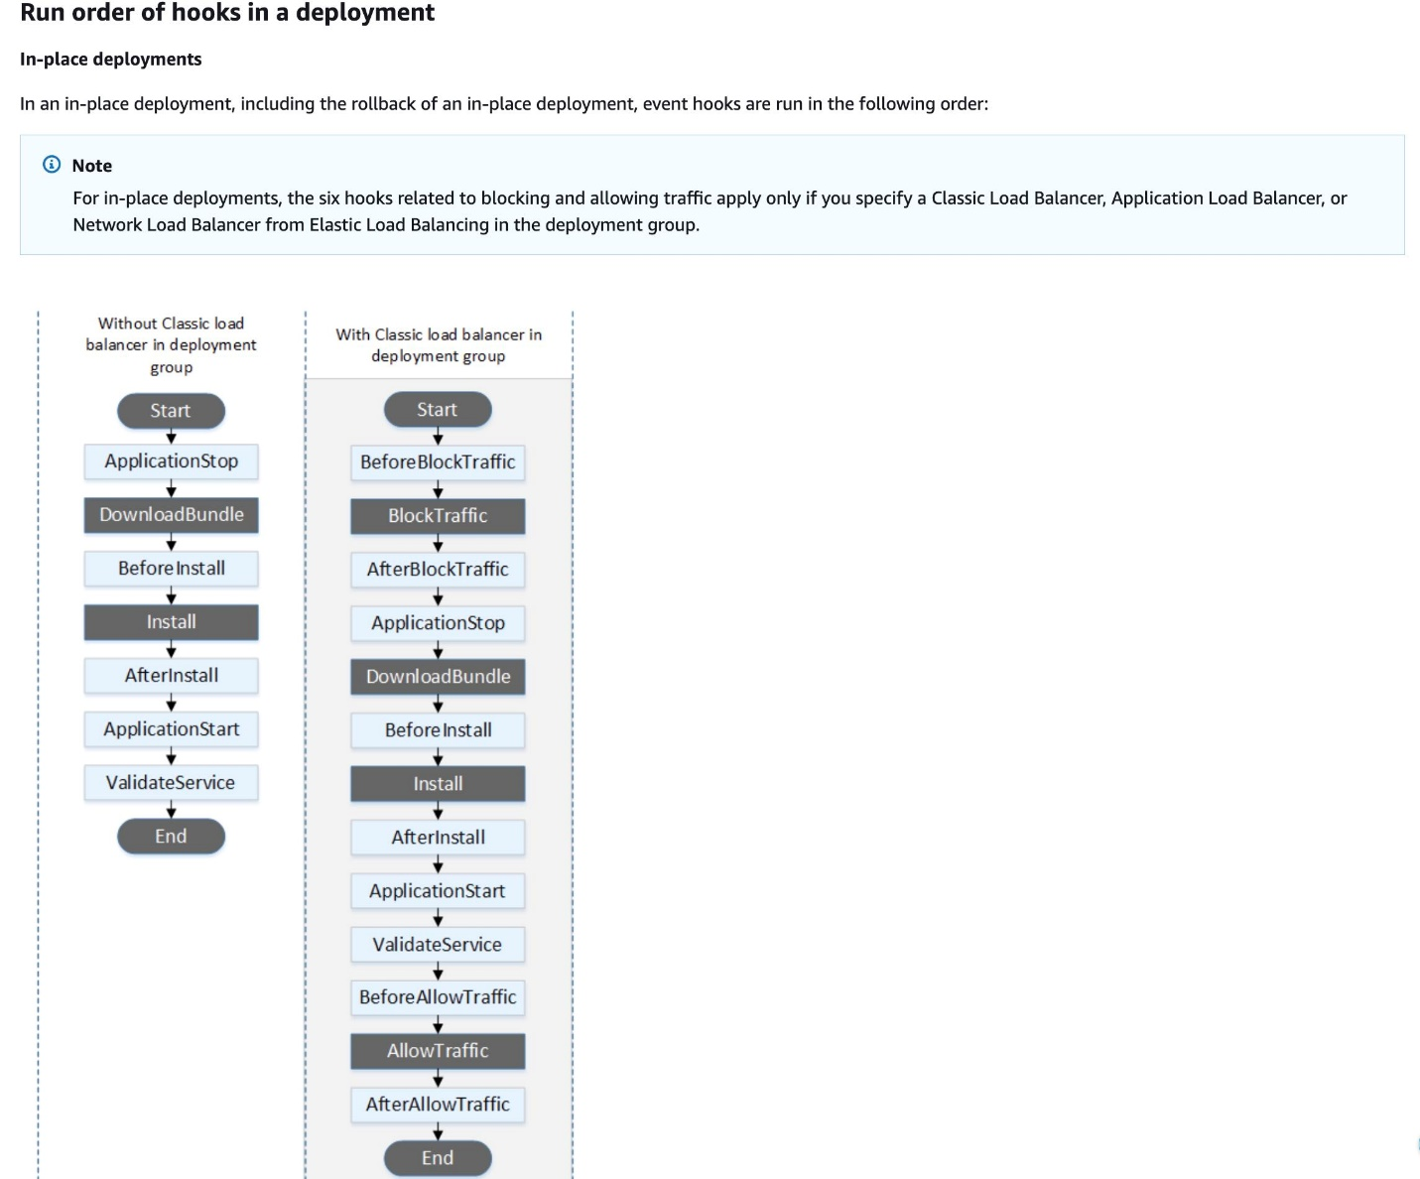 via - <https://docs.aws.amazon.com/codedeploy/latest/userguide/reference-appspec-file-structure-hooks.html>

Incorrect options:

**Before Install -> Application Stop -> ValidateService -> Application Start**

**Application Stop -> Before Install -> ValidateService -> Application Start**

**Before Install -> Application Stop -> Application Start -> ValidateService**

As explained above, these three options contradict the correct order of hooks, so these are incorrect.

References:

<https://docs.aws.amazon.com/codedeploy/latest/userguide/deployments.html>

<https://docs.aws.amazon.com/codedeploy/latest/userguide/reference-appspec-file-structure-hooks.html>

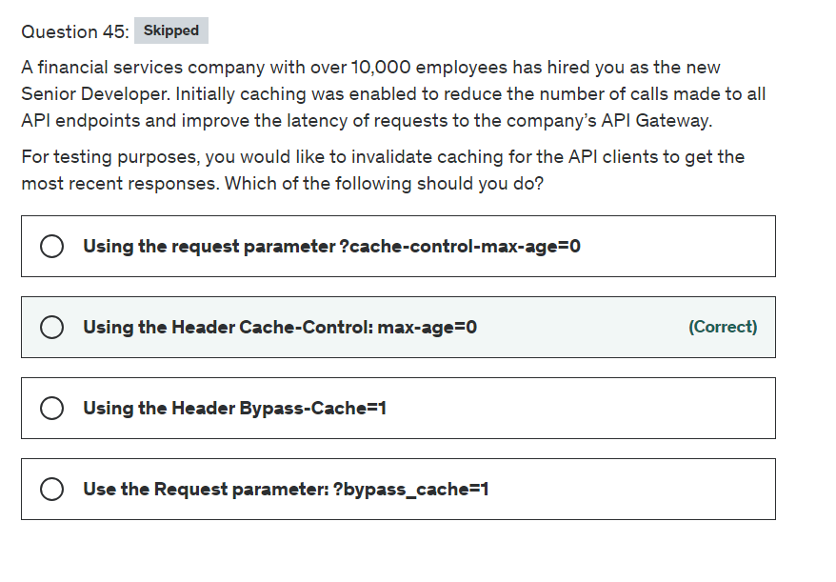

Explanation

Correct option:

**Using the Header Cache-Control: max-age=0**

A client of your API can invalidate an existing cache entry and reload it from the integration endpoint for individual requests. The client must send a request that contains the Cache-Control: max-age=0 header. The client receives the response directly from the integration endpoint instead of the cache, provided that the client is authorized to do so. This replaces the existing cache entry with the new response, which is fetched from the integration endpoint.

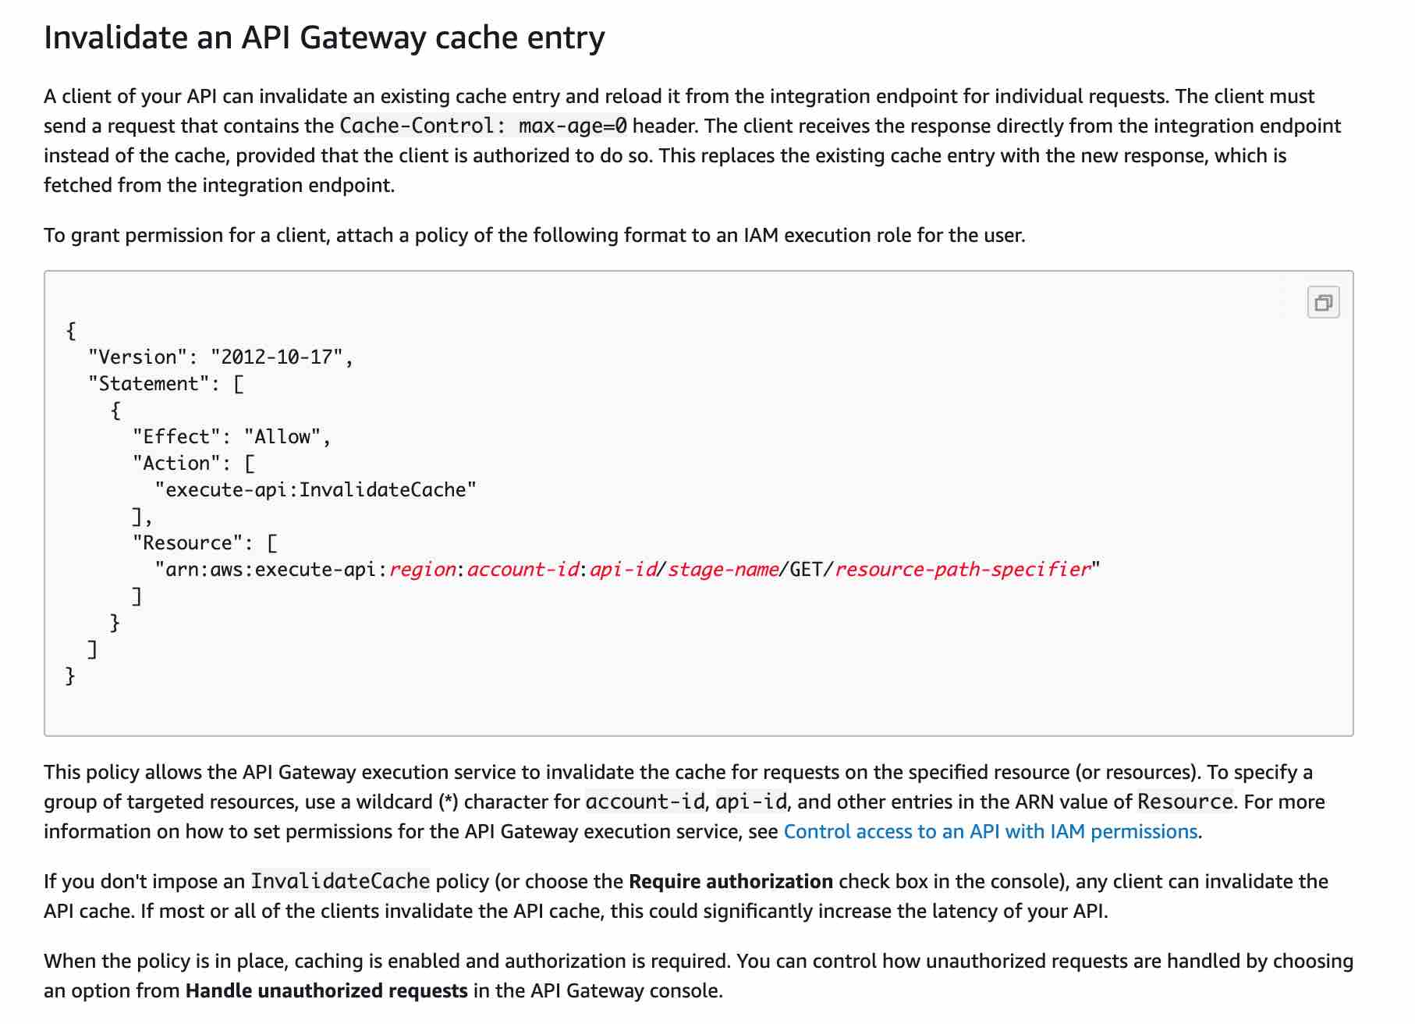 via - <https://docs.aws.amazon.com/apigateway/latest/developerguide/api-gateway-caching.html#invalidate-method-caching>

Incorrect options:

**Use the Request parameter: ?bypass_cache=1** - Method parameters take query string but this is not one of them.

**Using the Header Bypass-Cache=1** - This is a made-up option.

**Using the request parameter ?cache-control-max-age=0** - To invalidate cache it requires a header and not a request parameter.

Reference:

<https://docs.aws.amazon.com/apigateway/latest/developerguide/api-gateway-caching.html#invalidate-method-caching>

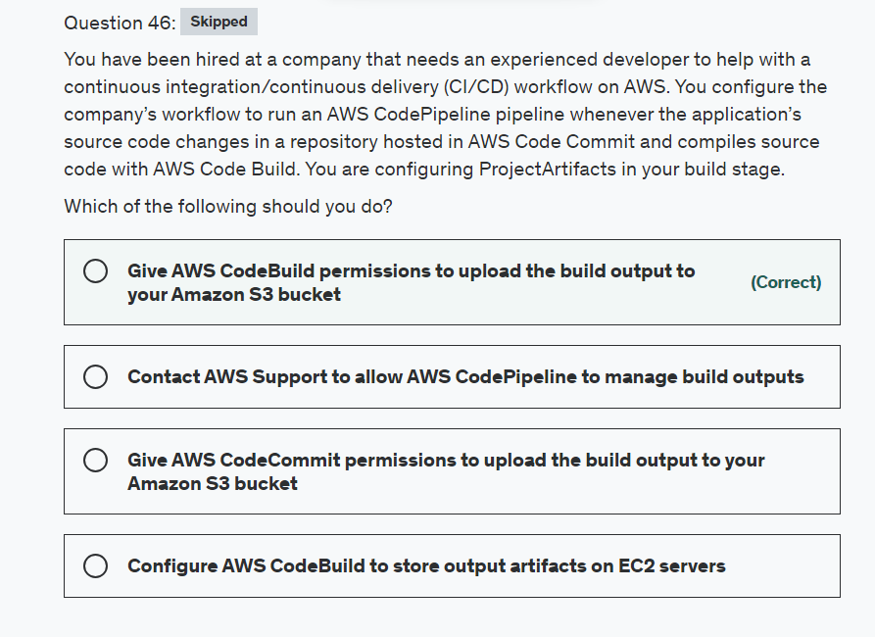

Explanation

Correct option:

**Give AWS CodeBuild permissions to upload the build output to your Amazon S3 bucket**

If you choose ProjectArtifacts and your value type is S3 then the build project stores build output in Amazon Simple Storage Service (Amazon S3). For that, you will need to give AWS CodeBuild permissions to upload.

Incorrect options:

**Configure AWS CodeBuild to store output artifacts on EC2 servers** - EC2 servers are not a valid output location, so this option is ruled out.

**Give AWS CodeCommit permissions to upload the build output to your Amazon S3 bucket** - AWS CodeCommit is the repository that holds source code and has no control over compiling the source code, so this option is incorrect.

**Contact AWS Support to allow AWS CodePipeline to manage build outputs** - You can set AWS CodePipeline to manage its build output locations instead of AWS CodeBuild. There is no need to contact AWS Support.

Reference:

<https://docs.aws.amazon.com/codebuild/latest/userguide/create-project.html#create-project-cli>

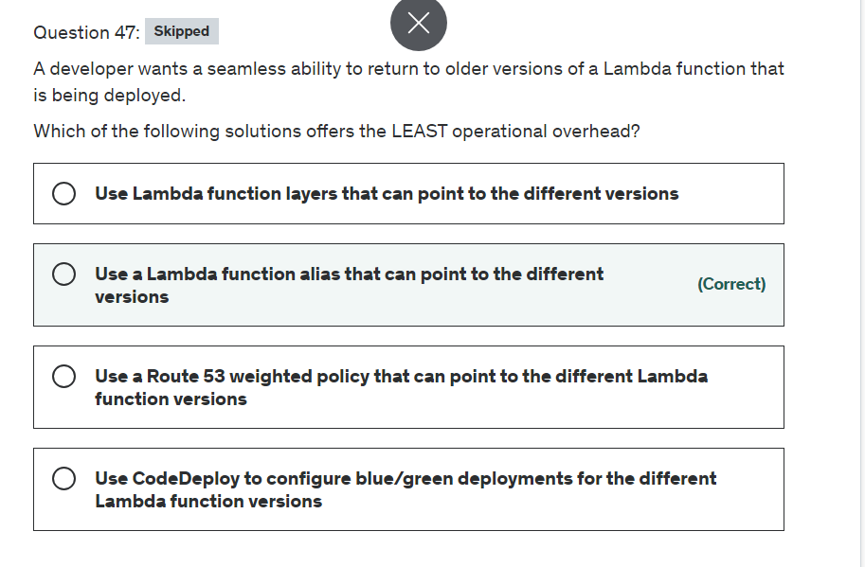

Explanation

Correct option:

**Use a Lambda function alias that can point to the different versions**

You can use versions to manage the deployment of your functions. For example, you can publish a new version of a function for beta testing without affecting users of the stable production version. Lambda creates a new version of your function each time that you publish the function. The new version is a copy of the unpublished version of the function.

By publishing a version of your function, you can store your code and configuration as a separate resource that cannot be changed.

A Lambda alias is like a pointer to a specific function version. Users can access the function version using the alias Amazon Resource Name (ARN). Each alias has a unique ARN. An alias can point only to a function version, not to another alias. You can update an alias to point to the different versions of the Lambda function.

Incorrect options:

**Use a Route 53 weighted policy that can point to the different Lambda function versions** - This option is a distractor, as Route 53 cannot be used for the given use case. Route 53 weighted policy lets you associate multiple resources with a single domain name (example.com) or subdomain name (acme.example.com) and choose how much traffic is routed to each resource. This can be useful for a variety of purposes, including load balancing and testing new versions of software.

**Use CodeDeploy to configure blue/green deployments for the different Lambda function versions** - A deployment to the AWS Lambda compute platform is always a blue/green deployment. You do not specify a deployment type option. When you deploy to an AWS Lambda compute platform, the deployment configuration specifies the way traffic is shifted to the new Lambda function versions in your application. You can shift traffic using a canary, linear, or all-at-once deployment configuration. Once deployed, you cannot go back to the previous versions of your Lambda function. So this option is incorrect.

**Use Lambda function layers that can point to the different versions** - Lambda layers provide a convenient way to package libraries and other dependencies that you can use with your Lambda functions. Using layers reduces the size of uploaded deployment archives and makes it faster to deploy your code. You cannot use the Lambda function layers to point to the different versions of the Lambda function.

References:

<https://docs.aws.amazon.com/lambda/latest/dg/configuration-aliases.html>

<https://docs.aws.amazon.com/lambda/latest/dg/configuration-versions.html>

<https://docs.aws.amazon.com/codedeploy/latest/userguide/deployment-configurations.html#deployment-configuration-lambda>

<https://docs.aws.amazon.com/lambda/latest/dg/configuration-layers.html>

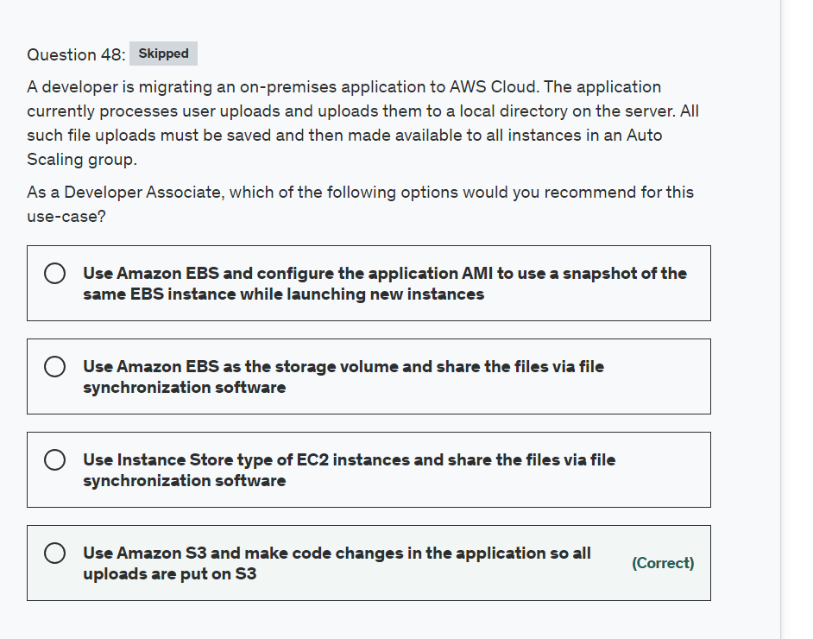

Explanation

Correct option:

**Use Amazon S3 and make code changes in the application so all uploads are put on S3**

Amazon S3 is an object storage built to store and retrieve any amount of data from anywhere on the Internet. It’s a simple storage service that offers an extremely durable, highly available, and infinitely scalable data storage infrastructure at very low costs.

Amazon S3 provides a simple web service interface that you can use to store and retrieve any amount of data, at any time, from anywhere on the web. Using this web service, you can easily build applications that make use of Internet storage.

You can use S3 PutObject API from the application to upload the objects in a single bucket, which is then accessible from all instances.

Incorrect options:

**Use Amazon EBS and configure the application AMI to use a snapshot of the same EBS instance while launching new instances** - Using EBS to share data between instances is not possible because EBS volume is tied to an instance by definition. Creating a snapshot would only manage to move the stale data into the new instances.

**Use Instance Store type of EC2 instances and share the files via file synchronization software**

**Use Amazon EBS as the storage volume and share the files via file synchronization software**

Technically you could use file synchronization software on EC2 instances with EBS or Instance Store type, but that involves a lot of development effort and still would not be as production-ready as just using S3. So both these options are incorrect.

Reference:

<https://aws.amazon.com/s3/faqs/>

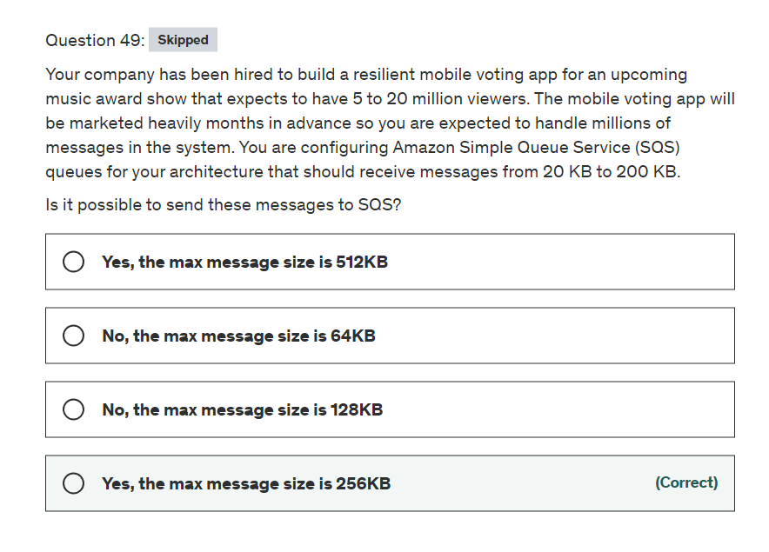

Explanation

Correct option:

**Yes, the max message size is 256KB**

The minimum message size is 1 byte (1 character). The maximum is 262,144 bytes (256 KB).

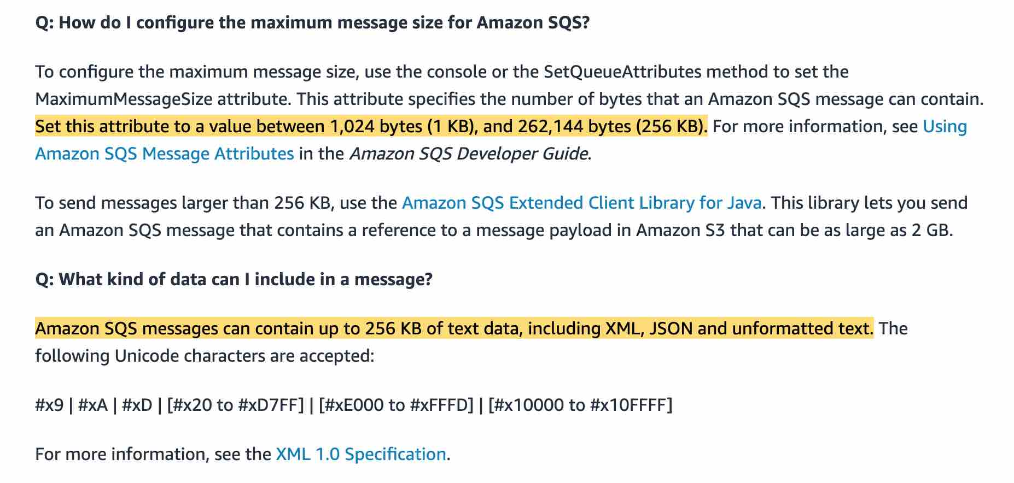 via - <https://aws.amazon.com/sqs/faqs/>

Incorrect options:

**Yes, the max message size is 512KB** - The max size is 256KB

**No, the max message size is 128KB** - The max size is 256KB

**No, the max message size is 64KB** - The max size is 256KB

Reference:

<https://aws.amazon.com/sqs/faqs/>

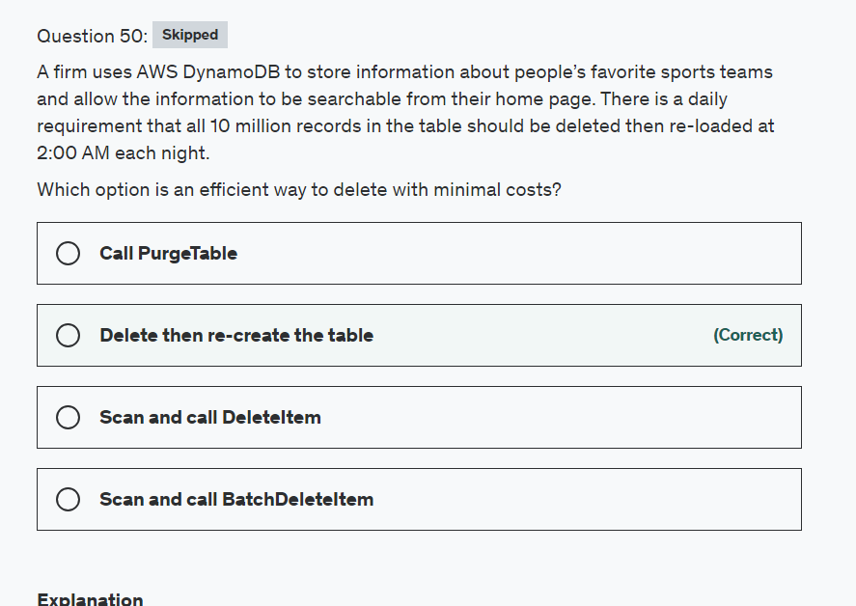

Explanation

Correct option:

**Delete then re-create the table**

The DeleteTable operation deletes a table and all of its items. After a DeleteTable request, the specified table is in the DELETING state until DynamoDB completes the deletion.

**Scan and call DeleteItem** - Scan is a very slow operation for 10 million items and this is not the best-fit option for the given use-case.

**Scan and call BatchDeleteItem** - Scan is a very slow operation for 10 million items and this is not the best-fit option for the given use-case.

**Call PurgeTable** - This is a made-up option and has been added as a distractor.

Reference:

<https://docs.aws.amazon.com/cli/latest/reference/dynamodb/delete-table.html>

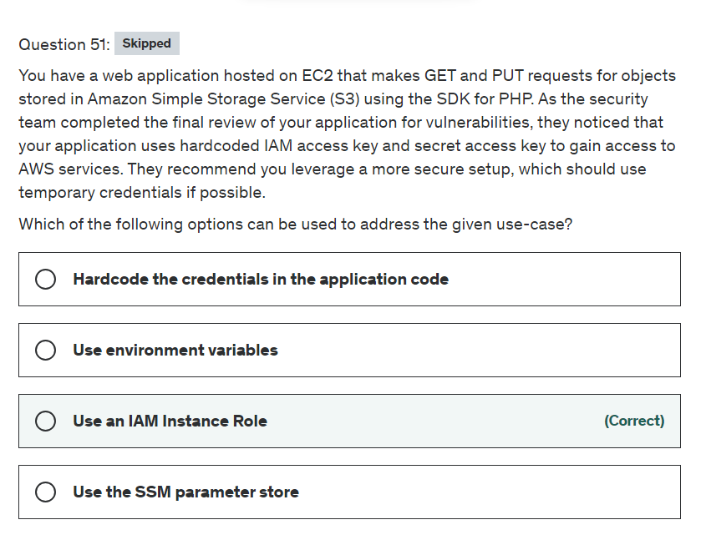

Explanation

Correct option:

**Use an IAM Instance Role**

An instance profile is a container for an IAM role that you can use to pass role information to an EC2 instance when the instance starts. The AWS SDK will use the EC2 metadata service to obtain temporary credentials thanks to the IAM instance role. This is the most secure and common setup when deploying any kind of applications onto an EC2 instance.

Incorrect options:

**Use environment variables** - This is another option if you configure AWS CLI on the EC2 instance. When configuring the AWS CLI you will set the AWS_ACCESS_KEY_ID and AWS_SECRET_ACCESS_KEY environment variables. This practice may not be bad for one instance but once you start running more EC2 instances this is not a good practice because you may have to change credentials on each instance whereas an IAM Role gets temporary permissions.

**Hardcode the credentials in the application code** - It will work for sure, but it's not a good practice from a security point of view.

**Use the SSM parameter store** - With parameter store you can store data such as passwords. The problem is that you need the SDK to access parameter store and without credentials, you cannot use the SDK. Use parameter store for other uses such as database connection strings or other secret codes when you have already authenticated to AWS.

Reference:

<https://docs.aws.amazon.com/IAM/latest/UserGuide/id_roles_use_switch-role-ec2_instance-profiles.html>

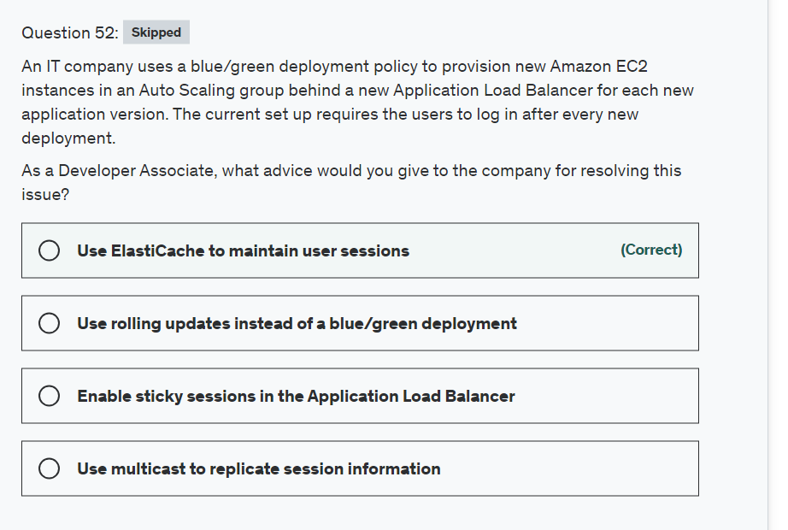

Explanation

Correct option:

**Use ElastiCache to maintain user sessions**

Amazon ElastiCache allows you to seamlessly set up, run, and scale popular open-Source compatible in-memory data stores in the cloud. Build data-intensive apps or boost the performance of your existing databases by retrieving data from high throughput and low latency in-memory data stores. Amazon ElastiCache is a popular choice for real-time use cases like Caching, Session Stores, Gaming, Geospatial Services, Real-Time Analytics, and Queuing.

To address scalability and to provide a shared data storage for sessions that can be accessed from any individual web server, you can abstract the HTTP sessions from the web servers themselves. A common solution to for this is to leverage an In-Memory Key/Value store such as Redis and Memcached via ElastiCache.

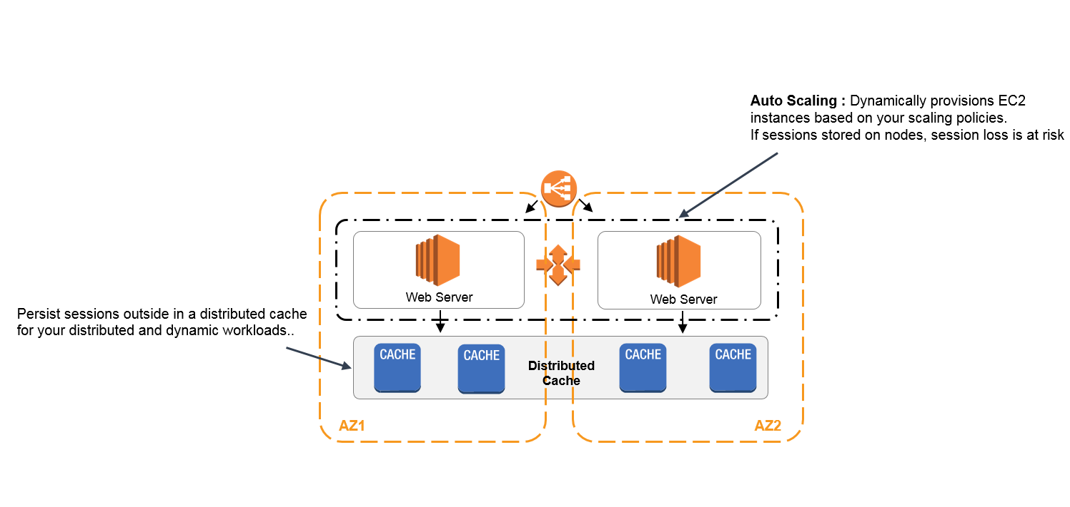 via - <https://aws.amazon.com/caching/session-management/>

Incorrect options:

**Use rolling updates instead of a blue/green deployment** - With rolling deployments, Elastic Beanstalk splits the environment's Amazon EC2 instances into batches and deploys the new version of the application to one batch at a time. It leaves the rest of the instances in the environment running the old version of the application. When processing a batch, Elastic Beanstalk detaches all instances in the batch from the load balancer, deploys the new application version, and then reattaches the instances.

This means that some of the users can experience session disruptions when the instances maintaining the sessions were detached as part of the given batch. So this option is incorrect.

**Enable sticky sessions in the Application Load Balancer** - As the Application Load Balancer itself is replaced on each new deployment, so maintaining sticky sessions via the Application Load Balancer will not work.

**Use multicast to replicate session information** - This option has been added as a distractor.

References:

<https://aws.amazon.com/caching/session-management/>

<https://docs.aws.amazon.com/elasticbeanstalk/latest/dg/using-features.rolling-version-deploy.html#environments-cfg-rollingdeployments-method>

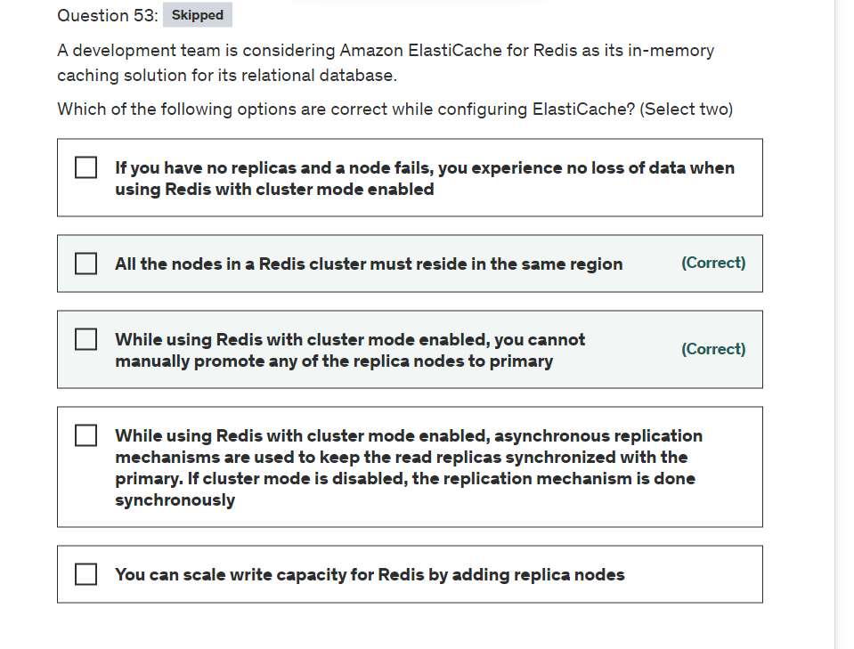

Explanation

Correct options:

**All the nodes in a Redis cluster must reside in the same region**

All the nodes in a Redis cluster (cluster mode enabled or cluster mode disabled) must reside in the same region.

**While using Redis with cluster mode enabled, you cannot manually promote any of the replica nodes to primary**

While using Redis with cluster mode enabled, there are some limitations:

You cannot manually promote any of the replica nodes to primary.

Multi-AZ is required.

You can only change the structure of a cluster, the node type, and the number of nodes by restoring from a backup.

Incorrect options:

**While using Redis with cluster mode enabled, asynchronous replication mechanisms are used to keep the read replicas synchronized with the primary. If cluster mode is disabled, the replication mechanism is done synchronously** - When you add a read replica to a cluster, all of the data from the primary is copied to the new node. From that point on, whenever data is written to the primary, the changes are asynchronously propagated to all the read replicas, for both the Redis offerings (cluster mode enabled or cluster mode disabled).

**If you have no replicas and a node fails, you experience no loss of data when using Redis with cluster mode enabled** - If you have no replicas and a node fails, you experience loss of all data in that node's shard, when using Redis with cluster mode enabled. If you have no replicas and the node fails, you experience total data loss in Redis with cluster mode disabled.

**You can scale write capacity for Redis by adding replica nodes** - This increases only the read capacity of the Redis cluster, write capacity is not enhanced by read replicas.

Reference:

<https://docs.aws.amazon.com/AmazonElastiCache/latest/red-ug/Replication.Redis.Groups.html>

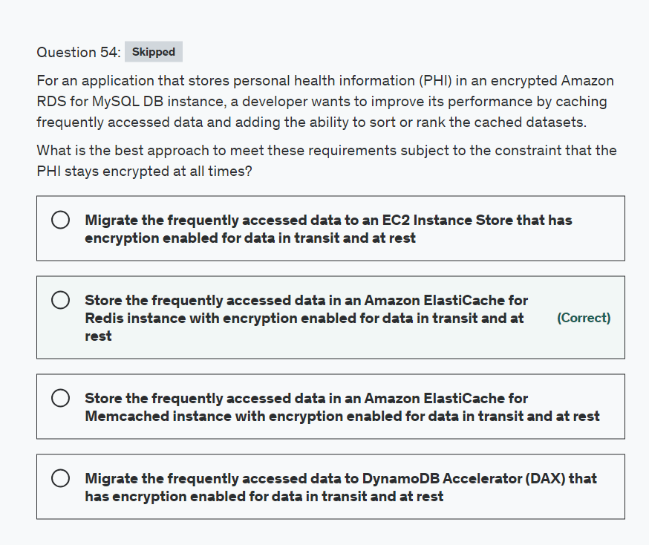

Explanation

Correct option:

**Store the frequently accessed data in an Amazon ElastiCache for Redis instance with encryption enabled for data in transit and at rest**

Amazon ElastiCache for Redis is a Redis-compatible in-memory data structure service that can be used as a data store or cache. It delivers the ease of use and power of Redis along with the availability, reliability, scalability, security, and performance suitable for the most demanding applications.

In addition to strings, Redis supports lists, sets, sorted sets, hashes, bit arrays, and hyperlog logs. Applications can use these more advanced data structures to support a variety of use cases. For example, you can use Redis Sorted Sets to easily implement a game leaderboard that keeps a list of players sorted by their rank.

Incorrect options:

**Store the frequently accessed data in an Amazon ElastiCache for Memcached instance with encryption enabled for data in transit and at rest** - Memcached is designed for simplicity and it does not offer support for advanced data structures and operations such as sort or rank.

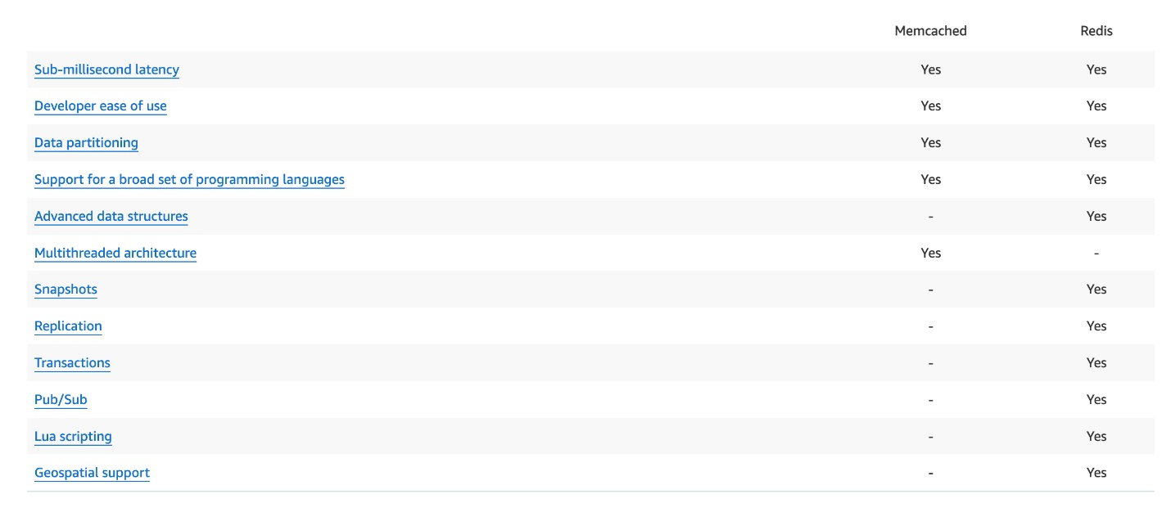 via - <https://aws.amazon.com/elasticache/redis-vs-memcached/>

**Migrate the frequently accessed data to DynamoDB Accelerator (DAX) that has encryption enabled for data in transit and at rest** - DAX is a DynamoDB-compatible caching service that enables you to benefit from fast in-memory performance for demanding applications. DAX cannot be used with RDS MySQL as a caching service, so this option is incorrect.

**Migrate the frequently accessed data to an EC2 Instance Store that has encryption enabled for data in transit and at rest** - This option is incorrect. EC2 instance store provides temporary block-level storage for your instance. This storage is located on disks that are physically attached to the host computer. Instance store is ideal for the temporary storage of information that changes frequently, such as buffers, caches, scratch data, and other temporary content. It can also be used to store temporary data that you replicate across a fleet of instances, such as a load-balanced pool of web servers.

References:

<https://aws.amazon.com/elasticache/redis/>

<https://aws.amazon.com/elasticache/redis-vs-memcached/>

<https://docs.aws.amazon.com/AWSEC2/latest/UserGuide/InstanceStorage.html>

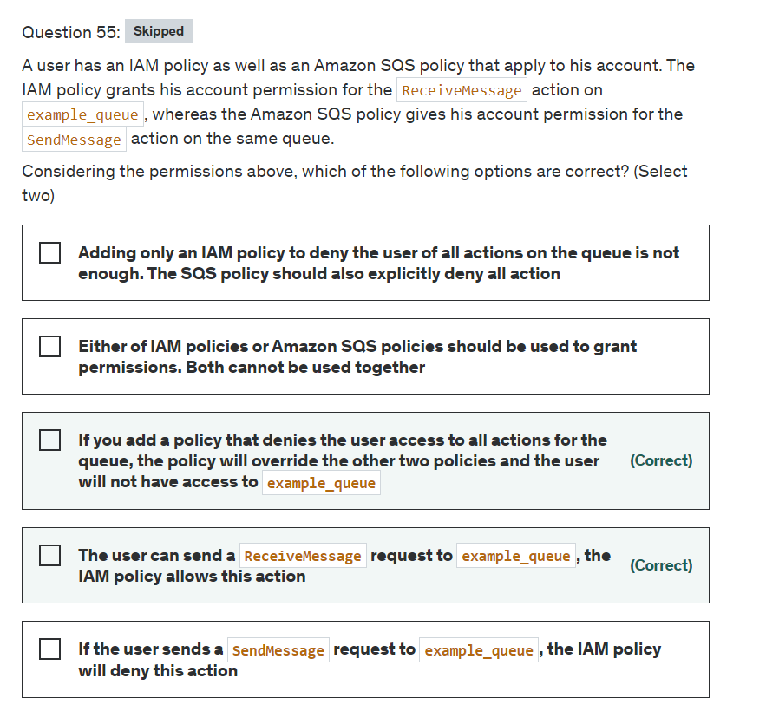

Explanation

Correct options:

**The user can send a ReceiveMessage request to example_queue, the IAM policy allows this action**

The user has both an IAM policy and an Amazon SQS policy that apply to his account. The IAM policy grants his account permission for the ReceiveMessage action on example_queue, whereas the Amazon SQS policy gives his account permission for the SendMessage action on the same queue.

How IAM policy and SQS policy work in tandem: 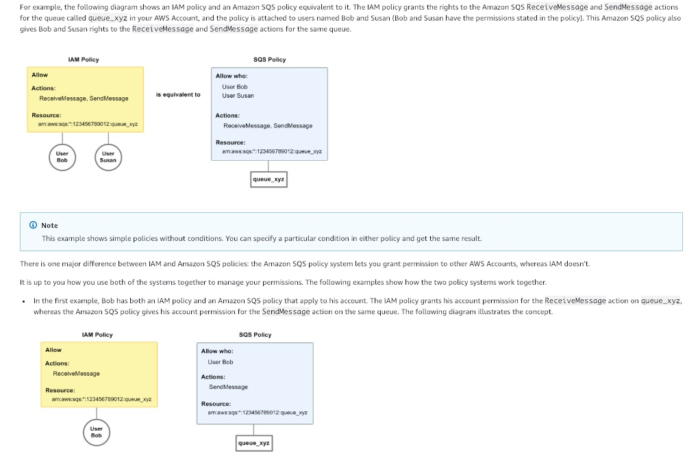 via - <https://docs.aws.amazon.com/AWSSimpleQueueService/latest/SQSDeveloperGuide/sqs-using-identity-based-policies.html>

**If you add a policy that denies the user access to all actions for the queue, the policy will override the other two policies and the user will not have access to example_queue**

To remove the user's full access to the queue, the easiest thing to do is to add a policy that denies him access to all actions for the queue. This policy overrides the other two because an explicit deny always overrides an allow.

You can also add an additional statement to the Amazon SQS policy that denies the user any type of access to the queue. It has the same effect as adding an IAM policy that denies the user access to the queue.

How IAM policy and SQS policy work in tandem: 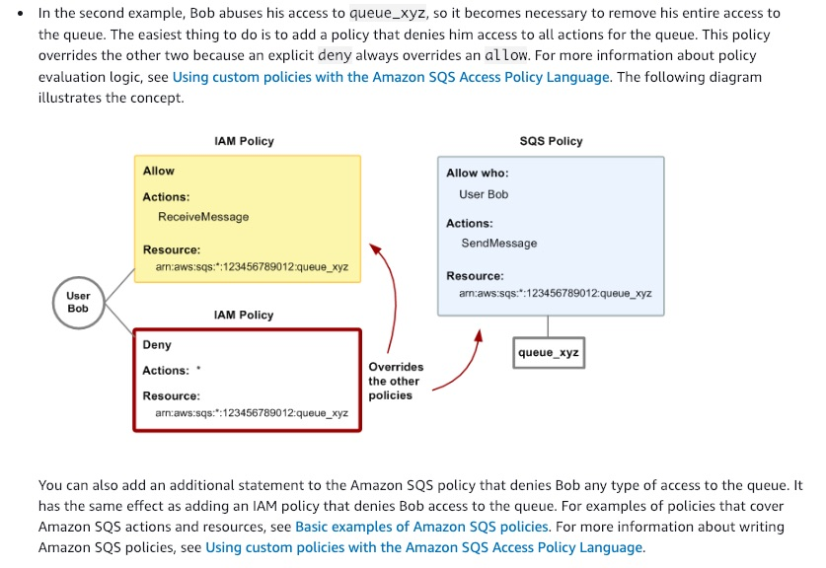 via - <https://docs.aws.amazon.com/AWSSimpleQueueService/latest/SQSDeveloperGuide/sqs-using-identity-based-policies.html>

Incorrect options:

**If the user sends a SendMessage request to example_queue, the IAM policy will deny this action** - If the user sends a SendMessage request to example_queue, the Amazon SQS policy allows the action. The IAM policy has no explicit deny on this action, so it plays no part.

**Either of IAM policies or Amazon SQS policies should be used to grant permissions. Both cannot be used together** - There are two ways to give your users permissions to your Amazon SQS resources: using the Amazon SQS policy system and using the IAM policy system. You can use one or the other, or both. For the most part, you can achieve the same result with either one.

**Adding only an IAM policy to deny the user of all actions on the queue is not enough. The SQS policy should also explicitly deny all action** - The user can be denied access using any one of the policies. Explicit deny in any policy will override all other allow actions defined using either of the policies.

Reference:

<https://docs.aws.amazon.com/AWSSimpleQueueService/latest/SQSDeveloperGuide/sqs-using-identity-based-policies.html>

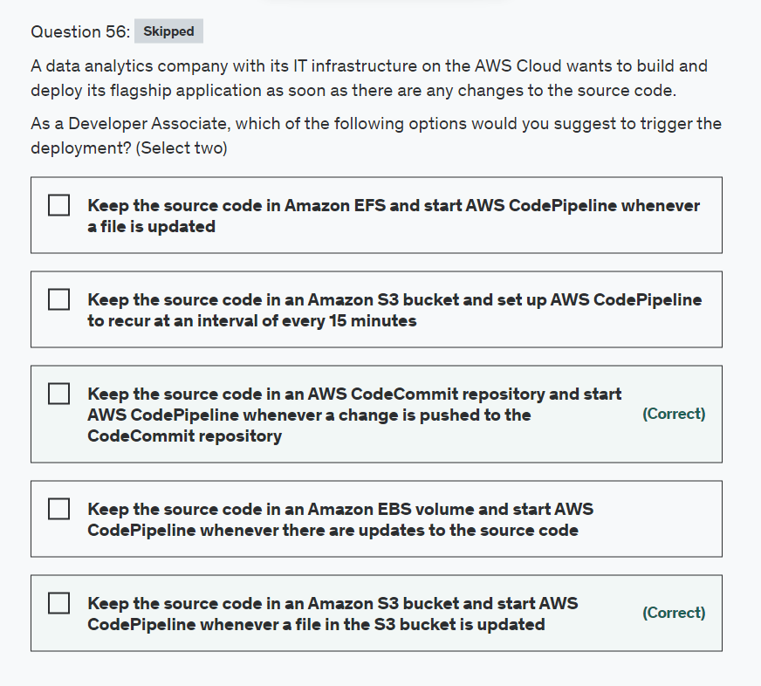

Explanation

Correct option:

**Keep the source code in an AWS CodeCommit repository and start AWS CodePipeline whenever a change is pushed to the CodeCommit repository**

**Keep the source code in an Amazon S3 bucket and start AWS CodePipeline whenever a file in the S3 bucket is updated**

AWS CodePipeline is a fully managed continuous delivery service that helps you automate your release pipelines for fast and reliable application and infrastructure updates. CodePipeline automates the build, test, and deploy phases of your release process every time there is a code change, based on the release model you define.

How CodePipeline Works: 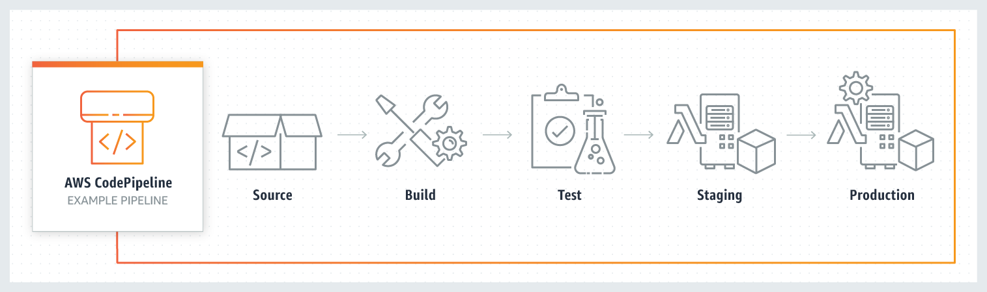 via - <https://aws.amazon.com/codepipeline/>

Using change detection methods that you specify, you can make your pipeline start when a change is made to a repository. You can also make your pipeline start on a schedule.

When you use the console to create a pipeline that has a CodeCommit source repository or S3 source bucket, CodePipeline creates an Amazon CloudWatch Events rule that starts your pipeline when the source changes. This is the recommended change detection method.

If you use the AWS CLI to create the pipeline, the change detection method defaults to starting the pipeline by periodically checking the source (CodeCommit, Amazon S3, and GitHub source providers only). AWS recommends that you disable periodic checks and create the rule manually.

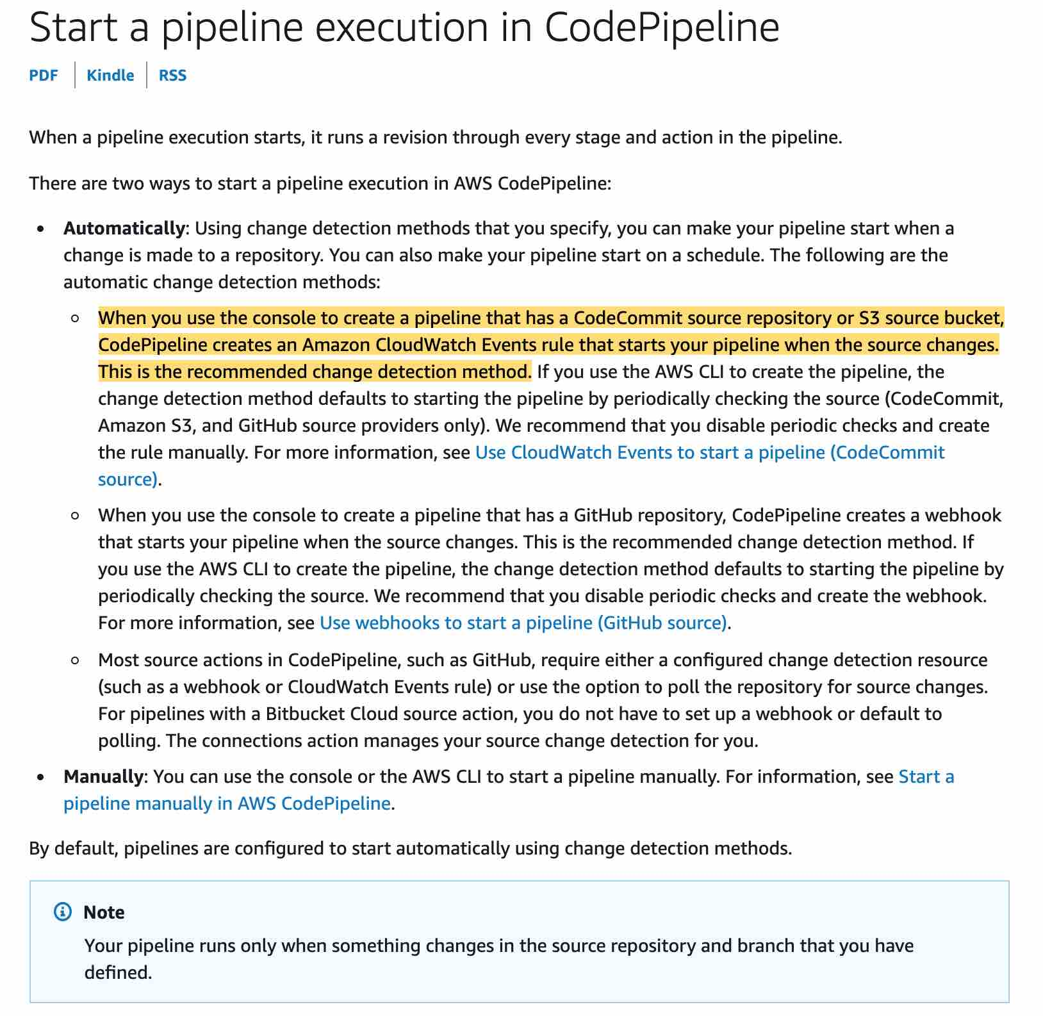 via - <https://docs.aws.amazon.com/codepipeline/latest/userguide/pipelines-about-starting.html>

Incorrect options:

**Keep the source code in Amazon EFS and start AWS CodePipeline whenever a file is updated**

**Keep the source code in an Amazon EBS volume and start AWS CodePipeline whenever there are updates to the source code**

Both EFS and EBS are not supported as valid source providers for CodePipeline to check for any changes to the source code, hence these two options are incorrect.

**Keep the source code in an Amazon S3 bucket and set up AWS CodePipeline to recur at an interval of every 15 minutes** - As mentioned in the explanation above, although you could have the change detection method start the pipeline by periodically checking the S3 bucket, but this method is inefficient.

Reference:

<https://docs.aws.amazon.com/codepipeline/latest/userguide/pipelines-about-starting.html>

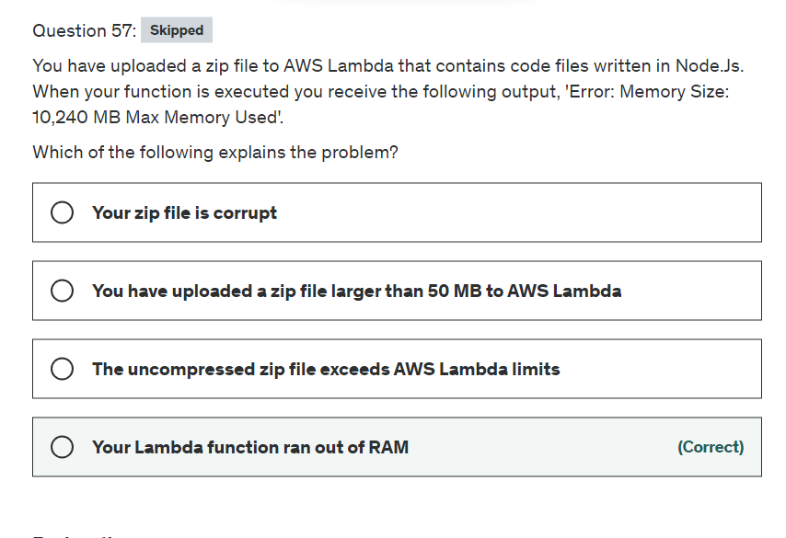

Explanation

Correct option:

**Your Lambda function ran out of RAM**

AWS Lambda lets you run code without provisioning or managing servers. You pay only for the compute time you consume.

How Lambda function works:

via - <https://aws.amazon.com/lambda/>

The maximum amount of memory available to the Lambda function at runtime is 10,240 MB. Your Lambda function was deployed with 10,240 MB of RAM, but it seems your code requested or used more than that, so the Lambda function failed.

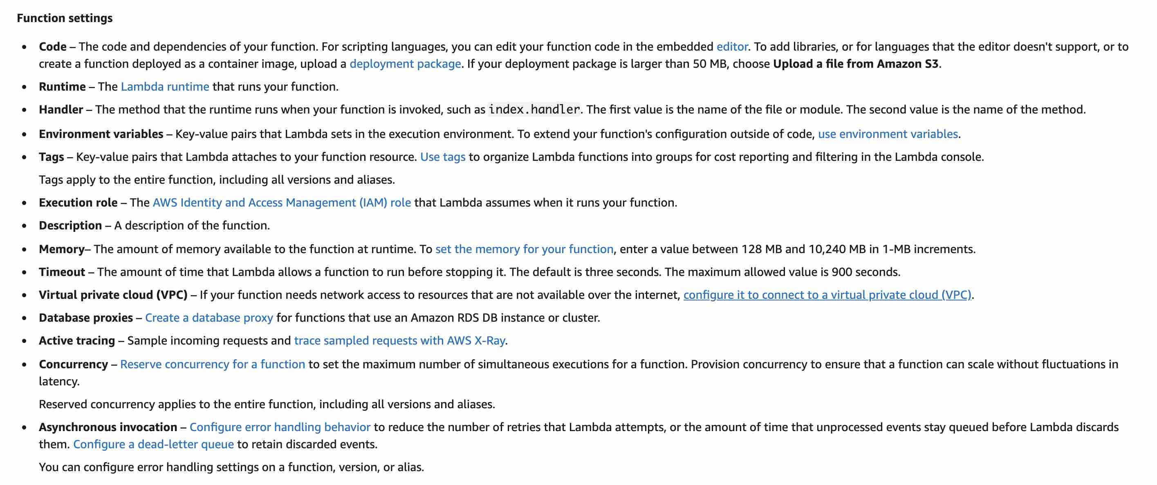 via - <https://docs.aws.amazon.com/lambda/latest/dg/configuration-console.html>

Incorrect options:

**Your zip file is corrupt** - A memory size error states that Lambda was able to extract so the file is not corrupt

**The uncompressed zip file exceeds AWS Lambda limits** - This is not correct as your function was able to execute.

**You have uploaded a zip file larger than 50 MB to AWS Lambda** - This is not correct as your lambda function was able to execute

Reference:

<https://docs.aws.amazon.com/lambda/latest/dg/configuration-console.html>

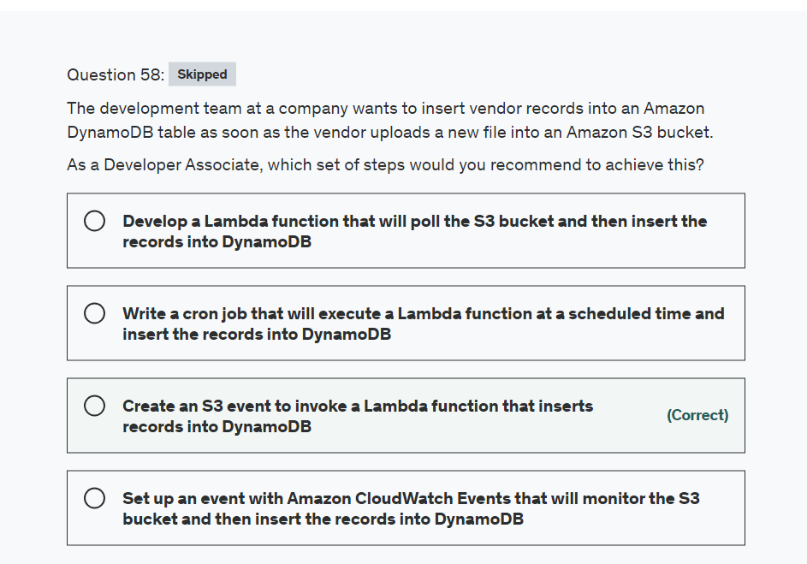

Explanation

Correct option:

**Create an S3 event to invoke a Lambda function that inserts records into DynamoDB**

The Amazon S3 notification feature enables you to receive notifications when certain events happen in your bucket. To enable notifications, you must first add a notification configuration that identifies the events you want Amazon S3 to publish and the destinations where you want Amazon S3 to send the notifications. You store this configuration in the notification subresource that is associated with a bucket.

Amazon S3 APIs such as PUT, POST, and COPY can create an object. Using these event types, you can enable notification when an object is created using a specific API, or you can use the s3:ObjectCreated:* event type to request notification regardless of the API that was used to create an object.

For the given use-case, you would create an S3 event notification that triggers a Lambda function whenever we have a PUT object operation in the S3 bucket. The Lambda function in turn would execute custom code to inserts records into DynamoDB.

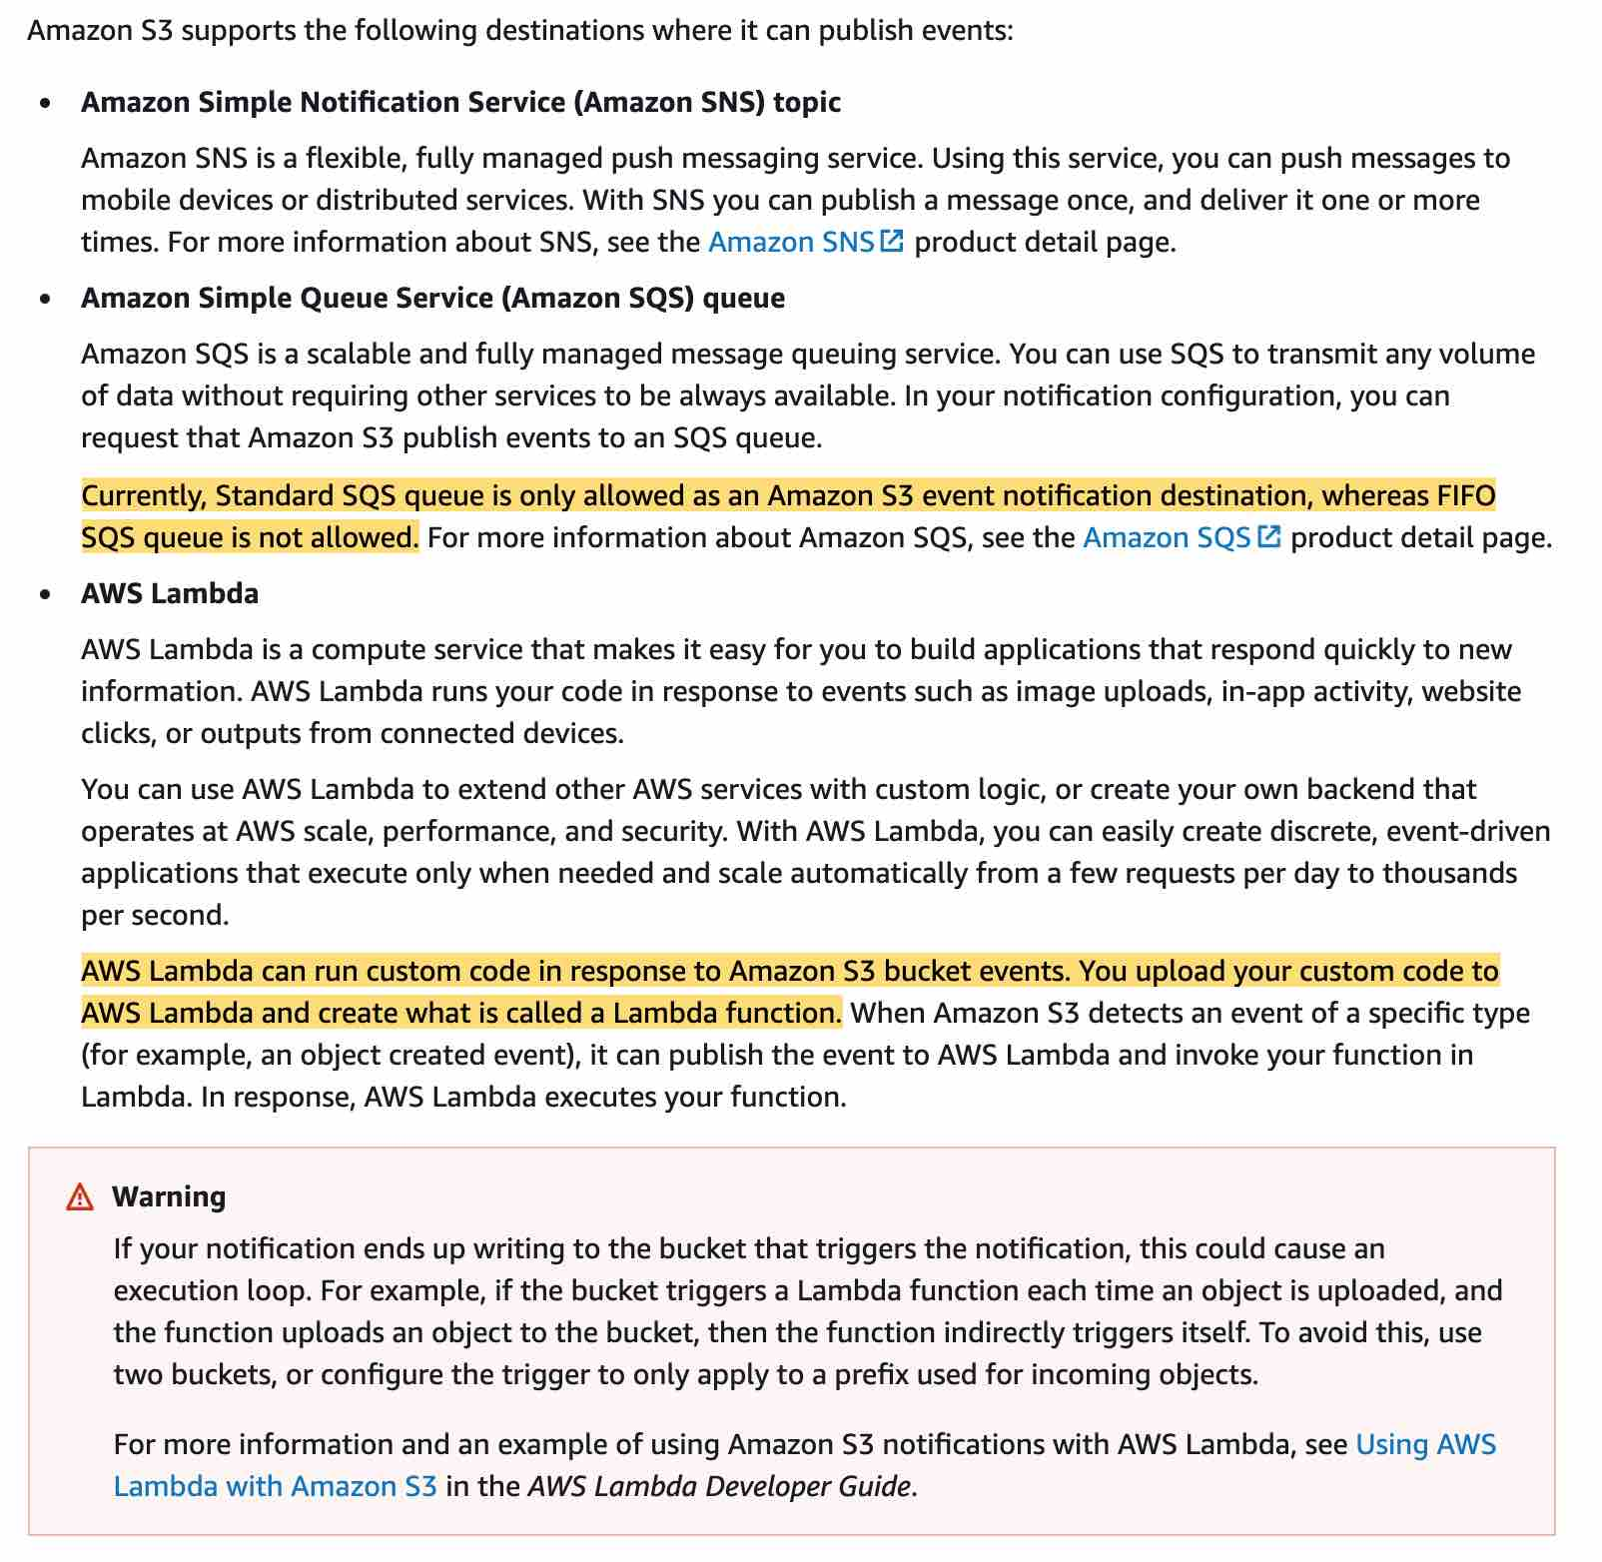 via - <https://docs.aws.amazon.com/AmazonS3/latest/dev/NotificationHowTo.html>

Incorrect options:

**Write a cron job that will execute a Lambda function at a scheduled time and insert the records into DynamoDB** - This is not efficient because there may not be any unprocessed file in the S3 bucket when the cron triggers the Lambda on schedule. So this is not the correct option.

**Set up an event with Amazon CloudWatch Events that will monitor the S3 bucket and then insert the records into DynamoDB** - The CloudWatch event cannot directly insert records into DynamoDB as it's not a supported target type. The CloudWatch event needs to use something like a Lambda function to insert the records into DynamoDB.

**Develop a Lambda function that will poll the S3 bucket and then insert the records into DynamoDB** - This is not efficient because there may not be any unprocessed file in the S3 bucket when the Lambda function polls the S3 bucket at a given time interval. So this is not the correct option.

Reference:

<https://docs.aws.amazon.com/AmazonS3/latest/dev/NotificationHowTo.html>

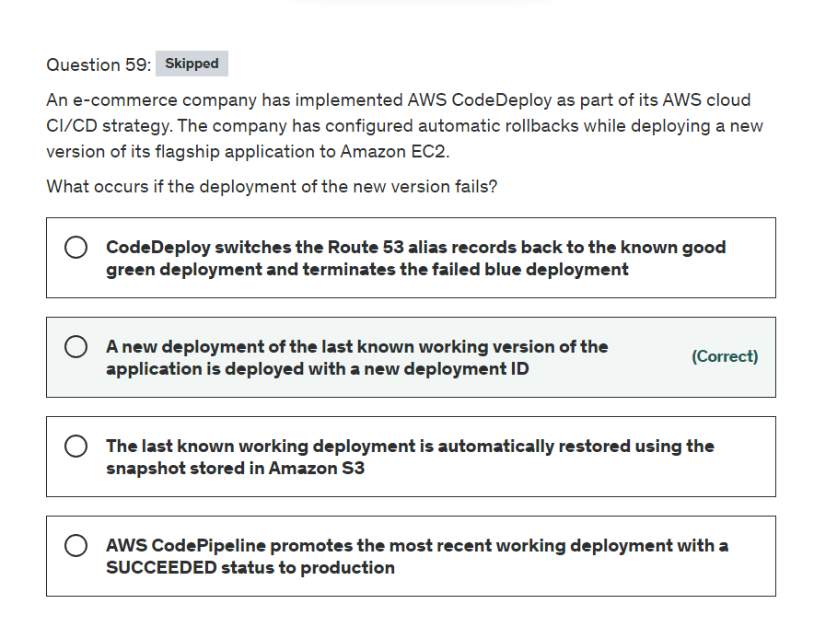

Explanation

Correct option:

**A new deployment of the last known working version of the application is deployed with a new deployment ID**

AWS CodeDeploy is a service that automates code deployments to any instance, including Amazon EC2 instances and instances running on-premises. AWS CodeDeploy makes it easier for you to rapidly release new features, helps you avoid downtime during deployment, and handles the complexity of updating your applications.

CodeDeploy rolls back deployments by redeploying a previously deployed revision of an application as a new deployment. These rolled-back deployments are technically new deployments, with new deployment IDs, rather than restored versions of a previous deployment.

To roll back an application to a previous revision, you just need to deploy that revision. AWS CodeDeploy keeps track of the files that were copied for the current revision and removes them before starting a new deployment, so there is no difference between redeploy and rollback. However, you need to make sure that the previous revisions are available for rollback.

Incorrect options:

**The last known working deployment is automatically restored using the snapshot stored in Amazon S3** - CodeDeploy deployment does not have a snapshot stored on S3, so this option is incorrect.

**AWS CodePipeline promotes the most recent working deployment with a SUCCEEDED status to production** - The use-case does not talk about using CodePipeline, so this option just acts as a distractor.

**CodeDeploy switches the Route 53 alias records back to the known good green deployment and terminates the failed blue deployment** - The use-case does not talk about the blue/green deployment, so this option has just been added as a distractor.

Reference:

<https://docs.aws.amazon.com/codedeploy/latest/userguide/deployments-rollback-and-redeploy.html>

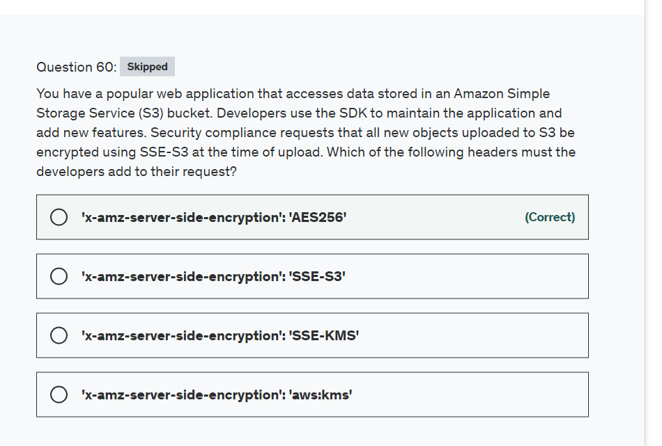

Explanation

Correct option:

**'x-amz-server-side-encryption': 'AES256'**

Server-side encryption protects data at rest. Amazon S3 encrypts each object with a unique key. As an additional safeguard, it encrypts the key itself with a master key that it rotates regularly. Amazon S3 server-side encryption uses one of the strongest block ciphers available to encrypt your data, 256-bit Advanced Encryption Standard (AES-256).

SSE-S3 Overview: 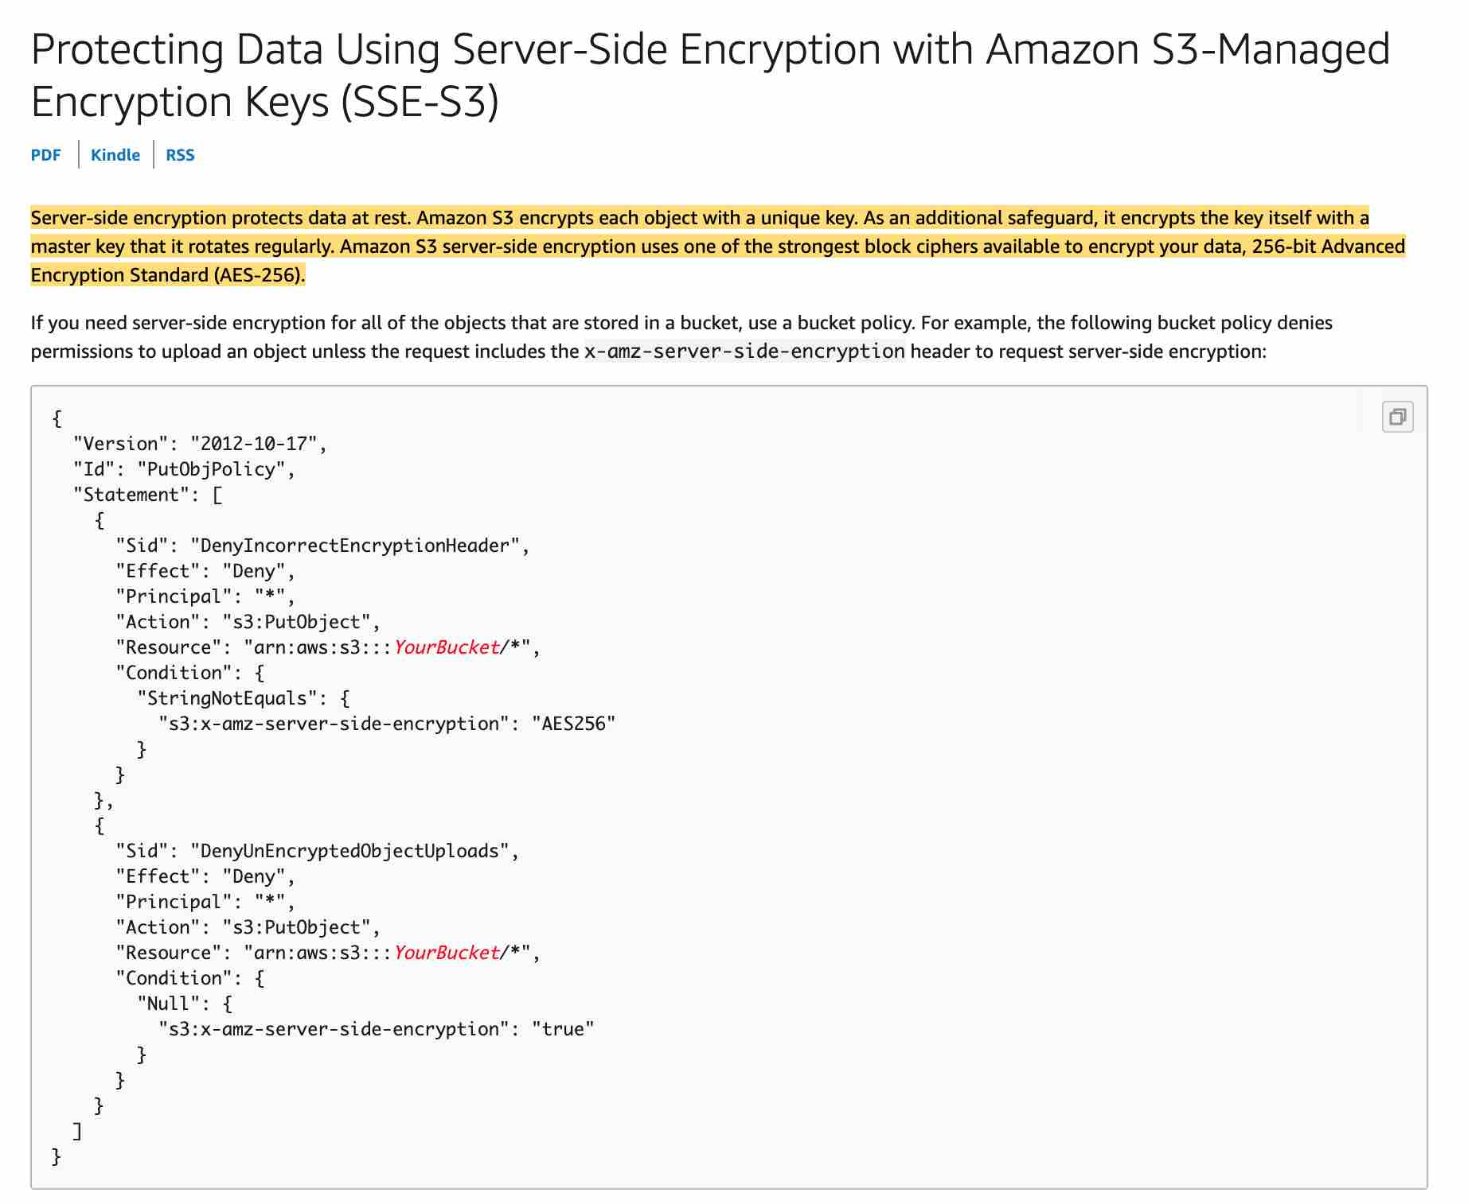 via - <https://docs.aws.amazon.com/AmazonS3/latest/dev/UsingServerSideEncryption.html>

**'x-amz-server-side-encryption': 'SSE-S3'** - SSE-S3 (Amazon S3-Managed Keys) is an option available but it's not a valid header value.

**'x-amz-server-side-encryption': 'SSE-KMS'** - SSE-KMS (AWS KMS-Managed Keys) is an option available but it's not a valid header value. A valid value would be 'aws:kms'

**'x-amz-server-side-encryption': 'aws:kms'** - Server-side encryption is the encryption of data at its destination by the application or service that receives it. AWS Key Management Service (AWS KMS) is a service that combines secure, highly available hardware and software to provide a key management system scaled for the cloud. Amazon S3 uses AWS KMS customer master keys (CMKs) to encrypt your Amazon S3 objects. AWS KMS encrypts only the object data. Any object metadata is not encrypted.

This is a valid header value and you can use if you need more control over your keys like create, rotating, disabling them using AWS KMS. Otherwise, if you wish to let AWS S3 manage your keys just stick with SSE-S3.

References:

<https://docs.aws.amazon.com/AmazonS3/latest/dev/UsingServerSideEncryption.html>

<https://docs.aws.amazon.com/AmazonS3/latest/dev/UsingEncryption.html>

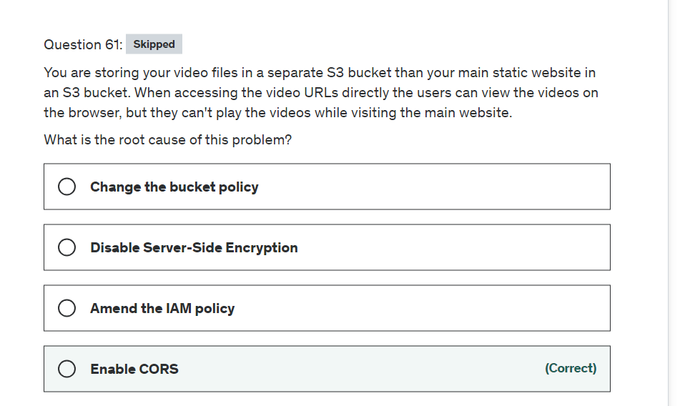

Explanation

Correct option:

**Enable CORS**

Cross-origin resource sharing (CORS) defines a way for client web applications that are loaded in one domain to interact with resources in a different domain. With CORS support, you can build rich client-side web applications with Amazon S3 and selectively allow cross-origin access to your Amazon S3 resources.

To configure your bucket to allow cross-origin requests, you create a CORS configuration, which is an XML document with rules that identify the origins that you will allow to access your bucket, the operations (HTTP methods) that will support for each origin, and other operation-specific information.

For the given use-case, you would create a <CORSRule> in <CORSConfiguration> for bucket B to allow access from the S3 website origin hosted on bucket A.

Please see this note for more details:  via - <https://docs.aws.amazon.com/AmazonS3/latest/dev/cors.html>

Incorrect options:

**Change the bucket policy** - A bucket policy is a resource-based AWS Identity and Access Management (IAM) policy that grants permissions. With this policy, you can do things such as allow one IP address to access the video file in the S3 bucket. In this scenario, we know that's not the case because it works using the direct URL but it doesn't work when you click on a link to access the video.

**Amend the IAM policy** - You attach IAM policies to IAM users, groups, or roles, which are then subject to the permissions you've defined. This scenario refers to public users of a website and they need not have an IAM user account.

**Disable Server-Side Encryption** - Amazon S3 encrypts your data at the object level as it writes it to disks in its data centers and decrypts it for you when you access it, if the video file is encrypted at rest then there is nothing you need to do because AWS handles encrypt and decrypt. Disabling encryption is not an issue because you can access the video directly using an URL but not from the main website.

Reference:

<https://docs.aws.amazon.com/AmazonS3/latest/dev/cors.html>

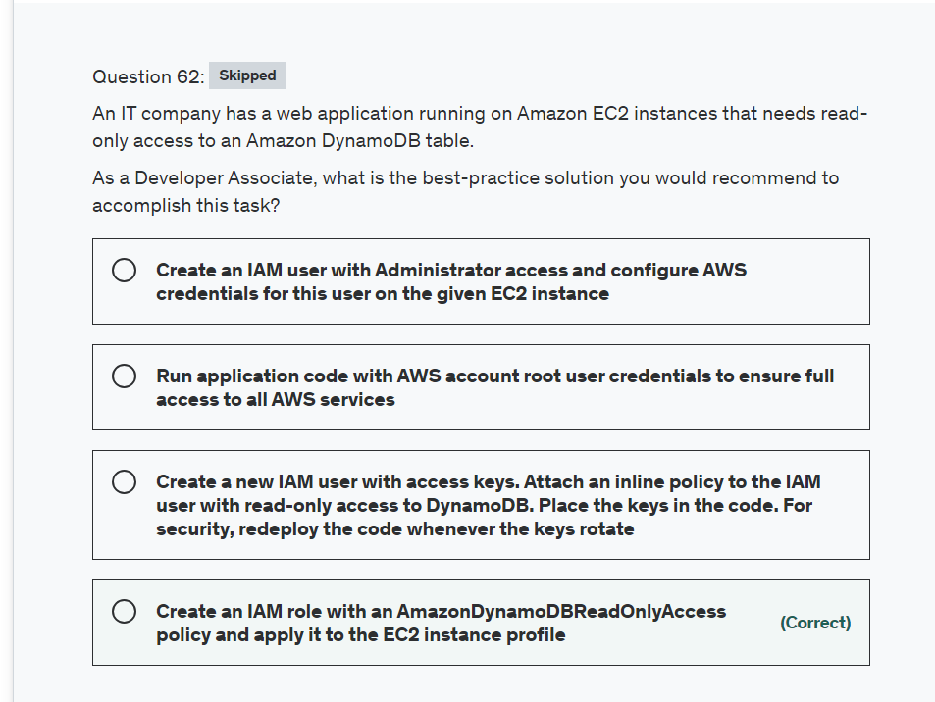Explanation

Correct option:

**Create an IAM role with an AmazonDynamoDBReadOnlyAccess policy and apply it to the EC2 instance profile**

As an AWS security best practice, you should not create an IAM user and pass the user's credentials to the application or embed the credentials in the application. Instead, create an IAM role that you attach to the EC2 instance to give temporary security credentials to applications running on the instance. When an application uses these credentials in AWS, it can perform all of the operations that are allowed by the policies attached to the role.

So for the given use-case, you should create an IAM role with an AmazonDynamoDBReadOnlyAccess policy and apply it to the EC2 instance profile.

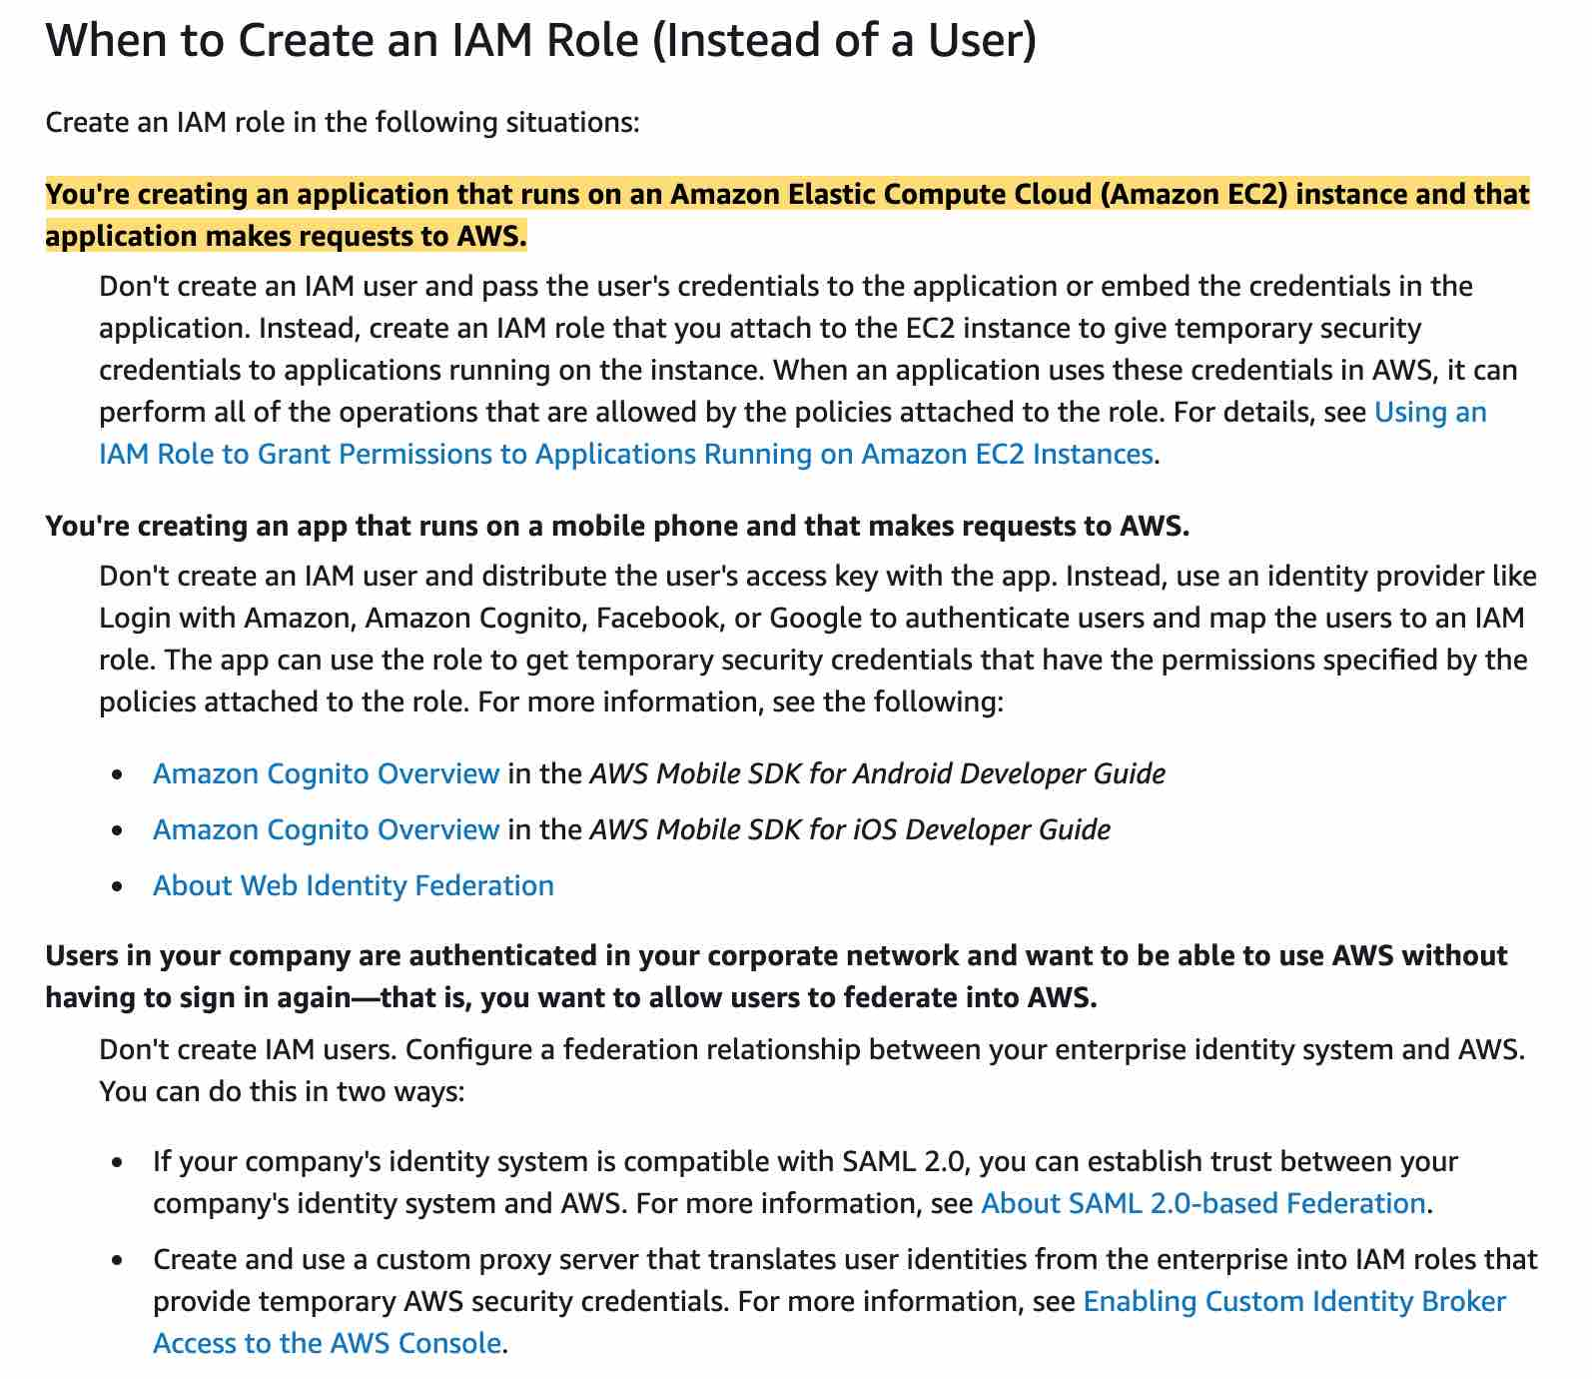 via - <https://docs.aws.amazon.com/IAM/latest/UserGuide/id.html>

Incorrect options:

**Create a new IAM user with access keys. Attach an inline policy to the IAM user with read-only access to DynamoDB. Place the keys in the code. For security, redeploy the code whenever the keys rotate**

**Create an IAM user with Administrator access and configure AWS credentials for this user on the given EC2 instance**

**Run application code with AWS account root user credentials to ensure full access to all AWS services**

As mentioned in the explanation above, it is dangerous to pass an IAM user's credentials to the application or embed the credentials in the application. The security implications are even higher when you use an IAM user with admin privileges or use the AWS account root user. So all three options are incorrect.

Reference:

<https://docs.aws.amazon.com/IAM/latest/UserGuide/id.html>

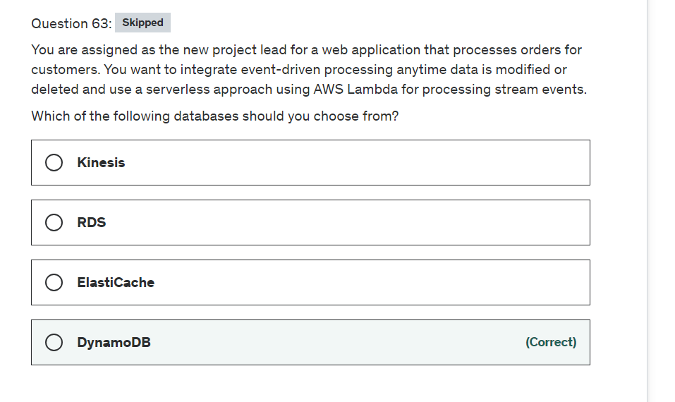

Explanation

Correct option:

**DynamoDB**

A DynamoDB stream is an ordered flow of information about changes to items in a DynamoDB table. When you enable a stream on a table, DynamoDB Streams captures a time-ordered sequence of item-level modifications in any DynamoDB table, and stores this information in a log for up to 24 hours. Applications can access this log and view the data items as they appeared before and after they were modified, in near real-time.

Whenever an application creates, updates, or deletes items in the table, DynamoDB Streams writes a stream record with the primary key attributes of the items that were modified.

DynamoDB Streams Overview: 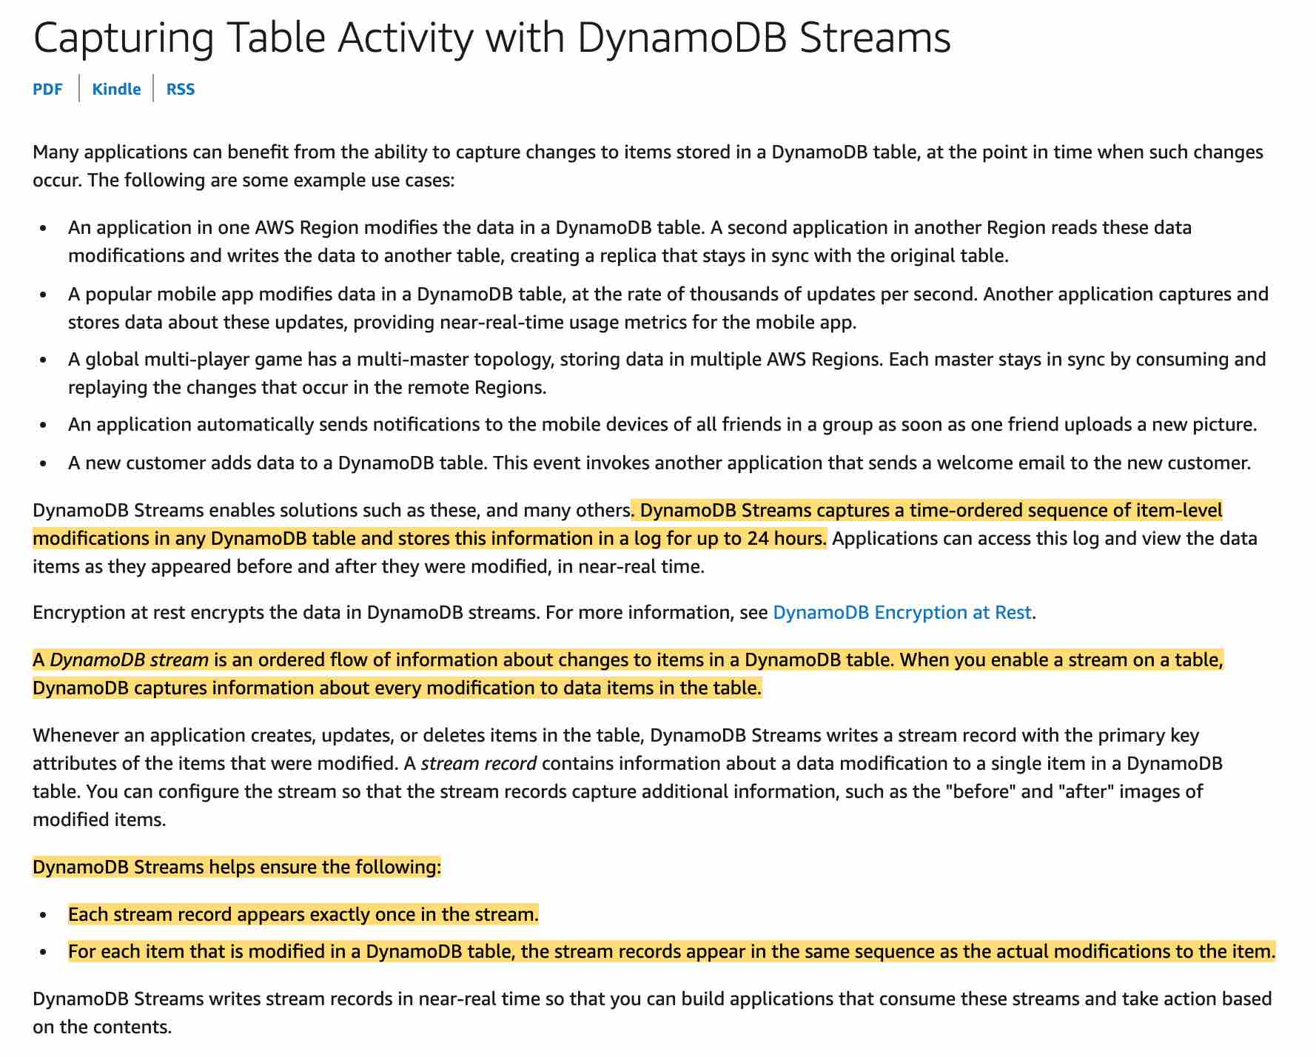 via - <https://docs.aws.amazon.com/amazondynamodb/latest/developerguide/Streams.html>

Incorrect options:

**RDS** - By itself, RDS cannot be used to stream events like DynamoDB, so this option is ruled out. However, you can use Amazon Kinesis for streaming data from RDS.

Please refer to this excellent blog for more details on using Kinesis for streaming data from RDS: <https://aws.amazon.com/blogs/database/streaming-changes-in-a-database-with-amazon-kinesis/>

**ElastiCache** - ElastiCache works as an in-memory data store and cache, it cannot be used to stream data like DynamoDB.

**Kinesis** - Kinesis is not a database, so this option is ruled out.

Amazon Kinesis Data Streams enables you to build custom applications that process or analyze streaming data for specialized needs. You can continuously add various types of data such as clickstreams, application logs, and social media to an Amazon Kinesis data stream from hundreds of thousands of sources.

How Kinesis Data Streams Work 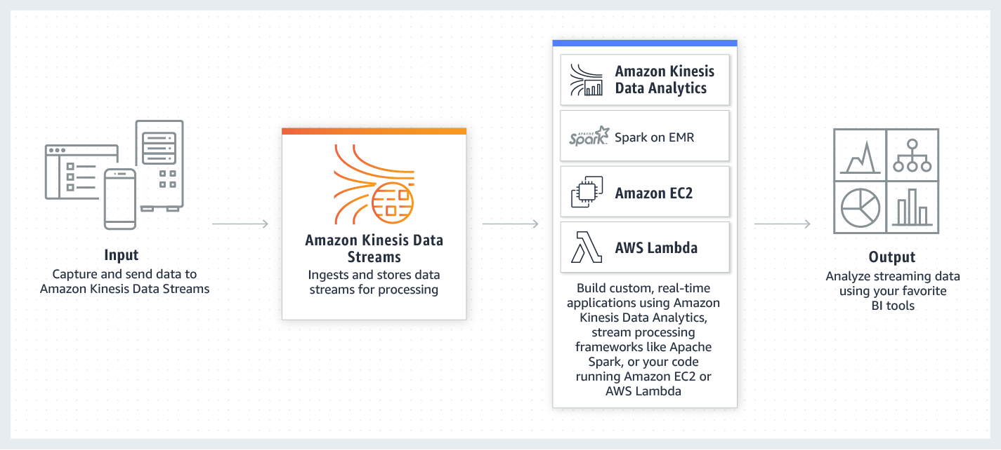 via - <https://aws.amazon.com/kinesis/data-streams/>

Reference:

<https://docs.aws.amazon.com/amazondynamodb/latest/developerguide/Streams.html>

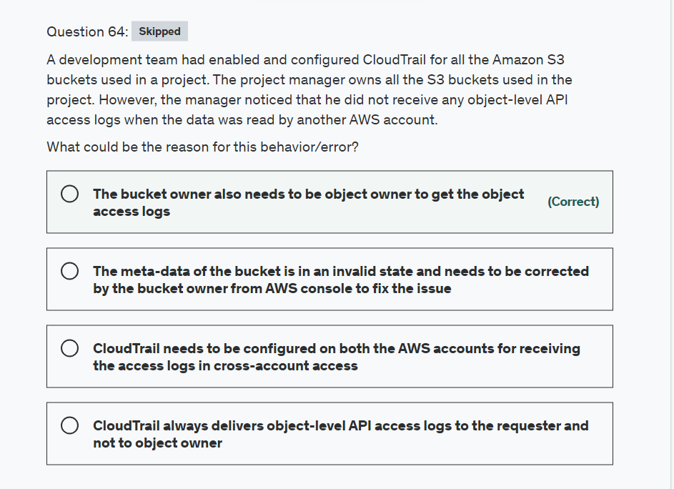

Explanation

Correct option:

**The bucket owner also needs to be object owner to get the object access logs**

If the bucket owner is also the object owner, the bucket owner gets the object access logs. Otherwise, the bucket owner must get permissions, through the object ACL, for the same object API to get the same object-access API logs.

Incorrect options:

**CloudTrail always delivers object-level API access logs to the requester and not to object owner** - CloudTrail always delivers object-level API access logs to the requester. In addition, CloudTrail also delivers the same logs to the bucket owner only if the bucket owner has permissions for the same API actions on that object.

**CloudTrail needs to be configured on both the AWS accounts for receiving the access logs in cross-account access**

**The meta-data of the bucket is in an invalid state and needs to be corrected by the bucket owner from AWS console to fix the issue**

These two options are incorrect and are given only as distractors.

Reference:

<https://docs.aws.amazon.com/AmazonS3/latest/userguide/cloudtrail-logging-s3-info.html#cloudtrail-object-level-crossaccount>

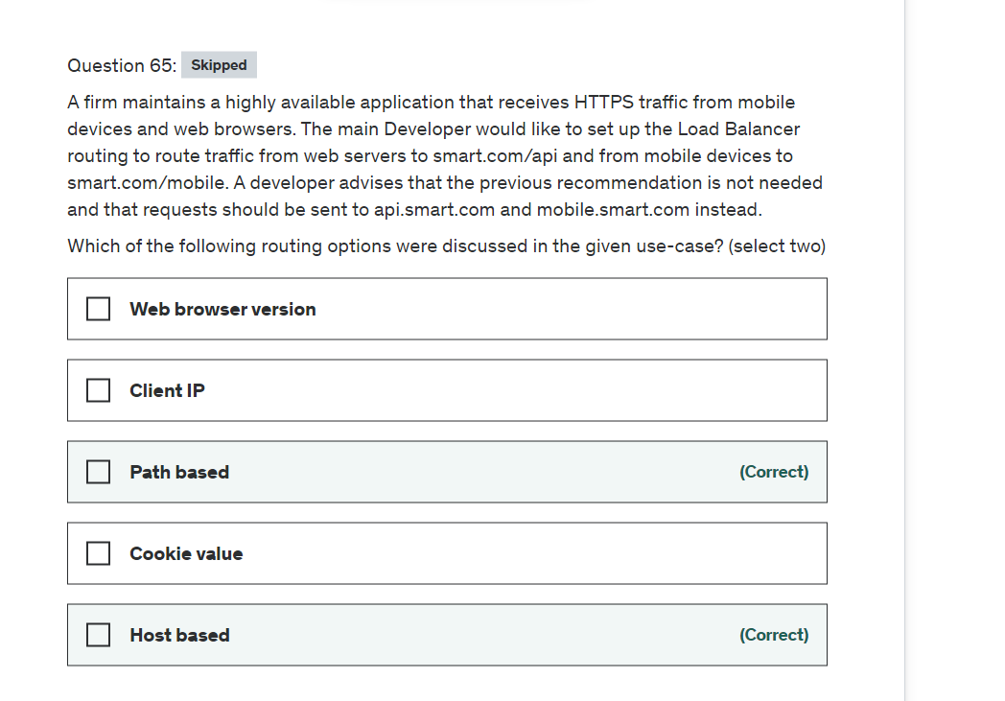

Explanation

Correct options:

**Path based**

You can create a listener with rules to forward requests based on the URL path. This is known as path-based routing. If you are running microservices, you can route traffic to multiple back-end services using path-based routing. For example, you can route general requests to one target group and request to render images to another target group.

This path-based routing allows you to route requests to, for example, /api to one set of servers (also known as target groups) and /mobile to another set. Segmenting your traffic in this way gives you the ability to control the processing environment for each category of requests. Perhaps /api requests are best processed on Compute Optimized instances, while /mobile requests are best handled by Memory Optimized instances.

**Host based**

You can create Application Load Balancer rules that route incoming traffic based on the domain name specified in the Host header. Requests to api.example.com can be sent to one target group, requests to mobile.example.com to another, and all others (by way of a default rule) can be sent to a third. You can also create rules that combine host-based routing and path-based routing. This would allow you to route requests to api.example.com/production and api.example.com/sandbox to distinct target groups.

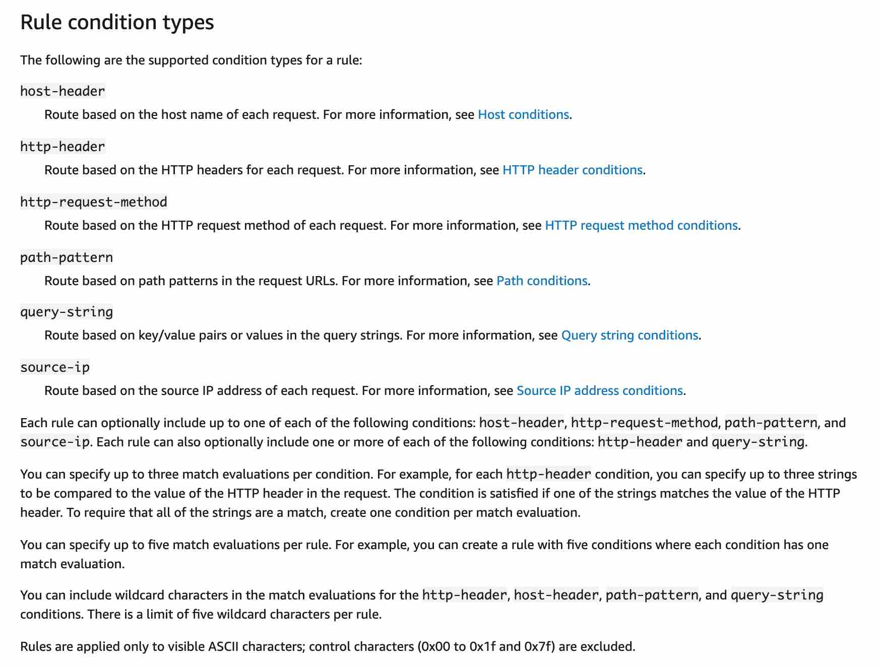 via - <https://docs.aws.amazon.com/elasticloadbalancing/latest/application/load-balancer-listeners.html#rule-condition-types>

Incorrect options:

**Client IP** - This option has been added as a distractor. Routing is not based on the client's IP address.

**Web browser version** - Routing has nothing to do with the client's web browser, if it was then there is something sneaky going on.

**Cookie value** - Application Load Balancers support load balancer-generated cookies only and you cannot modify them. When routing sticky sessions to route requests to the same target then cookies are needed to be supported by the client's browser.

Reference:

<https://aws.amazon.com/blogs/aws/new-host-based-routing-support-for-aws-application-load-balancers/>